NAME:……………………………………………………… INDEX NO:…………………………
SCHOOL:………………………………………………….. DATE:……………………………….
SIGN:………………………………..

121/2
MATHEMATICS
Paper 2
JULY/AUGUST 2012
Time: 2 ½ HOURS

BORABU – MASABA DISTRICTS JOINT EVALUATION TEST– 2012
Kenya Certificate of Secondary Education (K.C.S.E)

121/2
MATHEMATICS
Paper 2
JULY/AUGUST 2012
Time: 2 ½ HOURS

INSTRUCTIONS TO CANDIDATES

- This paper has Two sections: A and B
- Answer all the question in section A.
- In section B answer question 6 and any other two questions
- All answer must be written in the spaces provided

FOR EXAMINERS USE ONLY
Section I
1 | 2 | 3 | 4 | 5 | 6 | 7 | 8 | 9 | 10 | 11 | 12 | 13 | 14 | 15 | 16

GRAND TOTAL
Section II
17 | 18 | 19 | 20 | 21 | 22 | 23 | 24 | TOTAL

This paper consists of 16 printed pages. Candidates should check the question paper to ensure that all pages are printed as indicated and that no questions are missing

1. Use logarithms to evaluate
$\sqrt[3]{\frac{\text{45}\text{.}3×0\text{.}\text{00697}}{0\text{.}\text{534}}}$ (4mks)

2. One litre of melted metal is cast into 15 equal cubes. The volume of the metal is reduced by 4% on cooling. Calculate the dimension of a cube in cm (3mks)

3. Make P the subject of the formula in L=$\frac{2}{3}\sqrt{\frac{x−\text{PT}}{y}}$ (3mks)

4. Rono invested a sum of money shP at 24% per annum simple interest for 8 years and realized that he got the same amount as Wekesa who invested sh 2P for 4 years at compound interest.
Calculate the rate of interest per annum Wekesa enjoyed. (4mks)

5. By rounding each number to the nearest tens, approximate the value of
$\frac{\text{2454}×\text{396}}{\text{66}}$
Hence, calculate the percentage error arising, from this approximation to 4 significant figures (3mks)

6. Given that tan 15⁰=2-$\sqrt{3}$,find without using mathematical tables or a calculator, tan 75⁰ in the form of a+b$\sqrt{c}$,where a,b and c are integers. (3mks)

7. The position vectors of A and B are given as a=2i-3j+4k and b=-2i-j+2k respectively. Find to 2 decimal places, the length of vector AB. (3mks)

8. Solve for x in the equation
2 sin ²x-1=cos²x+sin x, where 0⁰x360⁰. (4mks)

9. Three towns A,B and C are such that B is 84km due north of A and C is on a bearing of 2950 from A at a distance of 60km.By using an appropriate scale drawing, final
(a) the distance between B and C (2mks)

(b) the bearing of C from B (1mk)

10. A particle moves a long a straight line AB.its velocity V metres per second after t seconds is given by v=t²-3t+5
Its distance from A at the time t=1 is 6 metres..
Determine its distance from A when t=3 (3mks)

11. Use binomial expansion to find the sum of all the terms that are rational number in the expansion of ${\left(3+\frac{1}{\sqrt{3}}\right)}^{4}$ (3mks)

12. Below is a circle centre O and a point M outside the circle. Construct two tangents to the circle from point M to touch the circle at P and Q.Hence measure angle POQ. (3mks)
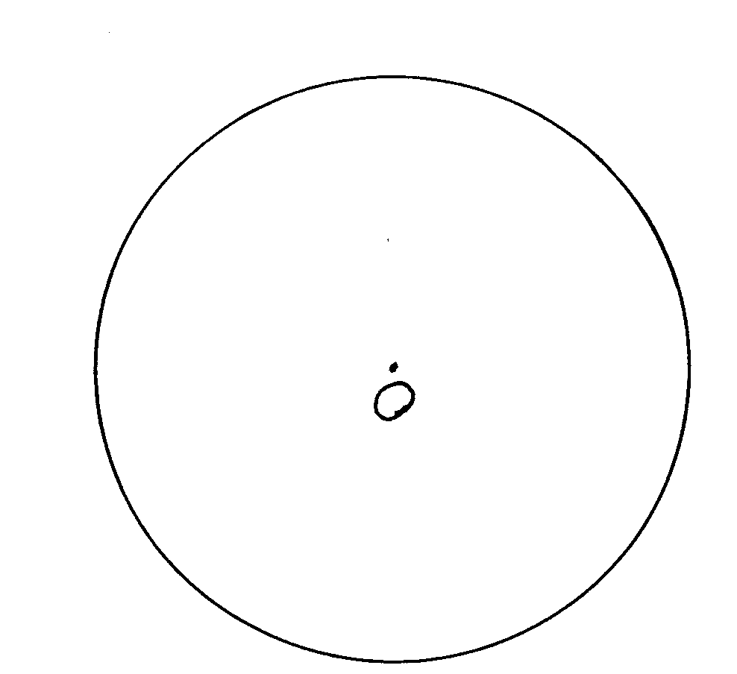

13. A matrix A=$\left(\begin{matrix}2 \\ 3 \\ 5\end{matrix}\right)$and B=$\left(\begin{matrix}a−2 \\ k−1 \\ \text{15}\end{matrix}\right)$
Another matric C is such that AC=B. Find C and hence evaluate the value of a and k. (3mks)

14. Two taps A and B together, can file water in a tank in 6 minutes. Tap A alone takes 5 minutes longer to fill, the tank than the tap B alone. How many minutes does it take tap B alone to fill the tank? (3mks)

15. W varies directly as the cube of x and inversely as y.Find w in terms of x and y given that W=80 when x=2 and y=5. (2mks)

- Find the radius and the co-ordinates of the centre of a circle whose equation is $\frac{1}{2}x+\frac{1}{2}y^{2}−3x+4y+6\frac{3}{8}=0$ (3mks)

17. A and B are two points on the earth’s surface and on latitude 30⁰N.The two points are on the longitude 40⁰W and 140⁰E respectively.
Calculate
(a) (i) The distance from A to B along a parallel of latitude in kilometers. (3mks)

(ii) The shortest distance from A to B along a great circle in kilometer (4mks)
(Take $π$=$\frac{\text{22}}{7}$and radius of the earth =6370km)

(b) If the local time at B is 8.00am,Calculate the local time at A (3mks)

18. Income tax rates are as shown below
Income (kf p.a) Rate (Ksh per £)
  - 2
4201-8000 3
8001-12600 5
12601-16800 6
16801 and above 7
Omari pays sh 4000 as P.A.Y.E per month .He has a monthly house allowance of Ksh 10800 and is entitled to a personal relief of ksh1, 100 per month. Determine
(i) his gross tax p.a in Ksh (2mks)

(ii) his taxable income in kf p.a (4mks)

(iii) his basic salary in ksh p.m (2mks)

(iv) his net salary per month (2mks)

19. The table below shows some values of the functions y=a cos (x-15)⁰ and y =b sin (x+50)⁰

x⁰ | 0 | 15 | 30 | 45 | 60 | 75 | 105 | 120 | 135 | 150
y=a cos (x-15)⁰ | 0.97 |  |  | 0.87 |  | 0.50 |  |  | -0.50 | -0.71
y=b sin (x+30)⁰ | 1.00 |  |  |  | 2.00 |  |  | 1.00 |  | 0.00

(a) Determine the value of a and b. (2mks)

(b) Hence, complete the table above (2mks)

(c) On the grid provided and on the same axes, draw the graphs of y =a cos (x-15)⁰ and y=b sin (x+30)
Grid

(d) Use your graph to solve a cos (x-15)- b sin (x+30)=0 (2mks)

20. (a) Construct triangle PQR using a pair of compasses and a ruler only such that PQ=7.5cm the
ratio of angle QPR and angle =5.3 and angle QRP=60⁰. (3mks)

(b) On the same diagram in (a) above construct the locus of a point S given that S is on the same side as R and S moves such that angle PSQ=75. (3mks)

(c) Construct the locus of a point T which moves in such a way that it is always equidistant from lines PQ and PR and produce if to intersect the locus of S at M..(Use the same diagram above) (2mks)

(d) By dropping a perpendicular from point M onto line PQ to meet it at N, measure MN. (2mks)

21. In an experiment the following values of x and y were obtained

x | 1.5 | 2 | 3 | 4 | 5 | 6
y | 5.05 | 4.22 | 3.27 | 2.73 | 2.38 | 2.12
It is known that the two variable x and y are connected by a law of the form y=ax^{n} where a and n are constants.

(a) Determine the linear equation connecting x and y. (1mks)

(b) Hence find graphically the values of the constants a and n. (8mks)

(c) Write down the law connecting x and y. (1mk)

22. In a road safety survey, 1000 vehicles were examined. 62 of these were found to have defective tyres, 30 had defective steering and 45 had defective brakes.
Assuming that this sample does accurately represent all the vehicles in the country, find the probability that a vehicles in the country, at random has:
(a) (i) defective brakes (1mks)

(ii) defective brakes but neither of the other two defectives (3mks)

(iii) has no defects (2mks)

(d) If the owner of a defective vehicle is warmed if his car has one or two of these defects, but is fined sh 300 if his car has all three defects, what is the total amount of filed that one would expect to be imposed after 10,000 vehicles had been inspected at random? (4mks)

23. The figure below shows a pully system where a conveyer belt is tied round the two wheels.
The radius of the larger wheel is 180cm and the distance between the centres of the wheels is 300cm and angle AMC=140⁰.
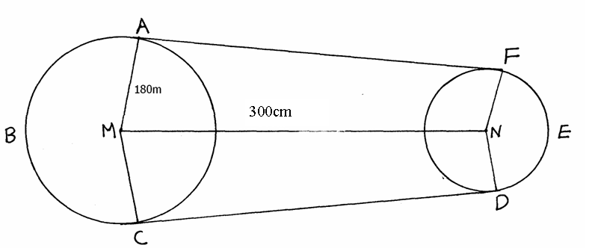
Determine
(a) length AF (2mks)

(b) length of the arc FED (4mks)

(c) Length of the arc ABC (2mks)

(d) the total length of the conveyor belt (2mks)

24. For a sample of 100 bulbs the time taken for each bulb to burn out was recorded. The table below shows the result of the measurements.

Time(in hour) | 15-19 | 20-24 | 25-29 | 30-34 | 35-39 | 40-44 | 45-49 | 50-54 | 55-59 | 60-64 | 65-69 | 70-74
Number of bulbs | 6 | 10 | 9 | 5 | 7 | 11 | 15 | 13 | 8 | 7 | 5 | 4

(a) using an assumed mean of 42,calculate
(i) the actual mean of distribution (4mks)

(ii) the standard deviation of the distribution (3mks)

(b) Calculate the quartile deviation (3mks)

End

