NAME:……………………………………………………… INDEX NO:…………………………
SCHOOL:………………………………………………….. DATE:……………………………….
SIGN:………………………………..

232/1
PHYSICS
PAPER 1
(THEORY)
JULY/AUGUST - 2012
TIME: 2 HOURS

BORABU-MASABA DISTRICTS JOINT EVALUATION TEST– 2012
Kenya Certificate of Secondary Education (K.C.S.E)

INSTRUCTIONS TO CANDIDATES

1. Write your name and index number in the spaces provided at the top of this page.
2. Sign and write the date of examination in the spaces provided above.
3. This paper consists of TWO sections: A and B
4. Answer ALL the questions in the sections A and B in the spaces provided.
5. ALL working MUST be clearly shown.
6. Non-programmable silent electronic calculators and KNEC mathematical tables may be used.

FOR EXAMINERS USE ONLY.

SECTION | QUESTIONS | MAXIMUM SCORE | CANDIDATE’S SCORE
A | 1 – 14 | 25
B | 15 | 11
 | 16 | 13
 | 17 | 13
 | 18 | 10
 | 19 | 08
Total Score |  | 80

This paper consists of 8 printed pages.
Candidates should check the question paper to ensure that all pages are printed as indicated and that no questions are missing.

Section A (25 marks)
1. The water level in a burette is 40.6 cm³. 50 drops of water each of volume 0.2 cm³are
added to the water in the burette. What is the final reading of the burette? (2mks)
.............................................................................................................................................................
.............................................................................................................................................................
2. Figure 1 shows a U-tube manometer used to measure lung pressure.
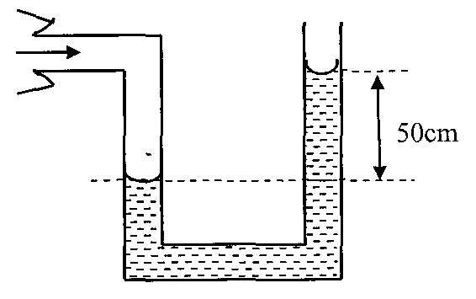
Figure 1

Determine the lung pressure given that atmospheric pressure 1.03 x 10⁵ Nm⁻² and density of
water 1000 kgm⁻³. (3mks)
.............................................................................................................................................................
.............................................................................................................................................................
.............................................................................................................................................................
.............................................................................................................................................................
3. On the axes provided sketch density-temperature graph, when water is heated from a
temperature of 0°C to 10°C. (2mks)
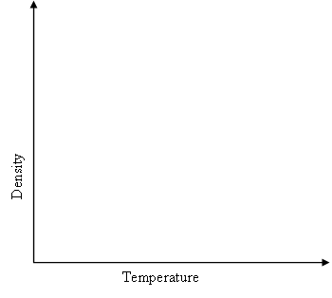

4. The springs in figure 2 are identical.
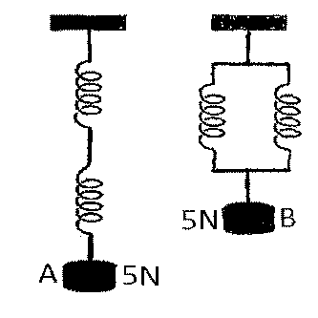
Figure 2
The extension produced in A is 4cm. What is the extension in B? (3mks)
.............................................................................................................................................................
.............................................................................................................................................................
.............................................................................................................................................................
.............................................................................................................................................................
5. State and explain how the motion of the smoke particles changes when the temperature
inside the smoke cell is lowered. (2mks)
.............................................................................................................................................................
.............................................................................................................................................................
.............................................................................................................................................................
.............................................................................................................................................................
6. The uniform rod of length one metre shown in figure 3 is in equilibrium.

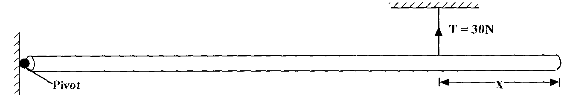

Figure 3
Find the value of x if the weight of the rod is 40N. (3mks)
.............................................................................................................................................................
.............................................................................................................................................................
.............................................................................................................................................................
.............................................................................................................................................................
7. Explain the washing effect of soap. (1mk)
.............................................................................................................................................................
.............................................................................................................................................................
8. Why are the tanks for storage of fuel by the Kenya pipeline company painted silvery? (1mk)
.............................................................................................................................................................
.............................................................................................................................................................
9. State one difference between lamina flow and turbulent flow. (1mk)
.............................................................................................................................................................
.............................................................................................................................................................
10. A dripless candle is weighted slightly on the bottom so that it floats upright in a container
filled with water as shown in figure 4.
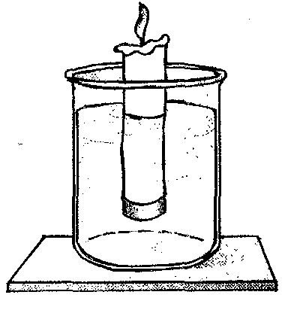
Figure 4
Explain what happens to the candle as it bums. (2mks)
.............................................................................................................................................................
.............................................................................................................................................................
.............................................................................................................................................................
.............................................................................................................................................................
11. In an experiment to estimate the size of an oil molecule, a spherical oil drop is introduced
on a clean water surface. It spreads to form a circular oil film. State one assumption made
in this experiment. (1mk)
.............................................................................................................................................................
.............................................................................................................................................................
12. Figure 5 a toy used to demonstrate one of the states of equilibrium.
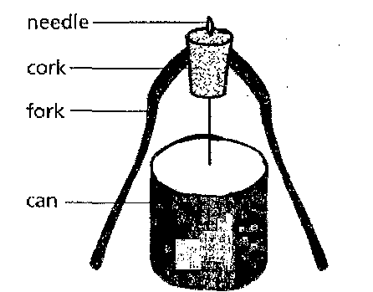
Figure 5

State with a reason the state of equilibrium of this toy (2mks)
.............................................................................................................................................................
.............................................................................................................................................................
13. The shelves in a refrigerator are made of metal gauze instead of metal plates. Why? (1mk)
.............................................................................................................................................................
.............................................................................................................................................................
14. On the axes provided sketch a graph of mechanical advantage (M.A) against load for a
pulley system. (1mk)
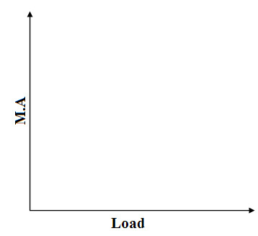

SECTION B (55 MARKS)

15. a) Define angular velocity. (1mk)
.............................................................................................................................................................
.............................................................................................................................................................
b) Figure 6 shows an object of mass 2.0 kg whirled in a vertical circle of radius 0.7 m
at a uniform speed of 50 ms⁻¹
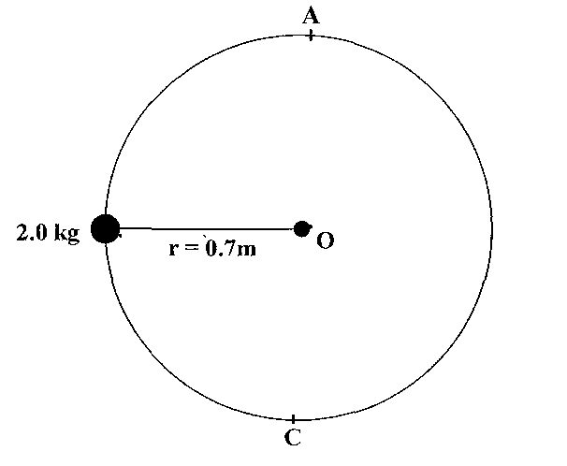
Figure 6
(i) Determine:
I the centripetal force on the object. (2mks)
.............................................................................................................................................................
.............................................................................................................................................................
II the tension in the string when the object is at A. (2mks)
.............................................................................................................................................................
.............................................................................................................................................................
III the tension in the string when the object is at B (2mks)
.............................................................................................................................................................
.............................................................................................................................................................
(ii) The speed of rotation is gradually increased until the string snaps. At what point
is the string likely to snap? Explain (2mks)
.............................................................................................................................................................
.............................................................................................................................................................
.............................................................................................................................................................
.............................................................................................................................................................

c) A centrifuge is used to separate cream from milk. A particle of cream has a smaller
mass than a particle of milk. Explain how the centrifuge does the separation. (2mks)
.............................................................................................................................................................
.............................................................................................................................................................
.............................................................................................................................................................
.............................................................................................................................................................
16. a) Figure 7 shows a section of a ticker tape produced by a ticker-timer operating at a
frequency of 50Hz.

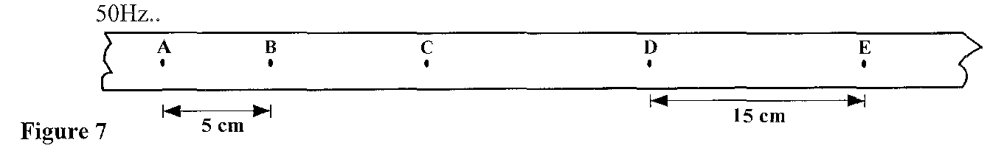

Figure 7 cm
Find the:
(i) time for one tick interval. (2mks)
.............................................................................................................................................................
.............................................................................................................................................................

(ii) average velocity between A and B. (2mks)
.............................................................................................................................................................
.............................................................................................................................................................
.............................................................................................................................................................
.............................................................................................................................................................
(iii) average velocity between D and E (2mks)
.............................................................................................................................................................
.............................................................................................................................................................
.............................................................................................................................................................
.............................................................................................................................................................
(iv) average acceleration. (2mks)
.............................................................................................................................................................
.............................................................................................................................................................
.............................................................................................................................................................
.............................................................................................................................................................

b) A girl drops a stone from the top a tower 45m tall. At the same time, a boy
standing at the base of the tower, projects another stone vertically upwards at
25ms⁻¹ (g = 10 ms⁻²)
Determine the:
(i) time when the stones meet. (3mks)
.............................................................................................................................................................
.............................................................................................................................................................
.............................................................................................................................................................
.............................................................................................................................................................
(ii) point at which the stones meet. (2mks)
.............................................................................................................................................................
.............................................................................................................................................................
17. a) Distinguish between latent heat of fusion and specific latent of fusion. (1mk)
.............................................................................................................................................................
.............................................................................................................................................................

b) Figure 8 shows a block of ice. A thin copper wire with two heavy weights
hanging from its ends-passes over the block. The copper wire is observed to
pass through the block of ice without cutting it in a process known as regelation.

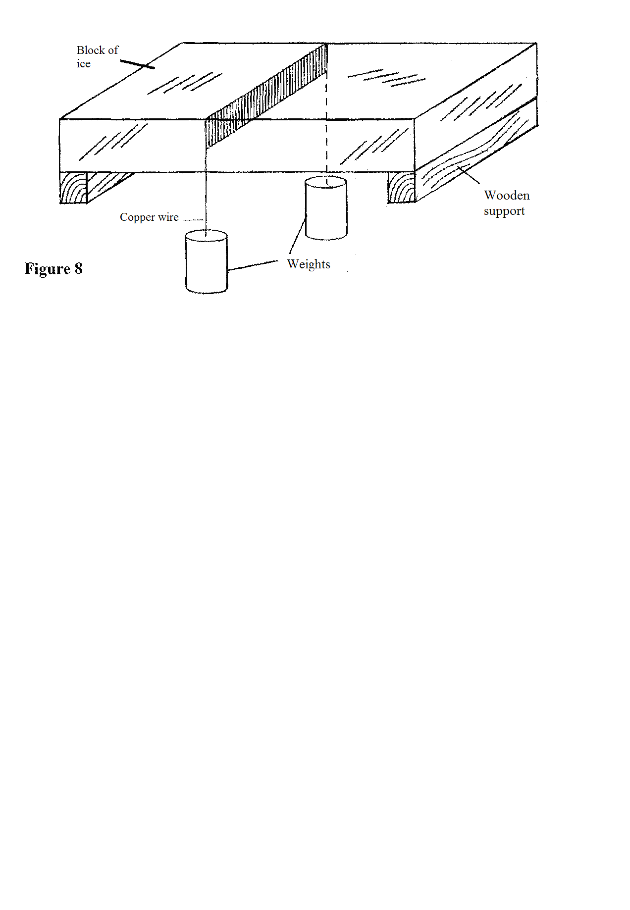
(i) Explain this observation, (3mks)
.............................................................................................................................................................
.............................................................................................................................................................
.............................................................................................................................................................
.............................................................................................................................................................
(ii) What would be the effect of replacing the copper wire with a cotton thread?
Explain. (2mks)
.............................................................................................................................................................
.............................................................................................................................................................
.............................................................................................................................................................
.............................................................................................................................................................
c) Figure 9 shows one method of measuring the specific latent heat of fusion of ice.
Two funnels A and B, contain crushed ice at 0°C.
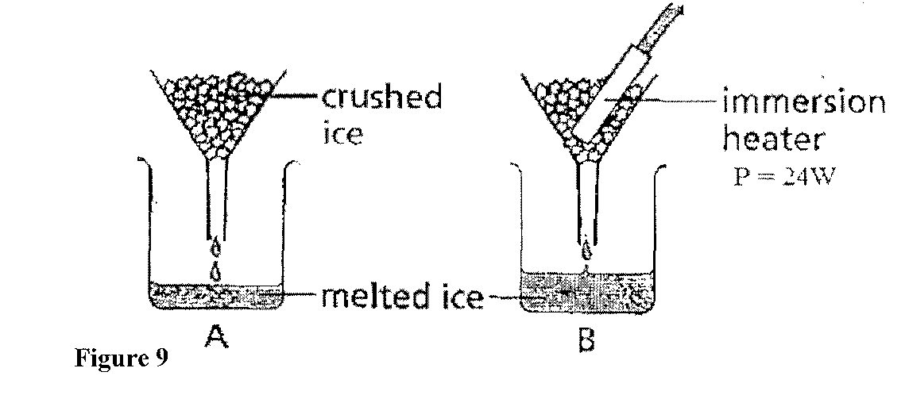
The mass of melted ice from each funnel is measured after 11 minutes. The results are shown below.
Mass of melted ice in A = 24g
Mass of melted ice in B = 63g
(i) What is the reason for setting up funnel A? (1mk)
.............................................................................................................................................................
.............................................................................................................................................................
(ii) Determine the:
I quantity of heat supplied by the heater. (2mks)
.............................................................................................................................................................
.............................................................................................................................................................
II mass of ice melted by the heater. (1mk)
.............................................................................................................................................................
.............................................................................................................................................................
III specific latent heat of fusion of ice. (3mks)
.............................................................................................................................................................
.............................................................................................................................................................

18. a) A balloon seller has a cylinder of helium gas which she uses to blow up her
balloons. The volume of the cylinder is 0.10 m³. It contains helium gas at a
pressure of 1.0 x 10⁷ Pa. she fills each balloon to a volume of 1.0 x 10⁻² m³
and a pressure of 1.2 x 10⁵ Pa.
(i) Explain, in terms of molecules how the helium in the cylinder produces
a pressure. (2mks)
.............................................................................................................................................................
.............................................................................................................................................................
.............................................................................................................................................................
.............................................................................................................................................................
(ii) Calculate the total volume the helium gas would occupy at a pressure of
1.2 x 10⁵ Pa if the temperature of the helium gas remains constant. (3mks)
.............................................................................................................................................................
.............................................................................................................................................................
.............................................................................................................................................................
.............................................................................................................................................................

(iii) Calculate the number of balloons of volume 1.0 x 10² m³ the seller can
fill with the helium gas. (2mks)
.............................................................................................................................................................
.............................................................................................................................................................
.............................................................................................................................................................
.............................................................................................................................................................

b) Figure 10 show a pressure-temperature graph for an ideal gas.
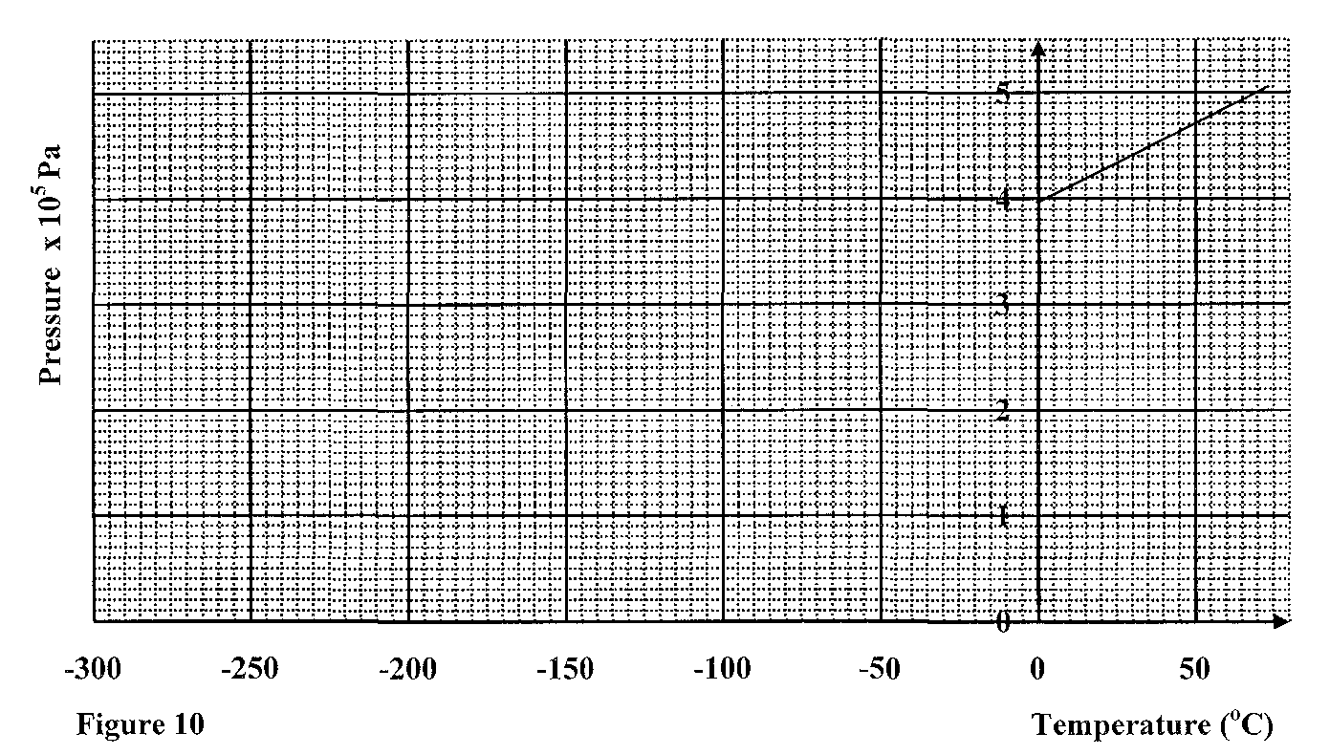
(i) From the graph determine the temperature of the gas when the gas pressure
is zero. (2mks)
.............................................................................................................................................................
(ii) Express this temperature in kelvin. (1mk)
.............................................................................................................................................................
.............................................................................................................................................................
19. a) A modem car with a strengthened passenger cage has regions at the front and the
back which can collapse in a crash. See figure 11
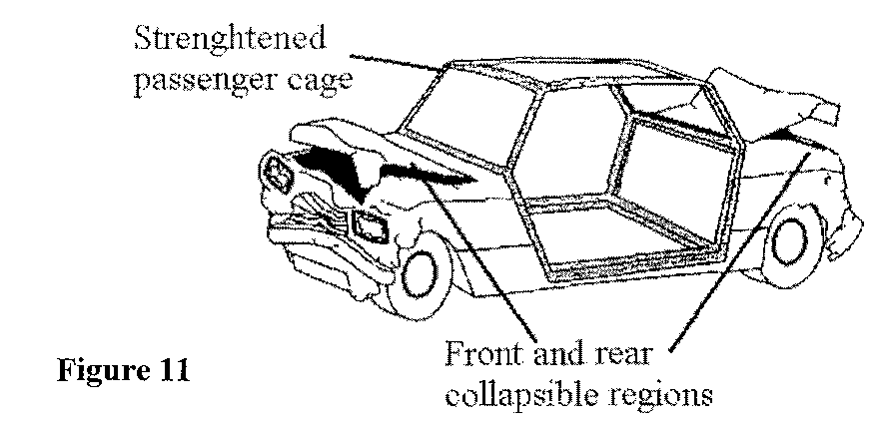

Explain how the collapsible regions should reduce passenger injury in a car
crash. (3mks)
.............................................................................................................................................................
.............................................................................................................................................................
.............................................................................................................................................................
.............................................................................................................................................................
b) An object of mass 150 kg moving at 2Oms’ collides with a stationary object of
mass 90kg. They couple after collision.
Determine the:
(i) Total momentum before collision. (2mks)
.............................................................................................................................................................
.............................................................................................................................................................
.............................................................................................................................................................
.............................................................................................................................................................
(ii) Total momentum after collision. (1mk)
.............................................................................................................................................................
.............................................................................................................................................................
(iii) Their common velocity after collision. (2mks)
.............................................................................................................................................................
.............................................................................................................................................................
.............................................................................................................................................................
.............................................................................................................................................................

End
End

