NAME:……………………………………………… INDEX NO:………………………/………..
SCHOOL:…………………………………………… CANDIDATE’S SIGN……………………..
DATE:……………………………………………….

232/1
PHYSICS
PAPER 1
JULY / AUGUST- 2012
TIME: 2 HOURS

BUTULA DISTRICT FORM FOUR JOINT MID YEAR EXAMINATION-2012
Kenya Certificate of Secondary Education (K.C.S.E)

232/1
PHYSICS
PAPER 1
JULY / AUGUST- 2012
TIME: 2 HOURS

INSTRUCTIONS TO THE CANDIDATES:
1. This paper consists of TWO SECTIONS A and B
2. Answer ALL questions in the spaces provided.
3. ALL working MUST be clearly shown.

For Examiners’ Use Only

SECTION | QUESTION | MAXIMUM SCORE | CANDIDATE’S SCORE
I | 1 - 11 | 25
II | 12 | 09
 | 13 | 11
 | 14 | 11
 | 15 | 10
 | 16 | 14
TOTAL SCORE |  | 80

This paper consists of 12 Printed pages. Candidates should check to ascertain that all pages are printed as indicated and that no questions are missing.
1. Figure 1
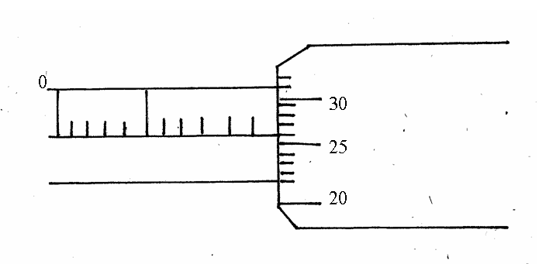
The micrometer screw gauge in figure 1 above has a zew error of -0.14-
Determine the real reading of the instrument. 3 mks

2. A bimetallic strip is made from aluminium and copper. When heated it bends as shown in figure 2 for the same temperature rise.
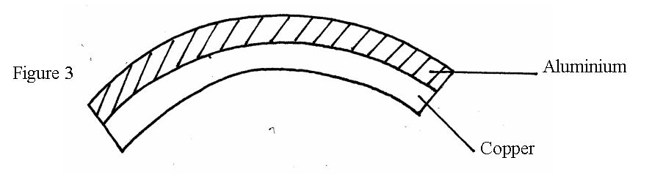
Draw a diagram showing the bimetallic strip after it is cooled below room temperature. (2 mks)

3. Explain the causes of random motion of pollen grains suspended in water as observed in Brownian motion. (2 mks)
……………………………………………………………………………………………………………………………………………………………………………………………………………………………………………………………………………………………………………………………………………………………………………………………………………………………….

4. State two ways in which the stability of a body can be increased. (2 mks)
……………………………………………………………………………………………………………………………………………………………………………………………………………………………………………………………………………………………………………………………………………………………………………………………………………………………
5. A piece of glass weighs 1.02N in alcohol and 1.50N in air. If the density of glass is 2.5g/cm³. Determine the relative density of alcohol.

6. The figure 4 below shows a velocity time graph for a racing car.
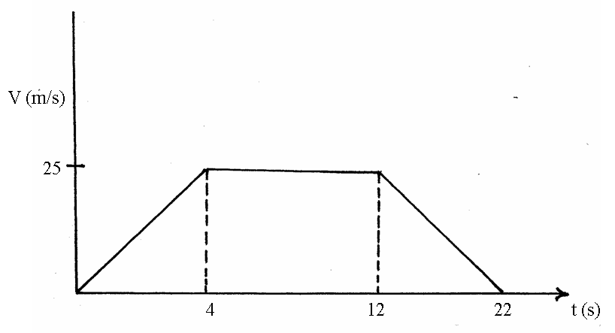
What is the total distance traveled by the car?

7. Explain why a liquid and not a gas is used as a hydraulic brake fluid. (1 mk)
………………………………………………………………………………………………………………………………………………………………………………………………………………

8. Water drops from a waterfall 84m high. The temperature of the water at the bottom is 26.2⁰C. Calculate the temperature at the top. Take specific heat capacity of water to be 4200J/kgk. (3 mks)

9. State Pascal’s principle. (1 mk)
………………………………………………………………………………………………………………………………………………………………………………………………………………………………………………………………………………………………………………………
10. State two factors which determine the thermal conductivity in a material. (2 mks)
……………………………………………………………………………………………………………………………………………………………………………………………………………………………………………………………………………………………………………………………………………………………………………………………………………………………….
11. The figure below shows a metal rod AB of length 2m horizontally balanced while supported by a pivot and a string.
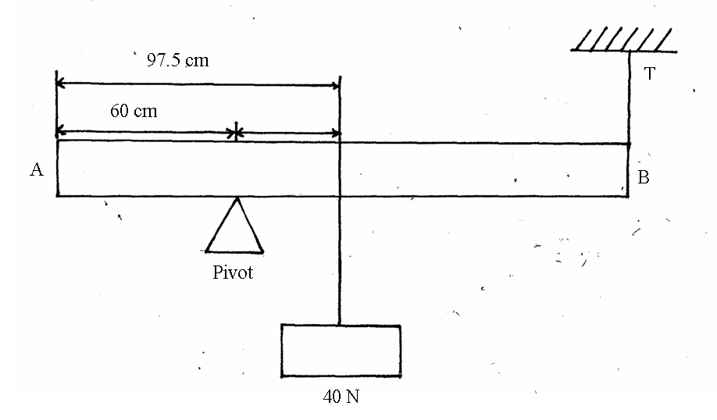
Determine the mass of the metal rod if the tension is 15N. (3 mks)

(b) State the type of equilibrium represented in the figure below. (1 mk)
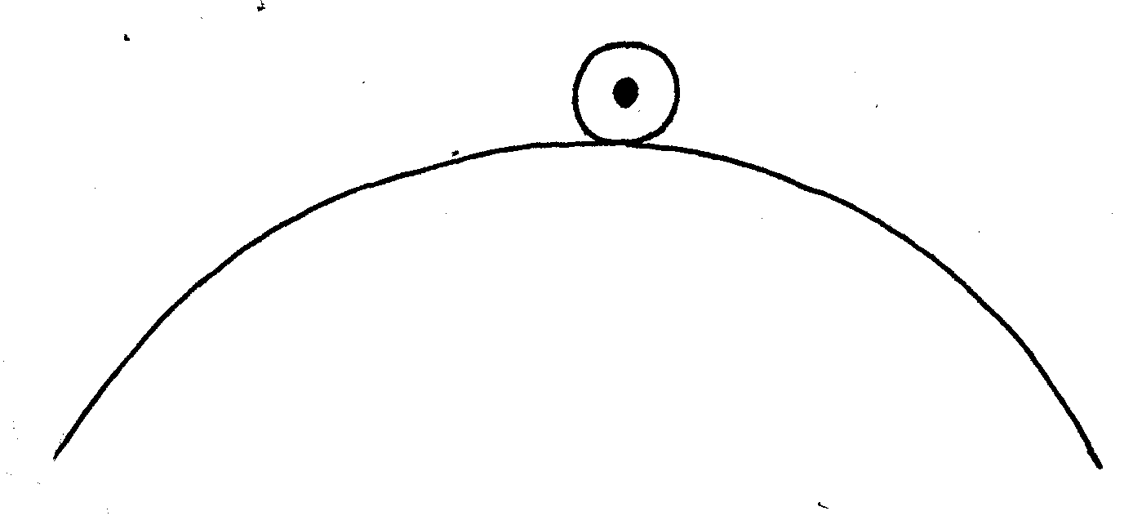
………………………………………………………………………………………………………………………………………………………………………………………………………………

SECTION B 55 MKS
Attempt all Questions in this section.
12. (a) State Archimedes’ principal (1 mk)
………………………………………………………………………………………………………………………………………………………………………………………………………………
(b) A block of length 40 cm, cross-sectional area of 4cm² and density 1.2 g/cm³ is completely immersed in a liquid of density 1.03 g/cm³ find
(i) The mass of the block (3 mks)

(ii) The weight of the block in the liquid. (3 mks)

(iii) The apparent loss in weight of the block if three quarter of it is immersed in the
liquid (3 mks)

13. The graph below shows how the temperature of a substance was changing with time when
warmed by an electric heater which supplied 100 Joules per second.
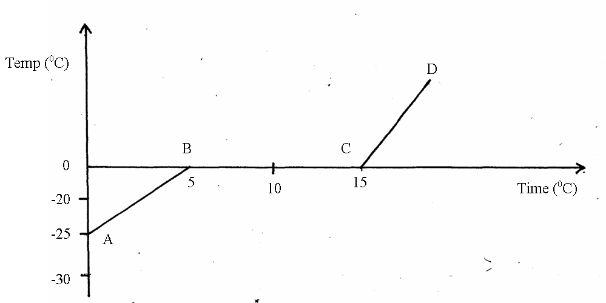

(a) How much time in seconds is taken by the heater to rise the temperature of the substance from -25⁰C to 0⁰C. (1 mk)

(b) How much thermal energy is supplied into the substance along AB? (3 mks)

(c) Determine the specific heat capacity of the substance if its mass is 0.095kg. (3 mks)

(d) What happened to the heat supplied along BC? (1 mk)
………………………………………………………………………………………………………………………………………………………………………………………………………………
(e) Calculate the specific latent heat of fusion of the substance. (2 mks)

14. (a) Define centripetal force. (1 mk)
………………………………………………………………………………………………………………………………………………………………………………………………………………
(b) An object of mass 0.5kg is attached to one end of a light inextensible string and whirled up in vertical circle of radius 1.0m and centre 0 as shown in figure 4 below such that the lowest point A is at the height of 4 m from the ground.
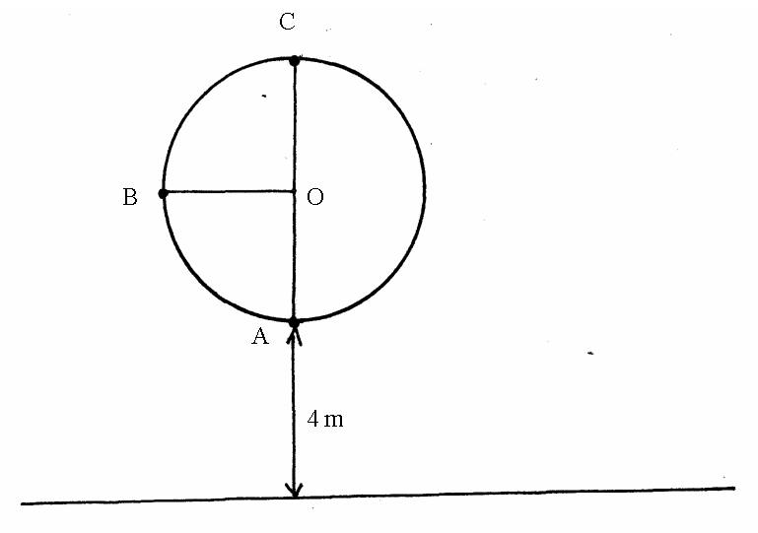
If the tension on the string when the object is at the lowest point A is 13.0N, calculate.
(i) The velocity V of the object. (3 mks)

(ii) The tension on the string when the object is at the
(i) Highest point C of the circle. (2 mks)

(ii) Point B of the circle (1 mk)

(iii) If the string was to break when the objects is at the lowest point A of the circle.
I Sketch on the diagram the path traced by the object until it hits the ground.
(1 mk)

(iv) Determine the horizontal distance moved by the stone from the time it leaves the path until it hits the ground. (3 mks)

15. (a) The graph in figure 6 below shows the relationship between pressure and temperature for a fixed mass of an ideal gas at constant volume.
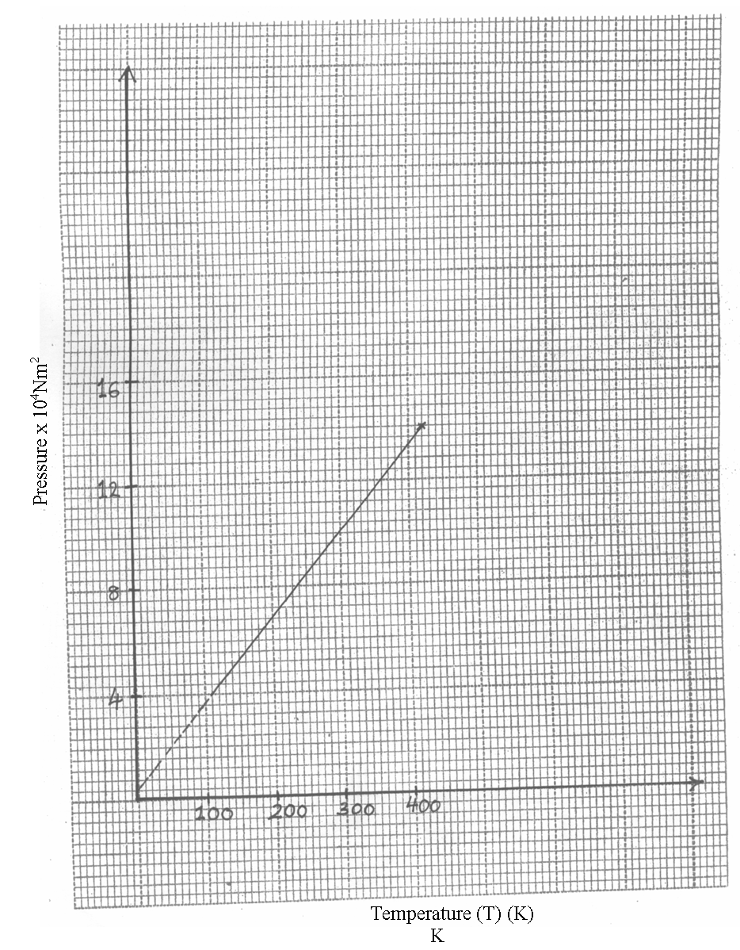

(i) Given that the relationship between pressure P and temperature t in Kelvin is of the form P=KT+C where k and c are constants.
Determine from the graph the value of k and c. (5 mks)

(ii) Why would it be impossible for the pressure of a gas to be reduced to zero in practice? (2 mks)
………………………………………………………………………………………………………………………………………………………………………………………………………………
(b) A gas is put into a container of fixed volume at a pressure of 2.1 × 105 N/m² and temperature of 27⁰C. The gas is then heated to a temperature of 327⁰C. Determine the new pressure. (3 mks)

16. (a) An object is thrown vertically upward with a velocity of 150m/s.
(Take g=10m/s²⁻)
Calculate
(i) Its velocity after 4 seconds (3 mks)

(ii) The distance covered in the first 5 seconds. (3 mks)

(iii) Maximum height reached. (2 mks)

(iv) Time taken to reach the maximum height. (3 mks)

(b) The vertical column of water issuing from a fountain is found to be 2.45m. Determine the velocity with which water issues from the foundation. (3 mks)

END

