NAME:…………………………………………… INDEX NO:………………………………/………...
SCHOOL:………………………………………… CANDIDATE’S SIGN……………………………...
DATE:……………………………………………..

232/2
PHYSICS
PAPER 2
JULY /AUGUST - 2012
TIME: 2 HOURS

BUTULA DISTRICT FORM FOUR JOINT MID YEAR EXAMINATION-2012
Kenya Certificate of Secondary Education (K.C.S.E)

232/2
PHYSICS
PAPER 2
JULY /AUGUST - 2012
TIME: 2 HOURS

INSTRUCTIONS TO CANDIDATES
a) Write your name index number and signature in the spaces provided above.
b) This paper consists of TWO sections A and B
c) Answer ALL questions in sections A and B in the spaces provided.
d) All working MUST be clearly shown.
d) Scientific calculators and KNEC mathematical tables may be used.

For Examiners’ Use Only

SECTION | QUESTION | MAXIMUM SCORE | CANDIDATE’S SCORE
A | 1 - 11 | 25
B | 12 | 10
B | 13 | 15
B | 14 | 10
B | 15 | 10
B | 16 | 10
TOTAL |  | 80

This paper consists of 12 Printed pages. Candidates should check to ascertain
that all pages are printed as indicated and that no questions are missing.

1. What is the capacity of a car battery which can produce 5 A of electricity for one week at the rate of 1 hour daily. (3 mks)

2. Distinguish between Transverse and longitudinal waves. (1 mk)
……………………………………………………………………………………………………………………………………………………………………………………………………………....
3. What is the voltage output for the cell arrangement below? (2 mks)
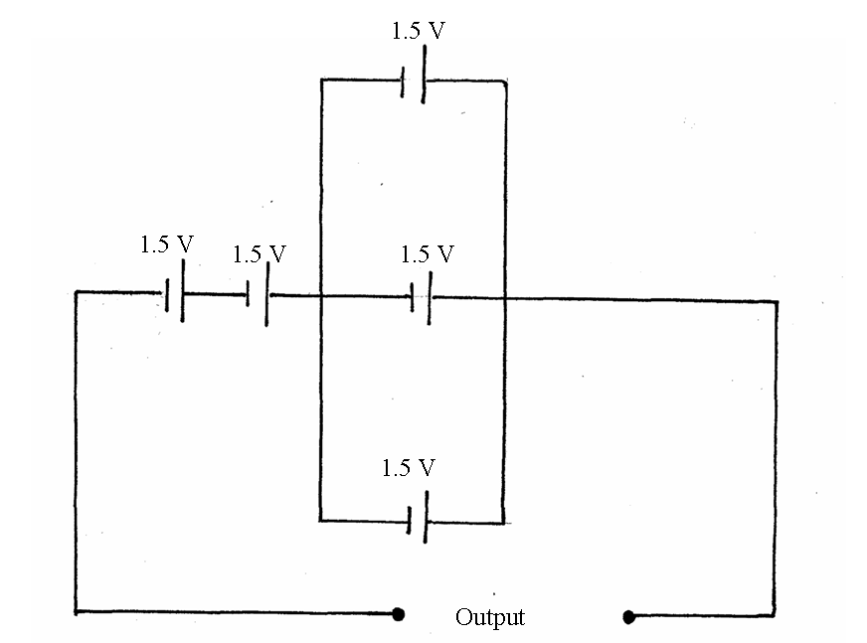

4. A ray of light is incident on a plane mirror as shown.
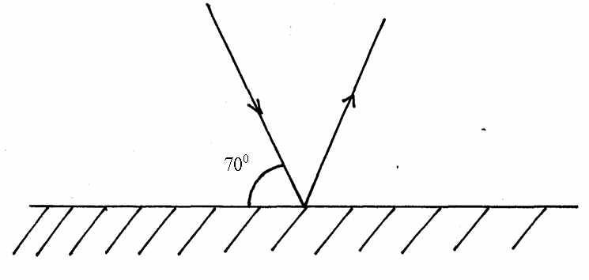
(a) What will be the angle through which the reflected ray rotates if the mirror is rotated anticlockwise through an angle of 35⁰? (2 mks)

(b) What would be the new angle of reflection (2 mks)

5. A radioactive substance decays as shown below.

How many alpha and beta particles are emitted?

6. Sketch a circuit diagram to show how two diodes can be used as a current full wave rectifier. (2 mks)

7. Using Dormain’s theory, explain magnetic saturation. (2 mks)
……………………………………………………………………………………………………………………………………………………………………………………………………………....
……………………………………………………………………………………………………………………………………………………………………………………………………………....

8. Four capacitors are connected as shown.
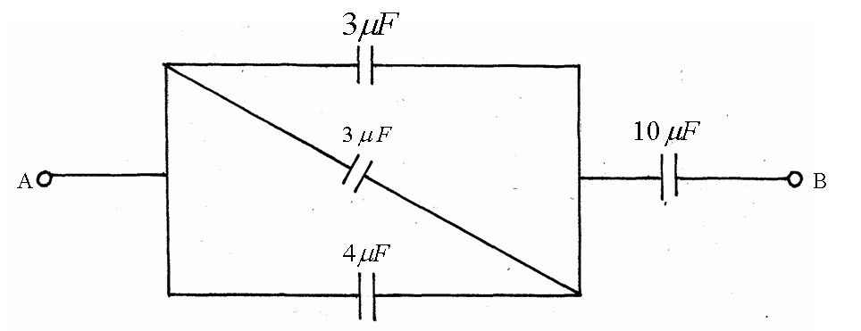
Calculate the effective capacitance between A and B. (3 mks)

9. Give any one different between light and sound waves. (1 mk)
……………………………………………………………………………………………………………………………………………………………………………………………………………....
10. An X-ray tube is operating with an anode potential of 10kV and a current of 15.0mA.
Calculate the number of electrons hitting the anode per second. (3 mks)

11. Why is soft iron preferred as core in making electromagnets? (2 mks)
……………………………………………………………………………………………………………………………………………………………………………………………………………....
SECTION B (55 MARKS)
12. (a) A source generates 40 waves in a second. If the wavelength is 8.0 cm, calculate the time the wave takes to reach a wall 100m from the source. (3 mks)

(b) State any two factors which affect the speed of sound. (2 mks) ……………………………………………………………………………………………………………………………………………………………………………………………………………....
……………………………………………………………………………………………………………………………………………………………………………………………………………....

(c) Distinguish between stationary and progressive. (1 mk)
……………………………………………………………………………………………………………………………………………………………………………………………………………....
(d) A policeman standing between two high walls firsts a gun. He hears the first echo after 3 seconds and the next 2 seconds later. What is the distance between the wall?
(Take velocity of sound 330m/s) (4 mks)

13. (a) State one difference between a transformer and an induction coil. (1 mk)
……………………………………………………………………………………………………………………………………………………………………………………………………………....

(b) State two energy losses in a transformer. (2 mks)
……………………………………………………………………………………………………………………………………………………………………………………………………………....
……………………………………………………………………………………………………………………………………………………………………………………………………………....
(c) A transformer has 10,000 turns on its secondary coil and 100 turns on its primary coil. An alternating current of 5.0A flows in the primary circuit when it is connected to a 12V a.c. supply
(i) State the type of transformer. (1 mk)
……………………………………………………………………………………………………………………………………………………………………………………………………………....
(ii) Calculate the power input to the transformer. (3 mks)

(iii) Calculate the E.M.F. across the secondary coil. (3 mks)

(iv) Determine the maximum current that could flow in a circuit connected to the secondary coil if the transformer is 90% efficient. (Use the same E.M.F. in secondary as you have calculated above). (3 mks)

(v) In transmitting power why is it necessary to step it up before transmission. Explain. (2 mks)
……………………………………………………………………………………………………………………………………………………………………………………………………………....
……………………………………………………………………………………………………………………………………………………………………………………………………………....
14. (a) The figure below shows the features of an x-ray tube.
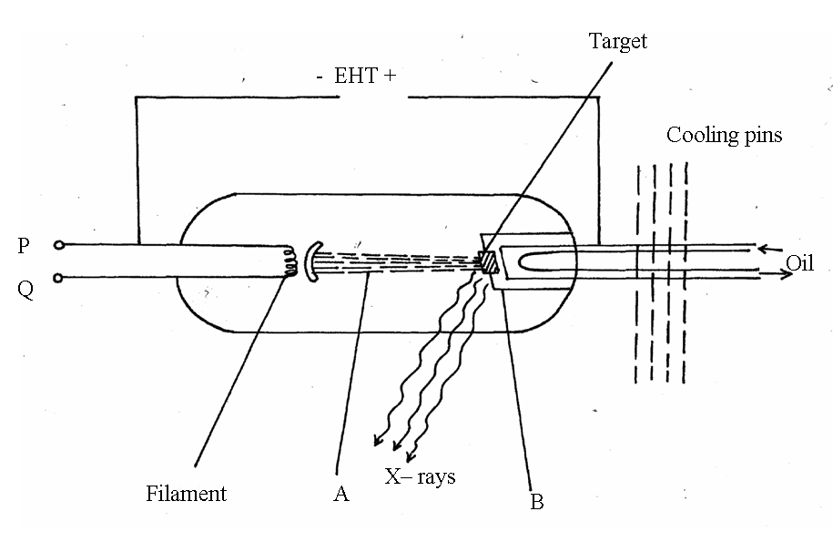
(i) Name the parts marked with letters A and B. (2 mks)
A……………………………………………………………………………………
B…………………………………………………………………………………….
(ii) Explain how a change in the potential across PQ changes the intensity of X – rays.
(2 mks)
……………………………………………………………………………………………………………………………………………………………………………………………………………....
……………………………………………………………………………………………………………………………………………………………………………………………………………....
(iii) During the operation of the tube, the target becomes very hot. Explain how this
heat is caused. (2 mks) ……………………………………………………………………………………………………………………………………………………………………………………………………………....
……………………………………………………………………………………………………………………………………………………………………………………………………………....

(iv) State the property of lead that makes it suitable for use as shielding material. (1 mk)
……………………………………………………………………………………………………………………………………………………………………………………………………………....
(b) In a certain X-ray tube, the electrons are accelerated by a p.d of 12,000V. Assuming all the energy goes to produce x-rays, determine the frequency of the x- rays produced (Plank’s constant h = 6.62 × 10⁻³⁴ js, charge on an electron = 1.6 × 10⁻¹⁹C). (3 mks)

15. The figure given shows the path of a ray of yellow light through a glass prism. The speed of yellow light in the prism is 1.88 × 10⁸ m/s.
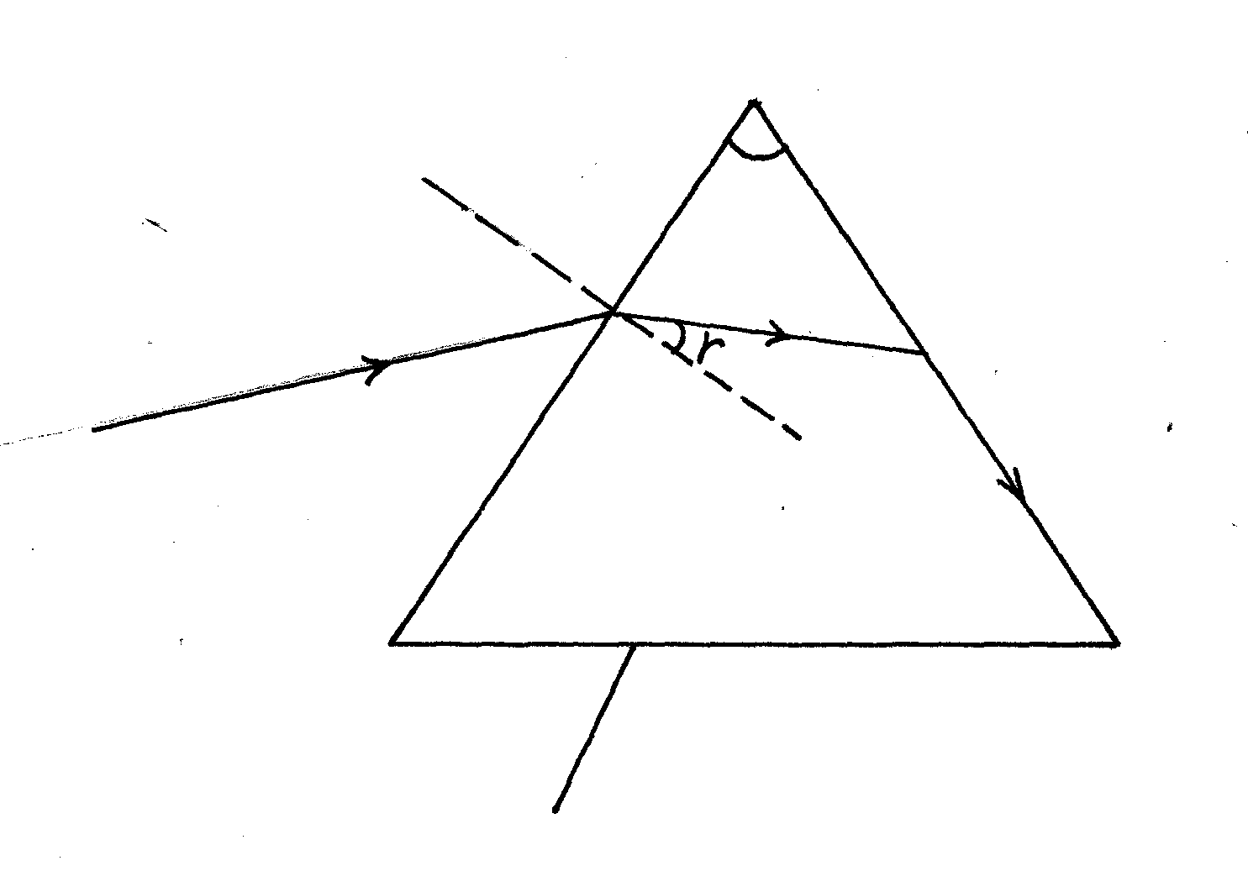
Glass Prism
Yellow light
60⁰

(a) Determine the refractive index of the prism material
(Speed of light in vacuum C=3.0×10⁸m/s) (2 mks)

(b) Show on the same figure above, the critical C, and determine its value. (4 mks)

(c) Given that r =31.2 determine the angle. (3 mks)

(d) On the same figure sketch the path of light after striking the prism if the prism was replaced by another one of lower refractive index. (Use dotted lines for your answer.)
(1 mk)

16. (a) What is meant by the term work function? (1 mk)
……………………………………………………………………………………………………………………………………………………………………………………………………………....
(b) When the frequency of the illuminating radiation is just equal to the threshold frequency of the surface, no photoelectric effect observed. Explain. (1 mk)

(c) In a photoelectric effect experiment, a certain surface was illuminated with radiation of different frequencies and stopping potential determined for each frequency. A graph of stopping potential (y – axis) against frequency was then plotted as shown

Graph of stopping potential, Vs (v) against frequency, £ (HZ)
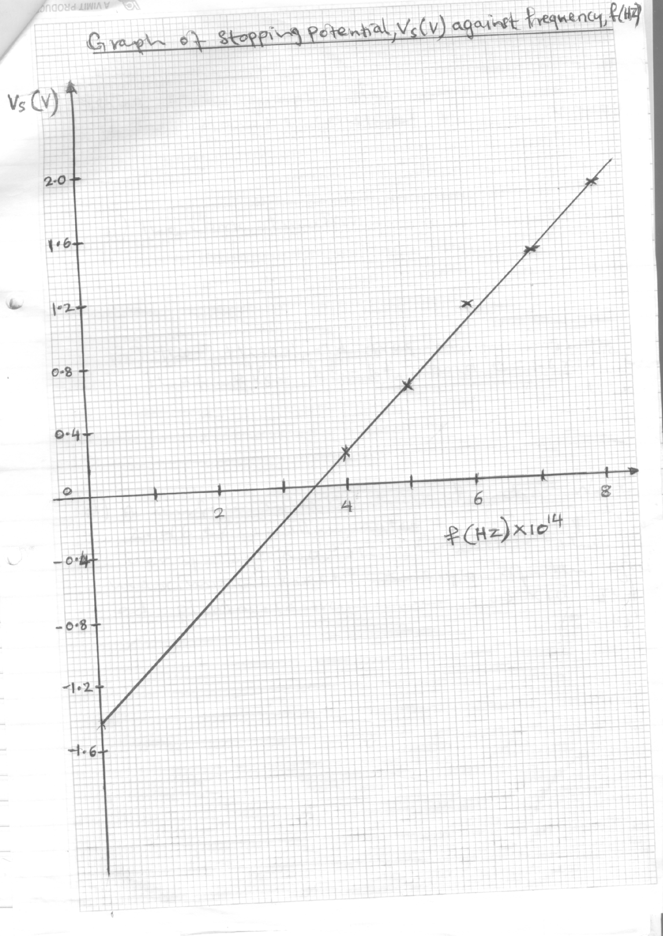

Using the graph determine.
(i) The Plancks constant, h (2 mks)

(ii) The work function (2 mks)

(iii) The threshold frequency given that eVs = hf – hf₀ and e = 1.6 × 10⁻¹⁹C. (1 mk)

(d) A surface whose work function W₀ is 2.4eV is illuminated by light of frequency
3.0 × 10¹⁵ HZ. Calculate the maximum kinetic energy of the ejected photo electrons
(h = 6.63 × 10⁻³⁴ Js) (3 mks)

END

