NAME:……………………………………………………… INDEX NO:…………………………
SCHOOL:………………………………………………….. DATE:……………………………….
SIGN:………………………………..

232/1
PHYSICS
PAPER 1
JULY / AUGUST- 2012
TIME: 2 HOURS

KERICHO DISTRICT JOINT KCSE TRIAL EXAMINATION-2012
Kenya Certificate of Secondary Education (K.C.S.E)

232/1
PHYSICS
PAPER 1
JULY / AUGUST- 2012
TIME: 2 HOURS

INSTRUCTIONS TO CANDIDATES

Answer all the questions in both sections in the spaces provided.

For Examiner’s use only
Question |  | Maximum score | Candidate’s score
SECTION A | 1-12 | 25MARKS
SECTION B | 13 | 11
 | 14 | 8
 | 15 | 13
 | 16 | 13
 | 17 | 10
TOTAL |  | 80MARKS

This paper consists of 12 printed pages. Candidates should check the question paper to ensure that all pages are printed as indicated and that no questions are missing.

SECTION A (25 MARKS)
Answer ALL the question in this section
1. State the kinetic theory of matter (1mk)
..................................................................................................................................................................................................................................................................................................................................................
2. The mass of a densite bottle of volume 50cm³ is 15.0g when empty.Aluminium turnings are poured into the bottle and the total mass is 65.0g.Water is then added into the turnings till the bottle is full. If the total mass of the bottle and its content is 95.0g.Calculate the densite of the aluminium turnings. (4mks)
(If density of water is 1000kg/m³)

3. Explain why trucks which carry heavy loads have many wheels. (1mk)
..................................................................................................................................................................................................................................................................................................................................................
4. State two ways of improving surface tension (2mks)
..................................................................................................................................................................................................................................................................................................................................................
5. Figure 1 below represents a simple fire alarm. Explain how it works (3mks)
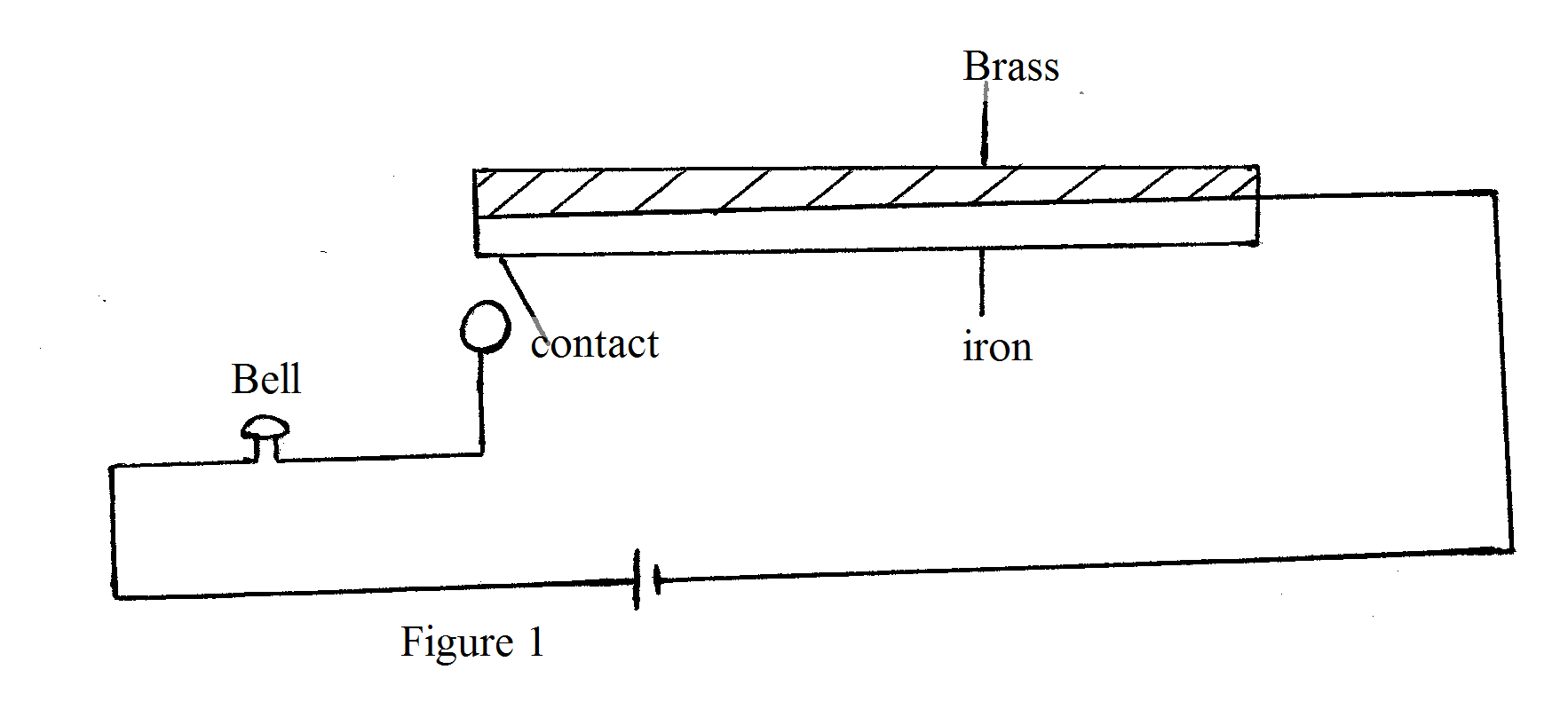
..................................................................................................................................................................................................................................................................................................................................................
..................................................................................................................................................................................................................................................................................................................................................
6. Explain why a wire a gauze is placed below a beaker while heating water in it (1mk)
..................................................................................................................................................................................................................................................................................................................................................
7. Figure 2 below shows alight rod balanced due to the action of the forces shown
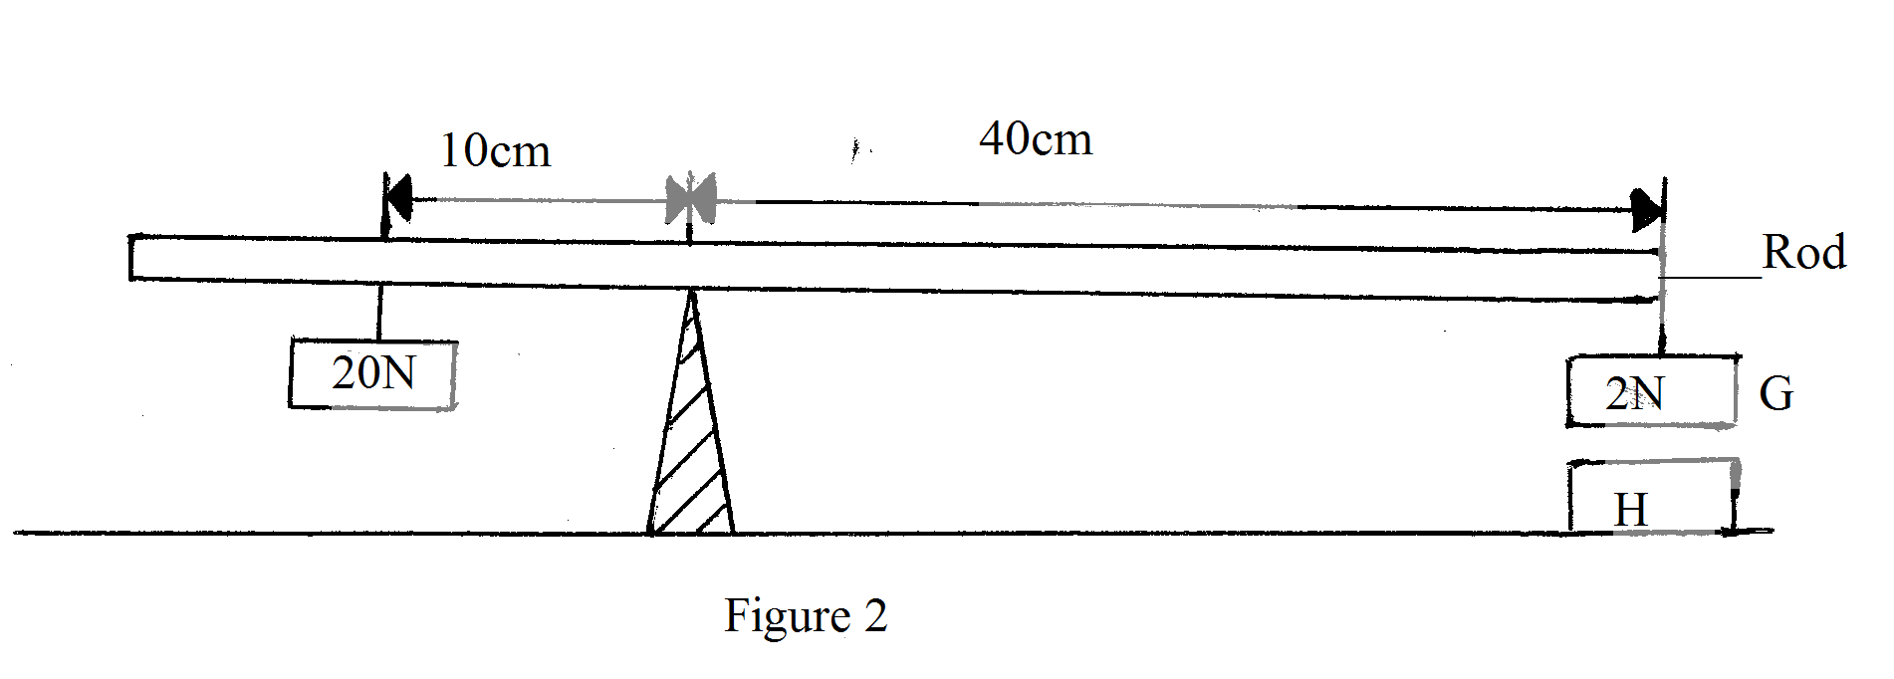
G is a magnet of weight 2N and it is a permanent magnet which is fixed. Determine the force between G and H, stating whether it is attractive or repulsive (3mks)

8. State Hooke’s law (1mk)
..................................................................................................................................................................................................................................................................................................................................................
9. Figure 3 below shows a burning weight ed tripless candle floating upright in water
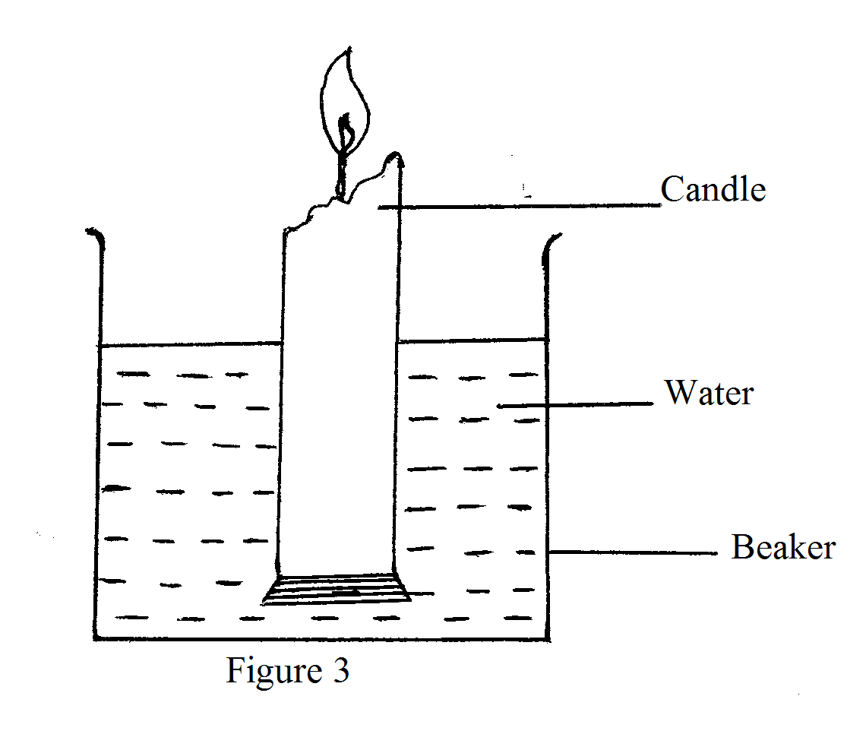
Explain what happens to the candle as it continues to burn (2mks)
..................................................................................................................................................................................................................................................................................................................................................
10. State Bernondi’s principle (1mk)
..................................................................................................................................................................................................................................................................................................................................................
11. Figure 4 below represents apart of a tape pulled through a tisker-timer is 50Hz, calculate the acceleration of the trolley (3mks)
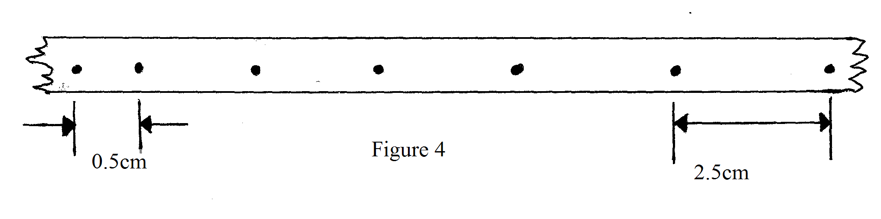

12. A fixed mass of gas occupying 4 litres at 27⁰c is compressed at constant temperature until the pressure is doubled. It is then cooled at constant pressure until the volume is 1 litre.What is the final temperature of the gas. (3mks)

SECTION B (55MKS)
Answer ALL the questions in this section
13. (a) Define the term inertia (1mk)
..................................................................................................................................................................................................................................................................................................................................................
(b) A body P of mass 4kg supported by alight inextensible string 4m long, is held at an angle of 60⁰ from the vertical position as shown in figure 5 below.
A second body R of mass 4kg rests at the edge of a platform 2m high, the body is released and strikes body R head-on in a perfectly elastic collision.
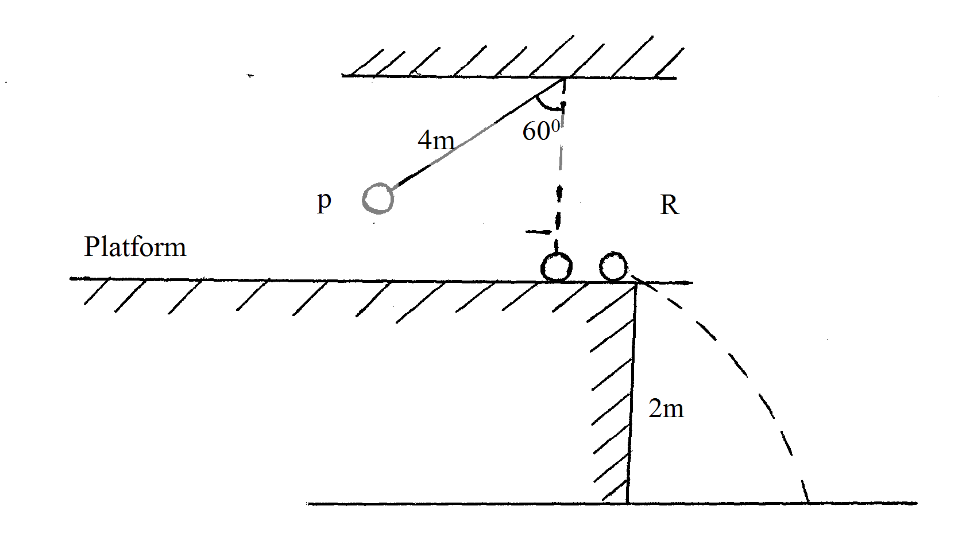
(i) Explain the term elastic collision (1mk)
..................................................................................................................................................................................................................................................................................................................................................
(ii) Determine how long it takes after P is released for body R to strike the ground (4mks)

(iii) How far from the base of the platform will body R strike the ground if P stops after the collision (3mks)

(c) A parachutist allows his leg to bend and roll over on the ground when he lands. Explain
(2mks)
..................................................................................................................................................................................................................................................................................................................................................
..................................................................................................................................................................................................................................................................................................................................................
14. (a) Efficiency of a machine can never be 100% .Explain (2mks)
..................................................................................................................................................................................................................................................................................................................................................
..................................................................................................................................................................................................................................................................................................................................................
(b) A man uses the inclined plane to lift a 50kg load through a vertical height of 4.0m.The inclined plane makes an angle of 30⁰ with the horizontal .If the efficiency of the inclined plane is 80%.
Calculate
(i) The effort needed to move the load up the inclined plane at a constant velocity (3mks)

(ii) The work done against friction in raising the load through the height of 4.0m(Take g=10N/kg) (3mks)

15. (a) You are provided with the following apparatus
-A filter funnel
-A thermometer
-A stop watch
-A beaker
-A stand, boss and clamp
-A weighing machine
-Ice at 0⁰c
-An immersion heated rated P watts
Describe an experiment to determine the specific latent heat of fusion of ice,clearly stating the measurements to be made. (4mks)

(b) 200g of ice 0⁰c is added to 400g water in a well lagged calorimeter of mass 40g.The initial temperature of the water was 40⁰c.If the final temperature of the mixture is x⁰c, (specific latent heat of fusion,Lf=3.36×10⁵Jkg⁻¹, specific heat capacity of water,c=4200Jkg⁻¹k⁻¹, specific heat capacity of copper =400Jkg⁻¹k⁻¹)
(i) derive an expression for the amount of heat gained by ice to melt it and raise its temperature to xºc (2mks)

(ii) derive an expression for the amount of heat lost by the calorimeter and its content when their temperature fall to xºc (2mks)

(iii) Determine the value of x (3mks)

(c) Ether is put into a beaker which is placed on a thin film of water. A student blows the ether through a pipe continuously, state and explain the observation made after some time. (2mks)
..................................................................................................................................................................................................................................................................................................................................................
..................................................................................................................................................................................................................................................................................................................................................
16. (a) A body is uniform circular motion experience acceleration despite having constant
velocity. Explain (2mks)
..................................................................................................................................................................................................................................................................................................................................................
..................................................................................................................................................................................................................................................................................................................................................
(b) A car travelling with uniform speed on a level circular path is likely to experience skidding. Explain (2mks)
..................................................................................................................................................................................................................................................................................................................................................
..................................................................................................................................................................................................................................................................................................................................................

(c) Figure 6 below shows a 40g wooden block being in a horizontal circular path of radius 20cm.If it takes 0.5 seconds to describe an arc length of 12cm.
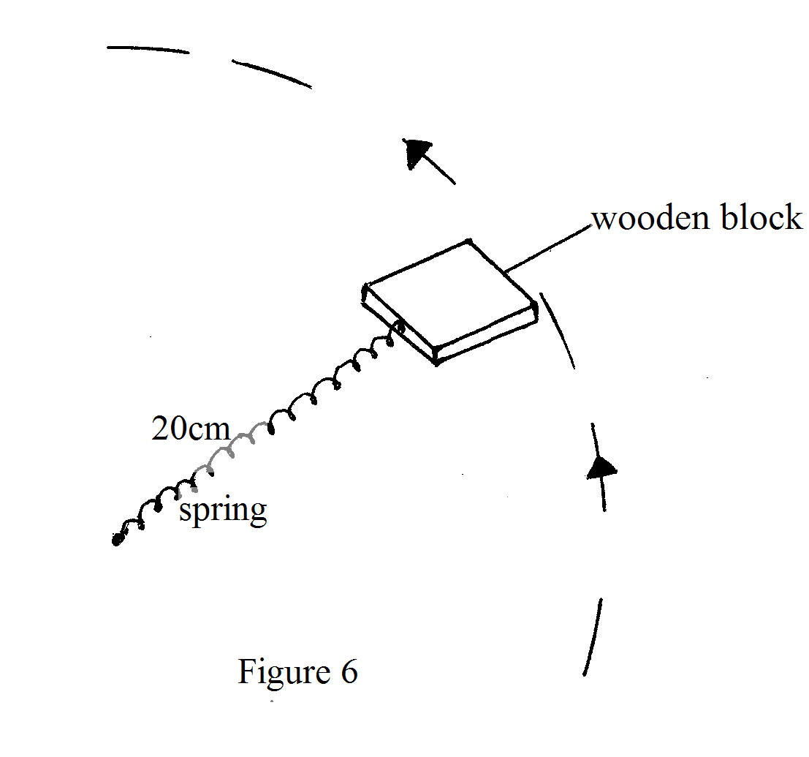
(i) Identify the forces acting on the wooden block (2mks)
............................................................................................................................................................
(ii) Determine the linear velocity of the block (2mks)
............................................................................................................................................................
............................................................................................................................................................
(iii) Determine the centrapetal force (2mks)
............................................................................................................................................................
............................................................................................................................................................
17. (a) A piece of sealing way weights 3N in air and 0.22N when immersed in water.Calculate
(i) Its relative denate (2mks)

(ii) Apparent weight in a liquid of density 800kg/m³ (2mks)

(b) Figure 7 below shows a uniform beam one meter long and weighing 2N kept in horizontal position by a body of weight 5N immersed in a liquid:-
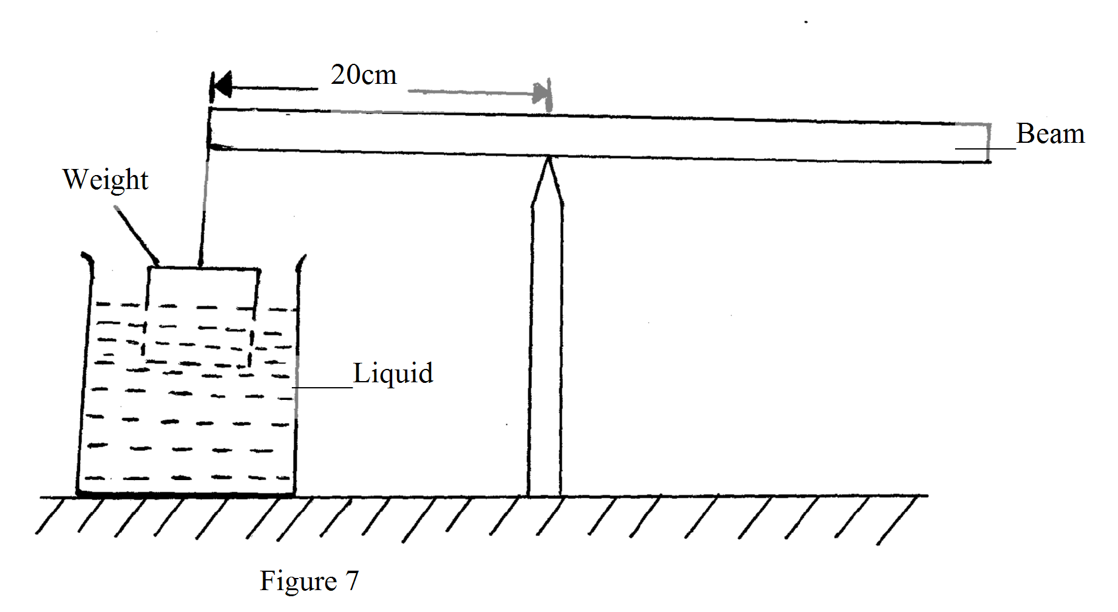
Determine the upthrust on the load (3mks)

(c) Figure 8 below shows a wooden block of dimensions 60cm by 40cm by 30cm held in position by a string attached to the bottom of a swimming pool. The density of water is 1000kg/m³.
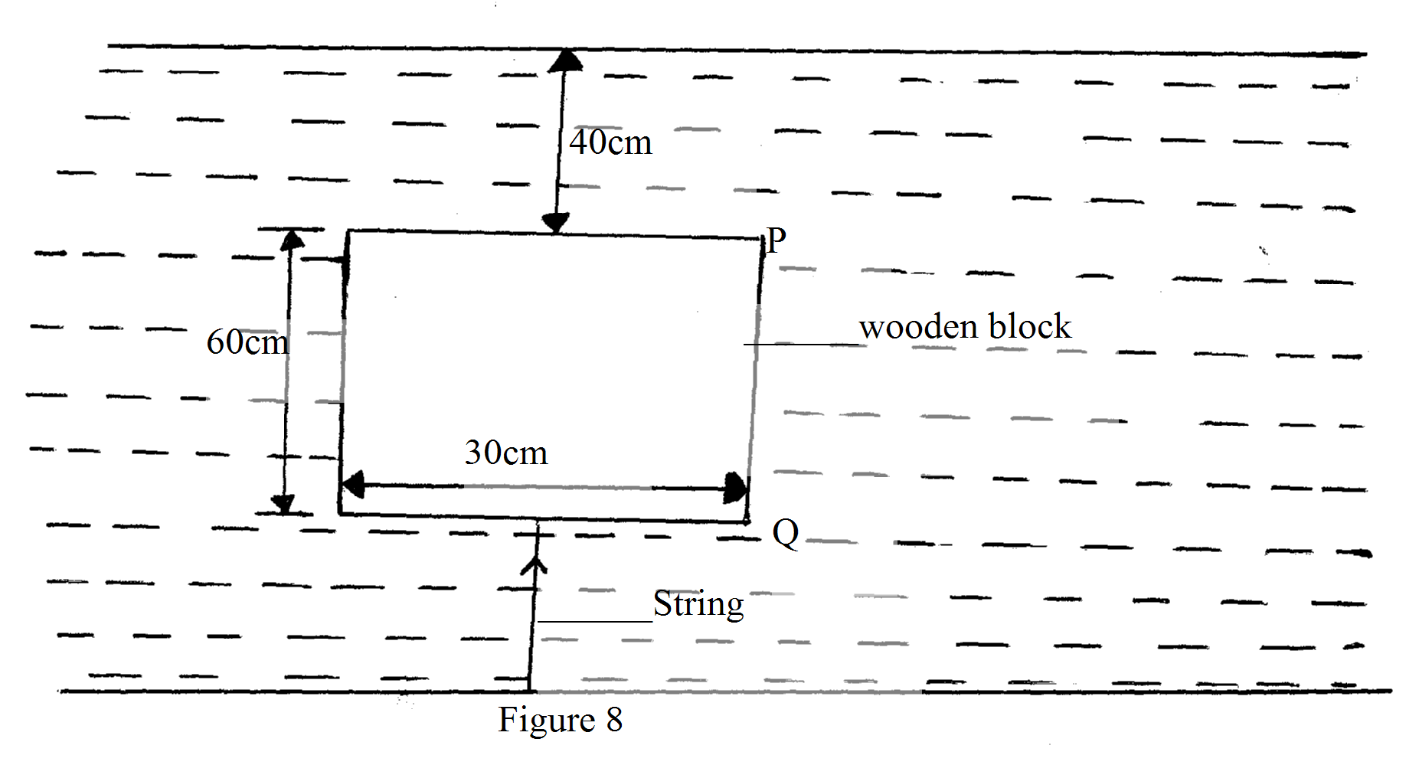

(i) Calculate the pressure at the bottom surface of the block (3mks)

(ii) Draw graph to show how the pressure on the block changes between P and Q (2mks)

End

