NAME:……………………………………………………… INDEX NO:…………………………
SCHOOL:………………………………………………….. DATE:……………………………….
SIGN:………………………………..

232/2
PHYSICS
PAPER 2
JULY / AUGUST - 2012
TIME: 2 HOURS

KERICHO DISTRICT JOINT KCSE TRIAL EXAMINATION-2012
Kenya Certificate of Secondary Education (K.C.S.E)

232/2
PHYSICS
PAPER 2
JULY / AUGUST- 2012
TIME: 2 HOURS

INSTRUCTIONS TO CANDIDATES
Write your name and index number in the spaces provided.
This paper consists of two sections A and B
Answer all the questions in section A and B in the spaces provided.
All working must be clearly shown.

For Examiner’s use only
Question |  | Maximum score | Candidate’s score
SECTION A | 1-11 | 25
SECTION B | 12 | 13
SECTION B | 13 | 12
SECTION B | 14 | 11
SECTION B | 15 | 10
SECTION B | 16 | 9
TOTAL |  | 80MARKS

This paper consists of 12 printed pages. Candidates should check the question paper to ensure that all pages are printed as indicated and that no questions are missing.

SECTION A (25 MARKS)
1. A positively charged rod is brought close to two spheres A and B, held by insulating handles as shown below.
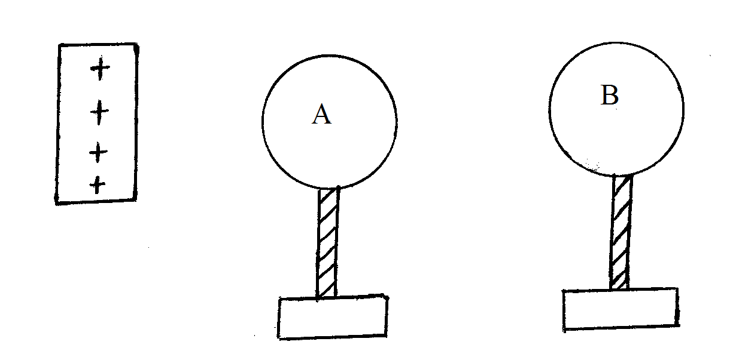
Indicate the charge on A and B (2mks)

2. The diagram below show the image formed by a convex mirror. Complete the diagram to show the position of the image
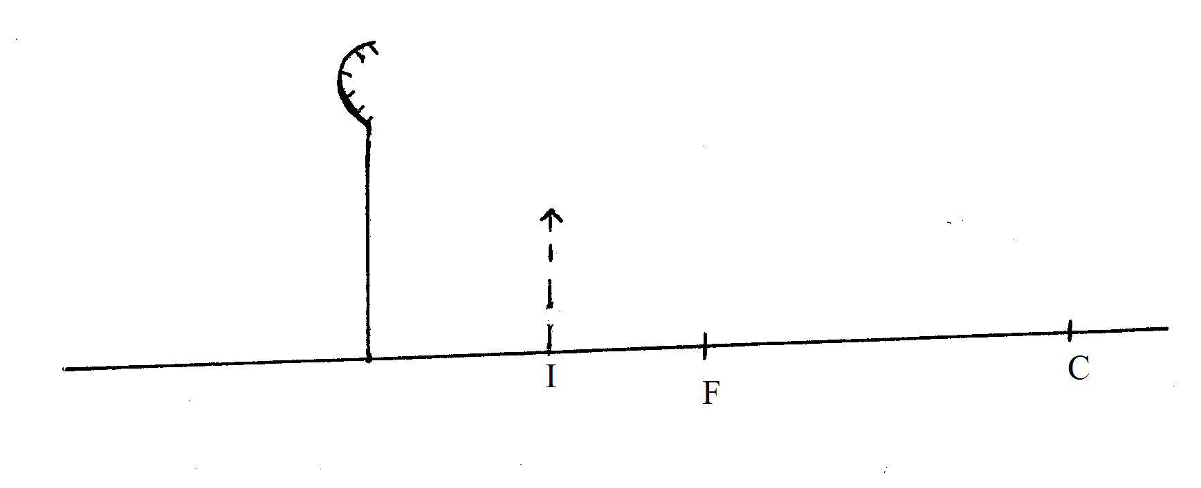
3. The sketch below shows the pd across a cell for various values of current through a resistance wire.
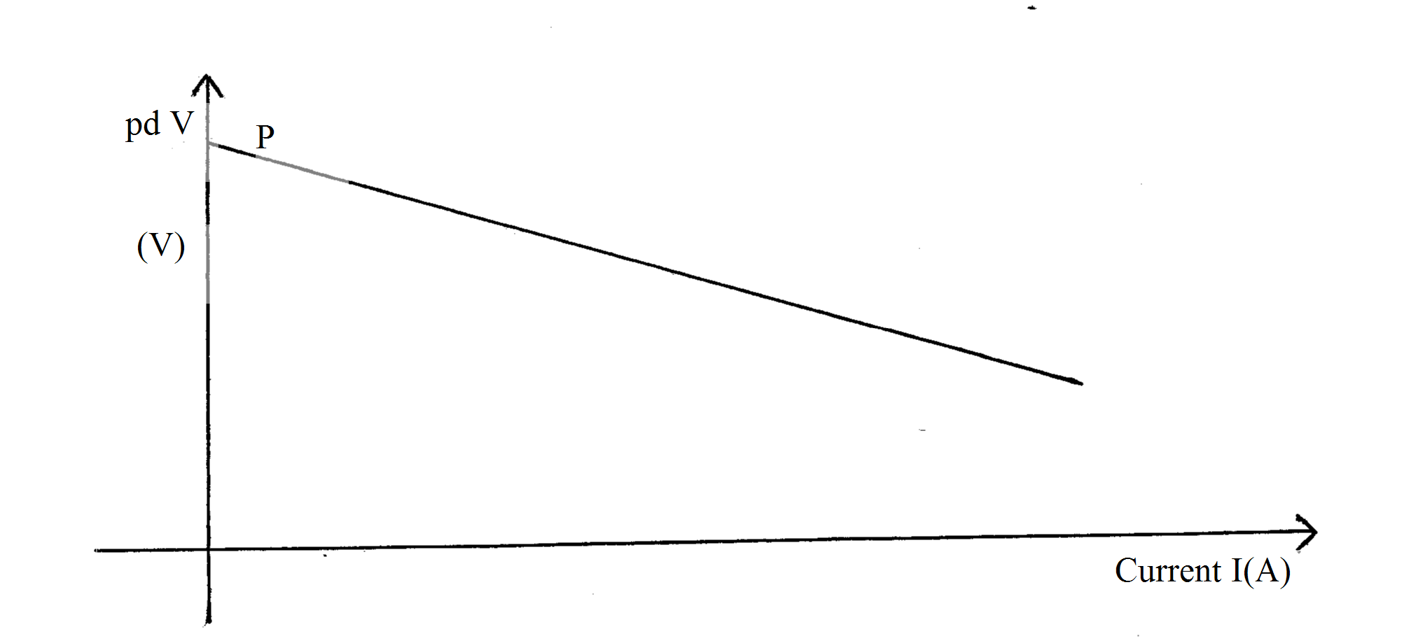
State and explain the significance of P (2mks)
....................................................................................................................................................................................................................................................................................................................................................................................................................................................................................................................................................................................................................................................

4. The figure below show two pole of a magnet and ring of plastic placed between them. Show the magnetic line of force between them (1mk)
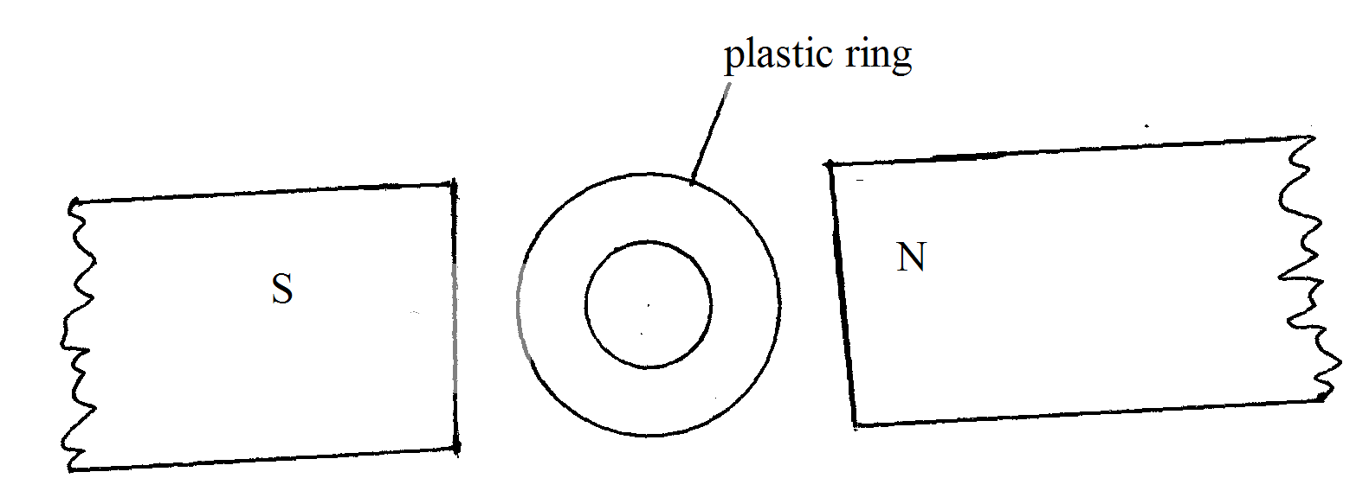
5. The diagram below shows plane waves passing through a medium. The waves encounter a concave shallow region. Complete the diagram to show the nature of the waves after posing through the shallow region (2mks)
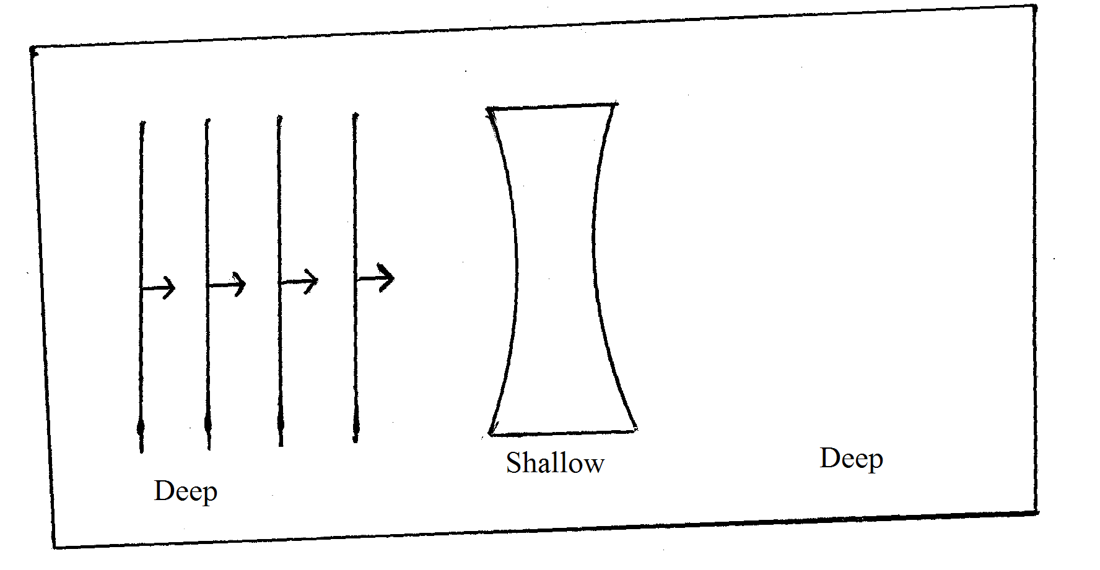

6. Two loudspeakers are connected so the output of an amplifies and arranged as shown below.
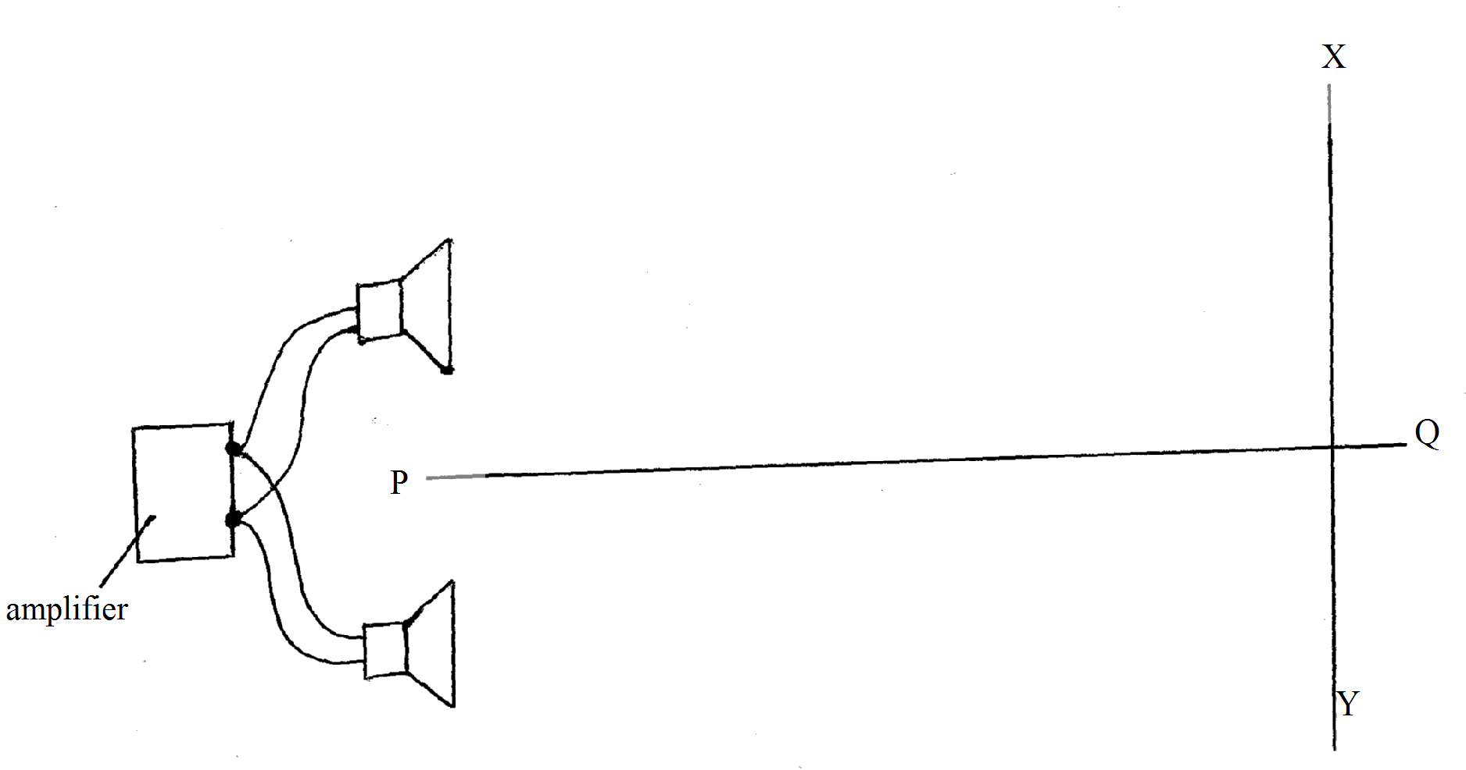
(c) A mass mg of radioactive isotope decay to 50g in 100 days. The half life of the isotope is 25days.
Calculate the initial mass of the isotope (2mks)

Give the numerical values of r,s
$\begin{matrix}\text{210} \\ \text{84}\end{matrix}\text{Pc}$ $\begin{matrix}\text{206} \\ \text{82}\end{matrix}\text{Pb} + \begin{matrix}r \\ s\end{matrix}X +\text{Energy}$
r _________________________________________ (1mk)
s ________________________________________ (1mk)
State the lined of energy given out in the process (1mk)
Two observers A and B, walk along the lines PQ and XY respectively. State and explain the observations made by:
Observation A (2mks)
..........................................................................................................................................................................................................................................................................................................................
Observation B (2mks)
..........................................................................................................................................................................................................................................................................................................................
7. The diagram shows part of a domestic wiring system
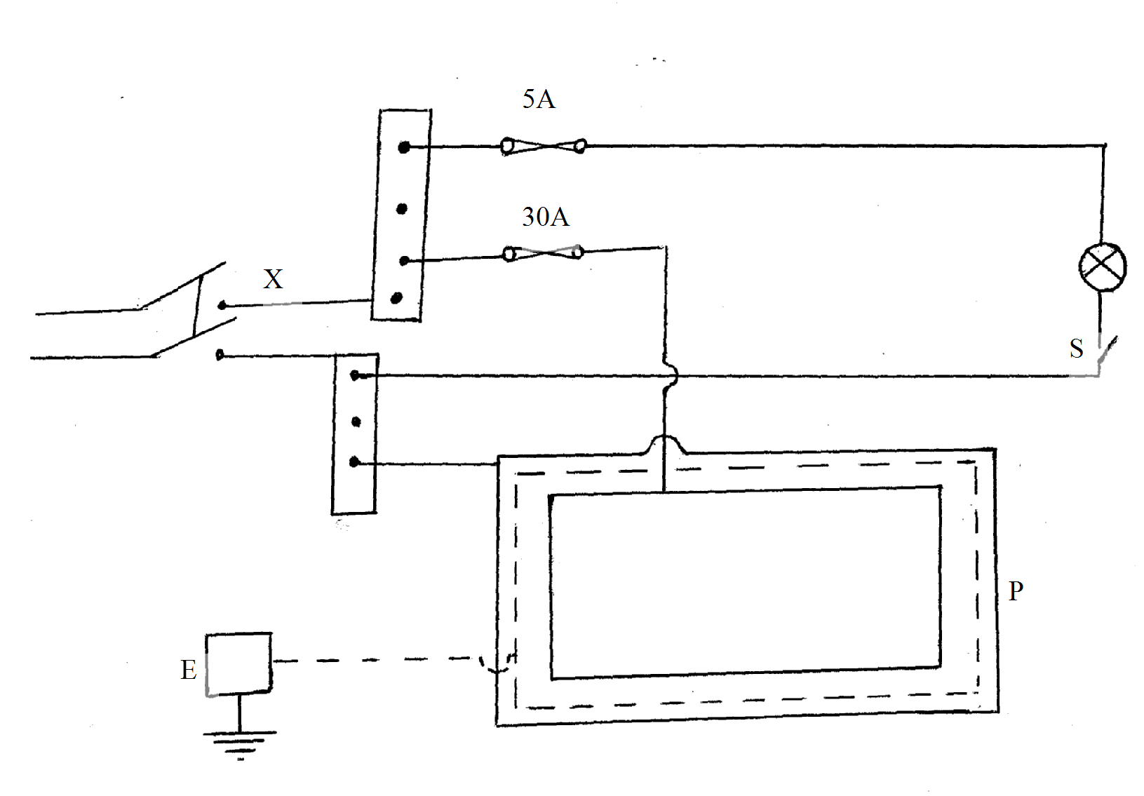
(i) State the parts a labelled in the circuit
x.............................................................
p of the whole circuit
(ii) Identify the mistake in the wiring

8. An electrical heating device is rated 1.5KW, 240V.What is the meaning of the rating? (1mk)
..........................................................................................................................................................................................................................................................................................................................
How much energy does it consume in a month if it is operated for 5 minutes daily? (3mks)

9. Uv rays are incident on a surface of a clean polished zinc plate. What is the effect of increasing the distance between the zinc plate as the uv source? (1mk)
..........................................................................................................................................................................................................................................................................................................................
10. State and explain the effect of increasing the filament current in an x-ray tube (2mks)
.......................................................................................................................................................................................................................................................................................................................... ..........................................................................................................................................................................................................................................................................................................................
11. The figure below shows the trace of a signal on a CRO
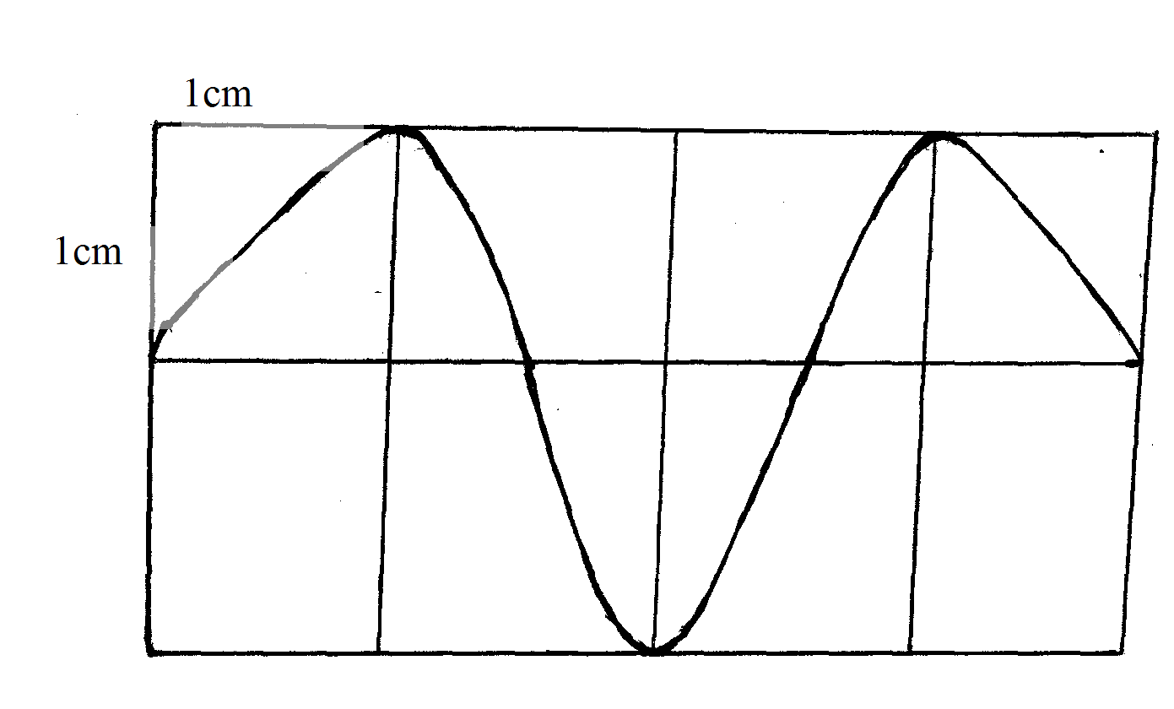
Given that the time base is set at 100ms/div, determine the frequency of the signal (2mks)

SECTION B (55 MKS)
12. (a) Define capacitance of a capacitor (1mk)
..........................................................................................................................................................................................................................................................................................................................
The figure below shows a charged electroscope two aluminium plates A and B arranged a shown
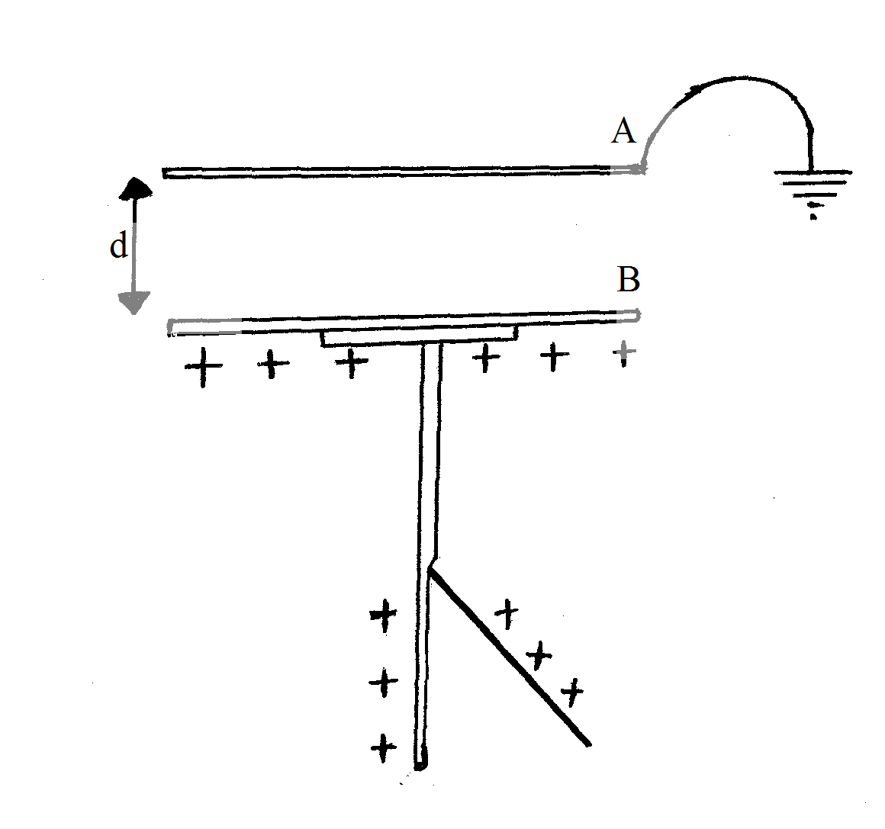
State and explain the observations made when:
(i) d is reduced (2mks)
..........................................................................................................................................................................................................................................................................................................................
(ii) the plate A is more horizontally (2mks)
..........................................................................................................................................................................................................................................................................................................................
(iii) a sheet of polythene is placed between A and B (2mks)
..........................................................................................................................................................................................................................................................................................................................
(b) Three capacitors are connected to a 10V battery as shown below.
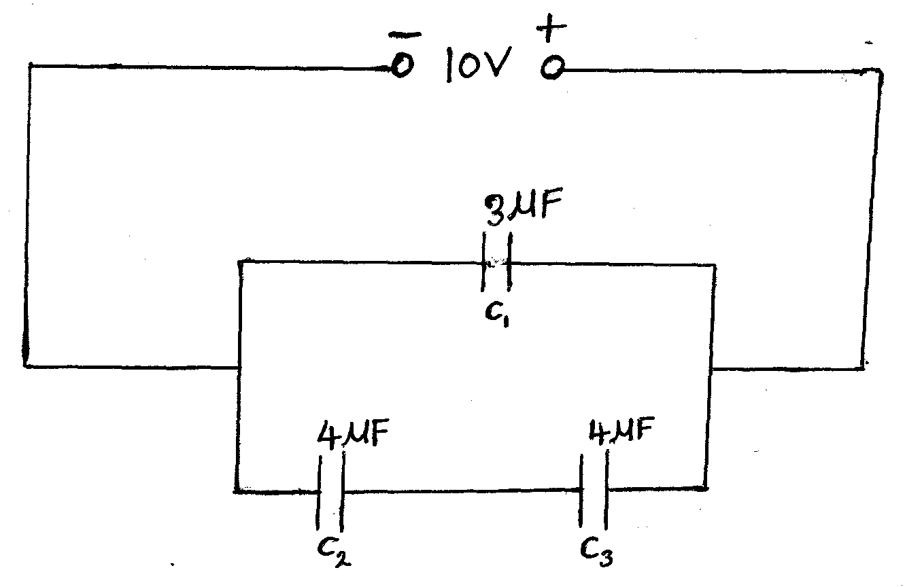

(i) Calculate the combined capacitance (3mks)

(ii) What is the charge on the 3$μ$F capacitor (3mks)

13. (a) State Len’s law of electromagnetic induction (1mk)
..........................................................................................................................................................................................................................................................................................................................
(b) The figure below shows a simple microphone in which sound warn from a person talking cause the diaphram to vibrate.
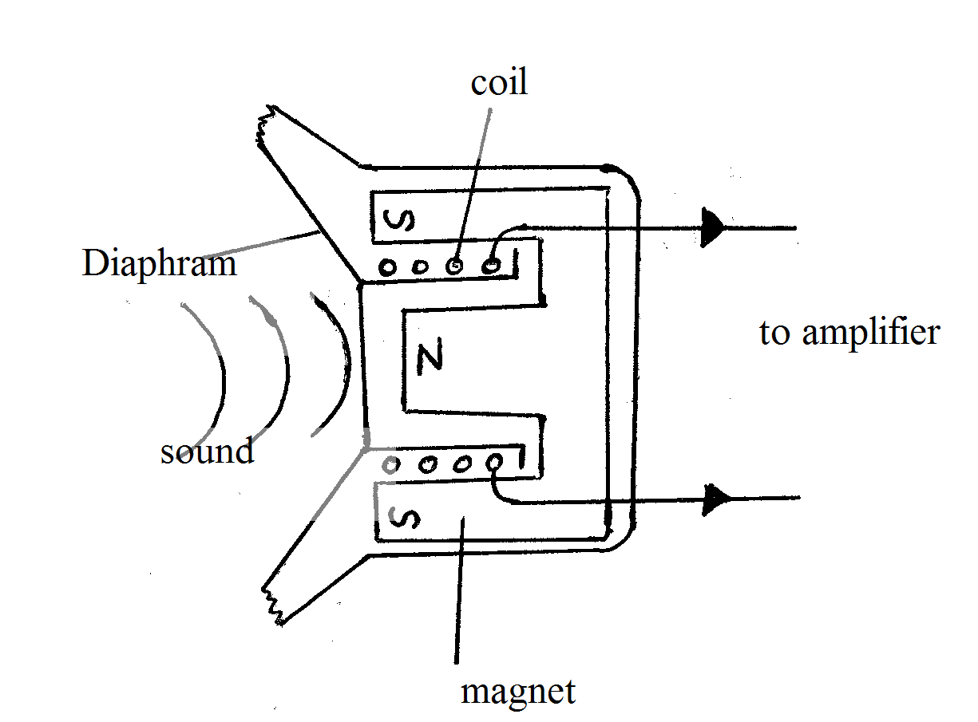
(i) Explain how a velocity current is induced in the coil when the diaphram vibrates (3mks)
..........................................................................................................................................................................................................................................................................................................................
..........................................................................................................................................................................................................................................................................................................................
(ii) State two way in which the induced current in (i) above can be increased (2mks)
..........................................................................................................................................................................................................................................................................................................................

(c) A transformer with 1200 turns in the primary coil and 120 turns in the secondary coil has 400v applied to its primary circuit, from an ac source.It is found that when a heater is connected to the secondary circuit, it produces heat at the rate of 600W.Assuming 100% efficiency ,determine the
(i) Voltage in the secondary circuit (3mks)

(ii) the current in the primary circuit (3mks)

14. (a) Define the refractive index of a substance (1mk)
..........................................................................................................................................................................................................................................................................................................................
(b) In an experiment to determine the refractive index of a liquid the liquid was poured into a measuring cylinder. A pin was placed at the bottom of the cylinder and another pin was used to locate the apparent position of the first pin. The real depth and the apparent depth were measured for various volumes of the liquid.
A plot of the volumes was obtained is shown below.

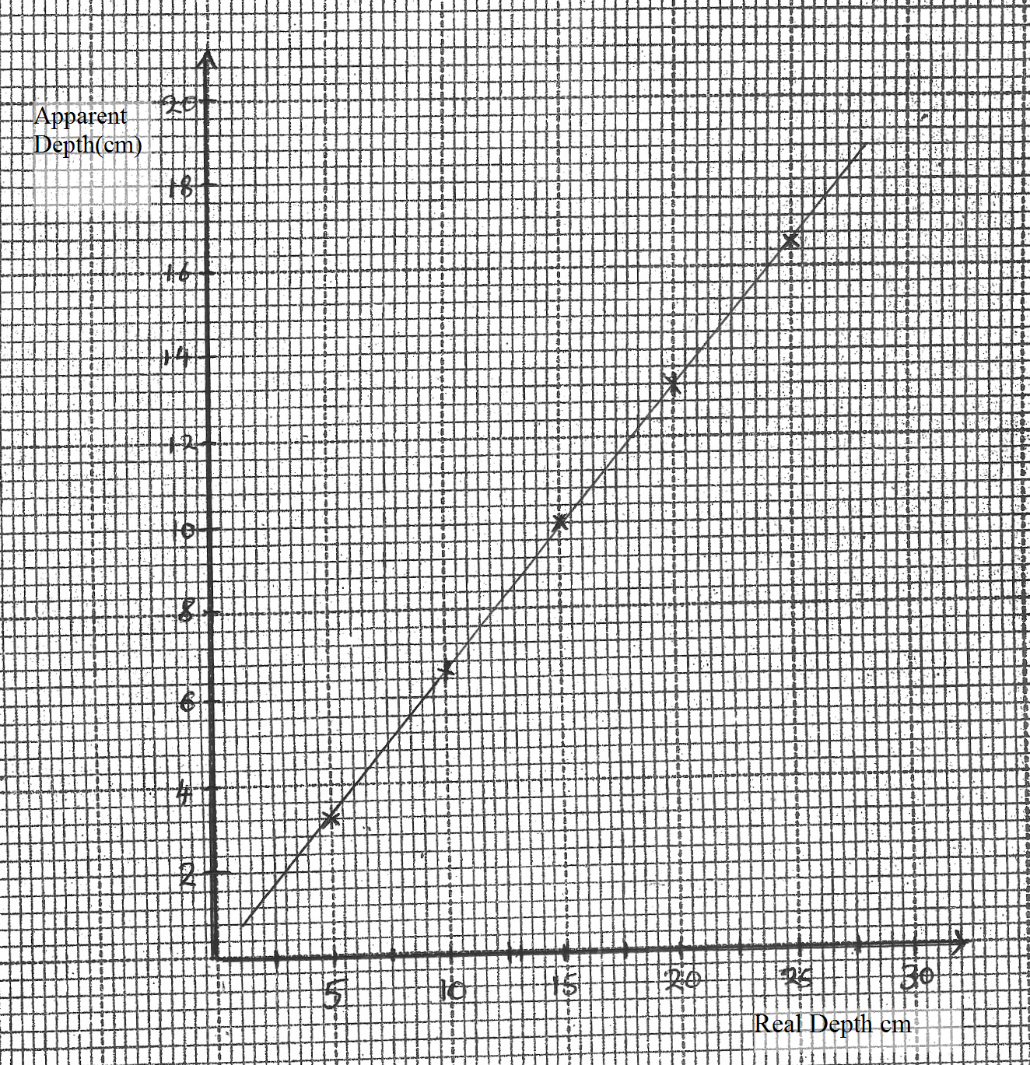

From the graph determine the refractive index of the liquid (3mks)

(c) The figure below shows a ray of light incident on a triangular prism and white screen s placed after the prism.
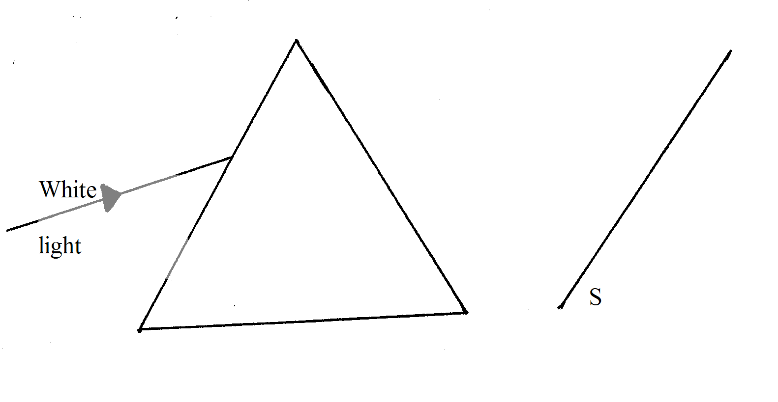
(i) Complete the path of the ray through the prism to show how a spectrum is formed on the screen (2mks)

(ii) A thermometer with a blackened bulb is placed at various parts of the spectrum. State with a reason the region where the thermometer indicates the highest reaching. (2mks)
..........................................................................................................................................................................................................................................................................................................................
..........................................................................................................................................................................................................................................................................................................................
(d) The figure below shows the displacement of a particle in a progressive wave incident on a boundary between deep and shallow region
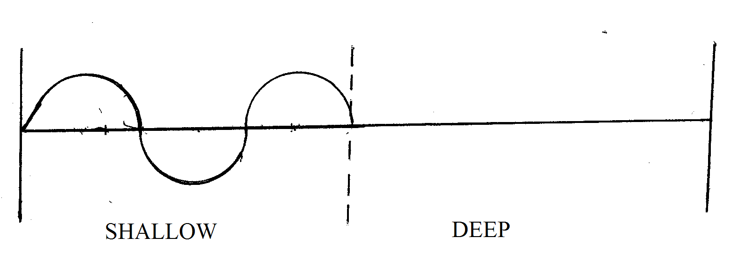
(i) Complete the diagram to show what is observed after boundary (1mk)
(ii) Explain the observation in (i) above (1mk)
..........................................................................................................................................................................................................................................................................................................................
(iii) State one assumption made in this experiment (1mk)
.............................................................................................................................................................
15. (a) The figure below shows the features of an x-ray tube
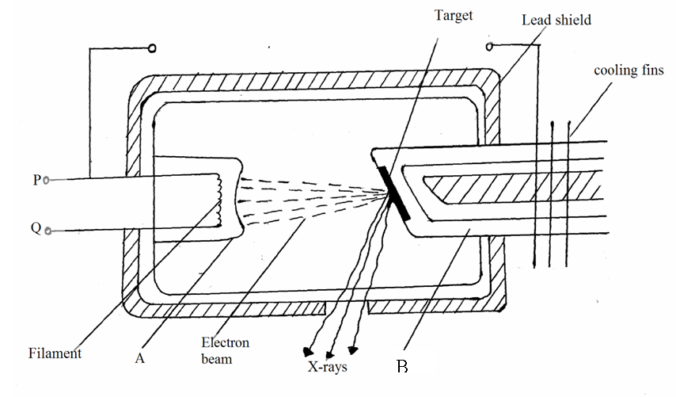
(i) Name the part labelled A and B (2mks)
..........................................................................................................................................................................................................................................................................................................................
(ii) Explain how change in the potential across PQ change the intensity of the x-rays produced in the tube (2mks)
..........................................................................................................................................................................................................................................................................................................................
..........................................................................................................................................................................................................................................................................................................................
(iii) During the operation of the tube, the target becomes very hot. Explain how the heat is caused (2mks)
..........................................................................................................................................................................................................................................................................................................................
..........................................................................................................................................................................................................................................................................................................................
(iv) What property of lead makes it suitable for use as shielding material? (1mk)
..........................................................................................................................................................................................................................................................................................................................
(b) In a certain X-ray tube, the electrons are accelerated by a pd of 12000v.Assuming that all the energy goes to produce x-rays, determine the frequency of the X-rays produced.(Take Planck’s constant h=6.62×10⁻³⁴ Js, and the charge an electron e=1.6×10⁻¹⁹c) (3mks)

16. (a) Define the following terms as used in photo electric effect
(i) Threshold frequency (f_{o}) (1mk)
.........................................................................................................................................................................................................................................................................................................................
(ii) Work function W_{o} (1mk)
..........................................................................................................................................................................................................................................................................................................................

(b) A surface whose work function W_{o} =6.4×10⁻¹⁹j in illuminated with light of frequency f=3.0×10¹⁵Hz.Find the maximum Kinetic energy of the emitted photoelectrons
(Take planks constant h=6.62×10⁻³⁴Js)

End

