Name………………………………………………………. Index No…………………/…….
School……………………………………………………… Date ………………………….…
Candidate’s Signature………………………

232/2
PHYSICS
Paper 2
JULY/AUGUST 2012
Time: 2 Hours

KISII SOUTH DISTRICT JOINT EVALUATION TEST-2012
Kenya Certificate of Secondary Education (K.C.S.E)

232/2
PHYSICS
Paper 2
JULY/AUGUST 2012
Time: 2 Hours

INSTRUCTIONS TO CANDIDATES

a) Write your name and index No. in the spaces provided above.
b) Sign and write the date of the examination in the space provided above
c) This paper consists of Two sections; A and B
d) Answer ALL the questions in Section A and B in the spaces provided.
e) All working MUST be Clearly shown
f) Non-programmable silent electronic calculators and KNEC Mathematical tables
may be used for calculations

FOR EXAMINER’S USE ONLY
Section | Question |  | Maximum score |  | Candidates score
A | 1-14 |  | 25
B | 15 |  | 9
B | 16 |  | 12
B | 17 |  | 11
B | 18 |  | 12
B | 19 |  | 11
TOTAL |  | 80

This paper consists of 12 printed pages.
Candidates should check the question paper to ascertain that all pages are Printed as indicated and that no question is missing

SECTION A(25 MARKS)
Answer all the questions in this section in the spaces provided after each question
1. Figure 1 shows part of an electric circuit. The current through the 13$Ω$ resistor is observed to be 2A..
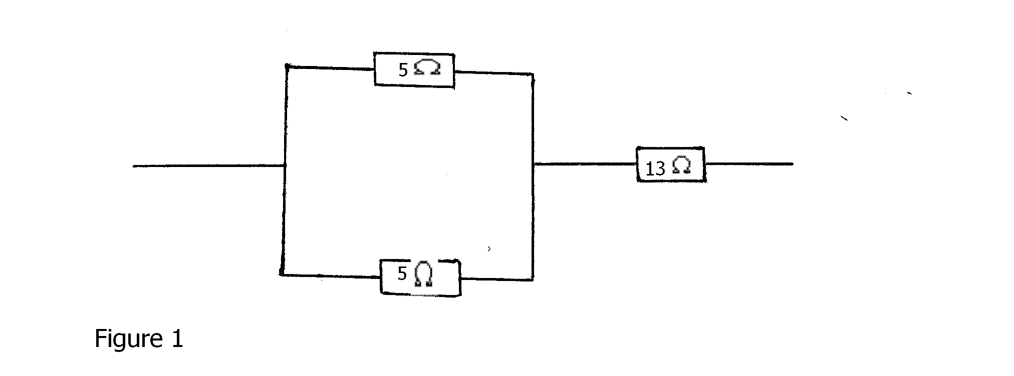
State the value of the current through each of the 5$Ω$ resistors. (1 mark)
………………………………………………………………………………………………………………………………………………………………………………………………………………
2. Figure 2 shows a horse-shoe magnet whose poles are labeled and two other magnets near it. Iron nails are attracted to the upper ends of the magnet as shown.
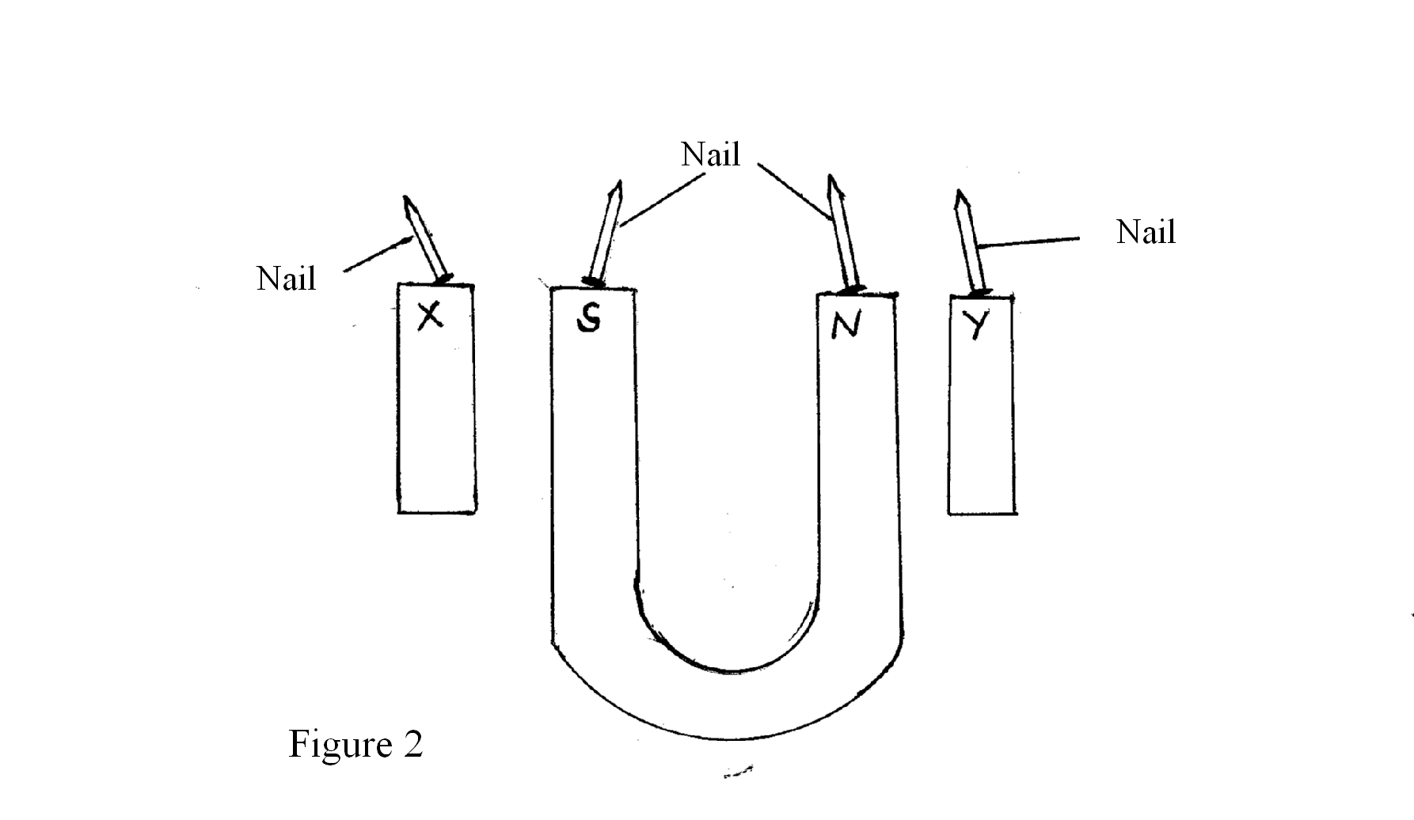
Identify the poles marked X and Y (1 mark)
X ……………………………… Y ………………………………………
3. Figure 3 shows how the displacement of a point varies with time as $α$waves passes it.
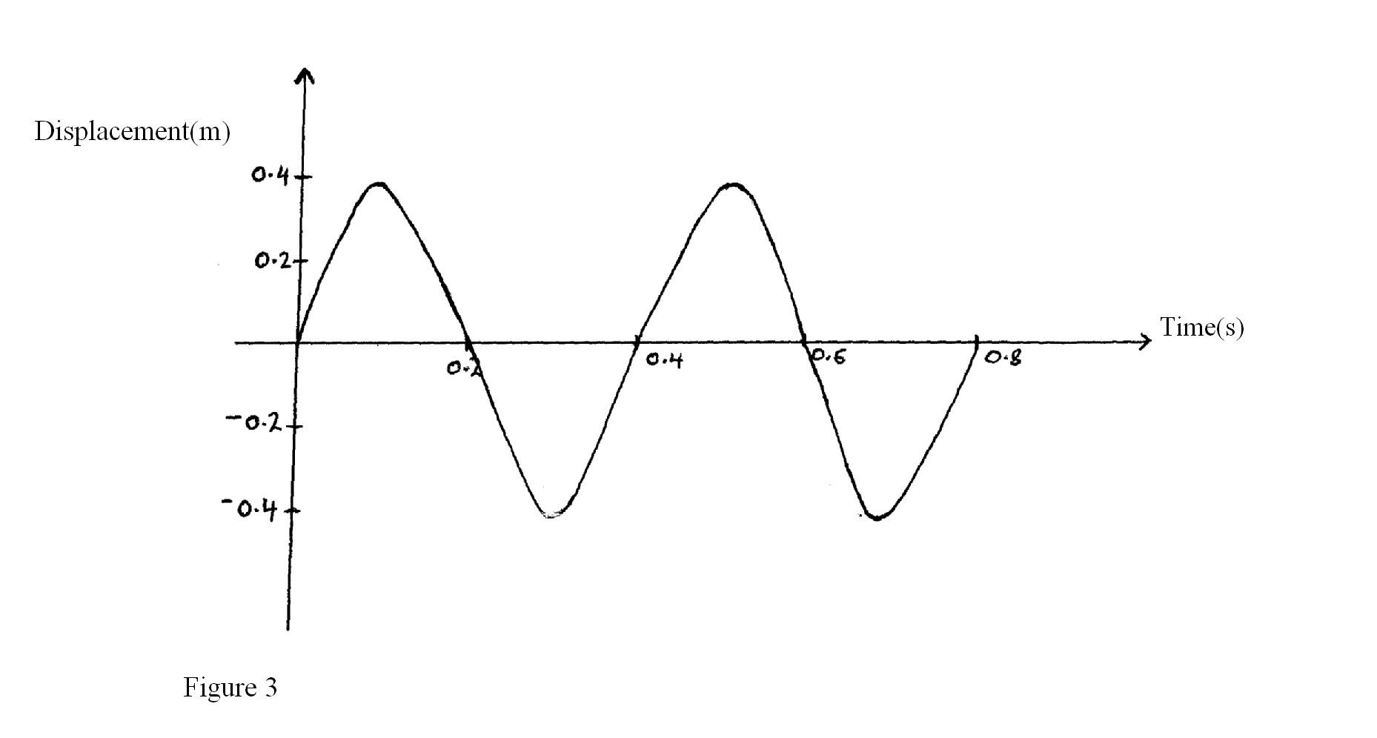
On the same diagram, draw a wave which passes the point with twice the frequency and half the amplitude of the one shown. (2 marks)
4. A boy standing in front of a cliff blows a whistle and hears the echo after 0.5s. He then moves 17 meters away from the cliff and blows the whistle again. He now hears the echo after 0.6s. Determine the speed of the sound. (2 marks)

5. A bulb is rated 100W, 240V. At what rate would it dissipate energy if it is connected to a 220V supply? (3 marks)

6. Figure 4 shows the circuit of a simple telephone receiver. When the telephone is lifted, a steady current flows through the solenoidS. When the person speaks into the microphone on the other side, a varying current flows.
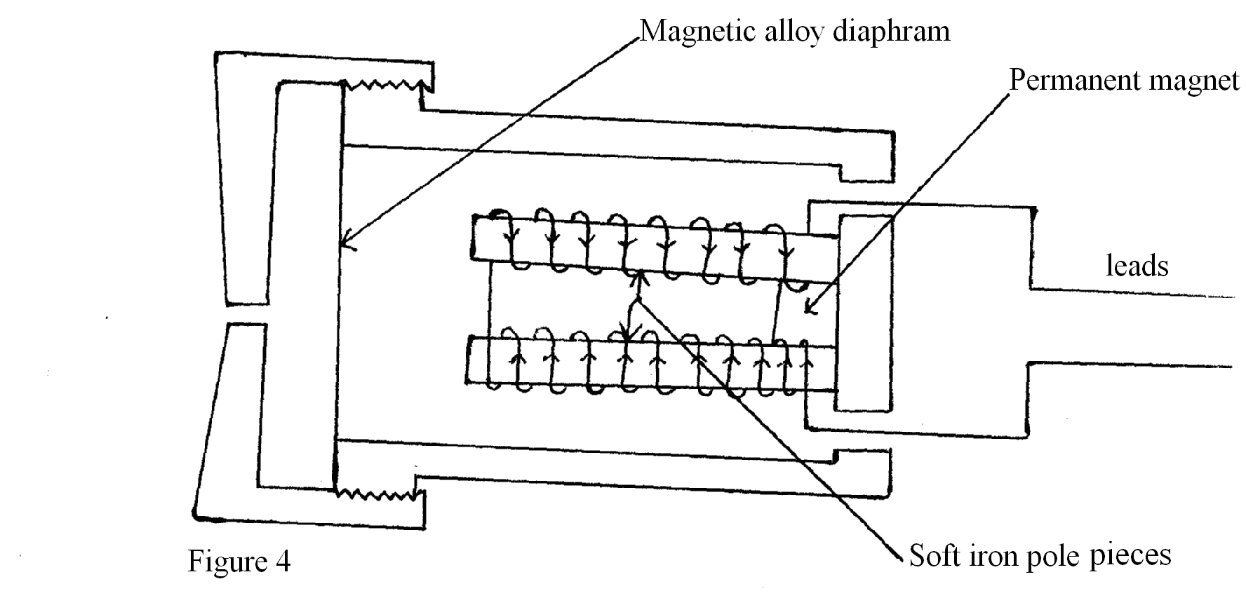
Explain how the speed current from the microphone is converted into sound in the receiver.
( 3 marks)
………………………………………………………………………………………………………………………………………………………………………………………………………………………………………………………………………………………………………………………………………………………………………………………………………………………………
7. A conductor is slowly brought near the cap of a positively charged electroscope. The leaf first collapses and then diverges. State the charge on the conductor. (1 mark)
………………………………………………………………………………………………………………………………………………………………………………………………………………
8. Figure 5 shows a ray of light incident on a mirror at an angle of 45⁰. Another mirror is placed at an angle of 45⁰ to the first one as shown .
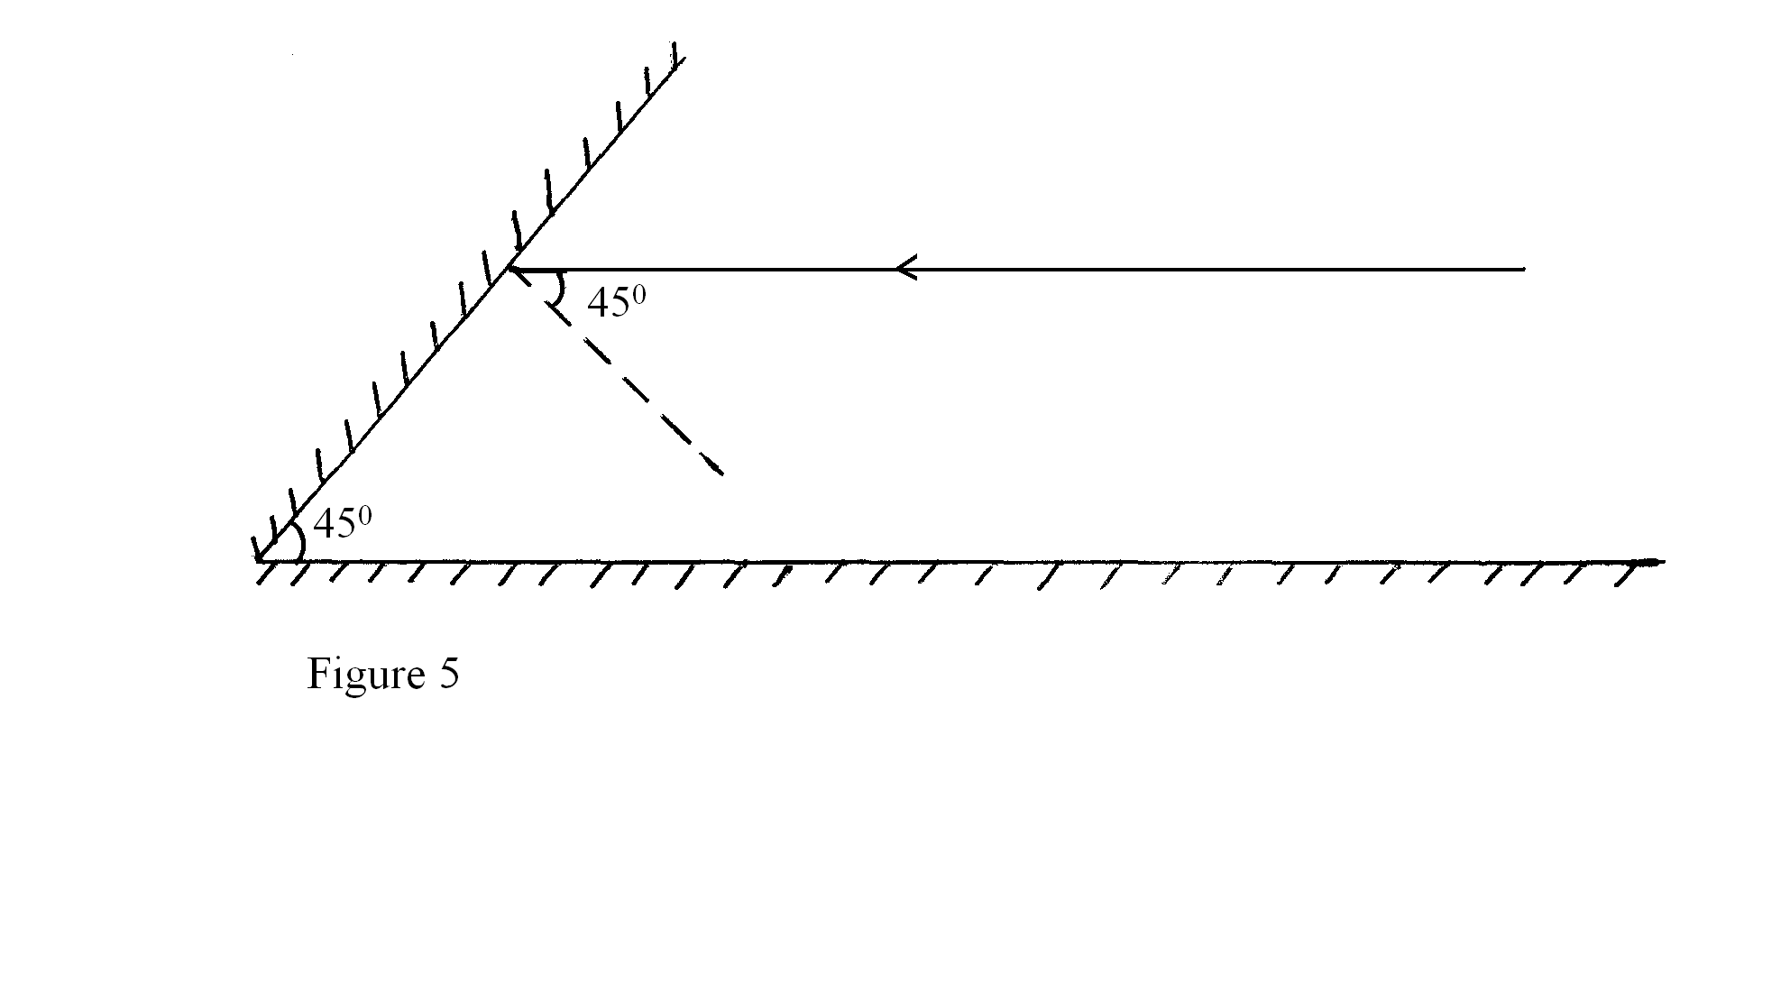
Sketch the path of the ray until it emerges. (2 marks)
9. Figure 6 shows an object, O, in front of a concave mirror and its image, I, formed after reflection.
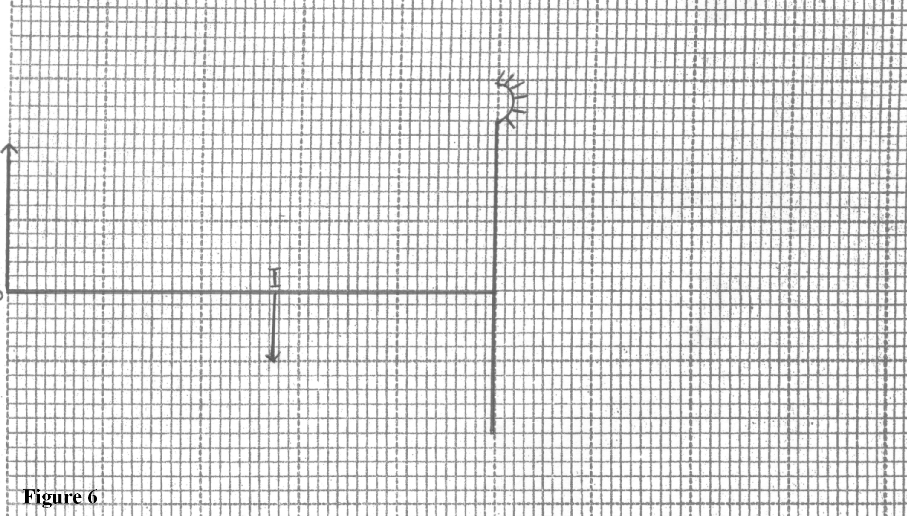
a) On the same diagram draw an appropriate ray(s) to locate the principal focus, F, of the mirror. (2 marks)
b) Determine the focal length of the mirror(Scale 1:5) (1 mark)

10. You are provided with 12V a.c source, four diodes and a resistor. Draw a circuit diagram for a full wave recifier and show the points at which the output is taken. (3 marks)

11. Table below shows radiations in their increasing order of wavelengths.
Gamma rays | x-rays | A | Visible light | Infra-red
Name the missing radiation A. (1 mark)
………………………………………………………………………………………………………………………………………………………………………………………………………………
12. Figure 7 shows a magnet being moved towards a stationery solenoid. It is observed that a current flows through the circuit in a direction P to Q
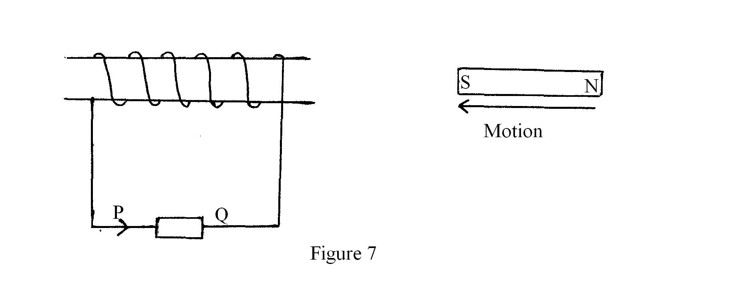
Explain why the current flows from P to Q. (1 mark)
………………………………………………………………………………………………………………………………………………………………………………………………………………………………………………………………………………………………………………………
13. State how the deflection system of a television differs from that of a CRO. (1 mark)
………………………………………………………………………………………………………………………………………………………………………………………………………………………………………………………………………………………………………………………
14. Figure 8 shows a ray of light incident on the face of a water prism.
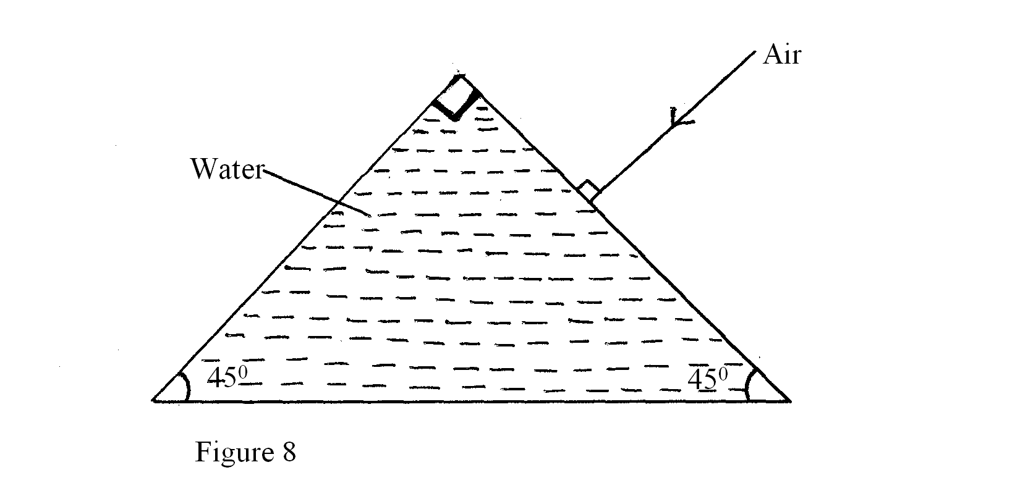
Sketch the path of the ray as it passes through the prism. Critical angle for the water is 49⁰.
(1 mark)
SECTION B (55 MARKS)
Answer all the questions in the spaces provided
15. a) Figure 9 shows a pair of parallel plates of a capacitor connected to a battery. The upper plate is displaced slightly to the left.

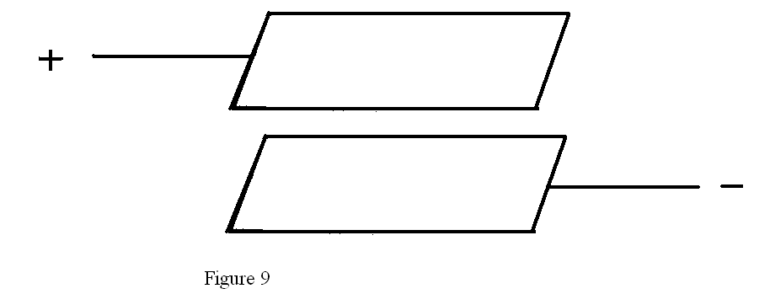
State with reason the effect of this movement on the capacitance. (2 marks)
………………………………………………………………………………………………………………………………………………………………………………………………………………………………………………………………………………………………………………………
b) Figure 10 shows an electrical circuit with three capacitors A, B and C of capacitance 4.0$μ$F, 5.0 $μ$F and 3.0$μ$F respectively connected to a 12V battery.
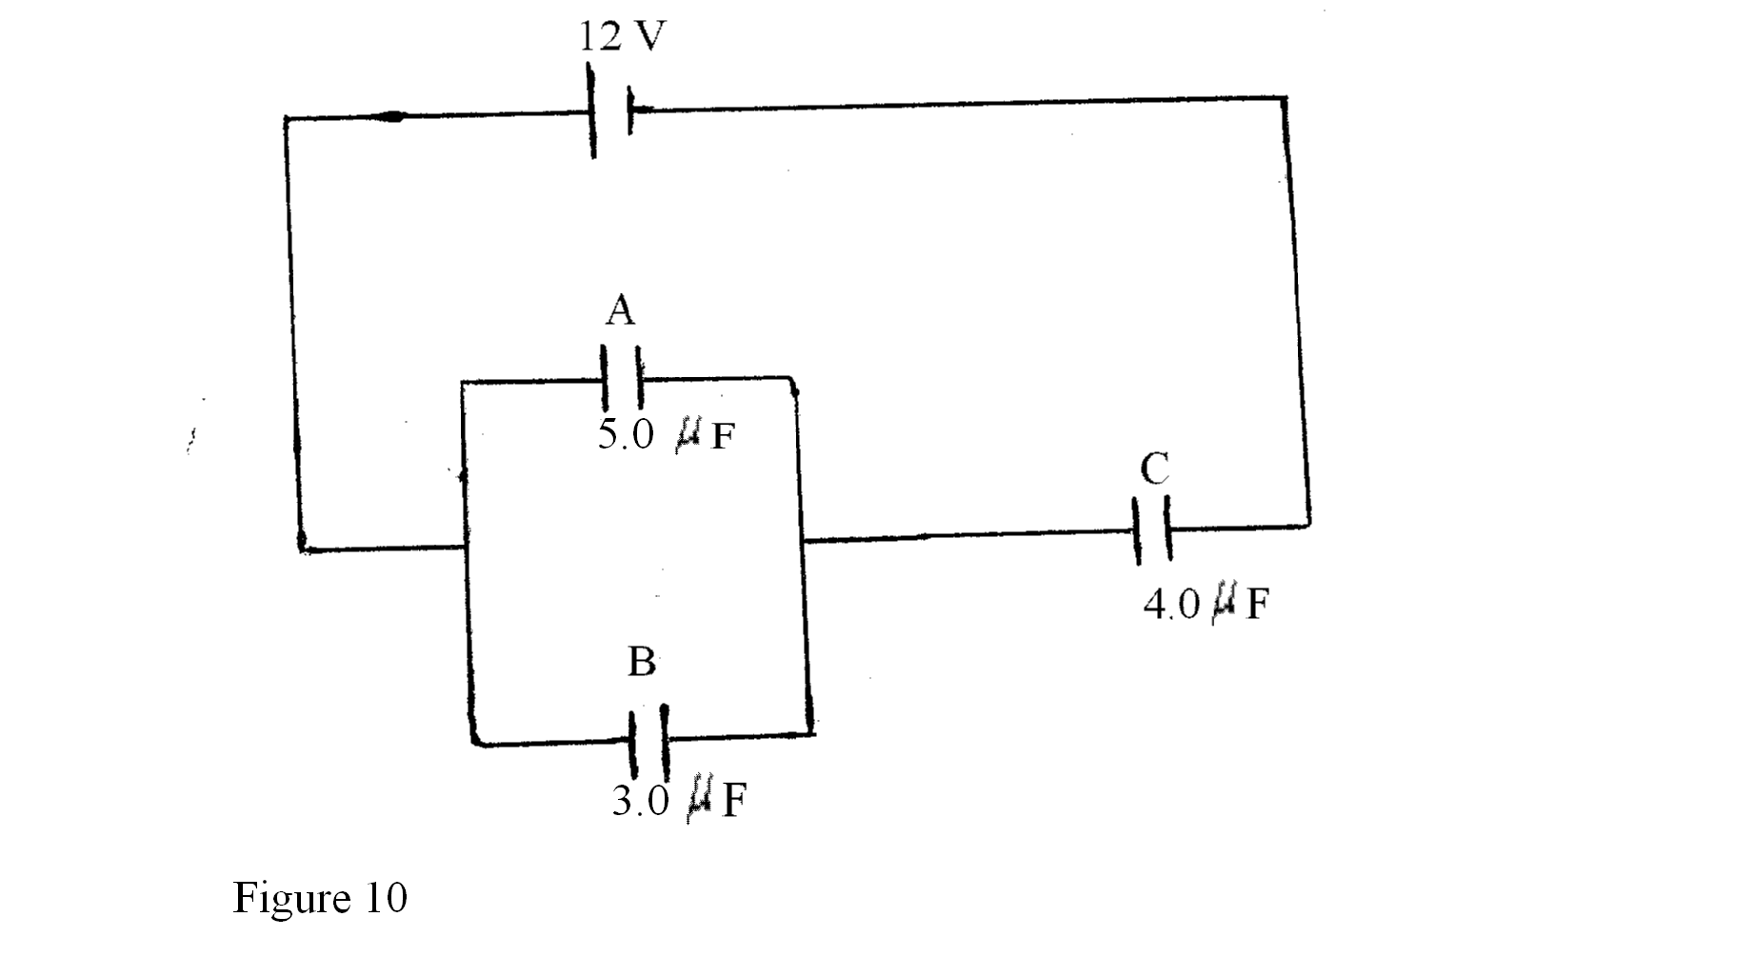
Determine:
i) The combined capacitance of the three capacitors. (3 marks)

ii) the charge on the capacitor C (2 marks)

iii) The potential difference across the capacitor A. (2 marks)

16. Figure 11 shows Ultra-violet light striking a polished Zinc plate placed on a negatively charged gold-leaf electroscope.
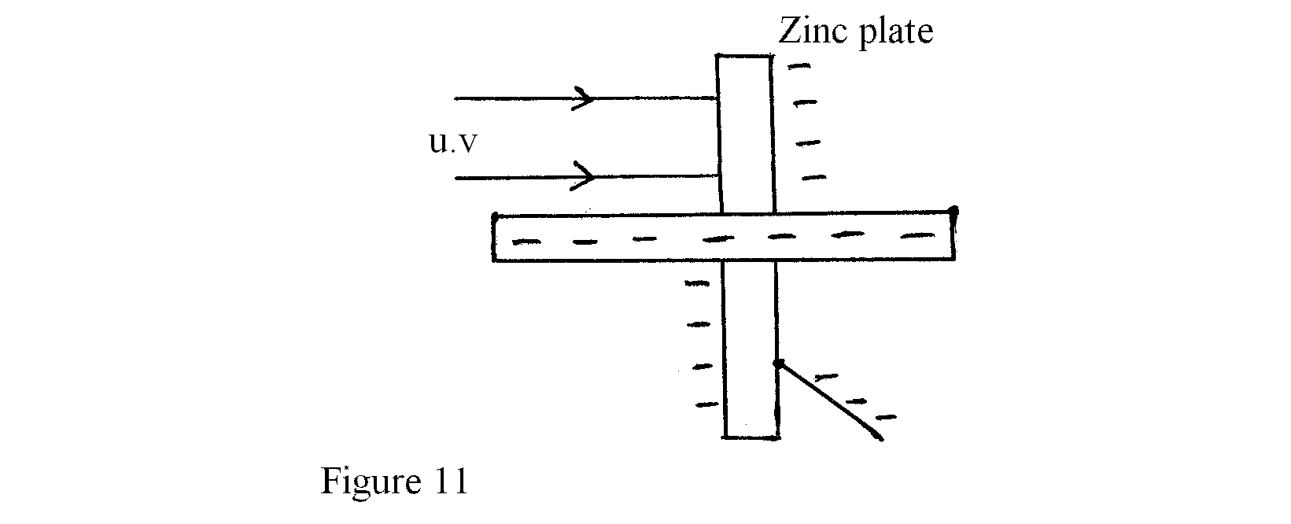
a) Explain the following observations;
i) The leaf of the electroscope falls. (2 marks)
………………………………………………………………………………………………………………………………………………………………………………………………………………
ii) When the same experiment was repeated with a positively charged electroscope the leaf did not fall (2 marks)
………………………………………………………………………………………………………………………………………………………………………………………………………………
b) i) State two factors which determine the speed of photoelectrons emitted by a metal
surface. (2 marks)
………………………………………………………………………………………………………………………………………………………………………………………………………………
- In an experiment using a photocell, U.V light of varying frequency but constant intensity was made to strike a metal surface. The maximum kinetic energy(KE_{Max}) of photoelectrons for each frequency, f, was measured. The graph shows how KE_{Max} varies with f
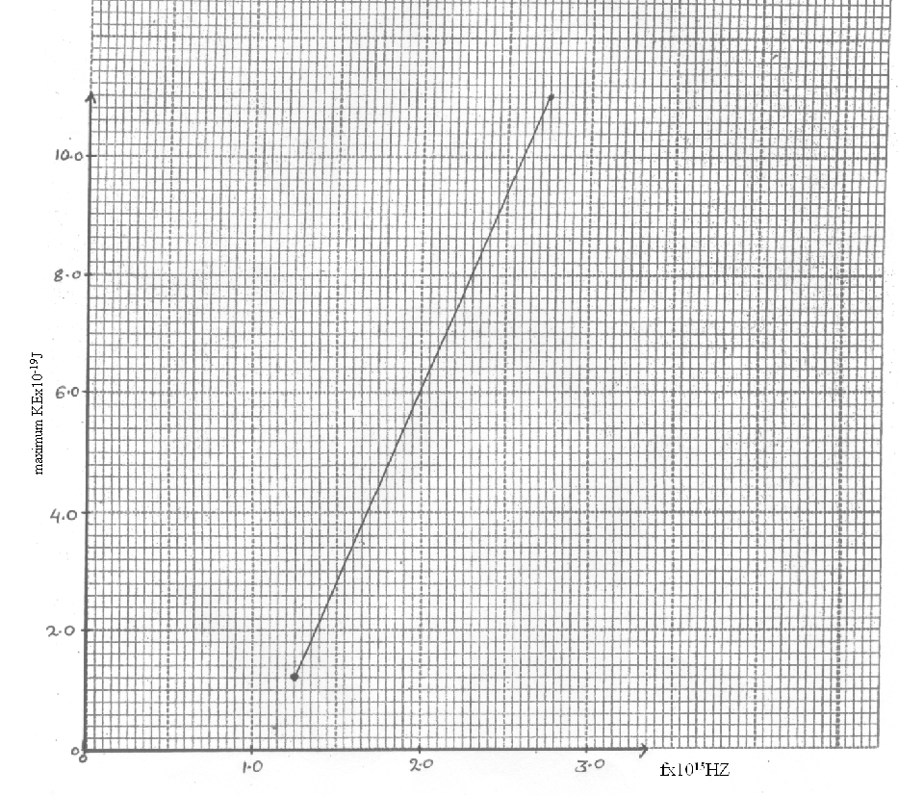
Given that KE_{Max}=hf-Ø, determine the values:
I) Constant h (3 marks)

II) Constant Ø ( 3 marks)

17. Figure 12 shows the path of radiation from a radioactive source after entering a magnetic field. The magnetic field is directed into the paper and is perpendicular to the plane of the paper as shown in the figure.
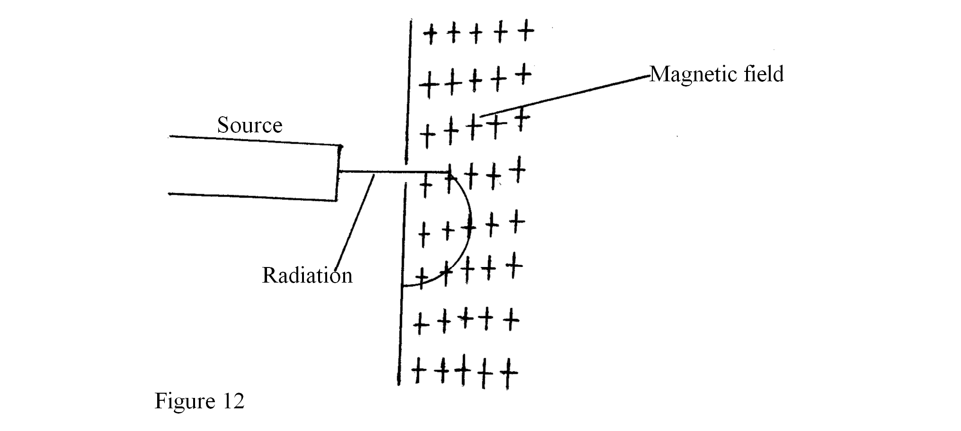
Identify the radiation. (1 mark)
………………………………………………………………………………………………………
Give a reason for your answer. (1 mark)
………………………………………………………………………………………………………………………………………………………………………………………………………………
- Below is a nuclear reaction
$$\begin{matrix}\text{232} \\ \text{90}\end{matrix}A\vec{k}\begin{matrix}\text{228} \\ \text{88}\end{matrix}B\vec{γ(\text{gamma})}\begin{matrix}Y \\ X\end{matrix}C$$
i) Identify radiation k (1 mark)
………………………………………………………………………………………………………
ii) Determine the values X and Y
X ………………………………………………………………….(1 mark)
Y …………………………………………………………………(1 mark)

c) Figure 13 shows a device for producing metal foils of constant thickness. Any change in
the thickness can be detected by the Geiger tube and recorded by the Geiger counter. The pressure exerted by the roller is then adjusted to keep the thickness constant.
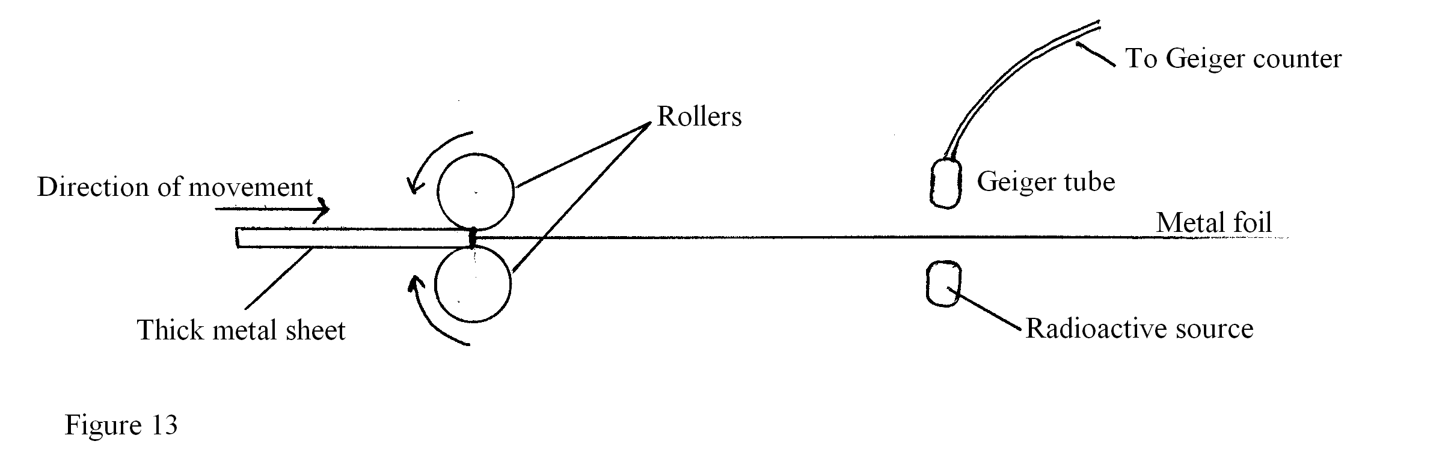
i) State the change in the metal foil that will lead to a decrease in the Geiger counter reading. (1 mark)
………………………………………………………………………………………………………
ii) Give a reason for your answer in c(i) above. (1 mark)
………………………………………………………………………………………………………………………………………………………………………………………………………………
iii) State the change in the roller pressure that should be made as a result of the decrease in the Geiger counter reading. (1 mark)
………………………………………………………………………………………………………………………………………………………………………………………………………………
iv) Give a reason for your answer in c(iii) above (1 mark)
………………………………………………………………………………………………………………………………………………………………………………………………………………
v) Explain why a source emitting $α$(alpha) particles only would not be suitable for this device. (2 marks)
………………………………………………………………………………………………………………………………………………………………………………………………………………
18. a) X-rays are used for detecting cracks inside metal beams
i) State the type of the x-rays used. (1 mark)
………………………………………………………………………………………………………………………………………………………………………………………………………………
ii) Give a reason for your answer in (i) above. (1 mark)
………………………………………………………………………………………………………………………………………………………………………………………………………………
- Figure 14 shows the features of an x-ray above.
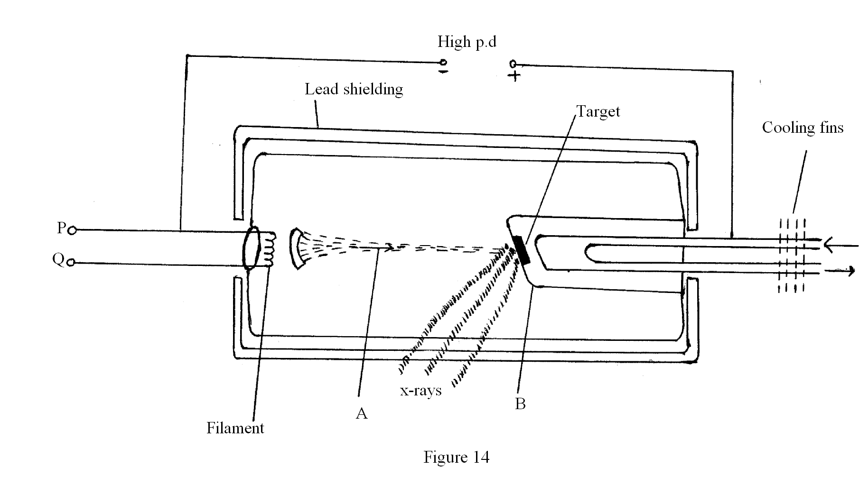
i) Name the parts labeled A and B (2 marks)
A ……………………………………………………………………………
B ……………………………………………………………………………
ii) Explain how a change in the potential across PQ changes the intensity of the x-rays produced in the tube. (2 marks)

iii) During the operation of the tube, the target becomes very hot. Explain how this heat is caused. (1 mark)

iv) What property of lead makes it suitable for use as shielding material?(1 mark)

c) In a certain x-ray tube, the electrons are accelerated by a p.d of 12000V. Assuming all the
energy goes to produce x-rays, determine the frequency of the x-rays produced.(Planks constant, h=6.62x10⁻³⁴Js and charge on an electron, e=1.6x10⁻¹⁹C) (4 marks)

19. Figure 15 shows a section of a house wire system.
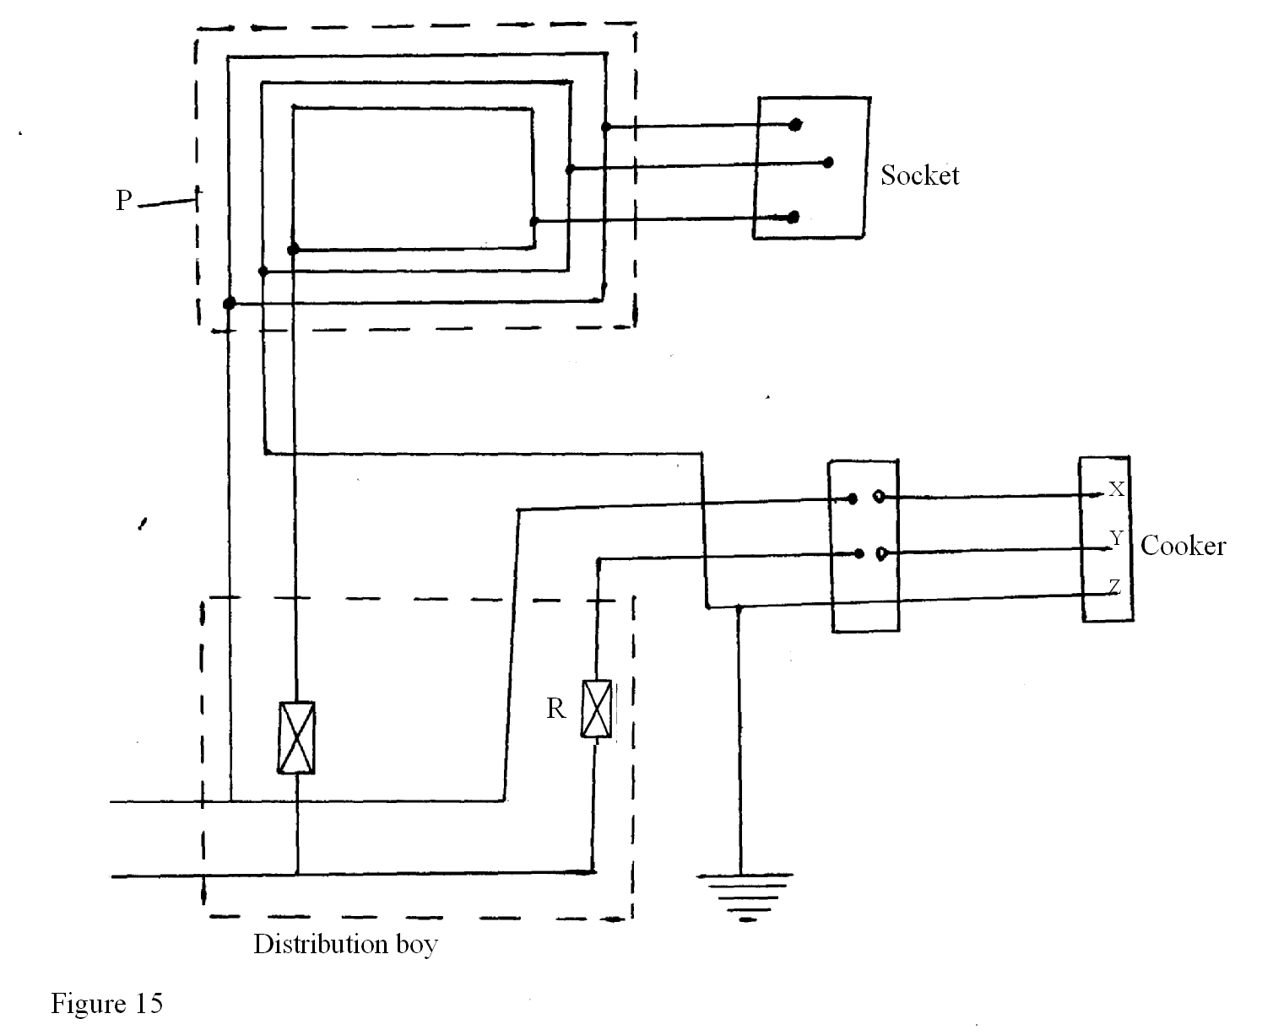
i) Name:
The circuit labeled P (1 mark)
……………………………………………………………………………….
The terminals labeled X, Y and Z (3 marks)
X ………………………………………………………………………….
Y ………………………………………………………………………….
Z ……………………………………………………………………………
ii) I State the purpose of R in the circuit. (1 marks)
……………………………………………………………………………………
II) Give a reason why R is connected to Y but not to X. (1 mark)
………………………………………………………………………………………………………………………………………………………………………………………………
iii) Why is the earthing necessary in such a circuit? (1 mark)
………………………………………………………………………………………….

b) Determine the cost of using an electric iron rated 1500W, for a total of 30 hours given that the cost of electricity per kwh is Ksh.8 (2 marks)

End
c) Explain why electric power is transmitted over long distances at high voltages(2 marks)

