Name:…………………………………………………………………….. Index No. ……………………….
School: ………………………………………………Date: …………………….. Sign……………………
232/2
PHYSICS
PAPER 2
JULY /AUGUST 2012
TIME: 2 HOURS

KISUMU NORTH AND EAST DISTRICT JOINT TEST
Kenya Certificate of Secondary Education 2012
232/2
PHYSICS
PAPER 2
JULY /AUGUST 2012

Instructions to candidates;
- Write your name, index number and name of your school in the spaces provided.
- This paper consists of two parts A and B.
- Answer all questions in section A and B in the spaces provided.
- All working MUST be shown in the spaces provided after questions.
- Mathematical tables and electronic calculators may be used.
- Candidates should check the question paper to ascertain that ascertain that all the pages are printed as indicated and that no questions are missing.
For examiners use only
Section | Question | Maximum score | Candidates score
A | 1-14 | 25
A | 15 | 11
A | 16 | 13
A | 17 | 11
B | 18 | 10
B | 19 | 10
 | Total score | 80
SECTION A (25 MARKS)
Answer ALL the questions in this section
- The figure 1 below shows the image in front of a mirror M.
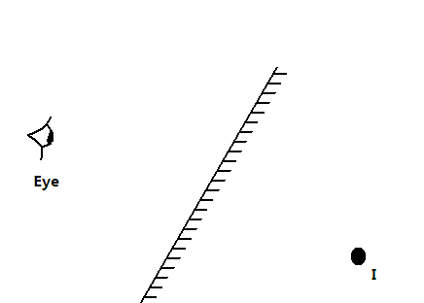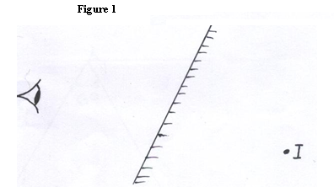
By ray diagram construction, locate the position of the object. (2marks)
- A negatively charged rod is brought rear the cap of a leaf electroscope. The cap is then earthed momentarily by touching with the finger. Finally the rod is withdrawn. The electroscope is found to be positively charged. Explain how this is acquired
(2marks)
..............................................................................................................................................
..............................................................................................................................................
..............................................................................................................................................
- Explain why the e.m.f of a dry cell drops if a large current is drawn for a short time and then recovers if allowed to rest. (2marks)
.........................................................................................................................................
.........................................................................................................................................
.........................................................................................................................................
.........................................................................................................................................
- Use the domain theory to explain how an unmagnetized piece of iron becomes magnetized when it is heated and then allowed to cool in a magnetized field. (2marks)
.........................................................................................................................................
.........................................................................................................................................
.........................................................................................................................................
.........................................................................................................................................
.........................................................................................................................................
- A boy observes his face in a concave mirror of focal length 100cm. If the mirror is 80cm away, state one characteristics of the image observed. (1mark)
.........................................................................................................................................
.........................................................................................................................................
- The coil of an electric motor is usually wound on a soft iron armature. State two purposes by this armature. (2marks)
.........................................................................................................................................
.........................................................................................................................................
.........................................................................................................................................
- A student stands at a distance 400m from a wall and claps two pieces of wood. After the first clap the student claps whenever an echo is heard from the wall. Another student starts a stopwatch at the first clap and stops it after the twentieth clap. The stopwatch records a time of 50 seconds. Find the speed of sound. (3marks)
.........................................................................................................................................
.........................................................................................................................................
.........................................................................................................................................
.........................................................................................................................................
.........................................................................................................................................
- The figure 2 below shows a displacement-time graph for a wave motion
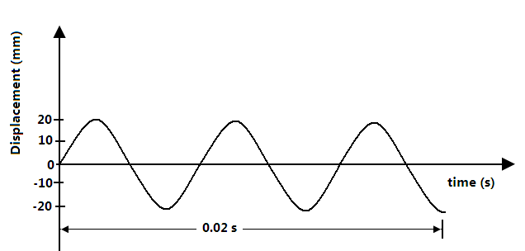
Figure 2
What is the frequency of the wave? (2marks)
.........................................................................................................................................
.........................................................................................................................................

- Figure 3 below shows an incomplete circuit diagram for a half-wave rectification of an AC voltage.
~
+
-
Out put
x
Figure 3

ac v

- Complete diagram by inserting a diode at X so that the output terminals are positive and negative as shown (1mark)
- On the axes provided below sketch a graph showing how the output voltage varies with time (1mark)
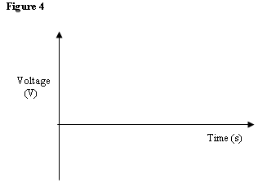
- The element of an electric hot plate has a resistance of 80Ohms. What is the energy dissipated when the element is kept on for 20 minutes on a 240V supply. (2marks)
................................................................................................................................................
................................................................................................................................................
................................................................................................................................................
................................................................................................................................................
- Describe how microwaves are used in determining distances of objects as in the radar. (1mrk)
................................................................................................................................................
................................................................................................................................................
................................................................................................................................................
................................................................................................................................................

- The figure 5 below shows a series of wave fronts one wavelength a part approaching a gap between two barriers in ripple tank.
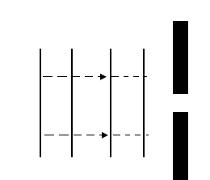
Figure 5
Show on the figure 5 what happens as the waves pass through the gap. (1mark)
- In the figure 6, below if the critical angle of glass is 39⁰ ,sketch on the diagram the path of a ray till it emerges from the prism. (2marks)

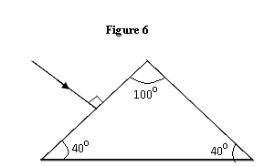

- Explain briefly how free electrons are produced in an X-ray tube. (1mark)
................................................................................................................................................
................................................................................................................................................
................................................................................................................................................
................................................................................................................................................
................................................................................................................................................

SECTION B (55MARKS)
Answer ALL the questions in this section.
- a) The refractive index of glass is ³/₂ and that of water is ⁴/₃. Calculate the refractive index of glass with respect to water.
................................................................................................................................................
..............................................................................................................................................
- The figure 7 below shows a ray of light incident at an angle of 35.6⁰ at point D on the first face of a glass prism ABC. The refractive index of the prism is 1.6.
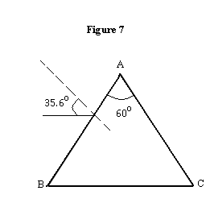
- Determine the angle of refraction at point D. (3marks)
......................................................................................................................................................
............................................................................................................................................................................................................................................................................................................
- Find the angle of incidence of the refracted ray on the face AC to 1.d.p. (2marks)
..................................................................................................................................................................................................................................................................................................................................................................................................................................................................
- Complete the diagram to show the emergent ray from the face AC. (2marks)

- a) State Lenz’s law of electromagnetic induction. (1mark)
............................................................................................................................................................
............................................................................................................................................................
............................................................................................................................................................
............................................................................................................................................................

b) In the figure 8 below the bar magnet is moved into the coil.
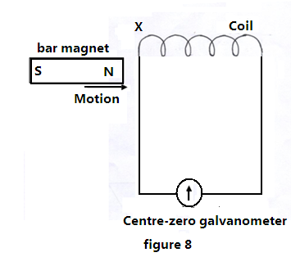
- State and explain what is observed in the galvanometer. (2marks)
.................................................................................................................................................................................................................................................................................
........................................................................................................................................
- Explain briefly the source of an electrical energy in the circuit. (2marks)
....................................................................................................................................
....................................................................................................................................
....................................................................................................................................
- State any two ways in which power is lost from the transformer and explain how each loss is minimized. (2marks)
............................................................................................................................................................
............................................................................................................................................................
............................................................................................................................................................
- A transformer is used to provide a potential difference of 100KV to an X-ray tube from 250V a.c mains supply.
A current of 100mA flows in the X-ray tube and the transformer is 100% efficient.
Calculate;
- The ratio of the number of turns of the secondary coil to the number of turns in the primary coil. (3marks)
........................................................................................................................................
........................................................................................................................................

- The current in the primary coil (2marks)
........................................................................................................................................
........................................................................................................................................
........................................................................................................................................
- State giving reasons which of the coils of the transformer is thinner. (2marks)
........................................................................................................................................
........................................................................................................................................
........................................................................................................................................
- a) The figure 9 below shows an experimental set up in a vacuum for investigating the effect of a magnetic field on the radiation emitted by a radioactive source S.

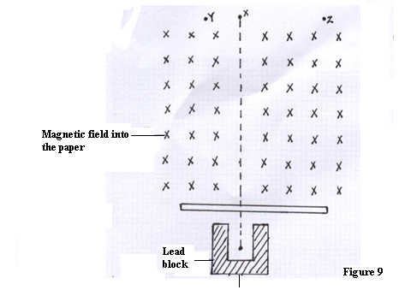
The background radiation at the place is 20 counts per minute. A detector is placed at X, Y and Z. and the results obtained are shown in the table below.
Position | X | Y | Z
Count / minute | 240 | 20 | 220
Use the table to explain which of the three types of radioactive radiations are emitted from the source. (3marks)
............................................................................................................................................................
............................................................................................................................................................
............................................................................................................................................................
............................................................................................................................................................

b) The graph in figure 10 below shows the activity of a sample radioactive material with time.

Graph

Figure 10
- Use the graph to estimate the half life of the material (2mrks)
............................................................................................................................................................................................................................................................................................................
......................................................................................................................................................
......................................................................................................................................................
- Explain why the concentrate does not go below 2 counts per second. (2mrks)
................................................................................................................................................
................................................................................................................................................
................................................................................................................................................
................................................................................................................................................
c) Explain why neither Alpha nor Gamma radiation is suitable to monitor the thickness of Aluminium foil manufactured in industries. (2mrks)
................................................................................................................................................
................................................................................................................................................
................................................................................................................................................
................................................................................................................................................
................................................................................................................................................
- a) State two factors that determine the capacitance of a parallel plate capacitor. (2marks)
................................................................................................................................................
................................................................................................................................................
................................................................................................................................................
................................................................................................................................................
b) Three capacitors of capacitance 100µƒ, 500aF and 400µƒ are connected together in a circuit.
- Draw a circuit diagram to show the arrangement of the capacitors which gives an effective capacitance of 250µƒ (2marks)
................................................................................................................................................
................................................................................................................................................
................................................................................................................................................
................................................................................................................................................
................................................................................................................................................
................................................................................................................................................
c) The figure 11 below shows a circuit where a battery of e.m.f 6V a voltmeter, switches X and
Y, two capacitors of capacitance 2 µF and 4 µFare connected.
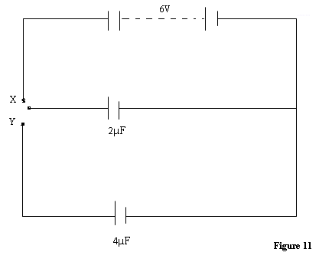
- Determine the charge stored in the 2 µF capacitor when switch X is closed and switch Y is open. (3marks)
................................................................................................................................................
................................................................................................................................................
................................................................................................................................................
................................................................................................................................................
- When switch Y is finally closed and switch X is open, determine the potential difference across each capacitor. (3marks)
................................................................................................................................................
................................................................................................................................................
................................................................................................................................................
................................................................................................................................................
- a) Distinguish between a real and virtual image. (2marks)
................................................................................................................................................
................................................................................................................................................
................................................................................................................................................
................................................................................................................................................
b) An object is placed 15cm from a converging lens of focal length 20cm. calculate the image position. (3marks)
................................................................................................................................................
................................................................................................................................................
................................................................................................................................................
................................................................................................................................................
c) In an experiment to determine the focal length of a converging lens, a graph of linear magnification M against image distance V was plotted as shown in figure 12 below.

graph

Use the figure 12 to determine the focal length of the lens. (4marks)
................................................................................................................................................
................................................................................................................................................
................................................................................................................................................
................................................................................................................................................
................................................................................................................................................
................................................................................................................................................
d) i) Name the eye defect shown in the figure 13 below. (1mark)
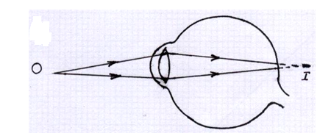Figure 13
- Draw another diagram to show how a suitable lens can be used to correct the defect.
(2marks)
......................................................................................................................................................
......................................................................................................................................................
......................................................................................................................................................
......................................................................................................................................................
......................................................................................................................................................
......................................................................................................................................................
......................................................................................................................................................
......................................................................................................................................................

