**Name…………………………………………………………………………… Index No……………..**

**School………………………………………………………………………….. Date………………….**

**Candidate’s signature…………………………………..**

**232/1**

**PHYSICS**

**PAPER 1**

**JULY / AUGUST 2012**

**TIME: 2 HOURS**

**LOITOKITOK DISTRICT JOINT EVALUATION TEST - 2012**

***Kenya Certificate of Secondary Education (K C.S.E.)***

**INSTRUCTIONS TO THE CANDIDATES:**

1. Write your name and index number in the spaces provided above.

2. This paper consists of two sections: A and B

3. Answer all the questions both in section A and B in the spaces provided below each question

4. All workings must be clearly shown; marks may be awarded for correct steps even if the answers are wrong.

5. Mathematical tables and silent electronic calculators may be used.

6. Take g = 10m/s2

**For Examiners’ Use Only**

|  |  |  |  |
| --- | --- | --- | --- |
| **SECTION** | **QUESTION** | **MAXIMUM SCORE** | **CANDIDATE’S SCORE** |
| **A** | 1 - 14 | 25 |  |
| **B** | 15 | 12 |  |
|  | 16 | 11 |  |
| 17 | 10 |  |
| 18 | 10 |  |
| 19 | 12 |  |
| **TOTAL** |  | **80** |  |

*This paper consists of 12 Printed pages.*

*Candidates should check to ascertain that all pages are printed as indicated and that no questions are missing.*

**SECTION A( 25 MARKS)**

1. The diagram below shows a portion of a micrometer screw gauge used to measure the diameter of a metal pipe . The reading on the gauge when the jaws were fully closed without the pipe was 0.012 cm

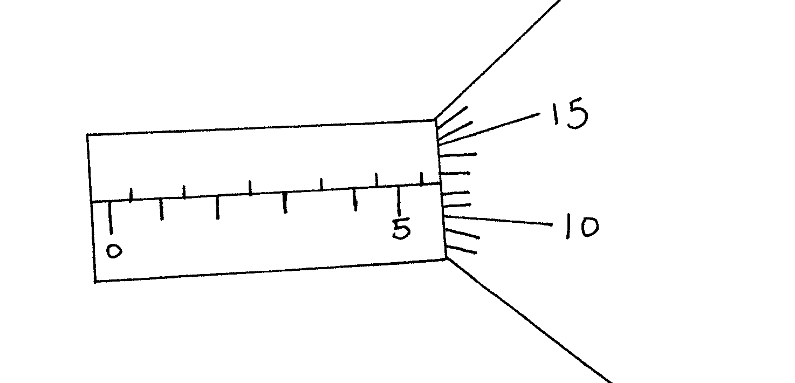

What is the length of the pipe? (2 marks)

1. Figure 2 below shows a soap film formed on a metal ring and a loop of thread inside it.

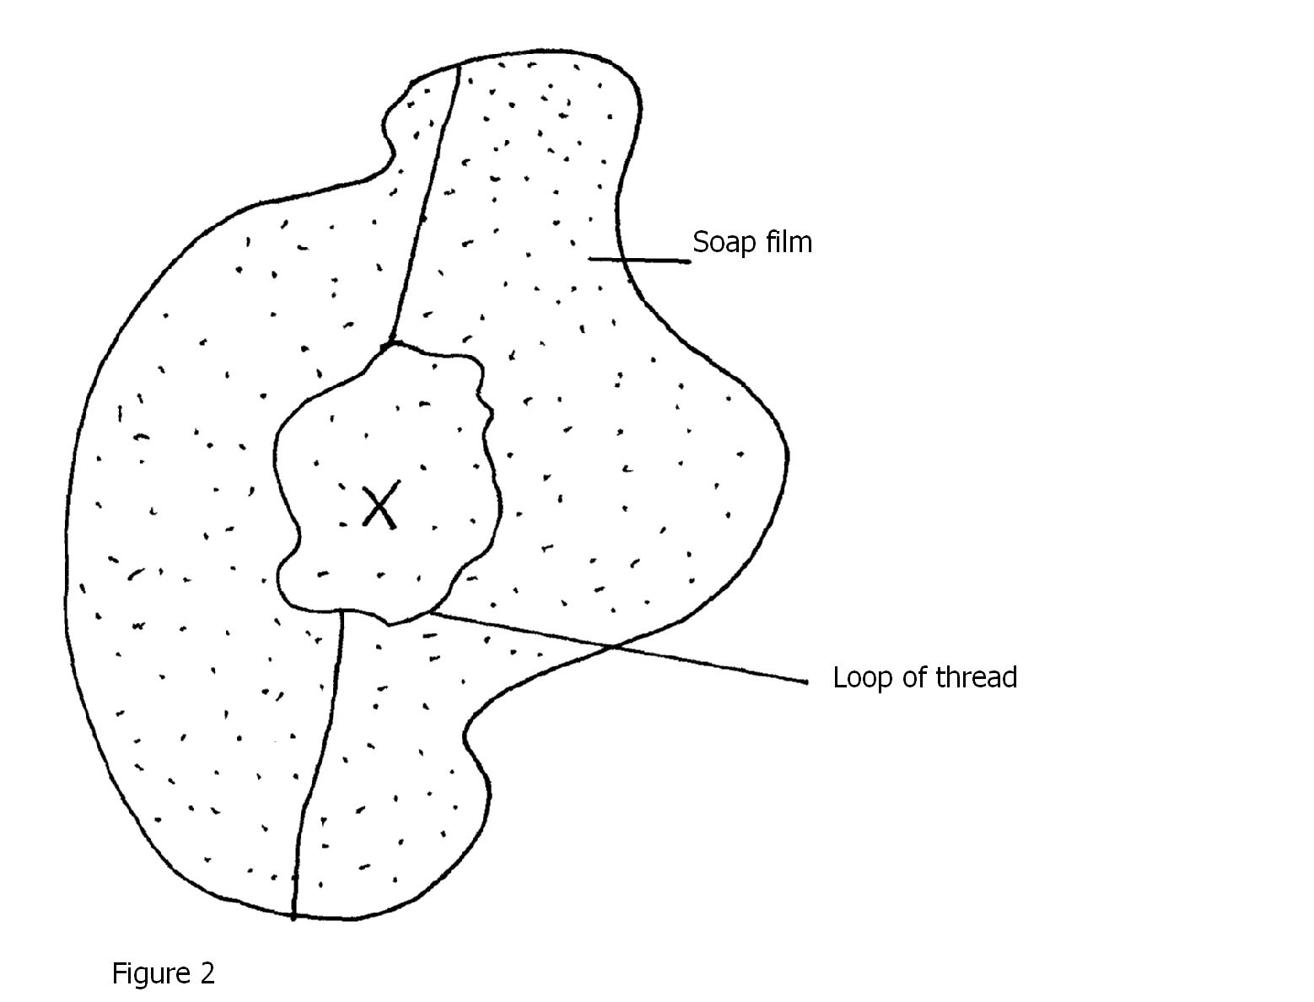

Explain what will happen when the film is punctured at x (3 marks)

………………………………………………………………………………………………………………………………………………………………………………………………………………………………………………………………………………………………………………………………………………………………………………………………………………………………

1. The system in figure three below is inn equilibrium.

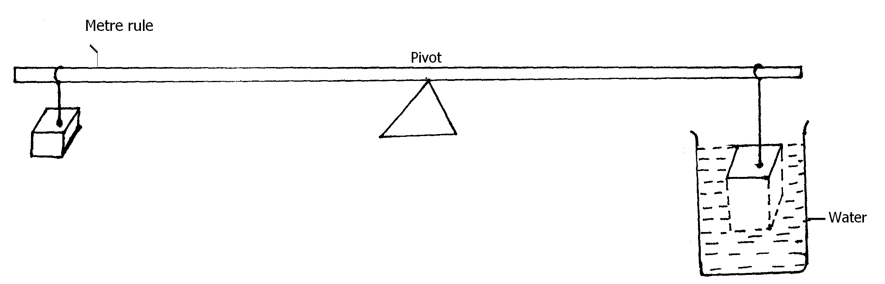

When the temperature of the water is raised the system is observed to tilt to the right, state the reason for this observation. (2 mark)

………………………………………………………………………………………………………………………………………………………………………………………………………………………………………………………………………………………………………………………………………………………………………………………………………………………………

1. Explain why when air enters hydraulic brake systems the brake fails to work. (1 mark)

……………………………………………………………………………………………………………………………………………………………………………………………………………

1. Figure 4 shows a bar made of iron and wood, and a flame is passed the joint with a piece of paper.

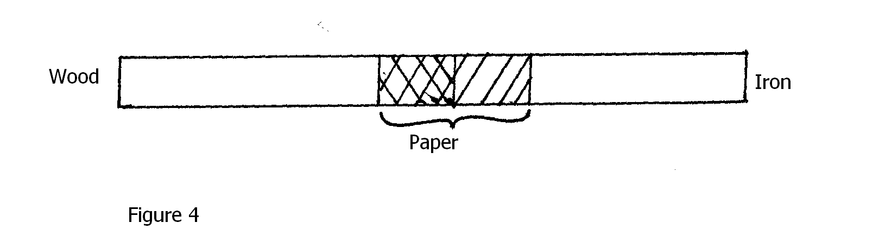

State what was observed at the junction between the two bars after sometimes. (1 mark)

………………………………………………………………………………………………………………………………………………………………………………………………………………

1. Explain why steel is selected for use to reinforce a concrete beam. (1 mark)

………………………………………………………………………………………………………………………………………………………………………………………………………………………………………………………………………………………………………………………

1. Figure 5 below shows a uniform bar length 1.0m pivoted near one end. The bar is kept in equilibrium by a spring balance as shown.

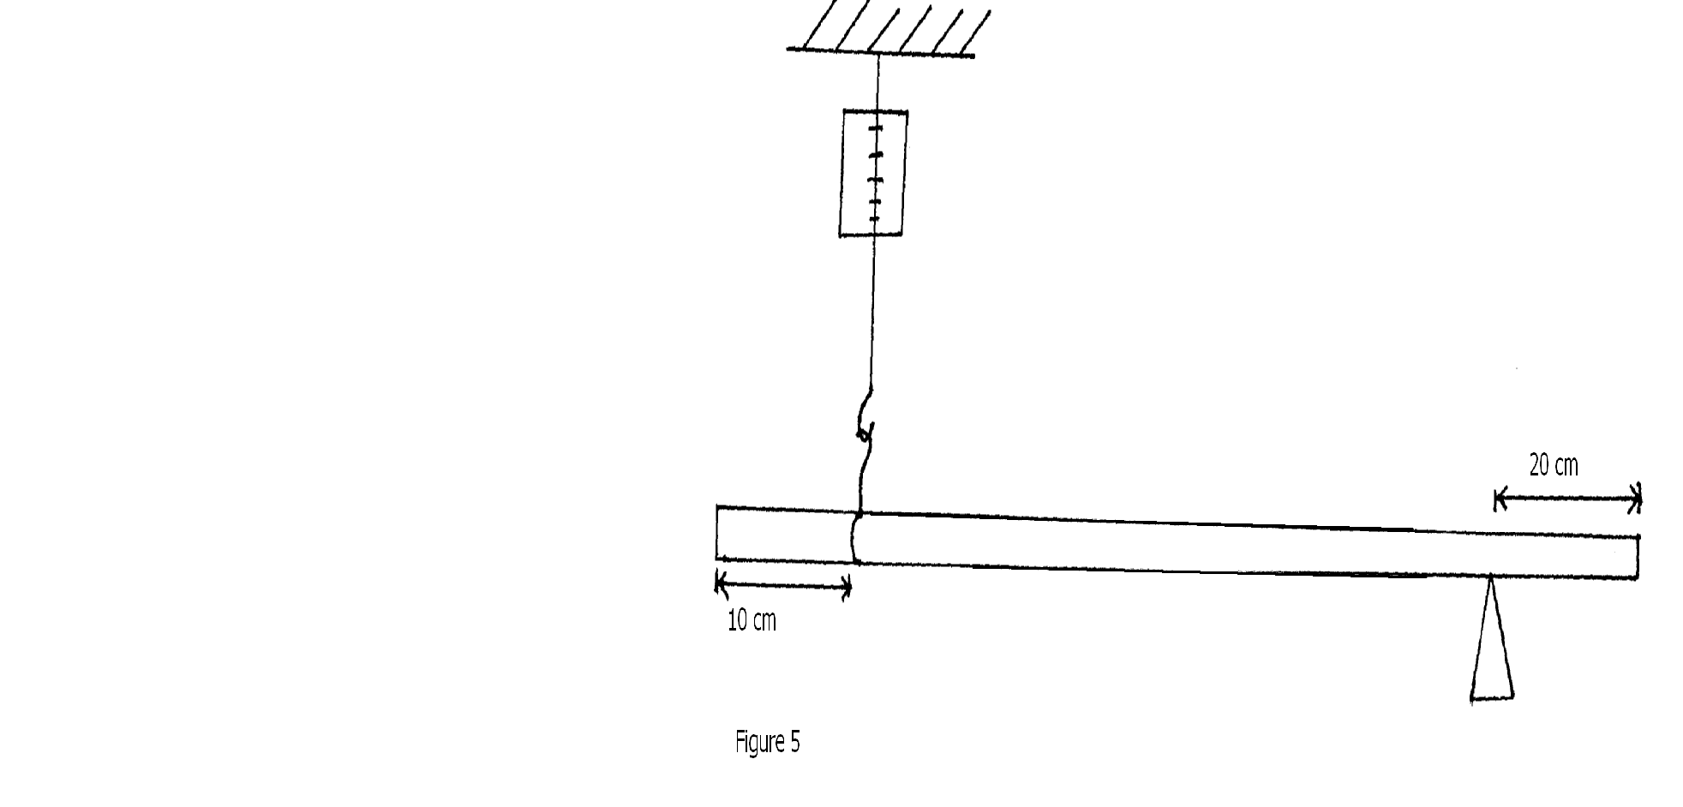

Given that the reading of the spring is 0.6 N, determine the reaction force at the pivot. (3 marks)

1. Water flows in a horizontal pipe of varying diameter as shown below. If the cross sectional area of A is 4.5 cm2 and that of B is 5.4 cm2. The rate at which water flows at A is 66m/s calculate the speed of water through B. (3 marks)

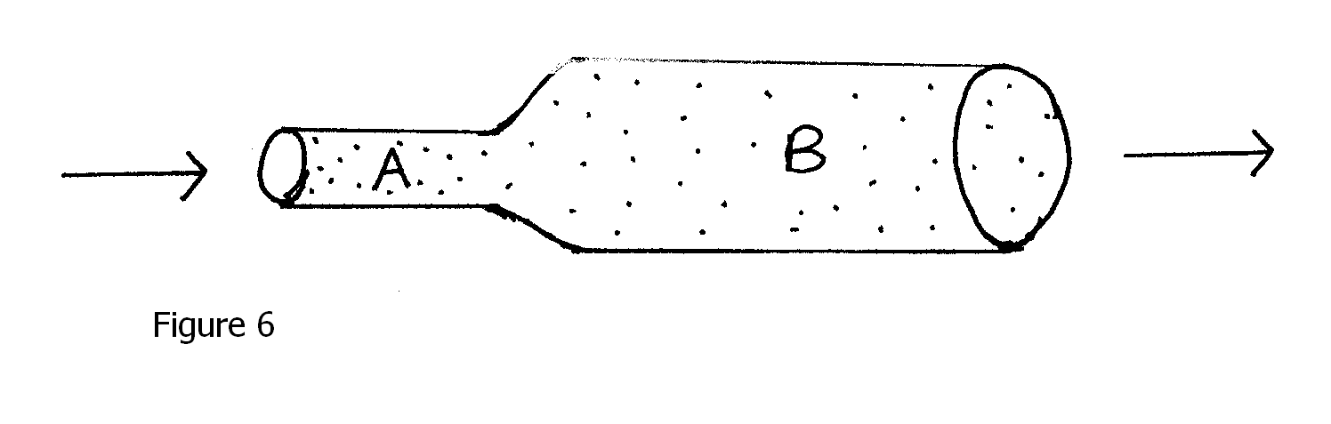

1. Three identical springs each of spring constant 10 N/m and weigh 0.5 N are used to support a load as shown in figure 7 below.

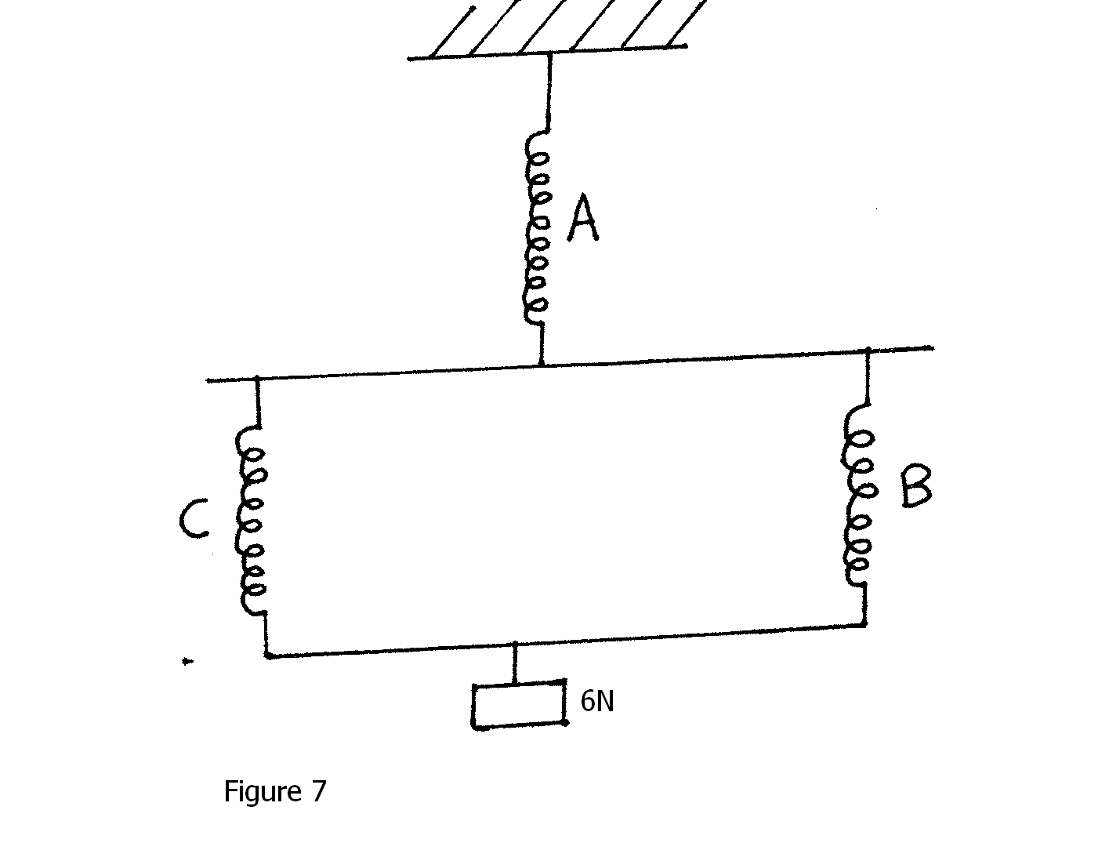

Determine the total extension of the system. (3 marks)

1. Figure 8 below shows a part of a tape pulled through a ticker by a trolley. If the frequency of the timer is 50Hz, calculate the acceleration of the trolley. (3 marks)

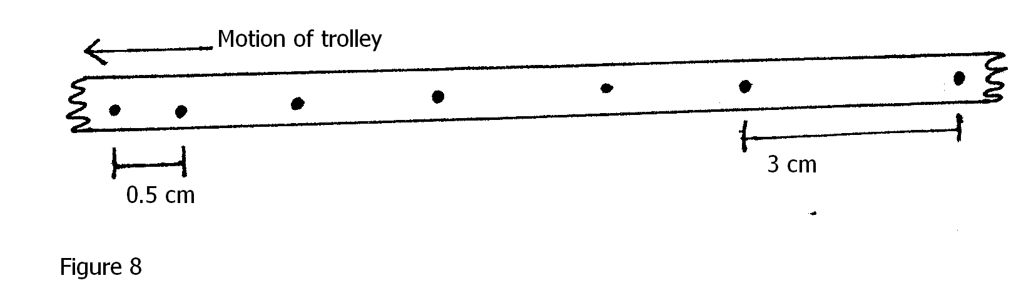

1. When graphite particles are suspended in water and observed through a microscope, they are seen to move in a random motion. Explain. (1 mark)

………………………………………………………………………………………………………………………………………………………………………………………………………………

1. Explain why the speed of a body in circular motion is constant but velocity is not. (1 mark)

………………………………………………………………………………………………………………………………………………………………………………………………………………

1. A glass block is suspended from spring balance and held inside a beaker without touching the beaker. Water is added gradually into the beaker. Figure 9 below shows the variation of up thrust on the block with depth o water in the beaker.

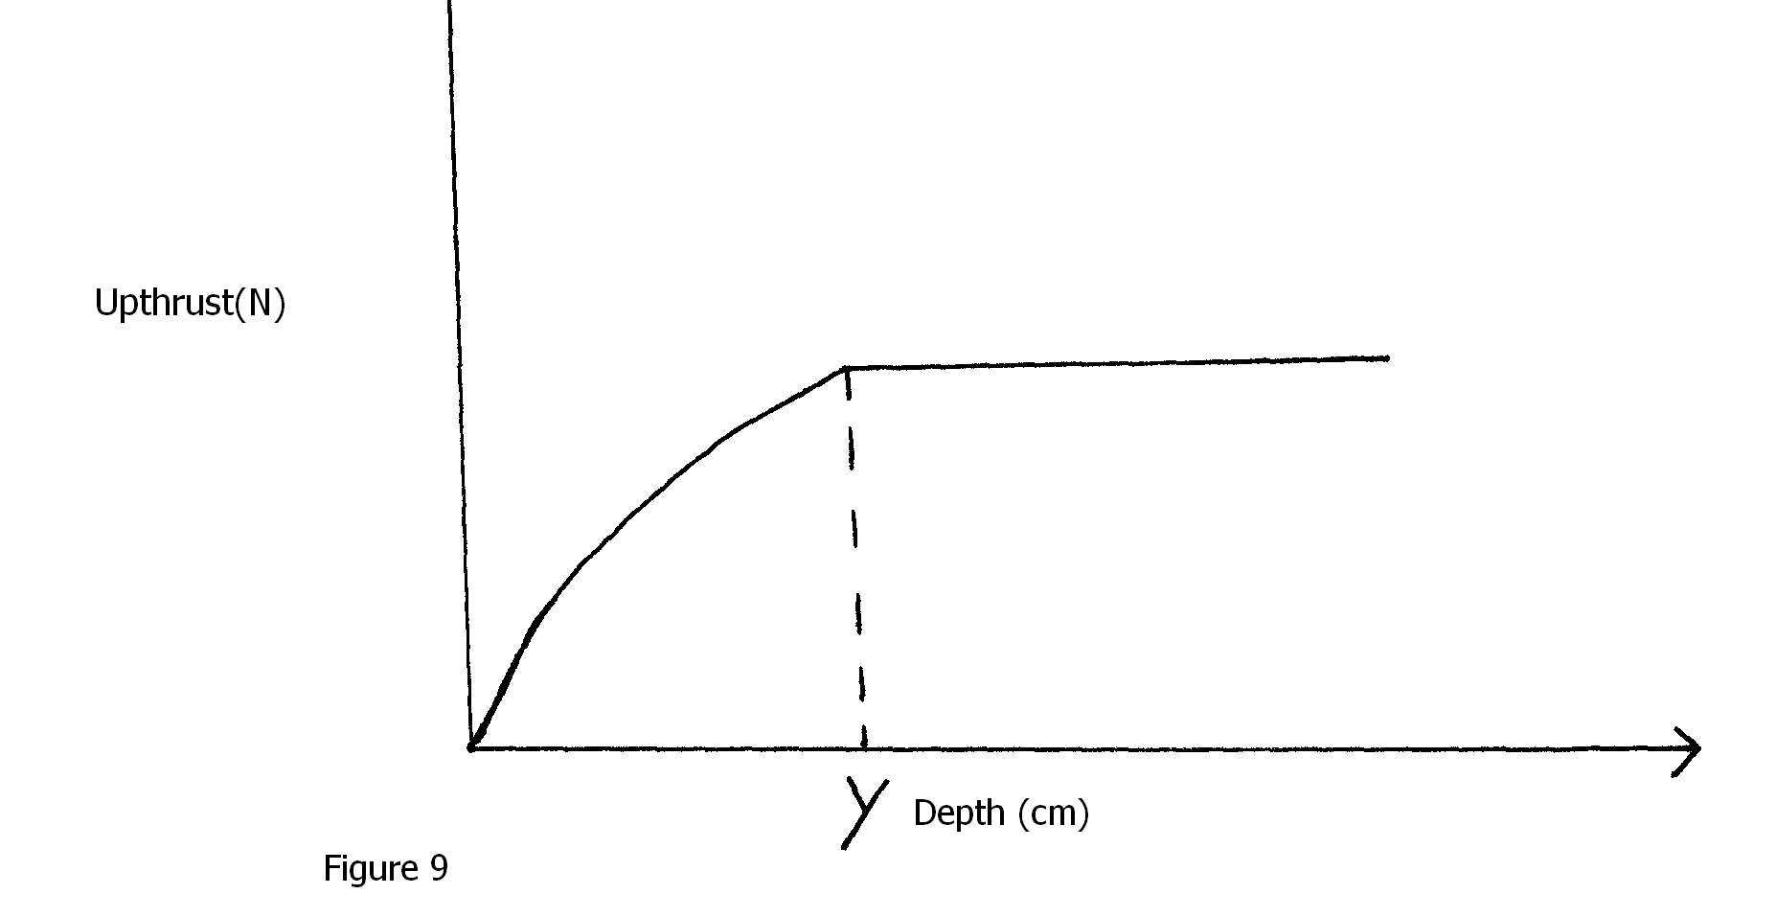

State one reason for the observation at y. (1 mark)

………………………………………………………………………………………………………………………………………………………………………………………………………………

1. A body of mass M is allowed to slide down inclined plane. State one factor that affects its final velocity at the bottom of the inclined plane. (1 mark)

………………………………………………………………………………………………………………………………………………………………………………………………………………………………………………………………………………………………………………………

**SECTION B(55 MARKS)**

1. a) What is an ideal gas? (1 mark)

………………………………………………………………………………………………………………………………………………………………………………………………………………

b) State the pressure law for an ideal gas. (1 mark)

………………………………………………………………………………………………………………………………………………………………………………………………………………

c) Figure 10 below shows a simple set-up to verify the pressure law.

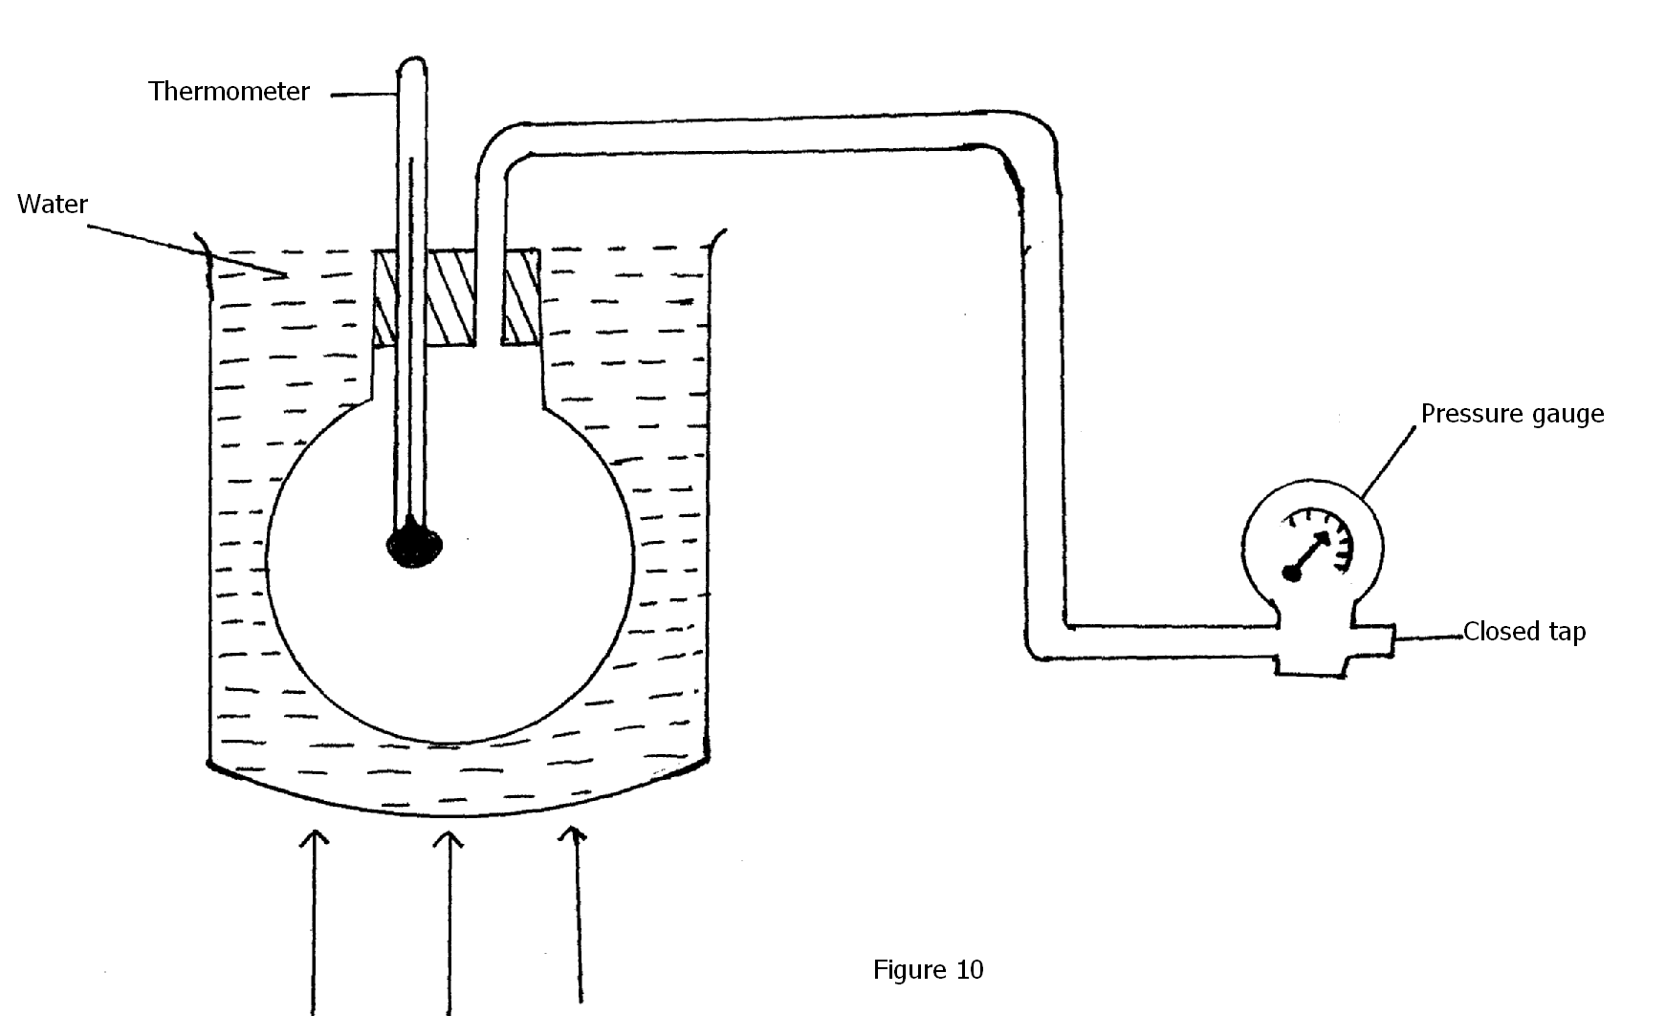

1. State all the measurement to be taken in the above experiment. (2 marks)

………………………………………………………………………………………………………………………………………………………………………………………………………………………………………………………………………………………………

1. Explain how results from the experiment can be used to determine the pressure law

(3 marks)

………………………………………………………………………………………………………………………………………………………………………………………………………………………………………………………………………………………………

1. Explain briefly how the Kinetic Theory accounts for the results obtained in the above experiment. (2 marks)

………………………………………………………………………………………………………………………………………………………………………………………………………………………………………………………………………………………………

d) A mass of a gas has a vole of 200 cm3 at room temperature of -740c and a pressure of 1 atmosphere. What is its volume at a pressure of 3 atmosphere and a temperature of 270c?

(3 marks)

1. a) Define velocity ratio. (1 mark)

………………………………………………………………………………………………………………………………………………………………………………………………………………

b) i) In an experiment carried out to determine the efficiency of a pulley system it was

found that when an effort of 80N was used to lift 300N the efficiency was 75%. Determine the effort applied to lift 80N when the efficiency of the same pulley system was 64% (3 marks)

ii) Give a reason why efficiency varies with load. (1 mark)

………………………………………………………………………………………………………………………………………………………………………………………………………………………………………………………………………………………………………………………………………………………………………………………………

c) Figure 11 shows hydraulic press system using a lever negligible mass. On the ride of the small piston pivoted at point P. A force of 50N is applied at R.

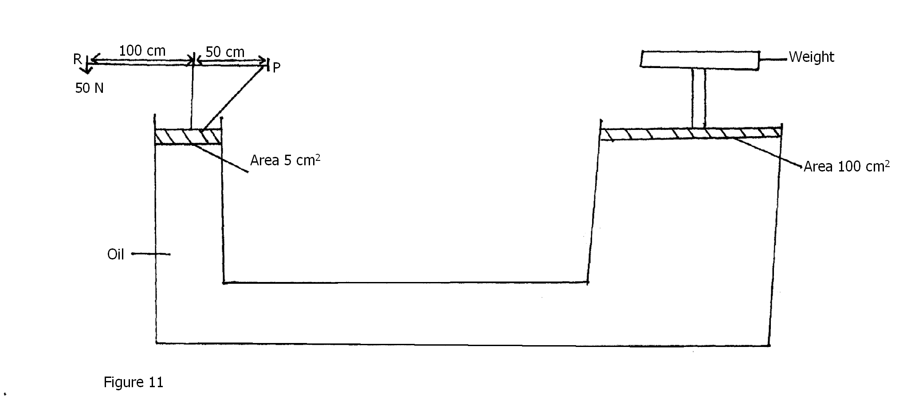

Calculate:

1. Force exerted by small piston on the liquid. (2 marks)
2. Pressure of liquid below the small piston. (2 marks)
3. The weight of object supported on the larger piston. (2 marks)
4. a) You are provided with the following apparatus

* A solid mass m
* Water of density Þw
* Liquid of density ÞL
* Spring balance

Describe how you would determine the relative density of the liquid. (3 mark)

………………………………………………………………………………………………………………………………………………………………………………………………………………………………………………………………………………………………………………………………………………………………………………………………

b) Figure 12 below shows a buoy B of volume 40 litres and mass 10Kg. It is held in position in sea water of density 1.04 gcm-3 by a light cable fixed to the bottom so that ¾ f the volume is below the surface of the sea water

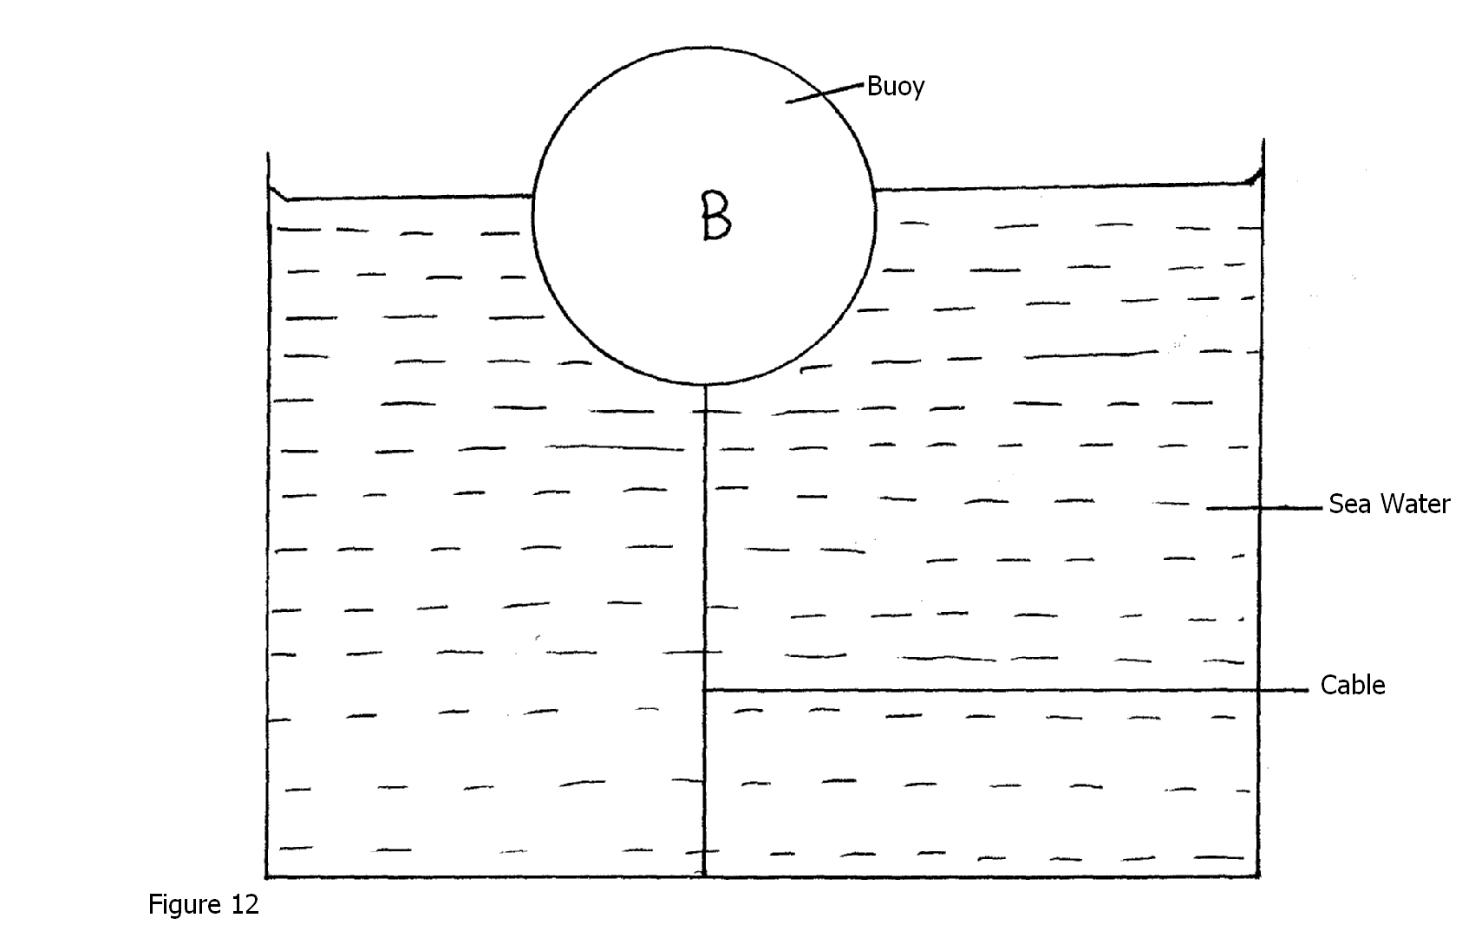

i) Show all the forces acting on the buoy at equilibrium. (3 marks)

………………………………………………………………………………………………………………………………………………………………………………………………………………………………………………………………………………………………

ii) Determine the tension in the cable. (2 marks)

c) Figure 13 shows a bulb hydrometer.

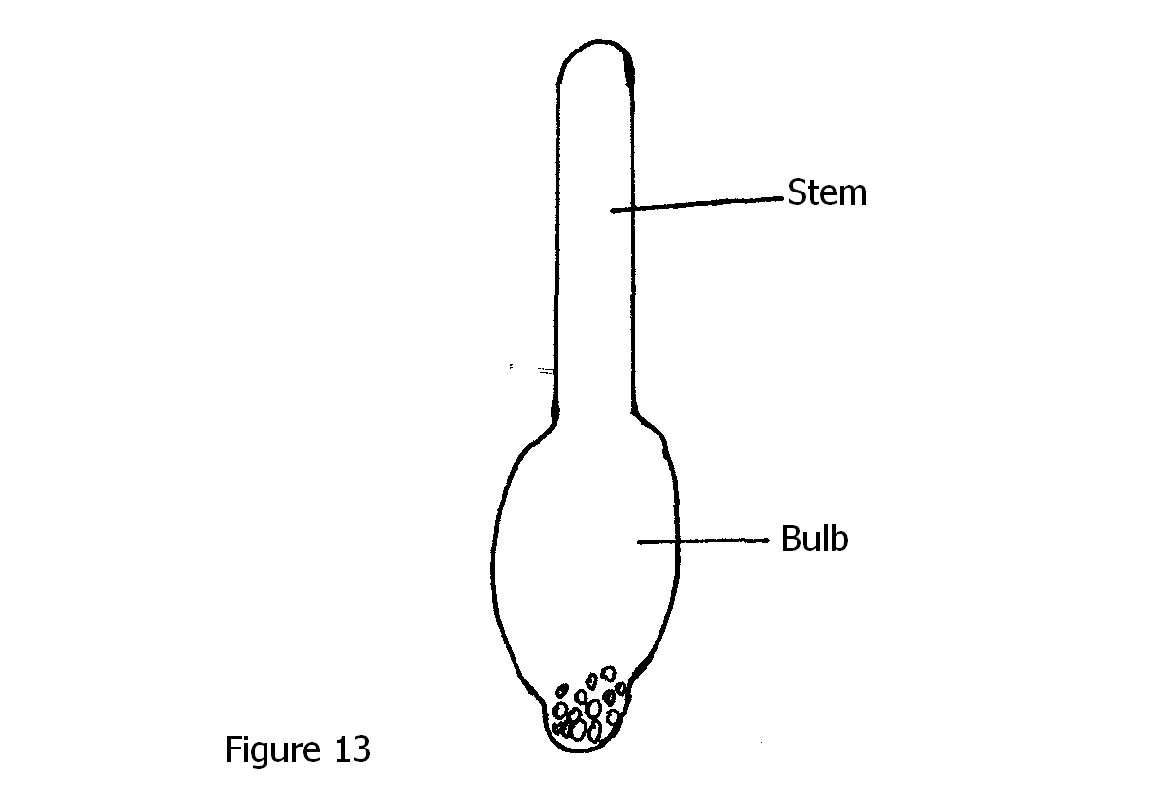

1. State the principle in the hydrometer. (1 mark)

……………………………………………………………………………………………………………………………………………………………………………

1. Explain why the hydrometer has a weighted bulb and narrow stem? (1 mark)

………………………………………………………………………………………………………………………………………………………………………………

1. a) Differentiate between speed and velocity. (1 mark)

………………………………………………………………………………………………………………………………………………………………………………………………………………

b) A body of mass 200g is tied to a string and whirled in a vertical circle of radius 1m with a speed of 4 m/s. Calculate:

i) The angular velocity. (2 marks)

ii) The tension in the string at the highest and lowest position. ( 2 marks)

c) A block of wood of mass 4Kg is suspended from a tree by a long light string. A bullet of mass 100g is fired with a velocity of 100m/s and embeds itself in the target.

i) At what velocity does the target begin to move after impact. (2 marks)

ii) How high does the target move? (2 marks)

1. State the energy changes on the impact up to the highest point. (1 mark)

………………………………………………………………………………………….……………………………………………………………………………………

1. a) Define specific latent heat of vapourization. (1 mark)

………………………………………………………………………………………………………………………………………………………………………………………………………………

b) In an experiment to determine the specific latent heat of vapourization of a liquid using an electrical method, the amount of heat required to vapourize a given mass, M, of a liquid were recorded as shown in the table.

|  |  |  |  |  |  |  |  |
| --- | --- | --- | --- | --- | --- | --- | --- |
| Q(J)x103 | 3.0 | 4.0 | 5.0 | 6.0 | 6.0 | 7.0 | 8.0 |
| M(Kg)x10-3 | 4.0 | 6.4 | 8.8 | 11.2 | 11.2 | 13.6 | 16.0 |

1. On the graph provided plot a graph of Q(y-axis) against M. (5 marks)



1. From the graph, determine the specific heat of vapourization of the liquid.(2 marks)
2. Suggest a reason why the graph does not pass through the origin. (1 mark)

………………………………………………………………………………………………………………………………………………………………………………………………

1. Write a possible equation for this graph. (1 mark)

………………………………………………………………………………………………

c) Calculate the amount of heat required to melt 30g of ice at 00c.(Latent heat of fusion of ice is 3.34x105JKg-1). Give your answer correct to two decimal places. (2 marks)

***END***