NAME:……………………………………………… INDEX NO:………………………/………..
SCHOOL:…………………………………………… CANDIDATE’S SIGN……………………..
DATE:……………………………………………….

232/1
PHYSICS
PAPER 1
JULY / AUGUST- 2012
TIME: 2 HOURS

MANGA DISTRICT JOINT EVALUATION EXAM– 2012
Kenya Certificate of Secondary Education (K.C.S.E)

232/1
PHYSICS
PAPER 1
JULY / AUGUST- 2012
TIME: 2 HOURS

INSTRUCTIONS TO THE CANDIDATES:
1. Write your Name and Index No in spaces provided above
2. Sign and write the date of examination in the spaces provided above
3. This paper consists of two sections A and B
4. Answer ALL the questions in section A and B in the space provided.
5. All working MUST be clearly shown where necessary.
6. Mathematical tables and silent electronic calculators may be used.
Take: acceleration due to gravity g=10ms⁻² or 10N/kg
Density of water = 1000kgm⁻³
Latent heat of fusion of ice = 3.34 ×10⁴Jkg⁻¹
Specific heat capacity of water = 4.2×10³Jkg⁻¹k⁻¹

For Examiners’ Use Only

SECTION | QUESTIONS | MAXIMUM SCORE | CANDIDATE’S SCORE
A | 1 - 12 | 25
B | 13 | 11
B | 14 | 13
B | 15 | 09
B | 16 | 12
B | 17 | 10
Total Score |  | 80

This paper consists of 12 Printed pages.
Candidates should check to ascertain that all pages are printed as indicated
and that no questions are missing.
SECTION A (25 Marks)
Answer all the questions in this section in the spaces provided.
1. A ball bearing on mass 1.5 × 10-3 kg is held between the anvil and spindle of a micrometer screw
gauge as shown in the figure 1 below.
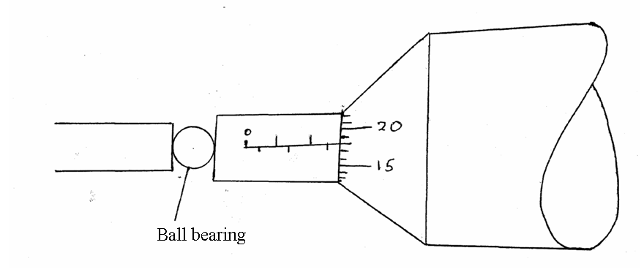
The reading between completely closed jaws without any object between them is 0.10 mm. What is the diameter of the ball bearing? (2 mks)

2. Find the density of the ball bearing in question 1 above correct to 3 significant figures. (3 mks)

3. A fixed mass of a gas a volume of 281.5 cm³ at a temperature of 27⁰C. At what temperature will it have a volume of 350cm³? (Assume pressure is constant) (3 mks)

4. Hot coffee in a cup is allowed to cool for 10 minutes. State TWO factors that will determine the final temperature of the tea. (2 mks)
………………………………………………………………………………………………………………………………………………………………………………………………………………
………………………………………………………………………………………………………………………………………………………………………………………………………………
5. Figure 2 below shows the levels attained by two liquids L₁ and L₂ after the temperature was lowered. The liquids were initially at the same level as shown by the dotted line.
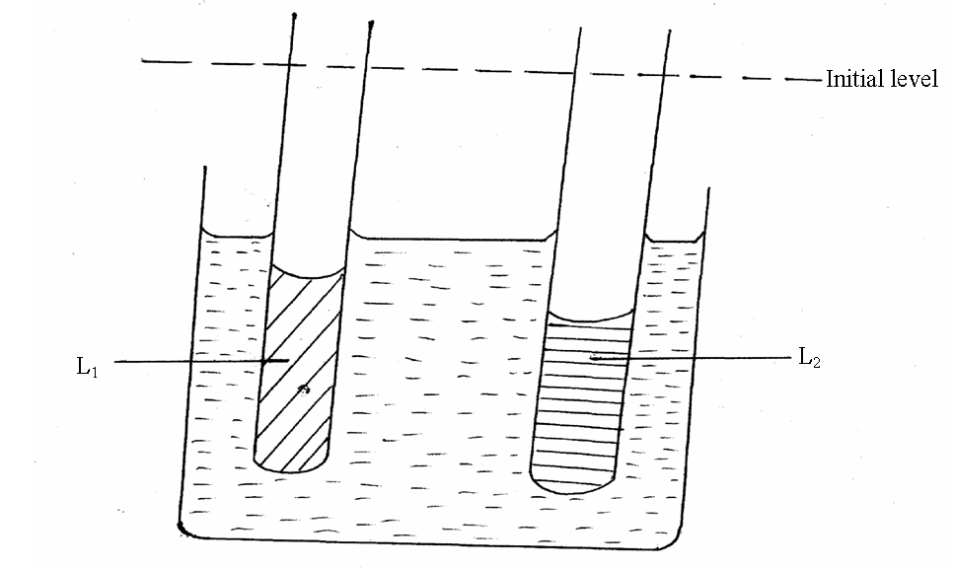
(a) Mark on the diagram the levels of the liquid when the temperature is raised above the initial value. (1 mk)
(b) Give a reason for your answer in (a) above (1 mk)
………………………………………………………………………………………………………………………………………………………………………………………………………………
6. A liquid flows through a pipe of varying cross-sectional area. If the liquid enters one end of the pipe of cross-sectional area 5 × 10⁻³ m² at 0.3⁻¹ and flows into a different end of a different cross-sectional area at this 1ms-1.Determine the cross-sectional area at this end. (2 mks)

7. A box of mass 300kg is pulled along an inclined plane by a force of 2 × 10³ N as shown below.
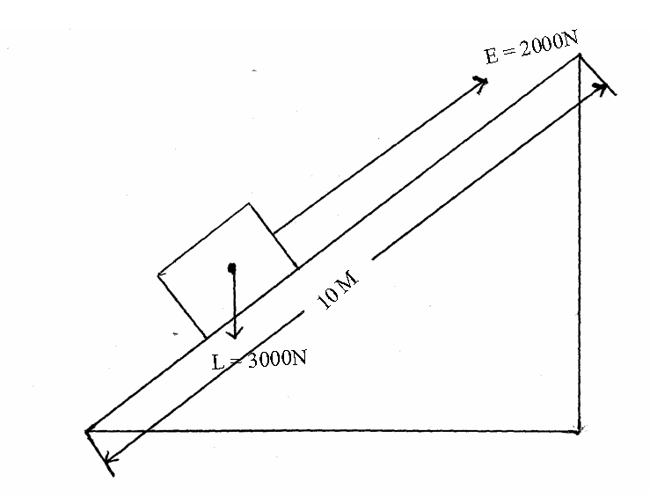
Determine the efficiency of the inclined plane. (3 mks)

8. The figure below shows a bucket filled with water of mass 5 kg tied to a string 3.0m long being
rotated in a vertical circle with a constant velocity of 5ms⁻¹
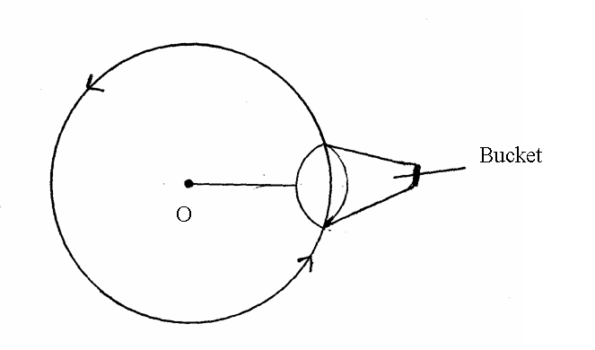
Calculate the maximum tension on the string (2 mks)

9. State two differences between boiling and evaporation. (2 mks)
………………………………………………………………………………………………………………………………………………………………………………………………………………
………………………………………………………………………………………………………………………………………………………………………………………………………………
10. State two ways in which the stability of an object can be decreased. (2 mks)
………………………………………………………………………………………………………………………………………………………………………………………………………………
………………………………………………………………………………………………………………………………………………………………………………………………………………
11. State the similarity between speed and velocity. (1 mk)
………………………………………………………………………………………………………………………………………………………………………………………………………………………………………………………………………………………………………………………………………………………………………………………………………………………………
12. The figure below shows a smooth card placed on the open end of a cup. A coin is placed on the card. When the card is suddenly pulled away horizontally, the coin drops into the cup.
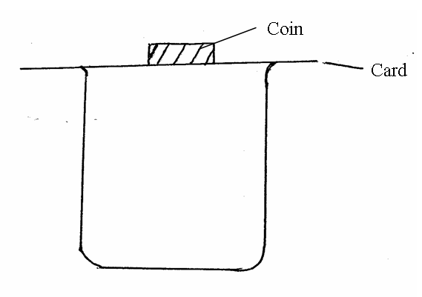
Explain this observation

SECTION B (55 Marks)
Answer all the questions in this section in the spaces provided.
13. (a) Define impulse and state its SI units. (2 mks)
………………………………………………………………………………………………………………………………………………………………………………………………………………
………………………………………………………………………………………………………………………………………………………………………………………………………………
(b) A policeman fires a bullet of mass 20g from a gun of mass 2kg, if the bullet emerges at a velocity of 300 ms⁻¹ from the muzzle, calculate the force the gun exerts on the policeman.
(4 mks)

(c) The diagram below shows a spherical object falling through a fluid.
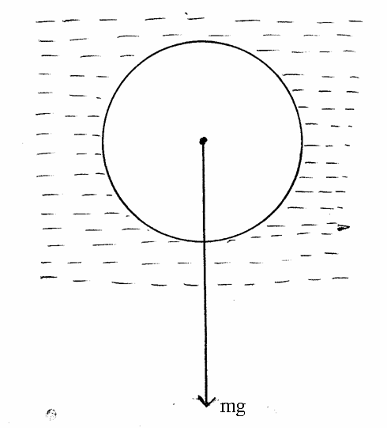
On the same diagram, show two other forces which act on the object. (2 mks)

(d) A graph of velocity against time for the object plotted for various fluids is shown below.
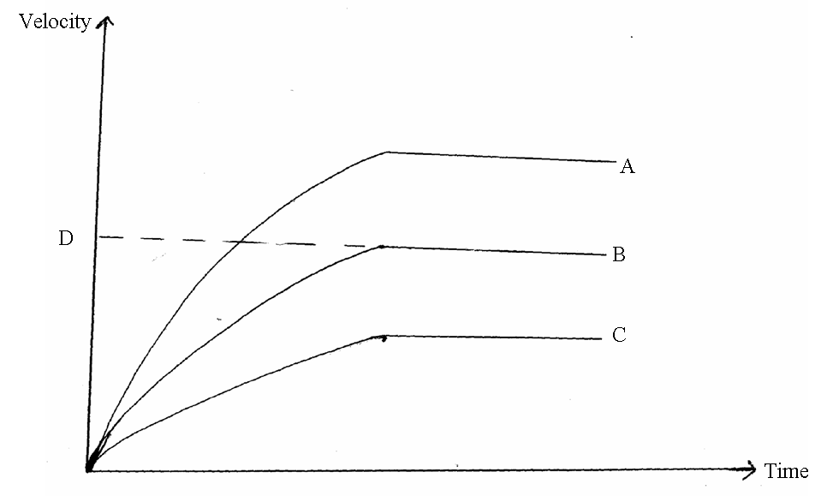
(i) Name the part labeled D (1 mk)
………………………………………………………………………………………………………………………………………………………………………………………………………………
(ii) Arrange the fluids A, B and C in order of decreasing density. (1 mk)
………………………………………………………………………………………………………………………………………………………………………………………………………………
(iii) State one factor that affects the resultant force of the body above as it falls through the fluid. (1 mk)
………………………………………………………………………………………………………………………………………………………………………………………………………………
14. (a) The diagram below represents a motor car hydraulic braking system.
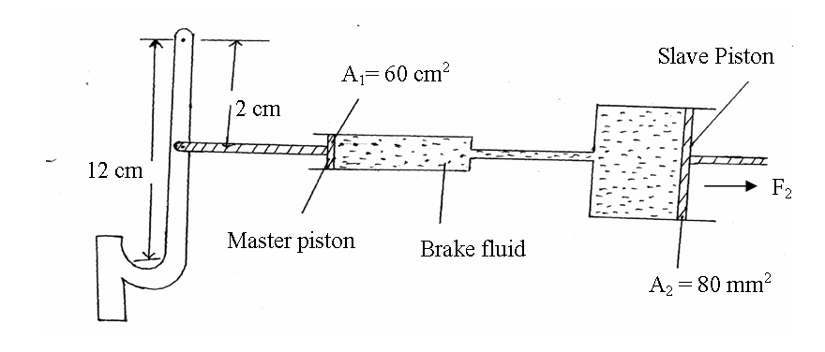
(i) State the property of the liquid used as brake fluid. (1 mk)
………………………………………………………………………………………………………………………………………………………………………………………………………………

(ii) Explain briefly how the system works. (2 mks)
………………………………………………………………………………………………………………………………………………………………………………………………………………
………………………………………………………………………………………………………………………………………………………………………………………………………………
(iii) An effort of 200N is applied on the brake pedal.
Calculate:
(I) The force F₁ applied to the master piston. (2 mks)

(II) The pressure on the fluid. (2 mks)

(III) The force, F₂, exerted on the salve piston. (2 mks)

(b) The figure below shows a rubber sucker.
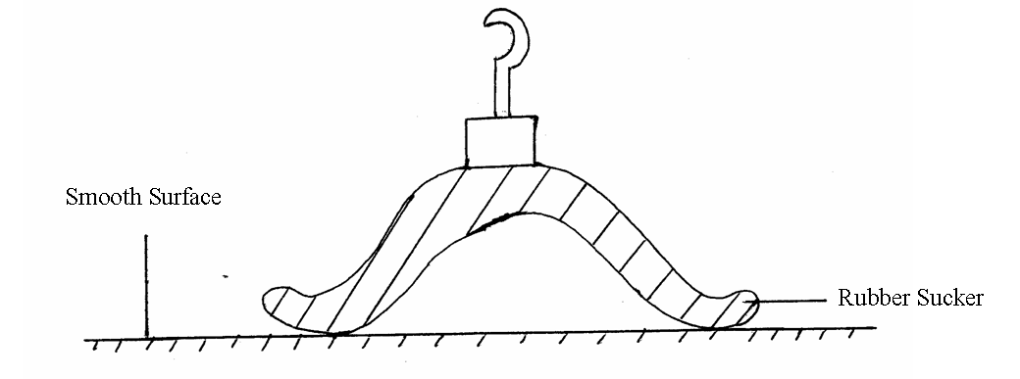
Explain why the sucker sticks on the smooth clean surface. (2 mks)
………………………………………………………………………………………………………………………………………………………………………………………………………………
………………………………………………………………………………………………………………………………………………………………………………………………………………
(c) The figure below shows a water manometer used to measure the pressure of a cooking gas.
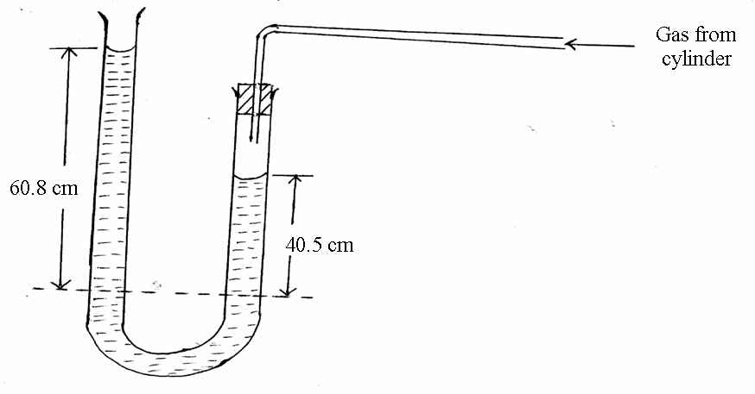
By how much is pressure of the gas above the atmospheric pressure? (2 mks)

15. (a) What is diffusion? (1 mk)
………………………………………………………………………………………………………………………………………………………………………………………………………………
(b) A smoke cell contains a mixture of trapped air and smoke. The cell is brightly lit and viewed through a microscope. State and explain what is observed. (2 mks)
………………………………………………………………………………………………………………………………………………………………………………………………………………
………………………………………………………………………………………………………………………………………………………………………………………………………………
(c) A beaker is filled completely with water. A spoon full of common salt is added slowly. The salt dissolves and the water does not overflow.
(i) Why is salt added slowly. (1 mk)
………………………………………………………………………………………………………………………………………………………………………………………………………………………………………………………………………………………………………………………
(ii) Why doesn’t the water overflow? (1 mk)
………………………………………………………………………………………………………………………………………………………………………………………………………………
(d) In the figure below, ammonia gas and an acid gas diffuse and react to form a white deposit on the walls of a long glass tube as shown.
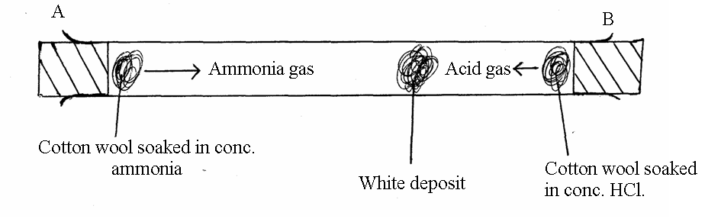
(i) What conclusion can be made from the result of this experiment? (1 mk)
………………………………………………………………………………………………………………………………………………………………………………………………………………
(ii) How does the size and mass of a gas affect its rate of diffusion? (1 mk)
………………………………………………………………………………………………………………………………………………………………………………………………………………
(iii) The experiment is performed at a lower temperature. Explain how the time taken to form the white deposit would be affected. (2 mks)
………………………………………………………………………………………………………………………………………………………………………………………………………………
………………………………………………………………………………………………………………………………………………………………………………………………………………
16. (a) State archimedes’ principle. (1 mk)
………………………………………………………………………………………………………………………………………………………………………………………………………………
(b) The figure below shows a cork floating on water and held to the bottom of the container by a thin thread.
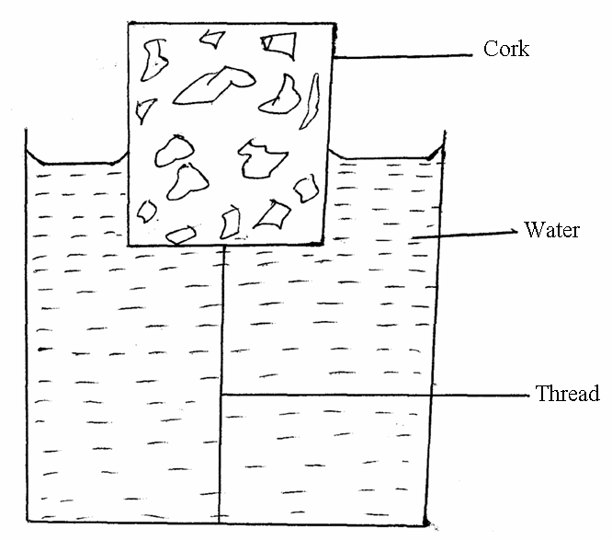
(i) Other than the upthrust force, which other 2 forces is acting on the cork. (2 mks)
………………………………………………………………………………………………………………………………………………………………………………………………………………
………………………………………………………………………………………………………………………………………………………………………………………………………………
(ii) Describe how the forces mentioned in (i) above changes when water is added into the container until it fills up. (2 mks)
………………………………………………………………………………………………………………………………………………………………………………………………………………
………………………………………………………………………………………………………………………………………………………………………………………………………………
(c) An object floating on water has a weight of 20N. Determine the volume of water it displaces. (3 mks)

(d) Why does a person swimming in fresh water taking a deep breath float without exhaling?
(2 mks)
………………………………………………………………………………………………………………………………………………………………………………………………………………
………………………………………………………………………………………………………………………………………………………………………………………………………………
(e) Explain why a hydrometer has a weighted base. (2 mks)
………………………………………………………………………………………………………………………………………………………………………………………………………………
………………………………………………………………………………………………………………………………………………………………………………………………………………
17. (a) Define specific latent heat of fusion of a substance and state its SI unit. (2 mks)
………………………………………………………………………………………………………………………………………………………………………………………………………………
………………………………………………………………………………………………………………………………………………………………………………………………………………
(b) Water of mass 2 ×10⁻³ kg at a temperature of 80⁰C is put in a well lagged copper calorimeter of mass 2 ×10⁻² kg. A piece of ice at 0⁰C and mass 2 × 10⁻³ kg is placed in the calorimeter and the mixture stirred gently until all the ice melts. The final temperature of the mixture is then measured to be 54⁰C.
Determine:
(i) The heat absorbed by the melting ice at 0⁰C. (2 mks)

(ii) The heat absorbed by the melted ice (water) to raise the temperature to 54⁰C. (2 mks)

(iii) State any two reasons why the heats given in (i) and (ii) above are inaccurate. (2 mks)
………………………………………………………………………………………………………………………………………………………………………………………………………………
………………………………………………………………………………………………………………………………………………………………………………………………………………
(c) Calculate the heat lost by the warm water and the calorimeter (specific heat capacity of the calorimeter = 400Jkg⁻¹k⁻¹). (2 mks)

END

