Name…………………………………………………………………………… Index No……………..
School………………………………………………………………………….. Date………………….
Candidate’s signature…………………………………..

232/1
PHYSICS
PAPER 1
JULY / AUGUST 2012
TIME: 2 HOURS

MBITA-SUBA DISTRICTS JOINT EXAMINATION - 2012
Kenya Certificate of Secondary Education – K.C.S.E

INSTRUCTIONS TO THE CANDIDATES:
1. Write your name and index number in the spaces provided above.
2. Sign and write the date of examination in the spaces provided.
3. This paper consists of two sections: A and B.
4. Answer ALL the questions in section and B in the spaces.
5. Non- programmable electronic calculators and KNEC tables may be used.
6. Where applicable take : g = ION/Kg; Density of water 1000kg/cm³

For Examiners’ Use Only

SECTION | QUESTION | MAXIMUM SCORE | CANDIDATE’S SCORE
A | 1 - 13 | 25
B | 14 | 10
 | 15 | 12
 | 16 | 12
 | 17 | 10
 | 18 | 11
TOTAL |  | 80

This paper consists of 12 Printed pages.
Candidates should check to ascertain that all pages are printed as indicated and that no questions are missing.

SECTION A( 25 MARKS)

1. In the spaces below, draw the scale of a vernier calipers showing a reading of 0.74 cm ( 2mks)
............................................................................................................................................................. .............................................................................................................................................................
.............................................................................................................................................................
2. The figure below shows three wooden blocks resting on a flat surface. (They are made of the same material).
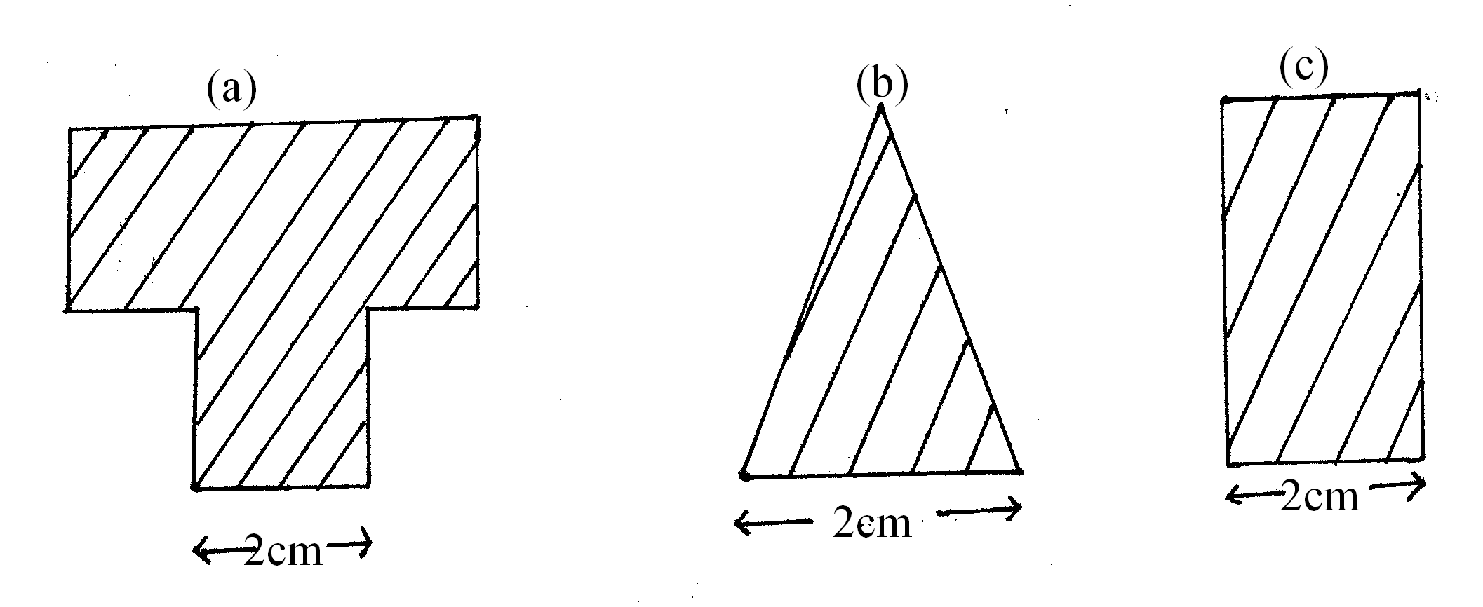

i) Arrange them starting with the most stable (1mk)
............................................................................................................................................................. .............................................................................................................................................................
.............................................................................................................................................................
ii) State the factor that have considered in 2(i) when arranging them . (1mk)
............................................................................................................................................................. .............................................................................................................................................................
.............................................................................................................................................................
3. The diagram shows a velocity time graph for a vehicle moving at 2mls and begins to accelerate at a time t = O seconds

Graph

What is the vehicle’s acceleration at time, t = 5 seconds. (2mks)
............................................................................................................................................................. .............................................................................................................................................................
............................................................................................................................................................. .............................................................................................................................................................
4. State any two conditions that must be satisfied for a body to float in a fluid. (2mks)
............................................................................................................................................................. .............................................................................................................................................................
.............................................................................................................................................................
5. Two cans A and B with holes at their bottoms are pressed down on water as shown.

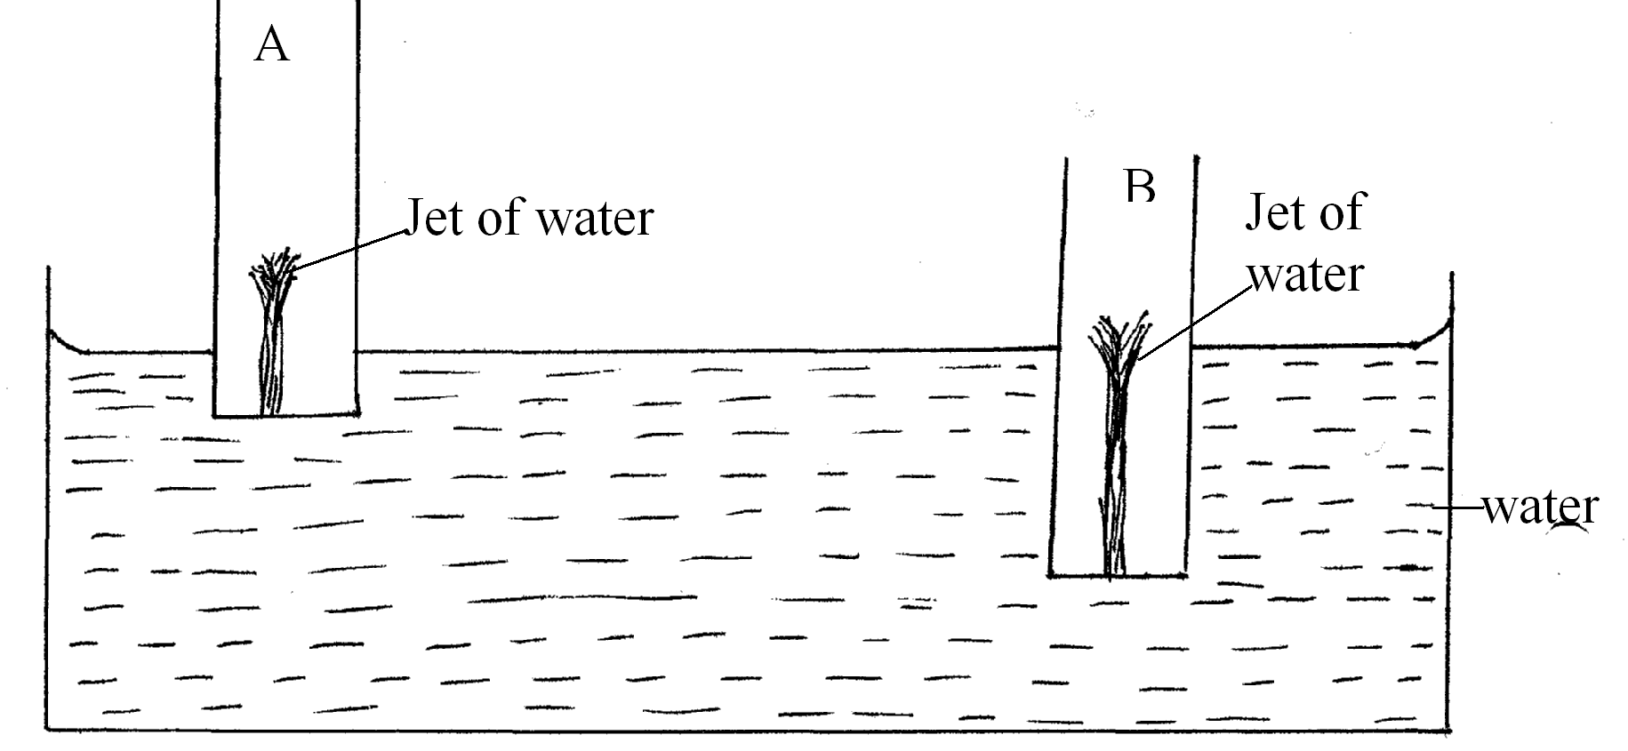
Explain why the jet of water in the tin B is larger than in A (2mks)
............................................................................................................................................................. .............................................................................................................................................................
.............................................................................................................................................................
6. The diagram below shows a horizontal copper wire tightly fixed. A mass M is suspended from the wire using a slider at a point closer to A than B.

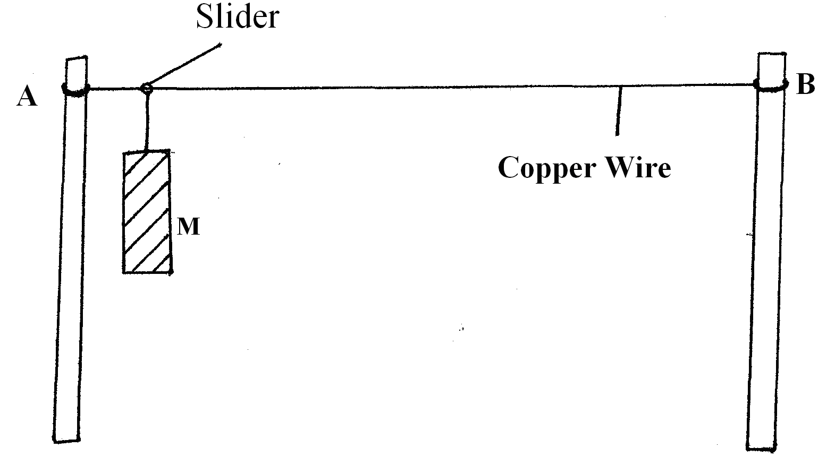

The copper wire is then heated for sometime, State and explain what is likely to be observed on the position of the mass. (2mks)
............................................................................................................................................................. .............................................................................................................................................................
.............................................................................................................................................................
7. Two identical springs, whose spring constant is 6.0N/ cm, are used to support a load of 60N as shown below.
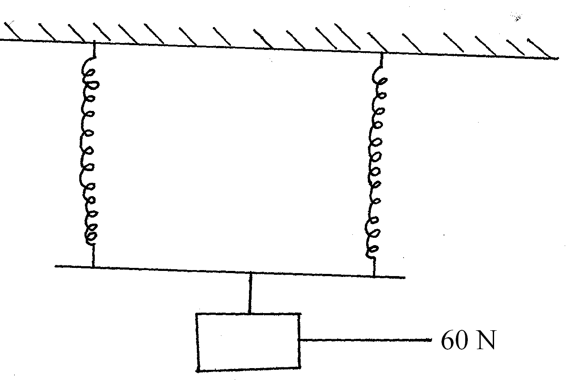

8. The figure below shows a cube of a certain wood whose density is the same as that of water. The cube is held on the surface of water. The cube is held on the surface of water in along beaker.
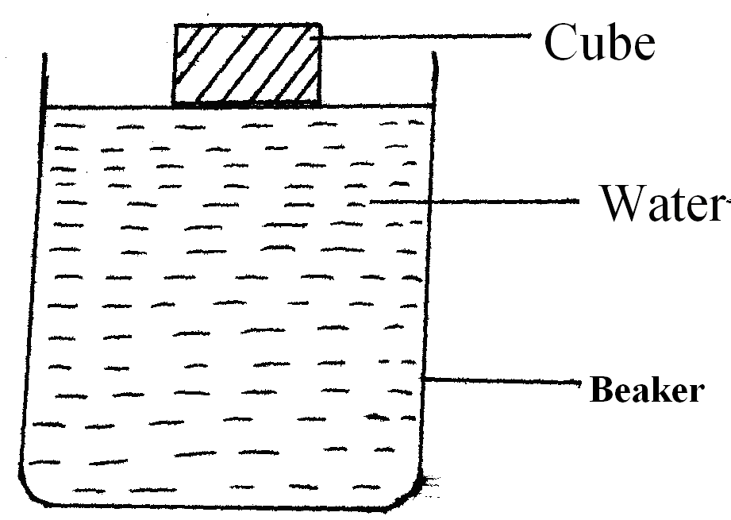
State and explain what happens to the cube after it is released. (2mks)
............................................................................................................................................................. .............................................................................................................................................................
............................................................................................................................................................ .............................................................................................................................................................
a) State one factor that determines the value of critical speed of a given body undergoing uniform circular motion (1mk)
............................................................................................................................................................. .............................................................................................................................................................
.............................................................................................................................................................
10. The figure shows a gas being bubbled through hot water.
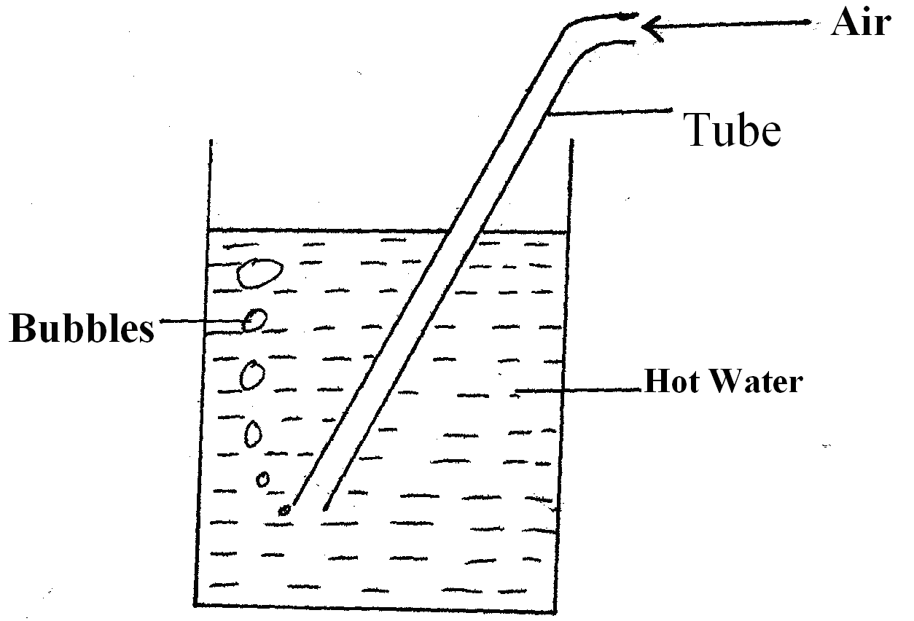
Explain why the bubbles increased in size as it rises to the water surface. (2mks)
............................................................................................................................................................. .............................................................................................................................................................
............................................................................................................................................................. .............................................................................................................................................................
11. A stone weight 2N in air and 1.2 N when totally immersed in water. Calculate the volume of the stone. ( 2mks)
............................................................................................................................................................. .............................................................................................................................................................
............................................................................................................................................................. .............................................................................................................................................................
12. Explain why in trying to move a rigid wall, a person is said to be doing no work. ( 1mk)
............................................................................................................................................................. .............................................................................................................................................................
.............................................................................................................................................................
13. The reading of mercury barometer is 70.0 cm. What is the pressure at the place in N/m² ( Density of mercury is 1.36 x 10⁴ Kg / m³) (2mks)
............................................................................................................................................................. .............................................................................................................................................................
.............................................................................................................................................................
.............................................................................................................................................................
SECTION B (55MKS)
Answer All questions in this section
14. a) Define centripetal acceleration . (1mk)
............................................................................................................................................................. .............................................................................................................................................................
.............................................................................................................................................................
b) An object of mass 400g revolves uniformly on a horizontal frictionless surface. It is attached by a cord 20 cm long to a fixed point P.
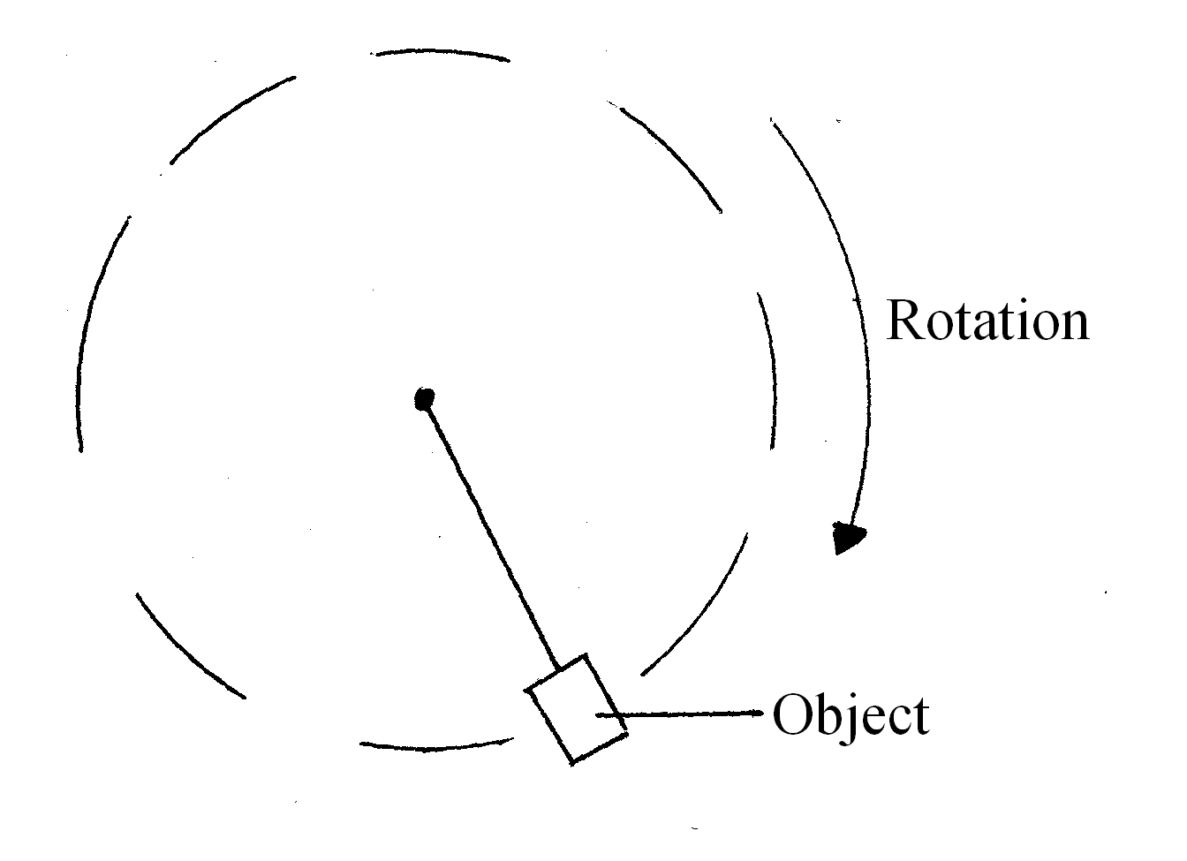
i) Mark and label on the diagram the direction of centripetal force F and linear velocity V. (2mk)
............................................................................................................................................................. .............................................................................................................................................................
.............................................................................................................................................................
ii) The object makes a revolutions per second. Determine the linear velocity of the object. (2mks)
............................................................................................................................................................. .............................................................................................................................................................
.............................................................................................................................................................
c) A stone is tied to a light string of length 0.5 m. If the stone has a mass with a uniform angular velocity of 6 revolutions per second, determine.
i) The period (2mks)
............................................................................................................................................................. .............................................................................................................................................................
.............................................................................................................................................................
ii) The tension of the string when the stone is at the bottom of the swing. (3mks)
............................................................................................................................................................. .............................................................................................................................................................
.............................................................................................................................................................
.............................................................................................................................................................
15. a) State and difference between evaporation and vapourisation. (1mk)
............................................................................................................................................................. .............................................................................................................................................................
.............................................................................................................................................................
b) The graph below shows the boiling process of water, Use it to answer the questions that follow.
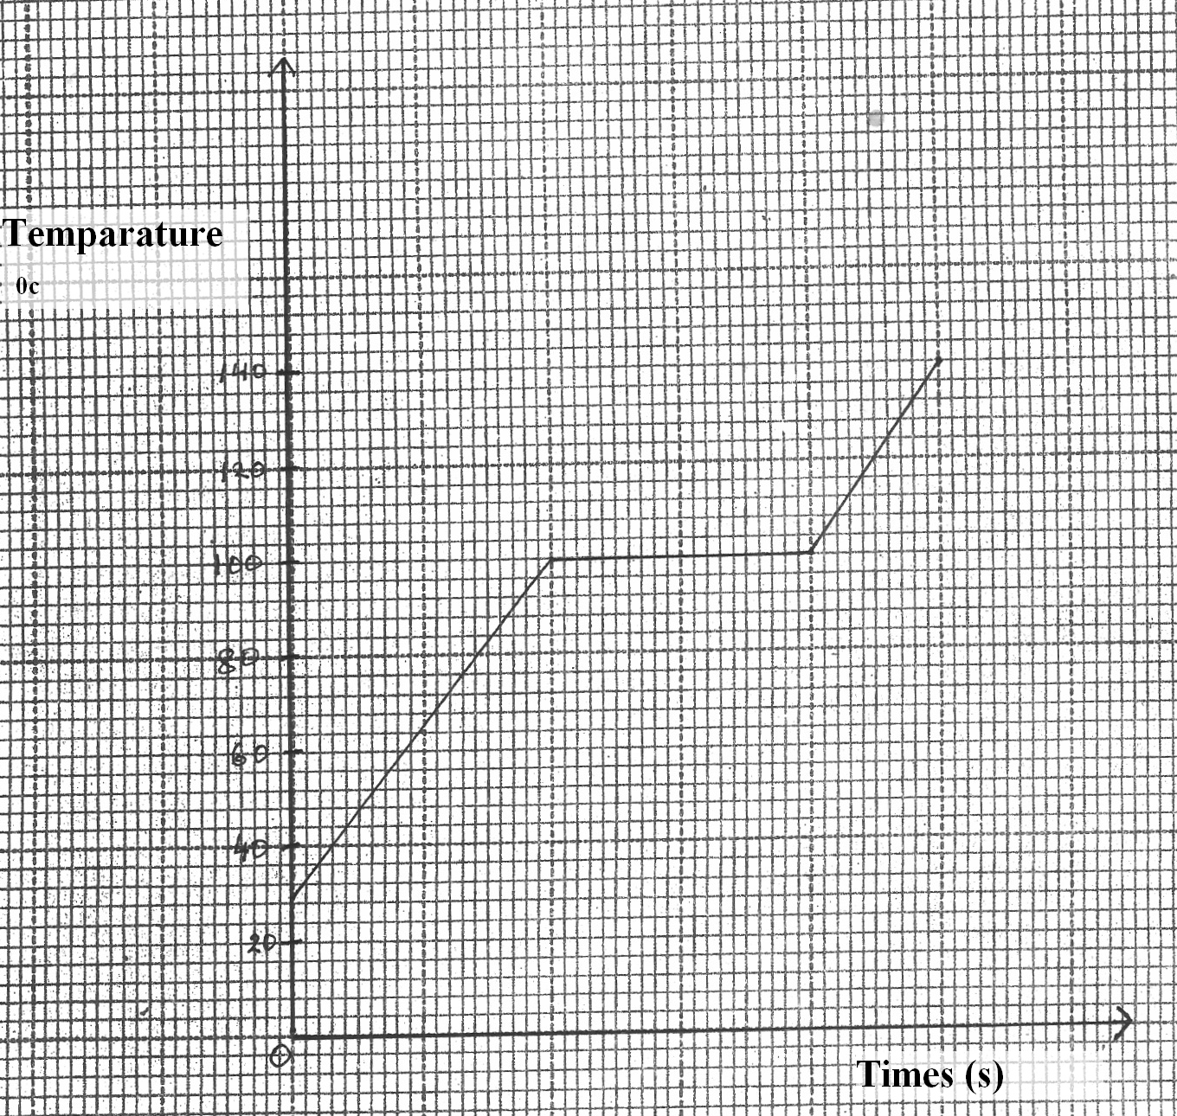
(i) State the room temperature from the graph. (1mk)
............................................................................................................................................................. .............................................................................................................................................................
.............................................................................................................................................................
ii) State what is happening along BC in the graph (1mk)
............................................................................................................................................................. .............................................................................................................................................................
.............................................................................................................................................................
c) 50g of stream at 100⁰C was passed into cold water at 20⁰C. The temperature of the mixture was 50⁰c. Taking specific heat capacity of water as 4200 J Kg⁻¹ K⁻¹ and specific latent heat of vapourisation of water as 2260 KJKg⁻¹ and ignoring heat losses, determine.
i) Quantity of heat lost by the steam. (3mks)
............................................................................................................................................................. .............................................................................................................................................................
............................................................................................................................................................. .............................................................................................................................................................
.............................................................................................................................................................
ii) Quantity of heat transferred from the condensed steam to the cold water. (3mks)
............................................................................................................................................................. .............................................................................................................................................................
............................................................................................................................................................. .............................................................................................................................................................
.............................................................................................................................................................
iii) Mass of the cold water (3mks)
............................................................................................................................................................. .............................................................................................................................................................
.............................................................................................................................................................
.............................................................................................................................................................
16. a) State any one differences between inelastic collision and elastic collision . (1mk)
............................................................................................................................................................. .............................................................................................................................................................
.............................................................................................................................................................
b) Two trolleys of masses 2.0 kg and 1.5 kg travelling towards each other at 0.20mls and 0.35mls respectively collide head on the trolleys combine on collision:-
i) Calculate their combined velocity. (3mks)
. ............................................................................................................................................................ .............................................................................................................................................................
.............................................................................................................................................................
ii) State the direction in which the trolleys will move after the collision.
............................................................................................................................................................. .............................................................................................................................................................
.............................................................................................................................................................
c) The graph below shows how force applied on a 20kg mass varies with time.
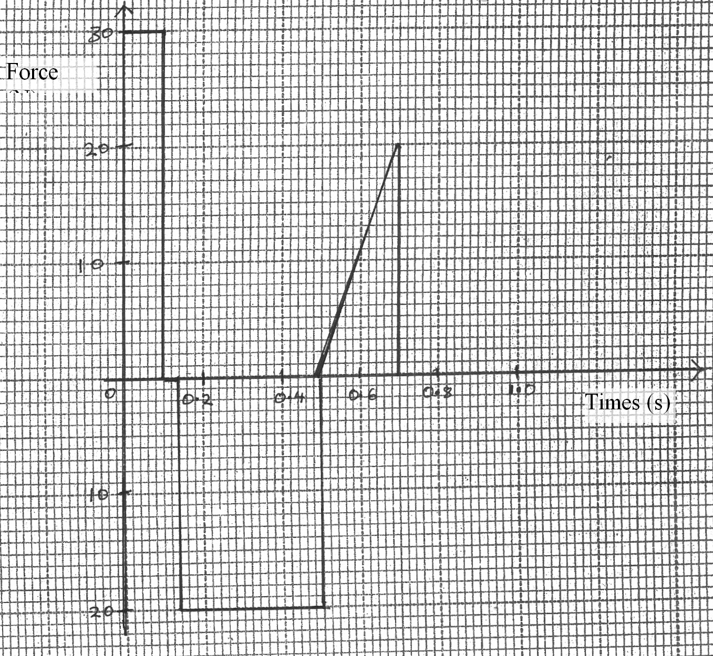
Find the total impulse after 0.7 seconds. ( 3mks)
............................................................................................................................................................. .............................................................................................................................................................
.............................................................................................................................................................
.............................................................................................................................................................
d) State Charle’s law (1mk)
............................................................................................................................................................. .............................................................................................................................................................
.............................................................................................................................................................
e) A gas has a volume of 20 cm³ at 27⁰c and normal atmospheric pressure.
Calculate the new volume of the gas if it is heated to 54⁰ c at the same pressure. (3mks)
............................................................................................................................................................. .............................................................................................................................................................
............................................................................................................................................................. ............................................................................................................................................................. .............................................................................................................................................................
.............................................................................................................................................................
17. a) State the law of floatation (1mk)
............................................................................................................................................................. .............................................................................................................................................................
.............................................................................................................................................................
b) Explain why hydrometer has a wide bulb with air in it. (2mks)
............................................................................................................................................................. .............................................................................................................................................................
............................................................................................................................................................. ............................................................................................................................................................. .............................................................................................................................................................
c) Alog of wood of mass 300kg floats on water, the density of wood is 750 kg/ms. What is the maximum numbers of pupils of average weight 400N that can sit on the log without making it wholly immersed. (3mks)
............................................................................................................................................................. .............................................................................................................................................................
............................................................................................................................................................. ............................................................................................................................................................. .............................................................................................................................................................
.............................................................................................................................................................
d) A uniform meter rule of masses 100g is kept in equilibrium by suspending a glass block in water as shown.
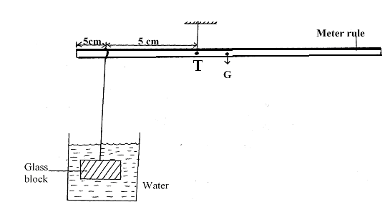
The volume of the glass block is 0.0005m³ point G is the centre of gravity of the meter rule and T is the turning point.
i) What is the distance from G to the turning point T. (1mk)
............................................................................................................................................................. .............................................................................................................................................................
.............................................................................................................................................................
ii) Determine the weight of the glass block (3mks)
............................................................................................................................................................. .............................................................................................................................................................
............................................................................................................................................................. .............................................................................................................................................................
18. a) The figure below shows an inclined plane of length 5m.
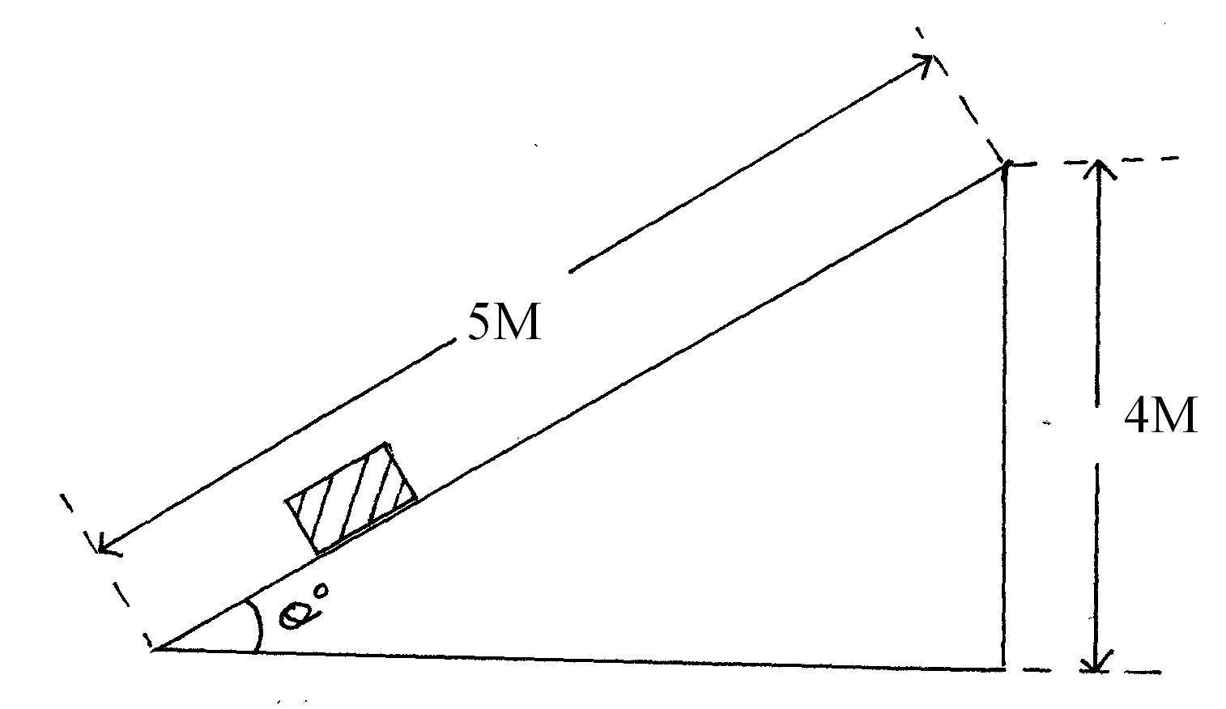
Find the velocity ratio of the inclined plane. (2mks)
............................................................................................................................................................. .............................................................................................................................................................
............................................................................................................................................................. .............................................................................................................................................................
b) Sketch the possible arrangement of the pulleys with a velocity ratio of S. (2mks)
............................................................................................................................................................. .............................................................................................................................................................
.............................................................................................................................................................
............................................................................................................................................................. .............................................................................................................................................................
.............................................................................................................................................................
............................................................................................................................................................. .............................................................................................................................................................
.............................................................................................................................................................
c) The table below shows the readings for various masses hung from a spring balance.

Mass (kg) | 0 | 0.02 | 0.04 | 0.06 | 0.08 | 0.10
Reading (mm) | 120 | 131 | 139`149 | 161 | 171
Force (N)
Extension ( mm)

i) Complete the table (2mks)

ii) Plot the graph of the force against extension on the grid provided below. (4mks)

From the graph, determine the extension when a mass of 0.045 kg is hung from the spring (1mk)
END

