NAME…………………………………………………………. INDEX NO. ………………/………
SCHOOL ……………………………………………………... SIGN ………………………………
DATE……………………………..

232/2
PHYSICS
Paper 2
JULY/ AUGUST, 2012
2 Hours

MBITA-SUBA DISTRICTS JOINT EXAMINATION - 2012
Kenya Certificate of Secondary Education – K.C.S.E

232/2
PHYSICS
Paper 2
JULY/ AUGUST, 2012
2 Hours

INSTRUCTION TO CANDIDATES

1. Write your name and index number in the spaces provided.
2. Sign and write the date of the examination in the spaces provided.
3. This paper consists of TWO sections A and B.
4. Answer ALL questions in section A and B in the spaces provided
5. ALL working must be clearly shown
6. Silent non-programmable electronic calculators and KNEC tables may be used unless otherwise stated.
7. Where applicable take acceleration due to gravity g = 10 m/s²

FOR EXAMINER’S USE ONLY
SECTION | QUESTION | MAXIMUM.SCORE | CANDIDATE’S SCORE
A | 1-14 | 25
B | 15 | 13
 | 16 | 12
 | 17 | 10
 | 18 | 10
C | 19 | 10

This paper consists of 12 printed pages.
Candidates should check the question paper to ensure that all pages are printed as indicated and no questions are missing
SECTION A (25 marks)

1. Figure 1 below shows two bar magnets north and south poles placed together as shown. In the figure sketch the magnetic field pattern between the two magnets. (1mk)

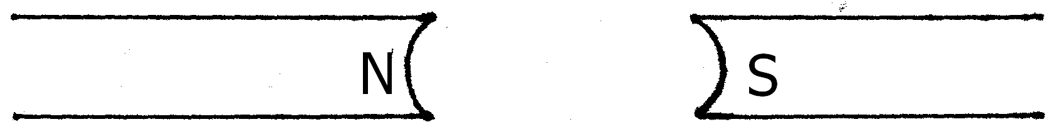

2. Figure 2 below shows a wire in a magnetic field. A current is switched on to flow through the wire in the direction shown. State the direction of motion of the wire. (1mk)
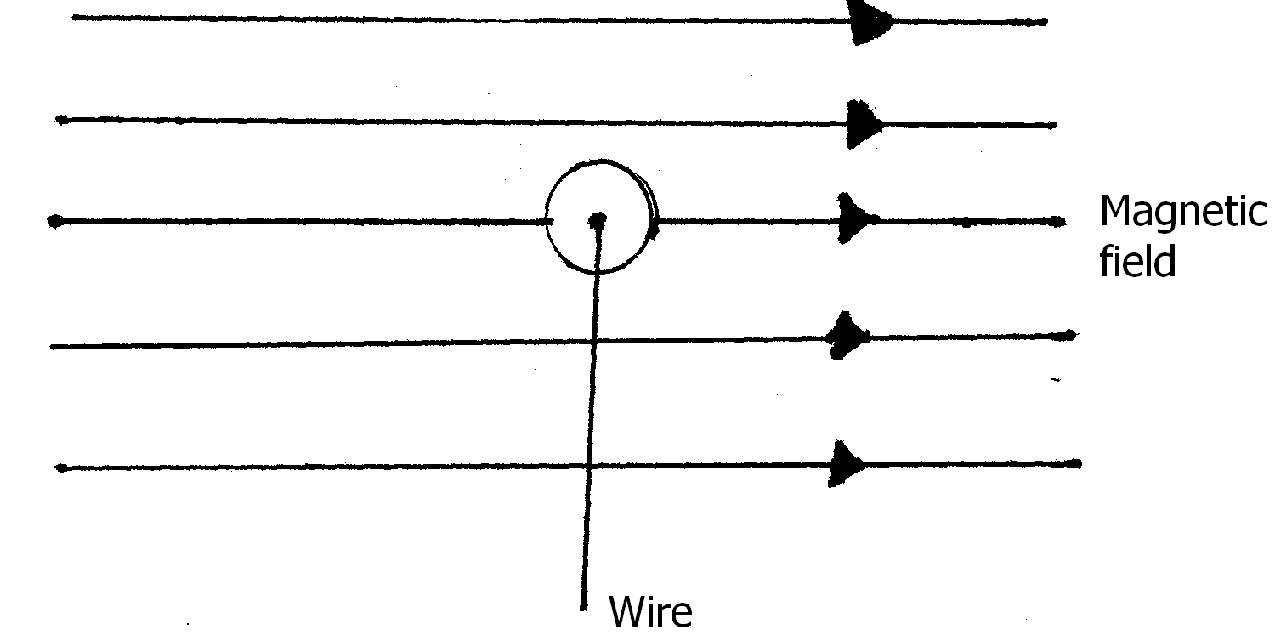
3. Explain the meaning of the following terms as used in waves: (2mks)
i) Amplitude
…………………………………………………………………………………………………………..
…………………………………………………………………………………………………………..
ii) Waveform
…………………………………………………………………………………………………………..
…………………………………………………………………………………………………………..
4. State the factor that determines the quality of the x-rays produced in the x-ray tube. (1mk)
…………………………………………………………………………………………………………..
5. In order to step up 12 V to 15 kV in an induction coil, the circuit below was used.
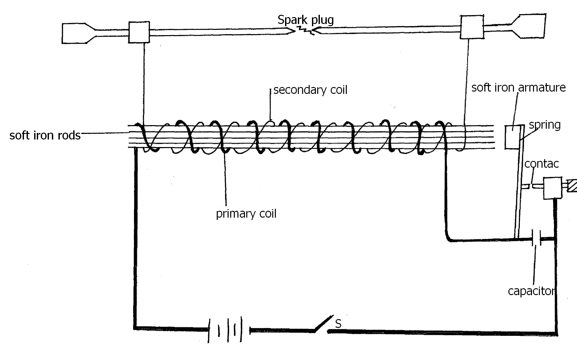
Explain how voltage is stepped up by the arrangement. (3mks)
…………………………………………………………………………………………………………..
…………………………………………………………………………………………………………..
…………………………………………………………………………………………………………..
…………………………………………………………………………………………………………..
6. The y-gain control of a C.R.O is set at 2V/div. Calculate the number of vertical divisions when it is showing a peak voltage of 50V. (2mks)

7. Figure 4(a) and fig 4(b) shows a p-n junction connected to a battery. It is observed that the current in 4(a) is greater than the current in 4(b).
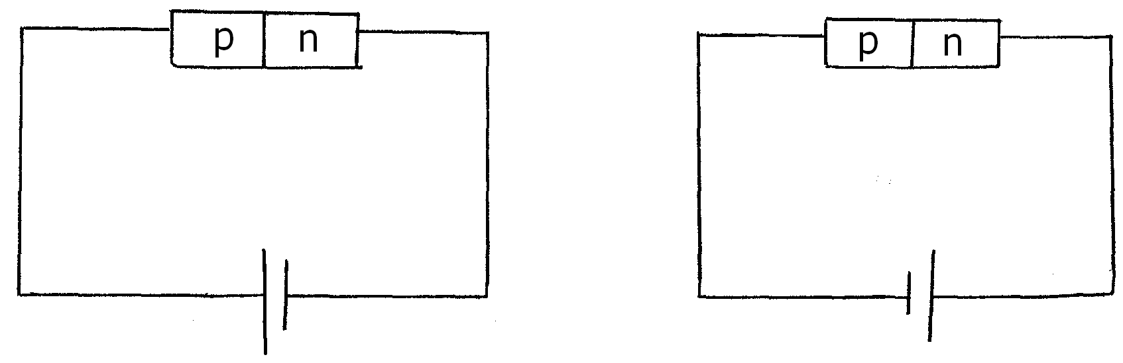
State the reason for this observation (2mks)
…………………………………………………………………………………………………………..
…………………………………………………………………………………………………………..
…………………………………………………………………………………………………………..
8. In figure 5, the internal resistance of the cell is 0.5$Ω$. Determine the ammeter reading when the switch S is closed. (3mks)
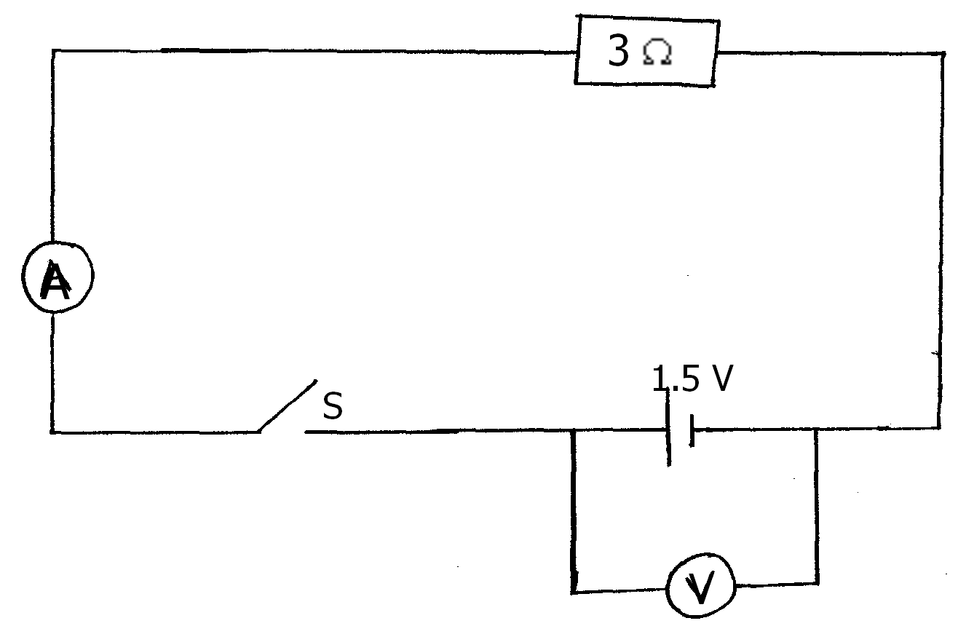
9. A Bunsen burner flame brought near to the cap of a charged electroscope causes the divergence of the leaf to decrease. Explain this observation. (1mk)
…………………………………………………………………………………………………………..
…………………………………………………………………………………………………………..

10. A sound wave in air is made up of compressions and rarefactions. Explain what is meant by compressions and rarefactions.
i) Compressions
…………………………………………………………………………………………………………..
…………………………………………………………………………………………………………..

ii) Rarefactions
…………………………………………………………………………………………………………..
…………………………………………………………………………………………………………..
11. State Snell’s law (1mk)
…………………………………………………………………………………………………………..
..................................................................................................................................................................
12. Figure 6 below shows a vibrating tuning fork. The prong takes 2ms to go from A to B. What is the frequency of the vibration? (2mks)

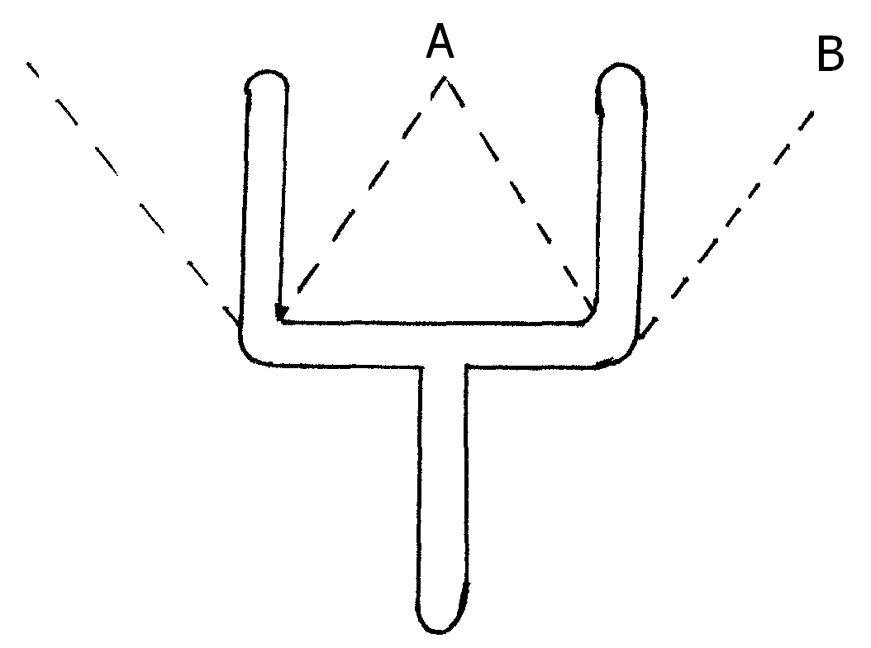

13. A bright object 50mm high stands on the axis of a concave mirror of focal length 100mm and at a distance of 300mm from the concave mirror. Determine the height of the image. (2mks)

14. A household electric lamp is rated as 240V, 60W. The filament of the lamp is made from tungsten and is a wire of radius 6.0 x 10⁻⁶ m. Calculate the length of the filament of the lamp when operating at constant temperature. (3mks)
(Resistivity of tungsten is 7.9 x 10⁻⁷ $Ω$m.)

SECTION B (55 marks)
Answer ALL the questions in the spaces provided below each question

15. a) Define capacitance (1mk)
…………………………………………………………………………………………………………..
…………………………………………………………………………………………………………..
b) In fig below, a sharp pin is fixed on a cap of a leaf of the electroscope. The electroscope is
highly charged and then left for sometime.
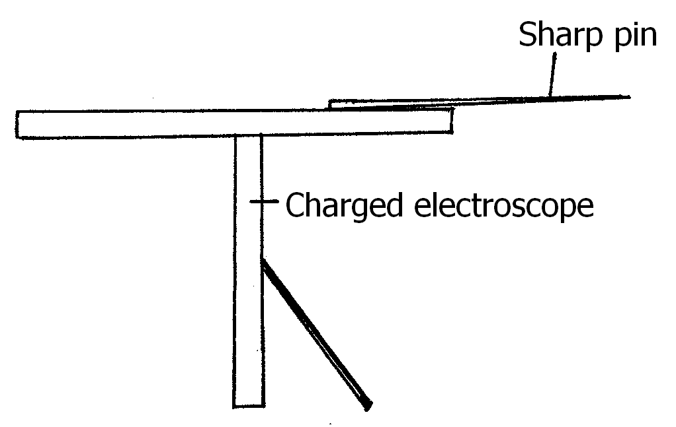
State and explain the observation made after sometime.
…………………………………………………………………………………………………………..
…………………………………………………………………………………………………………..
…………………………………………………………………………………………………………..
c) Figure below shows a circuit where a battery of e.m.f. 4.5 V, switches A and B, two
capacitors C₁ = 0.6$μ$F and C₂ = 1.0 $μ$F and a voltmeter are connected.

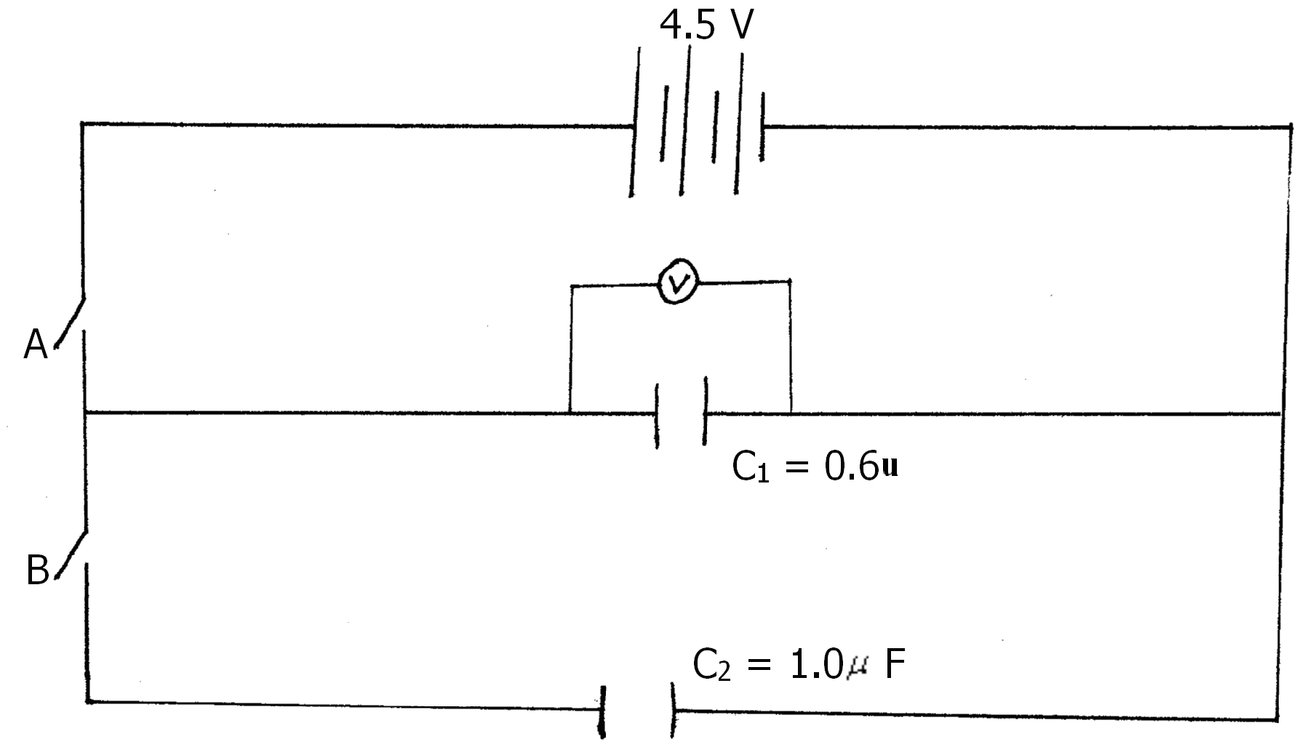
i) Determine the charge on C₁ when both switch A is closed and switch B is open.
(2mks)
…………………………………………………………………………………………………………..
…………………………………………………………………………………………………………..

ii) What is the effective capacitance C₁ When both switches A and B are closed.?(2mks)

ii) State and explain what is observed on the voltmeter when
I. Switch A is closed and switch B is open (2mks)
…………………………………………………………………………………………………………..
…………………………………………………………………………………………………………..
II. Switch A is closed and opened and then B is closed (2mks)
…………………………………………………………………………………………………………..
…………………………………………………………………………………………………………..
d) Fig shows a pair of parallel plates of capacitors connected to a battery. The upper plate is
displaced slightly to the left.
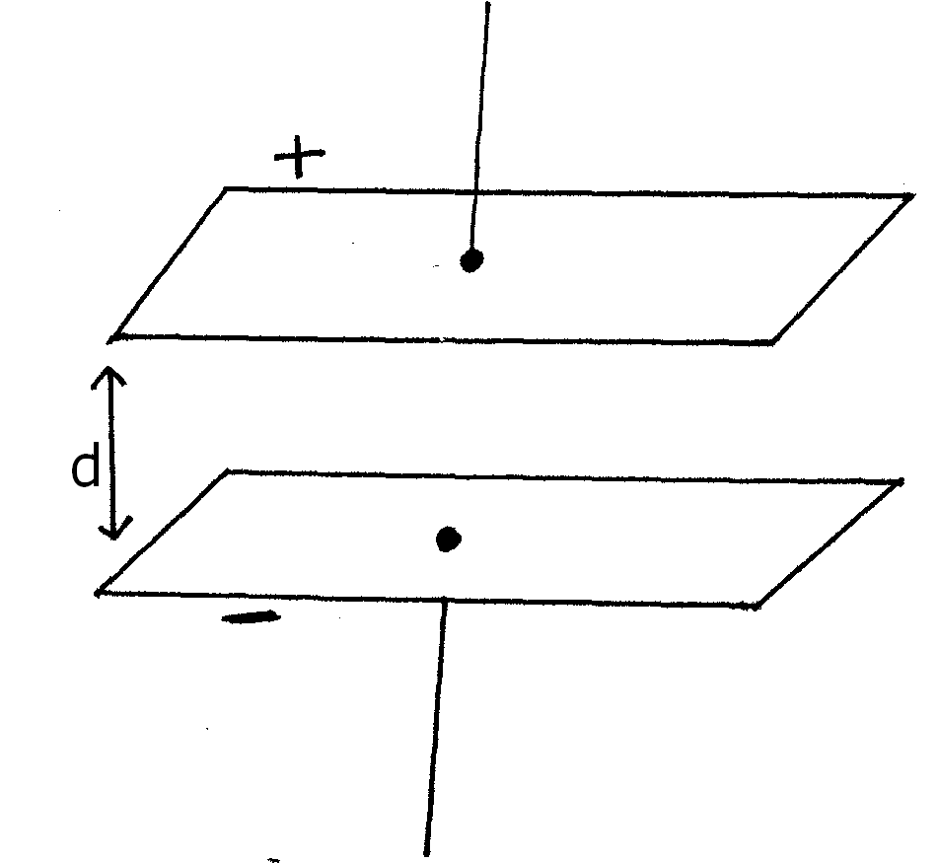
Suggest two adjustments that can be made to so as to reduce the effective capacitance.
(2mks)
…………………………………………………………………………………………………………..
……………………………………………………………………………………………………… …..
……………………………………………………………………………………………………… …..

16. a) Long distance transmission of power is done at a very high voltage. Explain. (1mk)
…………………………………………………………………………………………………………..
…………………………………………………………………………………………………………..
b) Fig below shows a section of a house wiring system
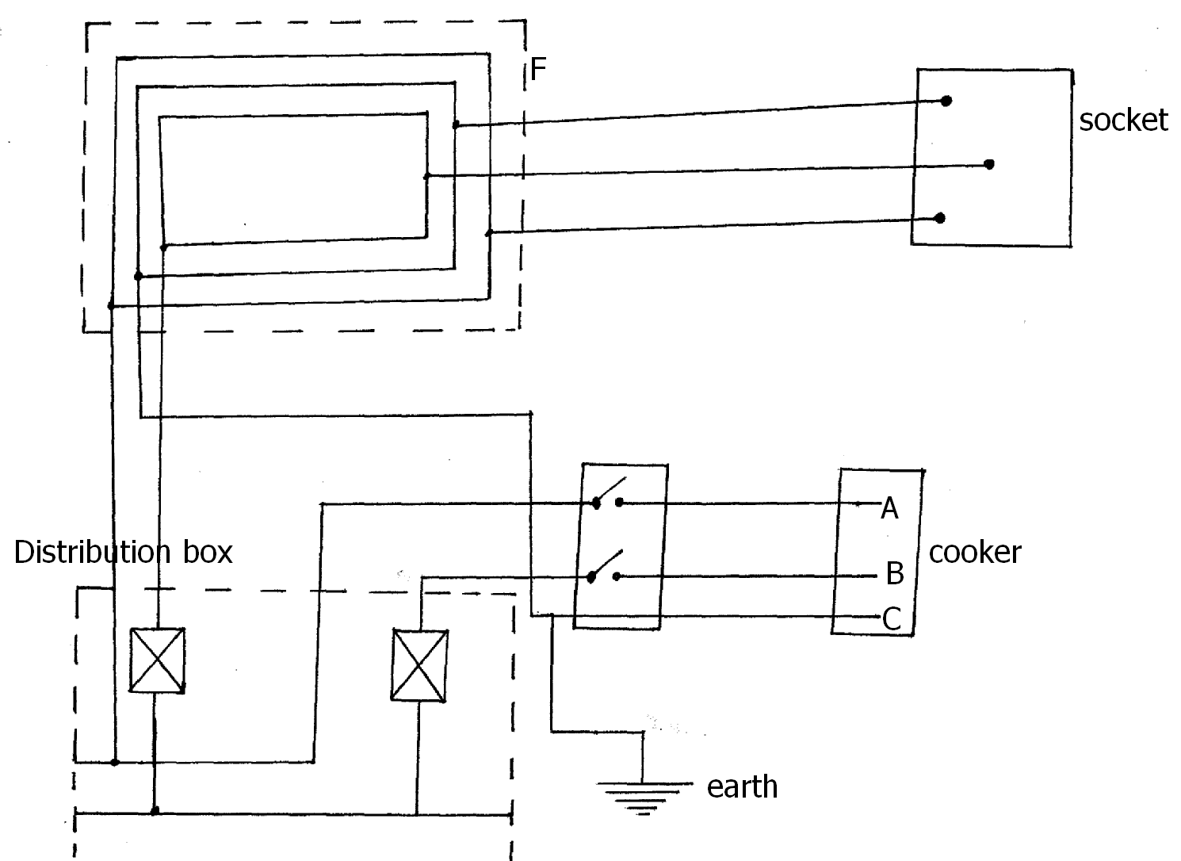

i) Name:
I. The circuit labeled F (1mk)
…………………………………………………………………………………………………………..
II. The terminals A and B (2mks)
A ………………………………………………………………………………..
B ……………………………………………………………………………......
ii) Give a reason why R is connected to B and not A
…………………………………………………………………………………………………………..
……………………………………………………………………………………………………… …..

iii) What is R (1mk)
…………………………………………………………………………………………………………..
iv) Why is earthing necessary in such a circuit?
…………………………………………………………………………………………………………..
…………………………………………………………………………………………………………..
c) 54kg of water in a metallic cylinder of heat capacity 9000 JK⁻¹ is heated from 10⁰ C to 80⁰ C
using an immersion heater rated 1800 W, 240V. Assuming that no heat is lost to the surrounding and the immersion heater works at its correct voltage. Find;
i) The current flowing through the water (2mks)

ii) The cost of heating the same mass of water from 10⁰ C to 80⁰ C, every day for 30 days. If electricity cost Sh. 6.70 per unit. (4mks)

17. a) Fig below shows an x-ray tube.
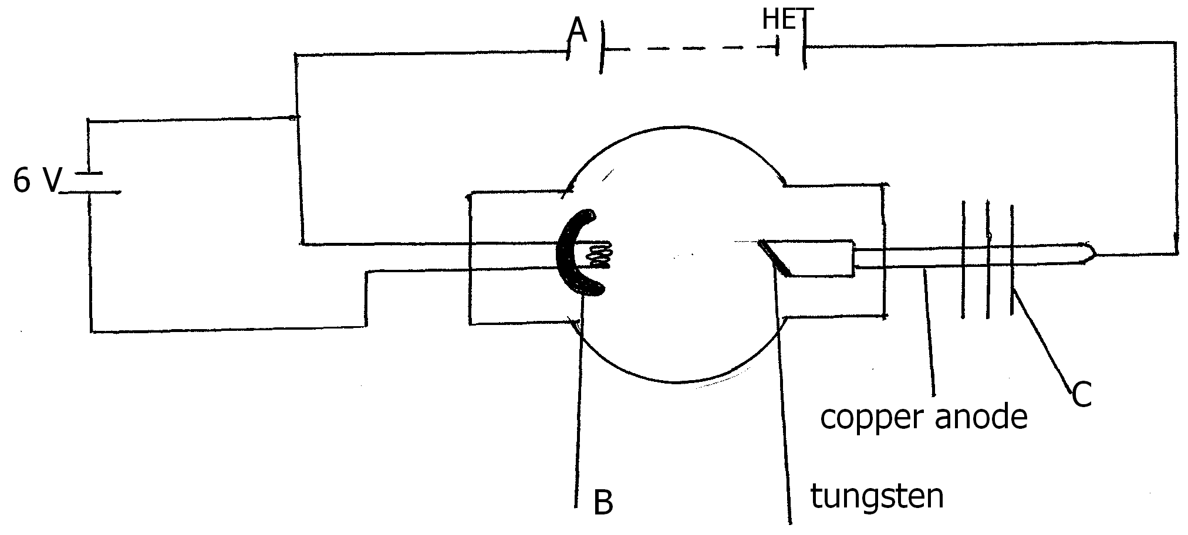
i) State the function of part B and C
B ……………………………………………………………………….. (1mk)
C ………………………………………………………………………. (1mk)
ii) Explain briefly how x-rays are produced in the tube (2mks)
…………………………………………………………………………………………………………..
…………………………………………………………………………………………………………..
…………………………………………………………………………………………………………..
……………………………………………………………………………………………………… …..
……………………………………………………………………………………………………… …..

iii) Why is the target (tungsten) made to rotate in modern x-ray tube (1mk)
…………………………………………………………………………………………………………..
…………………………………………………………………………………………………………..
iv) An x-ray operator wanted to produce harder x-rays that could penetrate flesh. State and explain the adjustments he would perform on the x-ray tube achieve this.
(2mks)
…………………………………………………………………………………………………………..
…………………………………………………………………………………………………………..
…………………………………………………………………………………………………………..
b) An x-ray tube has an accelerating potential difference of 50 kV. What is the shortest
wavelength in the x-ray beam. (3mks)
(h = 6.64 x 10⁻³⁴ Js, charge on electron, e = 1.6 x 10⁻¹⁹ C and velocity of light c= 3.0 x 10⁸ m/s)

18. a) The figure below shows a zinc plate placed on the cap of a negatively charged electroscope as
shown.
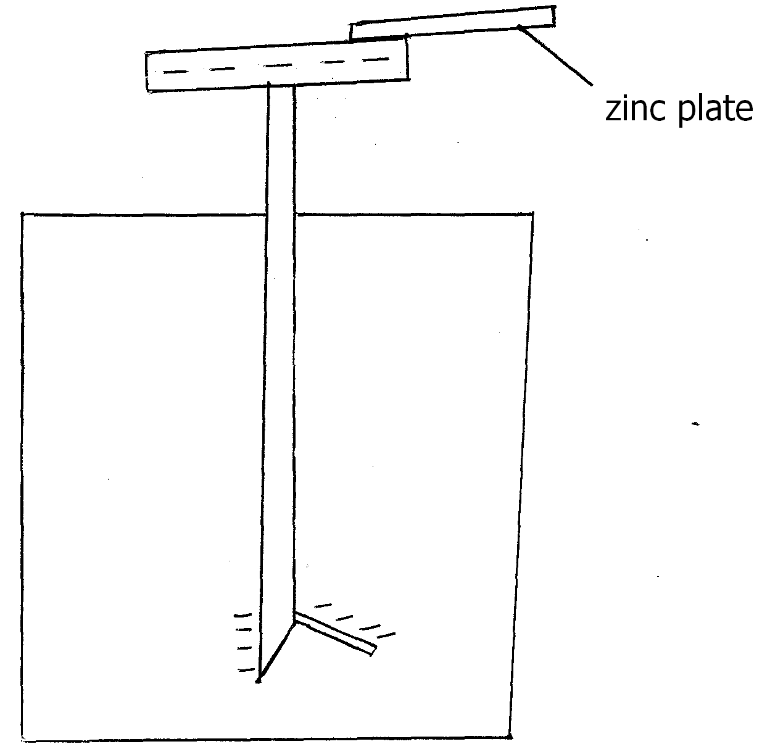
State and explain the observation made when zinc plate is irradiated by u.v. light as shown above. (1mk)
…………………………………………………………………………………………………………..
…………………………………………………………………………………………………………..
b) What is photoelectric effect (1mk)
…………………………………………………………………………………………………………..
…………………………………………………………………………………………………………..
c) In a photoelectric effect experiment, a certain surface was illuminated with radiation of
different frequencies and the stopping potential determined for each frequency. When stopping potentials were plotted against frequencies the graph below was obtained.
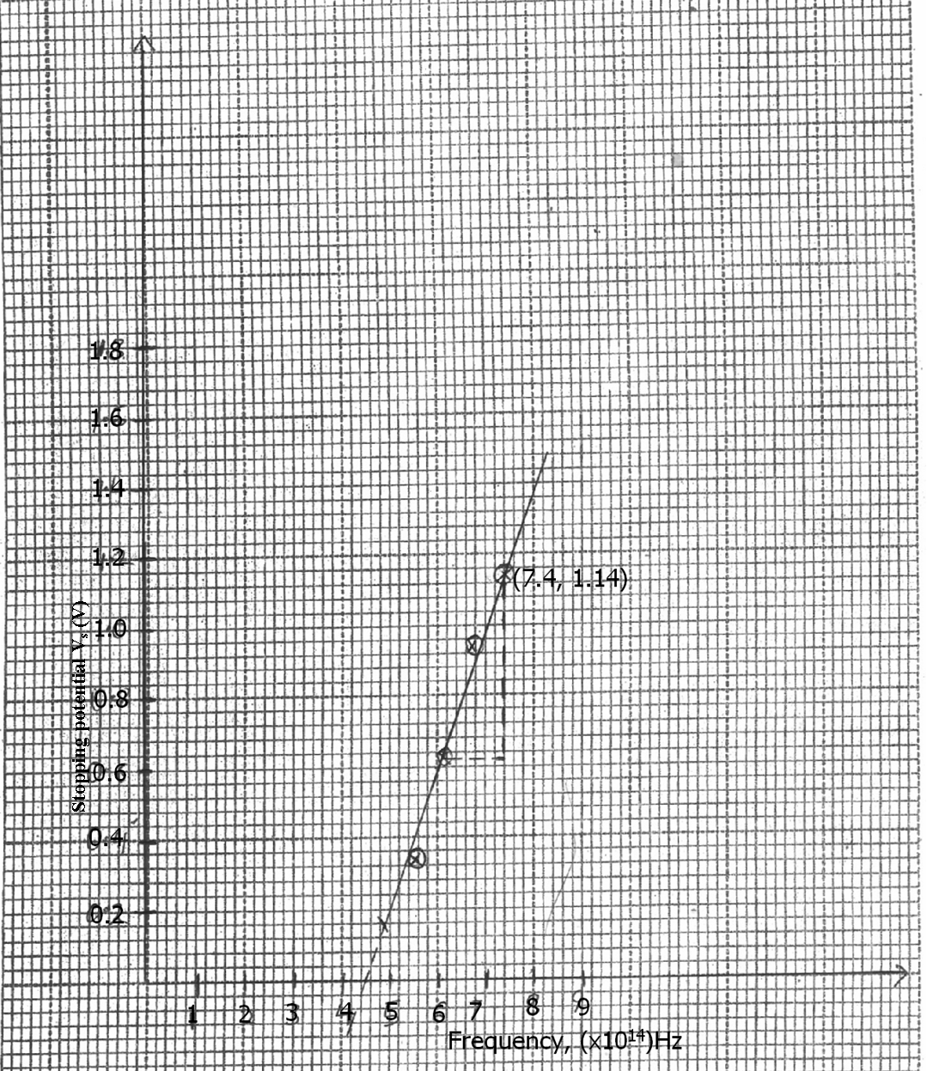

i) From the graph determine the plank’s constant and the work function of the surface given that eV_{s} = hf – hf_{o}. Where e = 1.6 x 10⁻¹⁹, W_{o} = hf_{o}, f_{o} = lowest frequency.
(5mks)

ii) A surface whose work function W_{o} = 6.4 x 10⁻¹⁹J is illuminated with light of frequency of 3.0 x 10¹⁵ Hz. Find the maximum photoelectric energy of the emitted photoelectrons (Use value f h obtained in (i) above) (2mks)

19. a) Define radioactivity (1mk)
…………………………………………………………………………………………………………..
b) What do you understand by the term background radiation (1mk)
…………………………………………………………………………………………………………..
…………………………………………………………………………………………………………..
c) Explain why bromine gas is added to the Geiger Muller tube (1mk)
…………………………………………………………………………………………………………..
…………………………………………………………………………………………………………..
d) In an experiment to determine the half life of a certain radioactive substance, the activity in
disintegrations per minute was measured for sometimes and results recorded as below. Taking background radiation as 20 disintegrations per minute, complete the table below.

Time in min | 0 | 10 | 20 | 30 | 40 | 50 | 60 | 70 | 80
Activity disintegration/min | 172 | 135 | 107 | 86 | 70 | 58 | 40 | 32 | 26
Actual activity dis/min

i) On the grid provided plot a suitable graph and use it to determine the half life t½ of the substance (5mks)

ii) How long would the activity of a sample iodine 128 take to drop from 1200 to 75 disintegration per second. (2mks)



END

