Name………………………………………………………. Index No…………………/…….
School……………………………………………………… Date ………………………….…
Candidate’s Signature…………

232/2
PHIYSICS
Paper2
July / August, 2012
Time: 2 Hours
TESO SOUTH DISTRICT JOINT EVALUATION TEST - 2012
Kenya Certificate of Secondary Education – K.C.S.E
232/2
PHIYSICS
Paper2
July / August, 2012
Time: 2 Hours

INSTRUCTIONS TO CANDIDATES
1. Write your name and Index number in the spaces provided above
2. This paper consist of two section A and B
3. Answer ALL the questions in section A and B in the space provided
4. ALL your workings MUST be clearly shown
6. Mathematics tables and silent Non-programmable electronic calculator may be used.

FOR OFFICIAL USE ONLY
SECTION | QUESTION | MAX SCORE | CANDIDATE SCORE
A | 1-12 | 25
B | 13  14  15  16  17  TOTAL MARKS | 13  13  07  10  12  80

This paper consists of 12 printed pages.
Candidates should check the question paper to ensure that all pages are printed as indicated and that no questions are missing.
SECTION A
1. A pin-hole camera 200mm long produces an image of 2mm diameter of the sun. If the sun’s
distance from the Earth is about 1.5×10⁸km, estimate the diameter of the sun. (2mks)

2. The figure shows an image I formed by an object placed in front of a convex mirror C is the
centre of curvature of the mirror.
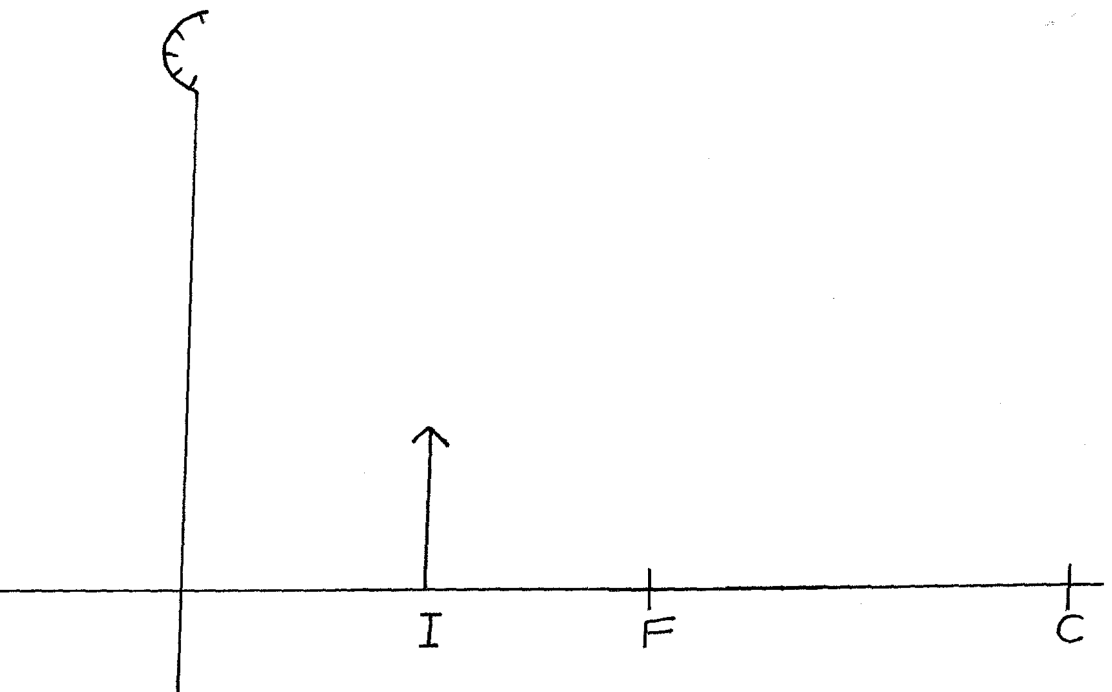
On the diagram, drawn appropriate rays and locate the position of the object and hence determine
the magnification of the image. (3mks)

3. State two factors affecting capacitance of a parallel plate capacitor. (2mks)
……………………………………………………………………………………………………………………………………………………………………………………………………………………………….

4. In the circuit shown in the figure below, which bulb, A or B is bright less?
Explain (2mks)
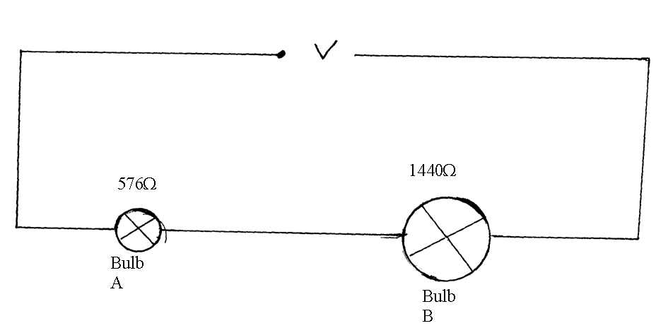

5. State one property of standing waves (1mk)
………………………………………………………………………………………………………………
6. With the aid of a diagram, show the lowest possible mode of vibration in a closed pipe. (1mk)

7. The figure shows a magnet. Point A and B are in front of the magnet.
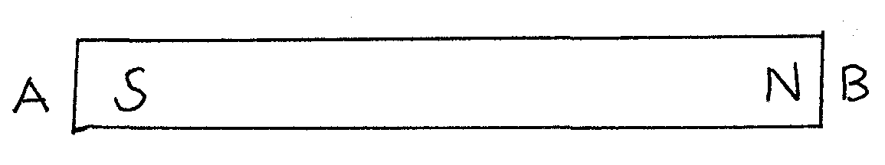
On the axes provided, sketch a graph showing how the magnetic field strength changes from A to
B. (2mks)
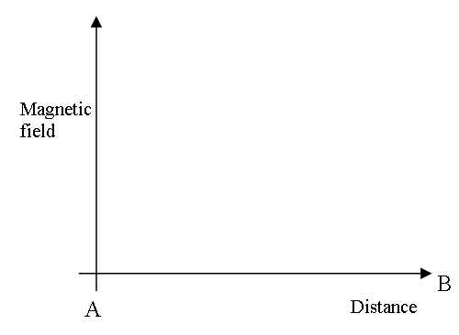

8. Determine the angle of reflection r in the diagram below (3mks)
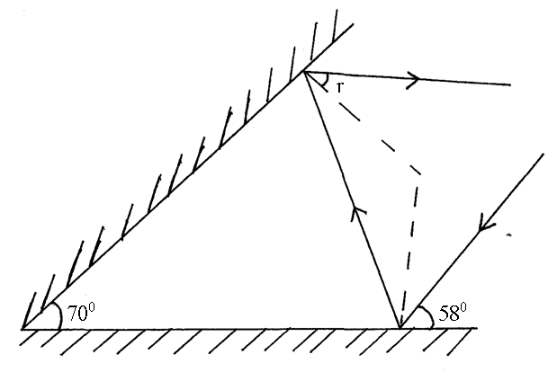
9. The apparent depth of a pond of water is 25% less than it’s real depth when viewed normally.
Calculate the refraction index of waters (3mks)

10. Determine the ammeter reading when a p.d of 30volts is applied across PQ in the figure below.
(3mks)
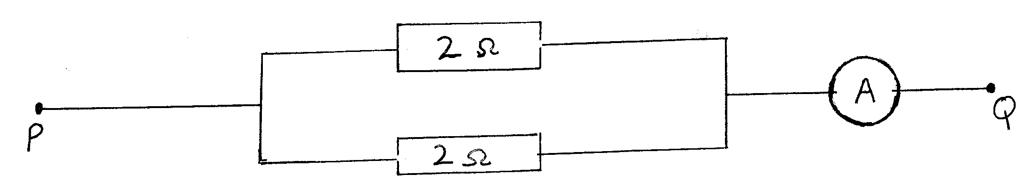

11. The figure below shows two identical pith balls A and B suspended with insulated threads .They
are separated by an insulator X.A is positively charged while B is negatively charged. The quantity of charge on B is three times the quantity of charge on A
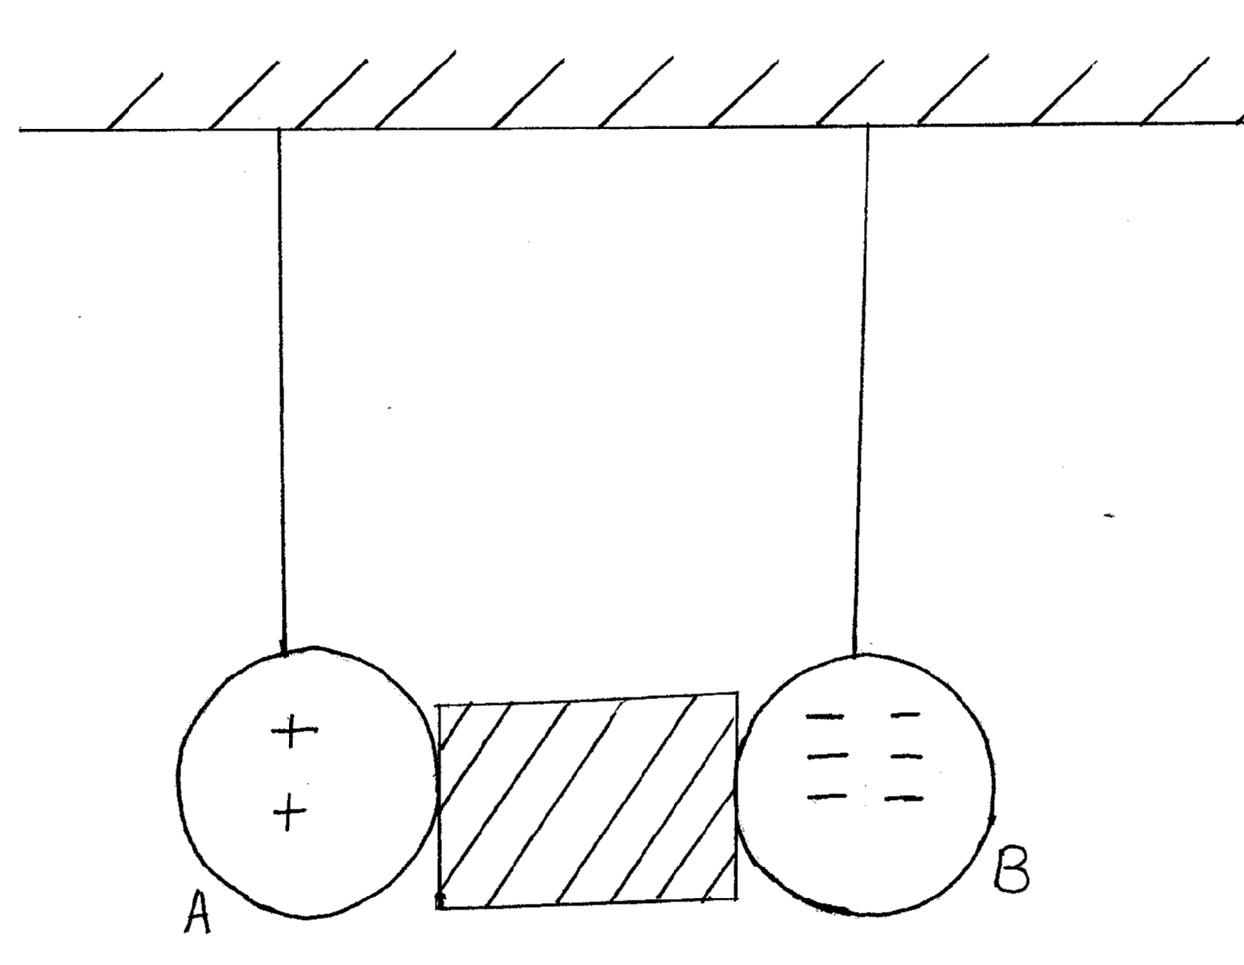
Sketch and explain on the space provided the final position of the pith balls after the insulation is removed. (2mks)

12. Explain why alpha particles are more ionizing than Beta particles. (1mk)
……………………………………………………………………………………………………………………………………………………………………………………………………………………………….

13. (a) State Snell’e law (1mk)
……………………………………………………………………………………………………………………………………………………………………………………………………………………………….
(b) A coin is placed beneath a transparent block of thickness 10cm and refractive index
1.56.Calculate the vertical displacement of the coin. (3mks)

(c) The speed of green light in a prism is 1.94×10⁸m/s
(i) Determine the refractive index of the Prism material (speed of light in air =
3.0×10⁸m/s) (2mks)

(ii) Determine the critical angle of the prism material (2mks)

(d) State two advantages of using optical fibre in communication (2mks)
……………………………………………………………………………………………………………………………………………………………………………………………………………………………….
(e) The refractive indices of water and glass are $32$ and $43$respectively. Find the value of $θ$ in
the figure below. (3mks)
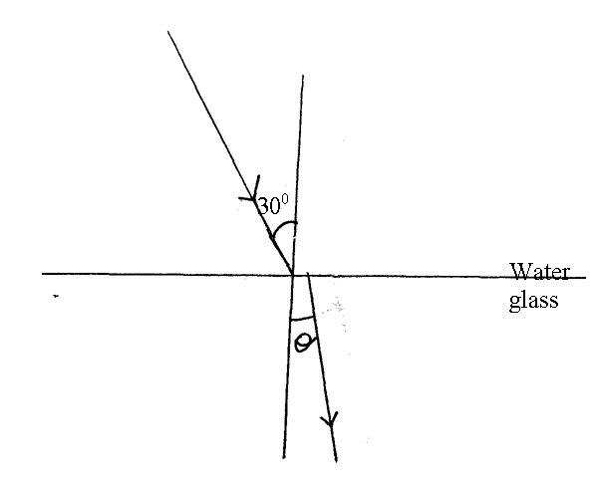
14. (a) State Ohm’s law (1mk)
……………………………………………………………………………………………………………………………………………………………………………………………………………………………….
(b) A wire was connected to a battery and was found that the energy converted to heat was
30J – When 20C of charge flowed through it in 5 seconds.
Calculate

- P.d between ends of the wire (3mks)

- Current through the wire (2mks)

- Resistance of the wire (2mks)

(c) If another wire has a diameter of 0.64mm, 64.3cm long and allows a current of 3.0A when
a pd of 6v is maintained at its ends. Calculate:
- It’s resistance (2mks)

- It’s resistivity (3mks)

15. A clean zinc plate was charged and then placed on the cap of a positively charged electroscope as
shown in figure below
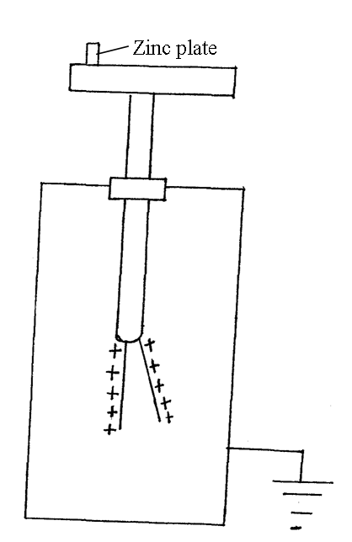
(a) State the charge on the plate before it was placed on the cap of the electroscope. (1mk)

(b) What would happen to the leaf of the electroscope if ultraviolet light was made to fall on
the zinc plate? Explain (2mks)
……………………………………………………………………………………………………………………………………………………………………………………………………………………………….
……………………………………………………………………………………………………………………………………………………………………………………………………………………………….
(c) Why is the zinc plate cleaned (1mk)
……………………………………………………………………………………………………………………………………………………………………………………………………………………………….
(d) A graph of kinetic energy of photoelectrons emitted by metal surface against the frequency
of radiation used is shown in the graph below
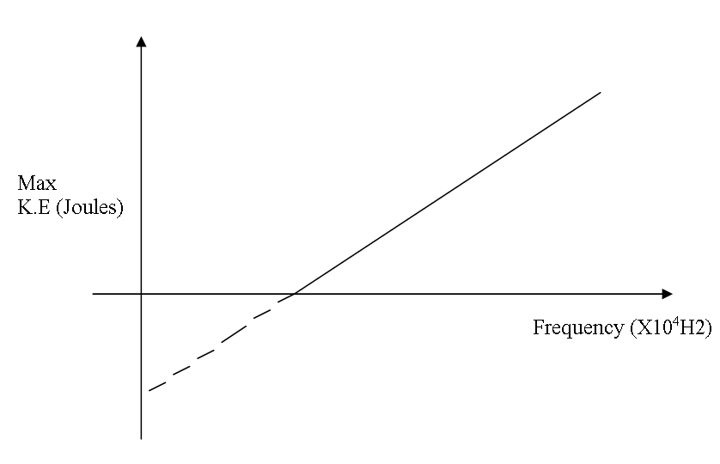
The graph is extrapolated to intersect the K.E axis
- From the graph, state the relationship between K.E and frequency. (1mk)
………………………………………………………………………………………………………………………………………………………………………………………………………………………………

- What’s the significance of the gradient of the graph? (1mk)
……………………………………………………………………………………………………………………………………………………………………………………………………………………………….
- Show on the graph the threshold frequency of the metal. (1mk)

16. (a) The following graph shows the variation of magnification,M,with image distance, v, for a
concave mirror.
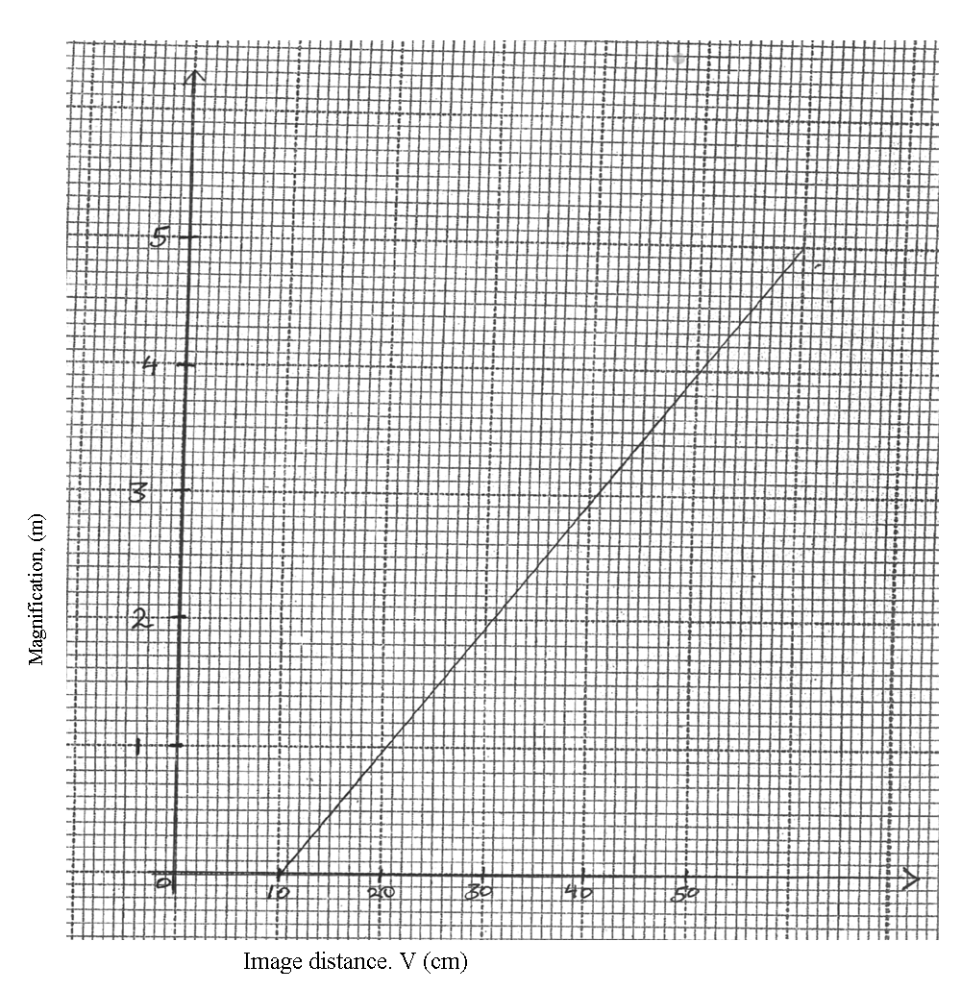

Determine
- The object position when the image position is 45cm (4mks)

- The focal length of the mirror (3mks)

(b) State one application of each of the following;
(i) Convex mirror (1mk)
……………………………………………………………………………………………………………………………………………………………………………………………………………………………….
(ii) Concave mirror
……………………………………………………………………………………………………………………………………………………………………………………………………………………………….
- Parabolic Reflector (1mk)
……………………………………………………………………………………………………………………………………………………………………………………………………………………………….
17. (a) State one difference between a transformer and an induction coil. (1mk)
……………………………………………………………………………………………………………………………………………………………………………………………………………………………….
(b) State two energy losses in a transformer (2mks)
……………………………………………………………………………………………………………………………………………………………………………………………………………………………….

(c) A transformer has 10.000 turns on it’s secondary coil and 100 turns on it’s punier coil. An alternating current of 5.0A flows in the primary circuit when it is connected to a 12v a.c supply.
(i) State the type of transformer (1mk)
……………………………………………………………………………………………………………………………………………………………………………………………………………………………….
(ii) Calculate the power input to the transformer (2mks)

(iii) Calculate the E.M.F a cross the secondary coil (2mks)

- Determine the maximum current that could flow in a circuit connected to the secondary coil if the transformer is 90% efficient (same E.M.F in secondary as you have calculated above) (3mks)

- In transmitting power why is it necessary to step it up before transmission.
Explain (1mk)
……………………………………………………………………………………………………………………………………………………………………………………………………………………………….
END

