NAME……………………………………………………….. INDEX NO……………………........................

121/1 CANDIDATE’S SIGN………….….….….…..
MATHEMATICS ALT A
PAPER 1 DATE……….…………………………………

TIME: 2½ HOURS

CENTRAL KENYA NATIONAL SCHOOLS JOINT EXAM - 2015

Kenya Certificate of Secondary Education
MATHEMATICS ALT A
PAPER 1
TIME: 2½ HOURS

INSTRUCTION TO CANDIDATE’S:
(a) Write your name, index number and school in the spaces provided at the top of this page.
(b) Sign and write the date of examination in spaces provided above.
(c) This paper consists of TWO sections: Section I and Section II.
(d) Answer ALL the questions in Section I and any five questions from Section II.
(e) Show all the steps in your calculation, giving your answer at each stage in the spaces
provided below each question.
(f) Marks may be given for correct working even if the answer is wrong.
(g) Non-programmable silent electronic calculators and KNEC Mathematical tables may
be used, except where stated otherwise.
(h) This paper consists of 16 printed pages.
(i) Candidates should check the question paper to ascertain that all the pages are printed
as indicated and that no questions are missing.
(j) Candidates should answer the questions in English.

FOR EXAMINER’S USE ONLY:

SECTION I
1 | 2 | 3 | 4 | 5 | 6 | 7 | 8 | 9 | 10 | 11 | 12 | 13 | 14 | 15 | 16 | TOTAL

SECTION II
Grand
Total

17 | 18 | 19 | 20 | 21 | 22 | 23 | 24 | TOTAL

Mathematics Paper 1 Turnover
SECTION I: (50 MARKS)

Answer all the questions in this section in the spaces provided.

1. Without using a calculator, evaluate:
$\frac{1\frac{4}{5} \text{of} \frac{\text{25}}{\text{18}} ÷ 1\frac{2}{3} × \text{24}}{2\frac{1}{3} − \frac{1}{4} \text{of} \text{12} ÷ \frac{5}{3}}$

Leaving your answer as a mixed number. (3mks)

2. Simplify:
$\frac{2a^{2} − 3\text{ab} − 2b^{2}}{4a^{2} − b^{2}}$ (3mks)

3. Without using Mathematical tables or a calculator evaluate:
$6 \text{Log} \sqrt[3]{\text{64}} + \text{10} \text{Log} \sqrt[5]{\text{243}}$ (3mks)

Mathematics Paper 1 2
4. In the figure below TP and TQ are tangents to the circle and PR is parallel to TQ. Find the angle marked b and c. (2mks)
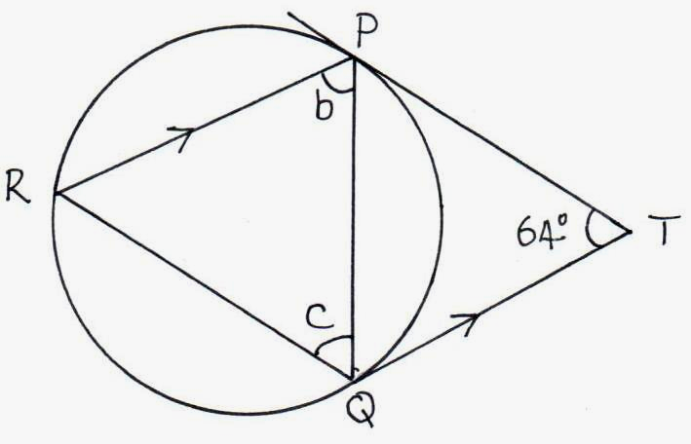

5. A train 20m long is moving at an average speed of 52km/h. Another train 30m long is moving in
the opposite direction at an average speed of 48km/h. How long do the trains take to completely
pass each other. Leave your answer in seconds. (3mks)

6. ABCDE is a regular pentagon. Its sides AB and DC are produced to meet at T. Calculate ∠BTC.
(2mks)
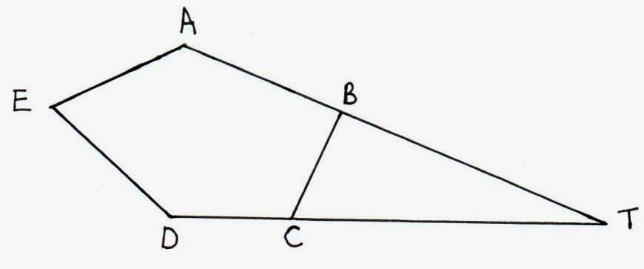

Mathematics Paper 1 3
7. Two cylindrical buckets are similar in shape with base radius 7cm and 10.5cm. The smaller bucket holds 4 litres. Calculate the volume of the larger bucket. (3mks)

8. A fridge costs Sh.1400. It may be bought at hire purchase by paying a deposit of Sh.3500 and the remainder, which has an interest charge of 18% added, in 12 equal monthly installments.
Calculate:
The monthly installments to the nearest shilling. (4mks)

9. The second term of four consecutive odd numbers is 2n + 1. If the sum of the three numbers
is 10104. Find the value of n. (3mks)

Mathematics Paper 1 4
10. A translation maps a point P (3, 2) onto P¹ (5, -4)
(a) Determine the translation vector. (1mk)

- A point Q¹ is the image of the point Q (2, 5) under the same translation. Find the length
of P¹Q¹, leaving the answer in surd form. (3mks)

11. A contractor employs 40 men to do a piece of work in 60 days each man working 9 hours a day.
He is then requested to do the job in 48 days. How many more men working 10 hours a day
does he need to employ. (3mks)

Mathematics Paper 1 5
12. Solve for y if: 9^{(y2)} = 27^{(2y + 2).} (4mks)

13. Solve for χ:
Sin (2χ + 20) = Cos $\frac{χ}{3}$. (3mks)

14. (i) Express 48 and 60 as a product of their prime factors. (2mks)

- A room of side 48m and 60m is to be decorated using square tiles side XM. Find the greatest area of the tile.
(2mks)

Mathematics Paper 1 6
15. A man spent $\frac{1}{9}$ of his salary on food and $\frac{1}{4}$ of the remainder on electricity and water bills.
He paid fees with 20% of his salary and invested 16% of what was left on business. After taking
a game drive on which he spent Ksh.2000, he saved Ksh.5350. Calculate his monthly earnings.
(3mks)

16. Form three inequalities that satisfy the region R. (3mks)
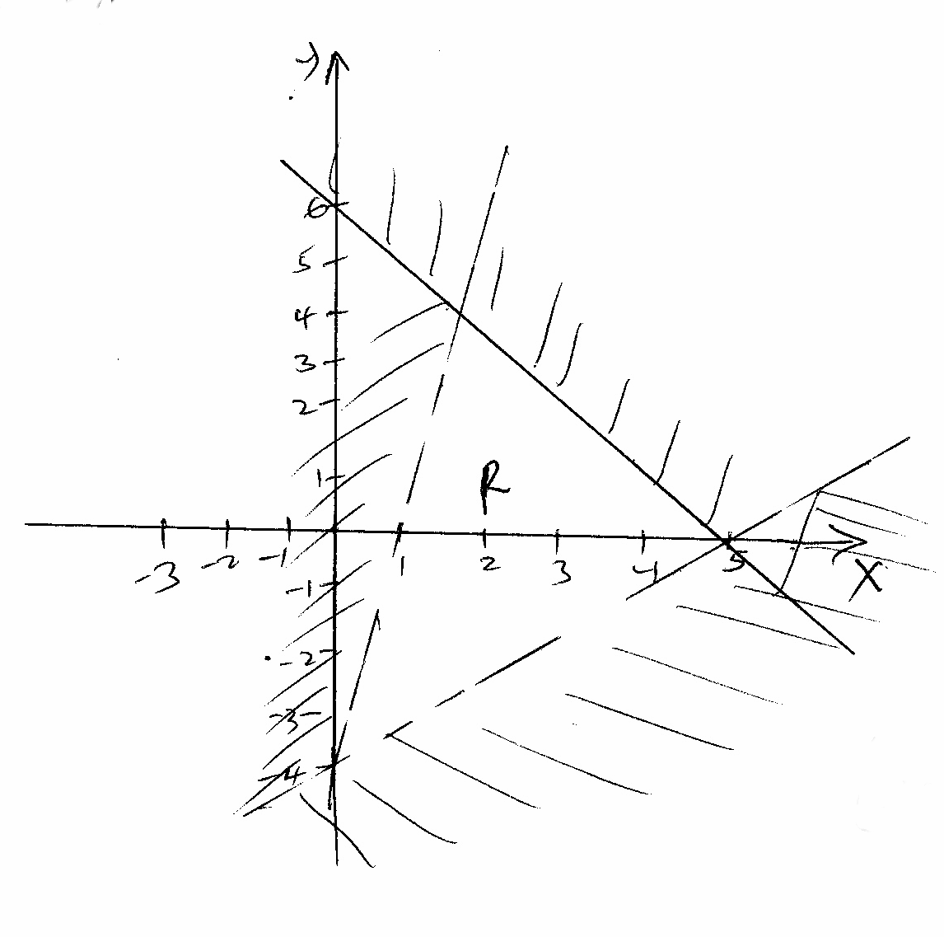

Mathematics Paper 1 7
SECTION II: (50 MARKS)

Answer only five questions from this section in the spaces provided:

17. Three hundred and sixty litres of a homogeneous paint is made by mixing three paints A, B and C. The ratio by volume of paint A to paint B is 3: 2 and paint B to paint C is 1: 2. Paint A costs
Sh.180 per litre, paint B Sh.240 per litre and paint C Sh.127.50 per litre.
Determine:
(a) The volume of each type of paint in the mixture. (5mks)

(b) The amount of money spent in making one litre of the mixture. (3mks)

(c) the percentage profit made by selling the mixture at Sh.221 per litre. (2mks)

Mathematics Paper 1 8
18. The length and breadth of a rectangle are given as (6χ - 1) and (χ - 2) cm respectively. If the length and breadth are each increased by 4cm, the new area is three times that of the original rectangle.
(a) Form an equation in χ and solve it. (4mks)

(b) Find the dimensions of the original rectangle. (2mks)

(c) Express the increase in area as a percentage of the original area. (4mks)

Mathematics Paper 1 9
19. Three points A (0, 4), b (2, 3) and C (-2, -1) are vertices of a triangle.
Find:
(a) (i) the gradient of AC. (1mk)

(ii) the gradient of the perpendicular bisector of line AC. (1mk)

(iii) the coordinates of the mid-point of line AC. (1mk)

(b) (i) the gradient of AB. (1mk)

(ii) the gradient of the perpendicular bisector of line AB. (1mk)

(iii) The coordinates of the mid-point of AB. (1mk)

Mathematics Paper 1 10
(c) (i) Find the equation of perpendicular bisector of AC. (1mk)

(ii) Perpendicular bisector of AB. (1mk)

(iii) Hence find the coordinates of the circumcentre of the triangle. (2mks)

Mathematics Paper 1 11
20. A bird flies from a tree P to another tree Q which is 50 metres on a bearing of 030° from P.
Form Q the bird flies 80 metres due West to another tree R and finally flies due South to another
tree S which is on a bearing of 240° from P.
- Construct an accurate scale drawing showing the positions of P, Q, R and S.
Use a scale of (1cm = 10m).
(i) From your diagram measure the distance and bearing of R from P. (3mks)

(ii) The distance of S from R in metres. (1mk)

(iii) The distance of S from P in metres.

Mathematics Paper 1 12
21. The table below shows marks out of 40 obtained by 100 students in form 2.

Marks | 1 - 5 | 6 - 10 | 11 - 20 | 21 - 25 | 26 – 40
No. of students | 7 | 3χ - 2 | 38 | 5χ + 3 | χ

(a) Determine the value of χ. (2mks)

- Using a scale 1cm to represent 5 marks on the horizontal axis and an area of 1cm² to represent 5 students, draw a histogram to represent this data. (5mks)

(c) Use histogram to estimate the median. (3mks)

Mathematics Paper 1 13
22. (a) Use the trapezium rule to estimate the area between the curve y = 3χ² + 1, lines χ = 1 and
χ = 3 and X-axis. Use five ordinates. (3mks)

(b) Use integration method to find the exact area under a curve y = 3χ² + 1. (3mks)

(c) Find the percentage error in estimating the area. (2mks)

Mathematics Paper 1 14
23. (a) The figure below is a model representing a rocket capsule. The model whose total height
is 15cm is made up of a conical top; a hemispherical bottom and the middle part is cylindrical. The radius of the base of the cone and that of the hemisphere are each 3cm. The height
of the cylindrical part is 8cm.
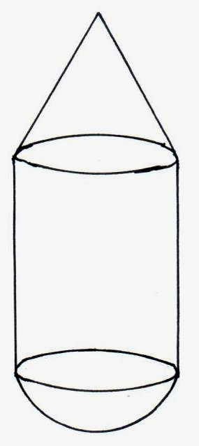

Calculate the external surface area of the model. (4mks)

- The actual rocket has a total height of 6 metres. The outside of the actual rocket capsule
is to be painted. Calculate the amount of paint required if an area of 20m² requires 0.75
litres of the paint. (6mks)

Mathematics Paper 1 15
24. In the triangle OAB, OA = a , OB = b and OC = $\frac{3}{2}$OA.
~
~
~
M divides OB in the ratio 3: 2.
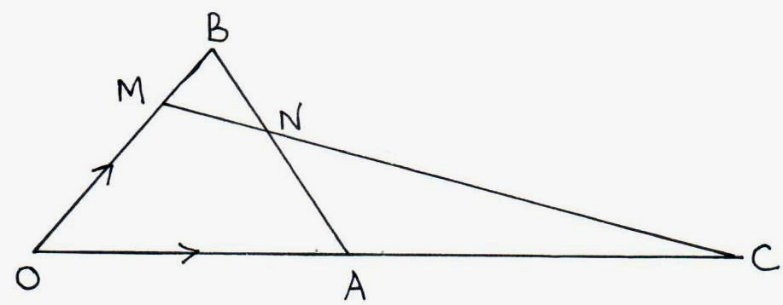

- Express in terms of a and b only, the vectors.
~
~
(i) AB. (1mk)

(ii) MC. (1mk)

- Given the MN = hMC and BN = KBA, express vector MN in two different
ways hence find the value of h and K. (6mks)

(c) Show that the points M, N and C are collinear. (2mks)

Mathematics Paper 1 16

