NAME……………………………………………………….. INDEX NO……………………........................

121/1 CANDIDATE’S SIGN………….….….….…..
MATHEMATICS ALT A
PAPER 1 DATE……….…………………………………
JULY/AUGUST, 2015
TIME: 2½ HOURS

KAHURO/KIHARU DISTRICT JOINT EXAMINATION - 2015

Kenya Certificate of Secondary Education
MATHEMATICS ALT A
PAPER 1
TIME: 2½ HOURS

INSTRUCTION TO CANDIDATE’S:
(a) Write your name, index number and school in the spaces provided at the top of this page.
(b) Sign and write the date of examination in spaces provided above.
(c) This paper consists of TWO sections: Section I and Section II.
(d) Answer ALL the questions in Section I and any five questions from Section II.
(e) Show all the steps in your calculation, giving your answer at each stage in the spaces
provided below each question.
(f) Marks may be given for correct working even if the answer is wrong.
(g) Non-programmable silent electronic calculators and KNEC Mathematical tables may
be used, except where stated otherwise.
(h) This paper consists of 16 printed pages.
(i) Candidates should check the question paper to ascertain that all the pages are printed
as indicated and that no questions are missing.
(j) Candidates should answer the questions in English.

FOR EXAMINER’S USE ONLY:

SECTION I
1 | 2 | 3 | 4 | 5 | 6 | 7 | 8 | 9 | 10 | 11 | 12 | 13 | 14 | 15 | 16 | TOTAL

SECTION II
Grand
Total

17 | 18 | 19 | 20 | 21 | 22 | 23 | 24 | TOTAL

Mathematics Paper 1 Turnover
SECTION I: (50 MARKS)

Answer all the questions in this section in the spaces provided.

1. The signals have been set to flash at interval of 15 minutes, 24 minutes if they all flash at 8.13am
when will they flash together. (2 marks)

2. Solve for m in the equation: (3 marks)
3^{4(m + 1)} + 3^{4m} = 246

3. Use logarithm to evaluate: (4 marks)
$\sqrt[3]{\frac{{\left(0\text{.}\text{08294}\right)}^{2} × {\left(\text{39}\text{.}\text{24}\right)}^{3}}{\text{8458}}}$

Mathematics Paper 1 2 Kahuro/Kiharu
4. Evaluate: (3 marks)
$\frac{\frac{1}{2} \text{of} 3\frac{1}{2} + 1\frac{1}{2}\left(2\frac{1}{2} − \frac{2}{3}\right)}{\frac{3}{4} \text{of} 2\frac{1}{2} ÷ \frac{1}{2}}$

5. A Kenyan Bank buys and sells foreign currencies as shown below.
Buying (Ksh.) Selling (Ksh.)
1 Euro 84.15 84.26
50 Japanese Yen 65.37 65.45

A Japanese travelling from France arrives in Kenya with 5000 Euros. He converts all the 5000
Euros to Kenya Shillings at the bank. While in Kenya he spends a total of Ksh.289,850 and then converts the remaining Ksh. to Japanese Yen at the bank. Calculate the amount in Japanese Yen
that he receives. (4 marks)

Mathematics Paper 1 3 Kahuro/Kiharu
6. Find the equation of a line passing through (2, 1) and perpendicular to the line which makes an angle of 45º with the χ-axis. (3 marks)

7. Use the tables of reciprocals and square roots to evaluate. (3 marks)
$\frac{0\text{.}1}{0\text{.}\text{0351}} + \sqrt{0\text{.}\text{498}}$

8. Convert $0\text{.}\overset{}{1}2\overset{}{3}$into a fraction. (3 marks)

Mathematics Paper 1 4 Kahuro/Kiharu
9. Find the perimeter of the figure below. Give your answer correct to 4s.f. (2 marks)
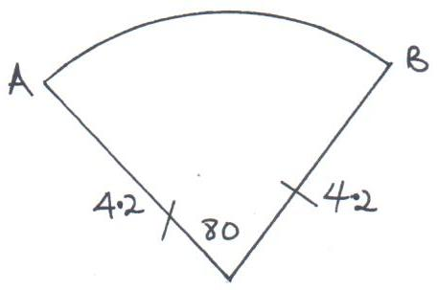

10. The interior angle of a regular polygon is $6\frac{1}{2}$times the exterior angle. How many sides has the polygon. (3 marks)

11. Simplify:
$\frac{3a^{2} − \text{48}}{\text{48} − \text{24}a + 3a^{2}}$ (3 marks)

Mathematics Paper 1 5 Kahuro/Kiharu
12. A solid metal cuboid 1.5m long, 0.4m wide and 0.25m high is made of material of density 7.5g/cm³. Calculate its mass in kg. (3 marks)

13. Thirty two men working at the rate of 9hrs a day can complete a piece of work in 7 days. How many more men working at the rate of 8hrs a day would complete the same work in 6 days? (3 marks)

14. Ruto is $2\frac{1}{4}$times as old as his son. Five years ago, the ratio of their ages was 8:3. What will be their ages 6 years from now? (4 marks)

Mathematics Paper 1 6 Kahuro/Kiharu
15. Two similar cylinders have diameter of 7cm and 21cm. If the larger cylinder has a volume of 6237cm³. Find the heights of the two cylinders. (4 marks)

16. Find the inequalities that define the region R shown in the figure below. (3 marks)
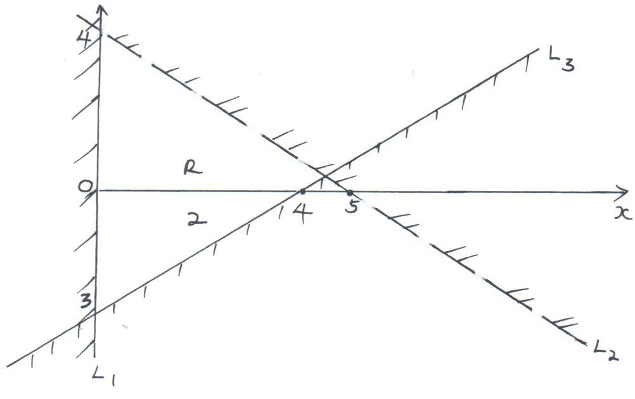

Mathematics Paper 1 7 Kahuro/Kiharu
SECTION B: (50 MARKS)

Answer any FIVE questions from this section.

17. A salesman is paid a commission of 2% on goods worth over Ksh.100000. He is also paid a monthly salary of Ksh.12000. In a certain month, he sold 360 pairs of shoes at Ksh.500 each pair.
(a) Calculate the salesman’s earning that month. (3 marks)

- The following month, his monthly salary was increased by 10%. His total earnings that month
were Ksh.17600. Calculate
(i) The total amount of money received from the sales of the shoes that month. (5 marks)

(ii) The number of pairs of shoes sold that month. (2 marks)

Mathematics Paper 1 8 Kahuro/Kiharu
18. In the figure below OQ = q and OR = r. Point X divides OQ in the ratio 1:2 and Y divides OR in the ratio 3:4. Lines XR and YQ intersect at E.
~
~
~
~
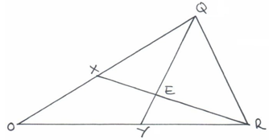

- Express in terms of q and r.
~
~
(i) XR. (1 mark)
~

(ii) YQ. (1 mark)
~

- If XE = mXR and YE = nYQ, express OE in terms of
~
~
~
~
~
(i) r, q and m. (1 mark)
~
~

(ii) r, q and n. (1 mark)
~
~

(c) Using the results in (b) above, find the values of m and n. (6 marks)

Mathematics Paper 1 9 Kahuro/Kiharu
19. From town P, a town Q is 60km away on a bearing South 80º East. A third town R is 100km from
P on the bearing South 40º West. A cyclist travelling at 20km/h leaves P for Q. He stays at Q for
one hour and then continues to R. He stays at R for 1½ hrs and then returns directly to P.
(a) Calculate the distance of Q from R. (3 marks)

(b) Calculate the bearing of R from Q. (4 marks)

(c) What is the time taken for the whole round trip? (4 marks)

Mathematics Paper 1 10 Kahuro/Kiharu
20. (a) Complete the table given below for the equation y = -2χ² + 3χ + 3 for the range -2 ≤ x ≤ 3.5
by filling in the blank spaces. (2 marks)
χ | -2 | -1.5 | -1 | -0.5 | 0 | 0.5 | 1 | 1.5 | 2 | 2.5 | 3 | 3.5
y |  | -6 |  | 1 |  |  |  |  |  | -2 |  | -11
(b) Use the values from the table above to draw the graph of y = -2χ² + 3χ + 3. (3 marks)

Mathematics Paper 1 11 Kahuro/Kiharu
- Use your graph to:
  - determine the integral values of χ in the graphs range which satisfy the inequality
2χ² - 3χ - 3 ≥ 3. (3 marks)

(ii) Solve -2χ² + 2χ + 5 = 0. (2 marks)

Mathematics Paper 1 12 Kahuro/Kiharu
21. A sector of a circle of radius 40cm subtends an angle of 26º at the centre of the circle.
$\left(\text{Take} π = \frac{\text{22}}{7}\right)$.
- Calculate
(i) the area of the sector. (2 marks)

(ii) the length of the arc. (2 marks)

- The sector is folded to form an inverted right cone. Calculate
(i) the base radius of the cone. (2 marks)

(ii) To one decimal place, the vertical height of the cone. (2 marks)

(c) Calculate the capacity of the cone in litres. (2 marks)

Mathematics Paper 1 13 Kahuro/Kiharu
22. The table below shows marks obtained by 100 candidates at Eastside High School in a Biology examination.
Marks | 15 - 24 | 25 - 34 | 35 - 44 | 45 - 54 | 55 - 64 | 65 - 74 | 75 - 84 | 85 - 94
Frequency | 6 | 14 | 24 | 14 | χ | 10 | 6 | 4
(a) Determine the value of χ. (2 marks)

(b) State the modal frequency. (1 mark)

(c) Calculate the median mark. (4 marks)

(d) Calculate the mean mark. (3 marks)

Mathematics Paper 1 14 Kahuro/Kiharu
23. (a) A racing cyclist completes the uphill section of a mountain course of 75km at an average
speed of (V + 20)km/h. Given that the difference between the time is one hour, form and
solve an equation in V. Hence,
- find the total time taken to complete the uphill and the downhill sections of the
course. (4 marks)

(ii) Calculate the cyclists average speed over the 150km. (2 marks)

(b) A train moving at an average speed of 72km/hr takes 15 seconds to complete cross a bridge that is 80m long.
(i) Express 72km/hr in metres per second. (2 marks)

(ii) Find the length of the train. (2 marks)

Mathematics Paper 1 15 Kahuro/Kiharu
24. (a) After t seconds, a particle moving along a straight line has a velocity of Vm/s and an
acceleration of (5 – 2t)m/s². the particles initial velocity is 2m/s.
(i) Express V in terms of t. (3 marks)

(ii) Determine the velocity of the particle at the beginning of the third second. (2 marks)

(b) Find the time taken by the particle to attain maximum velocity and the distance it covered to attain the maximum velocity. (5 marks)

Mathematics Paper 1 16 Kahuro/Kiharu

