NAME……………………………………………………….. INDEX NO……………………........................

121/2 CANDIDATE’S SIGN………….….….….…..
MATHEMATICS ALT A
PAPER 2 DATE……….…………………………………
JULY/AUGUST, 2014
TIME: 2½ HOURS

CENTRAL KENYA NATIONAL SCHOOLS JOINT EXAM - 2014

Kenya Certificate of Secondary Education
MATHEMATICS ALT A
PAPER 2
TIME: 2½ HOURS

INSTRUCTION TO CANDIDATE’S:
(a) Write your name, index number and school in the spaces provided at the top of this page.
(b) Sign and write the date of examination in spaces provided above.
(c) This paper consists of TWO sections: Section I and Section II.
(d) Answer ALL the questions in Section I and any five questions from Section II.
(e) Show all the steps in your calculation, giving your answer at each stage in the spaces
provided below each question.
(f) Marks may be given for correct working even if the answer is wrong.
(g) Non-programmable silent electronic calculators and KNEC Mathematical tables may be
used, except where stated otherwise.
(h) This paper consists of 16 printed pages.
(i) Candidates should check the question paper to ascertain that all the pages are printed
as indicated and that no questions are missing.
(j) Candidates should answer the questions in English.

FOR EXAMINER’S USE ONLY:

SECTION I
1 | 2 | 3 | 4 | 5 | 6 | 7 | 8 | 9 | 10 | 11 | 12 | 13 | 14 | 15 | 16 | TOTAL

SECTION II
Grand
Total

17 | 18 | 19 | 20 | 21 | 22 | 23 | 24 | TOTAL

Mathematics Paper 2 Turnover
SECTION I: (50 MARKS)

Answer all the questions in this section in the spaces provided.

1. Find the percentage error in:
$\frac{\text{20} × \text{25}\text{.}0}{\text{10}\text{.}5}$ (3mks)

2. Use reciprocal and square tables to evaluate, to 4 significant figures.
$\frac{1}{\text{485}\text{.}6} + 8\text{.}{\text{254}}^{2}$ (3mks)

3. Make K the subject of the formula and simplify.
$t = \frac{2y + 1}{\sqrt{2\text{Ky} + K}}$ (3mks)

Mathematics Paper 2 2
4. Expand ${\left(5 − \frac{χ}{2}\right)}^{6}$ up to term in χ³ uses your expansion to estimate the value of ${\left(4\frac{1}{2}\right)}^{6}$correct
to one decimal place. (2mks)

5. Find the number of terms in the series. a + 3a + 9a + ---- 243a. (3mks)

6. The number χ is chosen at random from the set (0, 3, 6, 9) and the number y is chosen at random
from the set (0, 2, 4, 6, 8). Calculate the probability of each of the following separate evens.
(a) χ > 6. (1mk)

(b) χ + y = 11. (2mks)

Mathematics Paper 2 3
7. Given that 4y = 3 Sin $\frac{2}{5}θ$ for O ≤ θ ≤ 360° determine.
(a) Amplitude of the curve. (1mk)

(b) Period of the curve. (2mks)

8. Find the radius and centre of the circle whose equation is:
$\frac{χ^{2}}{2} − 2χ + \frac{y^{2}}{2} − 5y + 2 = 0$ (3mks)

Mathematics Paper 2 4
9. Simplify the following:
$\frac{1 − \frac{\sqrt{5}}{3}}{\frac{2}{3} + \frac{\sqrt{5}}{3}}$

10. Construct the locus of point P such that ∠APB = 120° using a pair of compasses and ruler only.
(3mks)

11. Given that 5^{χ} = 7^{y} find the ratio χ: y. (3mks)

Mathematics Paper 2 5
12. Find the equation of the normal to a curve χ² = 4y + 1 at the point (2, 0.75). (4mks)

13. Calculate the standard deviation of 42, 45, 46, 50, 52, 56, 59. (3mks)

14. OA = 3i + 4j – 6K and OB = 2i + 3j + K. P divide line AB in the ratio 3: -2.
Write the coordinate of P. (3mks)

Mathematics Paper 2 6
15. Two variables y and χ are such that y varies partly as χ and partly as the square of χ. Determine
the relationship between y and χ given when χ = 2, y = 28, χ = 3, y = 48. (3mks)

16. Draw the net of the solid below and calculate surface area of its surfaces VA = VB = VC =
VD = 10cm. (3mks)
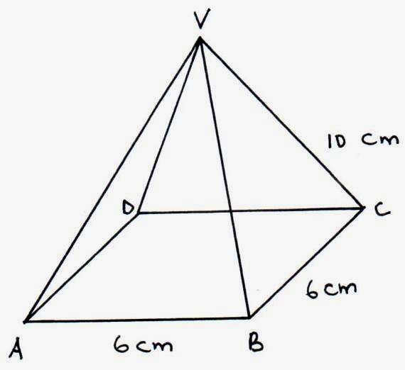

Mathematics Paper 2 7
SECTION II: (50 MARKS)

Answer only five questions from this section in the spaces provided:

17. The first, fourth and thirteenth terms of an Arithmetic Progression (AP) correspond to the first
three consecutive terms of an increasing Geometric Progression (G.P). Given the first term of
the AP is a and the common difference is d.
(a) Write down the first three terms of the G.P in terms of a and d. (1mk)

- The sum of the third and the eleventh terms of the A.P is 30.
Calculate:
(i) the common difference of the A.P. (5mks)

(ii) the first term of the A.P. (1mk)

(iii) the common ratio of the G.P. (1mk)

(iv) sum of the first 10 terms of the G.P. (2mks)

Mathematics Paper 2 8
18. (a) Complete the table below.
θ | 0° | 30° | 60° | 90° | 120° | 150° | 180° | 210° | 240° | 270° | 300° | 330° | 360°
Tan $\frac{1}{2} θ$ | 0.0° | 0.27 |  | 1 | 1.73 | 3.73 |  | -3.73 | -1.73
2 Cos θ |  | 1.73 | 1 |  |  | 1.73 |  |  |  | 0 | 1 | 1.73 | 2
(b) Using the grid provided and the table above, draw the graph of $Y = \text{tan} 12θ$ and Y = 2 Cos θ.
(5mks)
- Use your graph to:
(i) Solve$\text{tan} 12θ − 2 \text{Cos} θ = O$. (1mk)
(ii) determine period of $\text{tan} 12θ$. (1mk)
(iii) determine amplitude of y = Cos θ. (1mk)

Mathematics Paper 2 9
19. Income tax for all the income earned is charged at the rate shown in the table below.

Salary in Kƒ per month | Tax in Shs. per ƒ | Total tax per slab
The first 300 | 2
Next 300 | 3
Next 300 | 5
Next 300 | 7
Excess χ | 11

(a) Complete the table by filling the value for the total tax per slab. (2mks)

- Emma claiming a tax relief of Ksh.600 discovered that a total of Kshs.5710 is deducted from
her earnings in form of income tax. How much is her taxable amount in Ksh. (6mks)

- Determine her net income if she earns a non-taxable entertainment allowance of
Shs.3010 and that she pays a bank loan of Kshs.400. (2mks)

Mathematics Paper 2 10
20. In the figure below O is the centre of the circle TN is a tangent to the circle of m
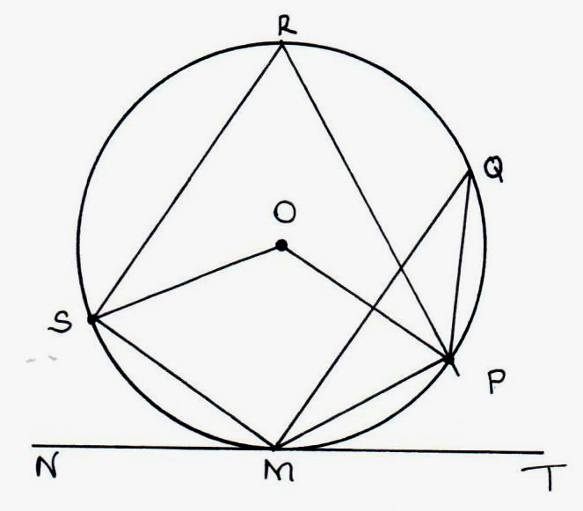
∠PQM = 15°
∠SMN = 33°

Giving reasons; find
- ∠POM.

- ∠PMT

- ∠PRS.

- ∠OSM

(v) ∠OPM

Mathematics Paper 2 11
21. (a) Draw the table for the equation y = χ³ + 2χ². (2mks)

χ | -3 | -2.5 | -2 | -1.50 | -1 | -0.5 | 0 | 0.5 | 1 | 1.5
2χ² | 18 | 12.5 | 8 | 4.5 | 2 |  | 0 |  | 1 | 4.5
χ³ | -27 |  | -8 |  | 1 |  | 0 |  | 1
y | -9 |  | 0 |  | 3 |  | 0 |  | 2

- On the grid provided, draw the graph of y = χ³ + 2χ² for -3 ≤ × ≤ 1.5. Take the scale 2cm
for 1 unit on the X-axis and 1cm for 1 unit on the Y-axis. (3mks)

(c) (i) Solve the equation χ³ + 2χ² = 0.
(ii) Solve the equation χ³ + 2χ² - χ - 2 = 0 using your graph and another line graph.(3mks)

Mathematics Paper 2 12
- The figure below shows a right pyramid with a square base ABCD. VC = 20cm, AB = BC = 10.
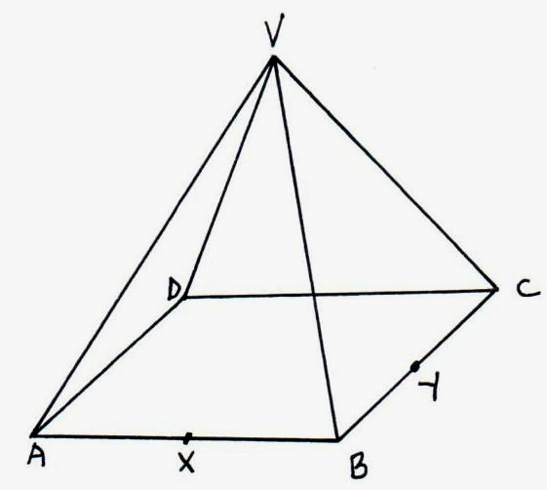

X and Y are the mid-point of AB and BC respectively. Calculate
(a) the vertical height VO to 2d.p. (3mks)

(b) the angle between VD and ABCD. (2mks)

(c) the angle which plane VXY makes with the base. (5mks)

Mathematics Paper 2 13
23. P and Q are two points on the same parallel of latitude 66°25¹, whose longitudes differ by 120°. Calculate
(a) the radius of the parallel of latitude where P and Q lie R (6370km). (2mks)

(b) the distance of P and Q measured along the parallel of latitude. (2mks)

(c) (i) the length of the straight line joining PQ. (2mks)

(ii) the distance PQ along the latitude in nautical mile. (2mks)

(d) If an aircraft took 30min to fly P to Q. Calculate its speed in knots. (2mks)

Mathematics Paper 2 14
24. In a certain Mathematical relationship, the values of A and B are found to obey the relationship
B = CA + KA² where C and K are constants. Below is a table of values of A and B.

A | 1 | 2 | 4 | 6
B | 3.2 | 6.75 | 15.1 | 25.2

(a) By drawing a suitable straight line graph, determine the values of C and K. (8mks)

Mathematics Paper 2 15
(b) Hence write the relationship between A and B. (1mk)

(c) Determine the value of B when A = 7. (1mk)

Mathematics Paper 2 16

