NAME……………………………………………………….. INDEX NO……………………........................

121/2 CANDIDATE’S SIGN………….…..….….…..
MATHEMATICS ALT A
PAPER 2 DATE……….…………………………….……
JULY/AUGUST, 2015
TIME: 2½ HOURS

KAHURO/KIHARU DISTRICT JOINT EXAMINATION - 2015

Kenya Certificate of Secondary Education
MATHEMATICS ALT A
PAPER 2
TIME: 2½ HOURS

INSTRUCTION TO CANDIDATE’S:
(a) Write your name, index number and school in the spaces provided at the top of this page.
(b) Sign and write the date of examination in spaces provided above.
(c) This paper consists of TWO sections: Section I and Section II.
(d) Answer ALL the questions in Section I and any five questions from Section II.
(e) Show all the steps in your calculation, giving your answer at each stage in the spaces
provided below each question.
(f) Marks may be given for correct working even if the answer is wrong.
(g) Non-programmable silent electronic calculators and KNEC Mathematical tables may
be used, except where stated otherwise.
(h) This paper consists of 16 printed pages.
(i) Candidates should check the question paper to ascertain that all the pages are printed
as indicated and that no questions are missing.
(j) Candidates should answer the questions in English.

FOR EXAMINER’S USE ONLY:

SECTION I
1 | 2 | 3 | 4 | 5 | 6 | 7 | 8 | 9 | 10 | 11 | 12 | 13 | 14 | 15 | 16 | TOTAL

SECTION II
Grand
Total

17 | 18 | 19 | 20 | 21 | 22 | 23 | 24 | TOTAL

Mathematics Paper 2 Turnover
SECTION I: (50 MARKS)

Answer all the questions in this section in the spaces provided.

1. Kamoni bought four pens and three books for a total of Shs.17 while Jane bought five similar pens and
two books for Shs.16. Find the cost of a pen and an exercise. (3 marks)

2. A shopkeeper mixes rice worth Kshs.47 and Kshs.55 per kg, how many kilograms of each should be
used to obtain 24kg of the mixture worth Kshs.52 per kg. (3 marks)

3. Solve for χ in
Log₂ (χ² - 9) = 3 log₂ 2 + 1 (3 marks)

Mathematics Paper 2 2 Kahuro/Kiharu
4. John deposits Shs.24000 in a fixed account. After 4 years the money accumulated to Kshs.45,000. If the bank paid compound interest of r% p.a compounded semi annually find r. (3 marks)

5. If 4χ² + 3χ - 20 + K is a perfect square find value of K. (3 marks)

6. A triangle whose area is 6.5cm² is mapped onto a triangle whose area is 13cm² by a matrix
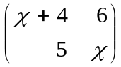. Find the possible values of χ. (4 marks)

Mathematics Paper 2 3 Kahuro/Kiharu
7. Given that χ is an acute angle and 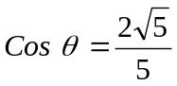 find without Mathematical tables or calculator
tan (90 - θ). (2 marks)

8. The diameter AB of a circle passes through points A (-4, 1) and B(2, 1). Find the equation of the
circle and leave your answer in the form χ² + y² + aχ + by = c where a, b and c are constants. (4 marks)

9. Expand 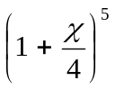up to the term in χ⁴. Hence evaluate (0.95)⁵ giving your answer correct to 4s.f. (3 marks)

Mathematics Paper 2 4 Kahuro/Kiharu
10. Two variables are such that A is partly constant and partly varies as the square root of B. Given that
A = 27 when 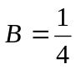 and A = 18; when B = 25, find A when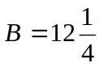. (3 marks)

11. A curve passes through the point (3, -3), if its gradient function is 5χ² + 1, find its equation. (2 marks)

12. Pipe A can fill an empty water tank in 3hrs while Pipe B can fill the same tank in 6hrs. When the tank
is full it can be emptied by Pipe C in 8hrs. Pipe A and B are opened at the same time when the tank
is empty. If one hour later Pipe C is also opened, find the total time taken to fill the tank. (3 marks)

Mathematics Paper 2 5 Kahuro/Kiharu
13. Make χ the subject of the formula:
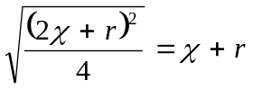 (3 marks)

14. The 16th term of an A.P. is seven times the 8th term. The sum of the first ten terms is -35. Find the first term and the common difference. (4 marks)

Mathematics Paper 2 6 Kahuro/Kiharu
15. The following were recorded on a field note book by a surveyor. Taking the base line as 550M find
the area in M². (3 marks)

 |  |  | B
 |  |  | 550 | 120 | TO | A
 | C | 150 | 450
 |  |  | 250 | 90 | T O | D
 | E | 60 | 40
 |  |  | F

16. Given that 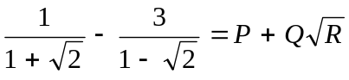 find the values of P, Q and R. (4 marks)

Mathematics Paper 2 7 Kahuro/Kiharu
SECTION B: (50 MARKS)

Answer any FIVE questions from this section.

17. The table below shows the rates at which income tax is charged on annual income.
Annual taxable income  (K£) | Rates (Shs. Per K£)
1 – 2800 | 3
2801 - 4600 | 5
4601 – 7200 | 6
7201 – 9000 | 7
9001 – 11800 | 9
11801 – 13600 | 10
Over 13600 | 12

A company employee earns a gross monthly salary of Ksh.18600. He is housed by the company
and as a result, his taxable income is increased by 15%. If the employee is married and claims
a monthly family relief of Shs.250, calculate
(a) his taxable income. (2 marks)

(b) his net salary per month. (8 marks)

Mathematics Paper 2 8 Kahuro/Kiharu
18. (a) Complete the table below for the function y = Sin 2χ and y = 3 Cos χ for -180º ≤ x ≤ 180º. (2 marks)
χº | -180 | -150 | -120 | -90 | -60 | -30 | 0 | 30 | 60 | 90 | 120 | 150 | 180
Sin 2χ | 0 |  |  | 0 | -0.87 |  |  |  | 0.87 | 0 |  |  | 0
3 Cos χ | -3 | -2.6 |  | 0 |  | 2.6 |  |  |  |  | -1.5
(b) On the same axes, draw the graph of y = Sin 2χ and y = 3 Cos χ -180º ≤ x ≤ 180º. (5 marks)
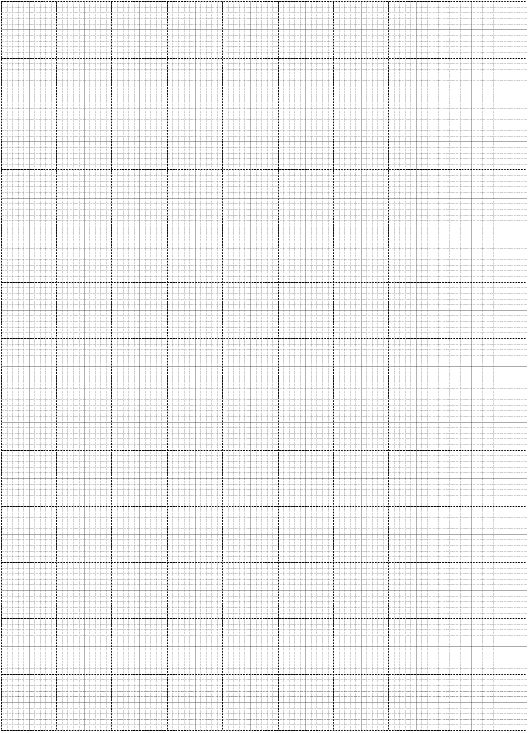

Mathematics Paper 2 9 Kahuro/Kiharu
- Use the graph in (b) above to find:
  - the value of χ such that 3 Cos χ - Sin 2χ = 0. (1 mark)

  - the difference in value of y when χ = 45º. (1 mark)

(iii) Range of values of χ such that 3 Cos x > 1.5. (1 mark)

Mathematics Paper 2 10 Kahuro/Kiharu
19. In the diagram below ∠EDG = 36º, ∠ABG = 42º line EDC and ABC are tangents to the circle at
D and B respectively.
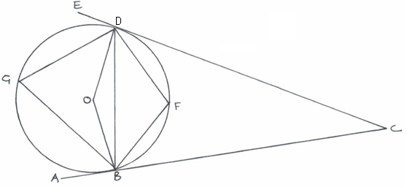

Calculate by giving reason.
(a) ∠DGB. (2 marks)

(b) Obtuse ∠DOB. (2 marks)

(c) ∠GDB. (2 marks)

(d) ∠DCB. (2 marks)

(e) ∠DFB. (2 marks)

Mathematics Paper 2 11 Kahuro/Kiharu
20. The position of two towns are A (30ºS, 20ºW) and B (30ºS, 80ºE) find
(a) the difference in longitude between the two towns. (1 mark)

- (i) the distance between A and B along parallel of latitude in km (take radius of the earth
as 6370km and 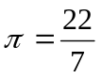). (3 marks)

(ii) in nm. (2 marks)

(c) Find local time in town B when it is 1.45pm in town A. (4 marks)

Mathematics Paper 2 12 Kahuro/Kiharu
21. In the figure below A and B are centres of the circle intersecting at point P and Q, angle PBQ = 97.2º while PAQ = 52º, PB = 4cm while AP = 10cm.
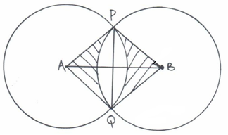

Determine:-
(a) the length AB. (3 marks)

(b) the area of sector APQ. (2 marks)

(c) the area of the quadrilateral, APBQ. (3 marks)

(d) area of the shaded region. (2 marks)

Mathematics Paper 2 13 Kahuro/Kiharu
22. ABCD is a quadrilateral with vertices A (3, 1), B (2, 4), C (4, 3), D (5, 1).
(a) Draw the image A¹B¹C¹D¹ image of ABCD under transformation matrix 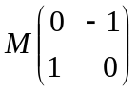
and write down the co-ordinates. (4 marks)
- A transformation represented by 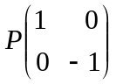maps A¹B¹C¹D¹ onto A¹¹B¹¹C¹¹D¹¹ determine
the co-ordinates of the image and draw A¹¹B¹¹C¹¹D¹¹. (3 marks)

- Determine the single matrix of transformation which maps ABCD onto A¹¹B¹¹C¹¹D¹¹
and describe the transformation. (3 marks)

Mathematics Paper 2 14 Kahuro/Kiharu
23. (a) Without using a set square or a protractor, construct triangle ABC such that AB = AC = 5.4cm
and angle ABC = 30º. (3 marks)

(b) Measure BC. (1 mark)

(c) A point P is always on the same side of BC as A. Draw the locus of P such that
angle BAC is always twice angle BPC. (2 marks)

(d) Calculate the area of triangle ABC. (2 marks)

(e) Draw a perpendicular from A to meet BC at D. Measure AD. (2 marks)

Mathematics Paper 2 15 Kahuro/Kiharu
24. The figure below represent a right pyramid with vertex V and a rectangular base PQRS.
VP = VQ = VR = VS = 18cm and QR = 12cm, M and O are midpoints of QR and PR respectively.
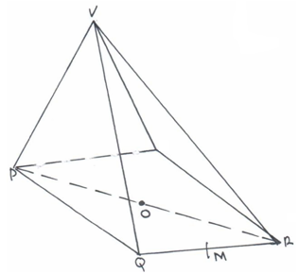

Find:
(a) the length of the projection of VP on the plane PQRS. (3 marks)

(b) size of angle between VP and plane PQRS. (3 marks)

(c) size of angle between plane VQR and PQRS. (4 marks)

Mathematics Paper 2 16 Kahuro/Kiharu

