NAME:……………………………………………………… INDEX NO:…………………………
SCHOOL:………………………………………………….. DATE:……………………………….
SIGN:………………………………..

121/1
MATHEMATICS
PAPER 1
JULY/AUGUST - 2012
TIME: 2 ½ HOURS

KISII SOUTH DISTRICT EVALUATION EXAM-2012
Kenya Certificate of Secondary Education (K.C.S.E)

121/1
MATHEMATICS
PAPER 1
JULY/AUGUST - 2012
TIME: 2 ½ HOURS

INSTRUCTIONS TO CANDIDATES
1. Write your name and index number in the spaces provided at the top of this page.
2. This paper consists of two sections: Section l and Section II.
3. Answer all questions in section l and five questions from Section II.
4. Show all the steps in your calculations, giving your answers at each stage in the spaces below
each question.
5. Marks may be given for correct working even if the answer is wrong.
6. Non- programmable silent electronic calculators and KNEC Mathematical tables may be used.

FOR EXAMINER’S USE ONLY
SECTION I
1 | 2 | 3 | 4 | 5 | 6 | 7 | 8 | 9 | 10 | 11 | 12 | 13 | 14 | 15 | 16 | TOTAL

SECTION II GRAND TOTAL

17 | 18 | 19 | 20 | 21 | 22 | 23 | 24 | TOTAL

This paper consists of 16 printed pages. Candidates should check the question paper to ascertain that all pages are printed as indicated and that no questions are missing.

SECTION I (50 MARKS)
Answer all the questions in this section.
1. Without using a calculator, evaluate, $\frac{214 +35 ÷56 \text{of} 225}{17\text{10}}$, leaving your answer as a fraction in its simplest form. ( 3mks)

2. Find the equation of a perpendicular bisector of a line AB if the coordinates of A and B are
(-4,-2) and (6,2) respectively. (3mks)

3. Use squares, squares roots and reciprocal tables only to evaluate the following giving your answer correct to 2 decimal places. (4mks)

4. Find the integral values of x for which: (3mks)
-6 < 3x + 3
14 – 3x >2
14 – 3x > 2

5. Pipe A empties a full tank in 8 hours, pipe B empties in 6 hours and pipe C empties in 3 hours. If all the three pipes are open for 30 minutes and then pipe A closed , How long will it take to empty a full tank.

6. Without using a calculate or mathematical table, evaluate.
$\frac{8^{23} + 4 ^{32}}{{\text{16}}^{−34}}$

7. Simplify the expression: (3mks)
$\frac{3x^{2}−4\text{xy} +y^{2}}{9x^{2}−y^{2}}$

8. Two trains T₁ and T₂, traveling in opposite directions on parallel tracks are just beginning pass one another. Train T₁ is 72metres long and is traveling at 108km/hr.T2 is 78 metres
Long and traveling at 72km/hr. Find the time in seconds the two take to completely pass one another. (4mks)

9. In the figure bellowed and EA are tangents to the circle at D and A. DC is parallel to AB and <BDC = 51^{0.} Calculate the value of x. (3mks)
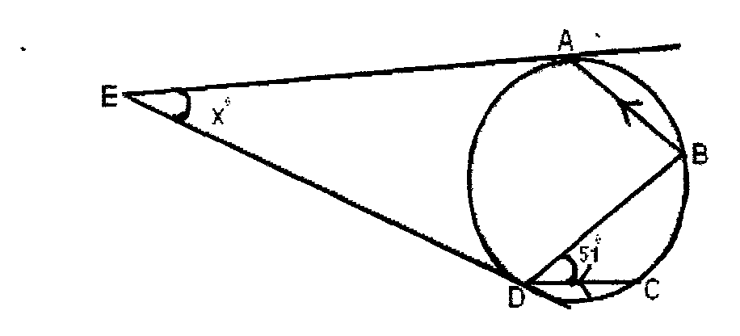

10. Two similar containers have base areas 25cm² and 324cm² respectively. Calculate the Capacity of the larger container correct to one decimal place if the capacity of the smaller
one is 8cm³ (3mks)

11. Solve for m in;
Log5 – 2 + (2m+10) = log (m-4) (4mks)

12. Given that $1\text{.}\overset{}{0} \overset{}{5}$1.05 = 1 a/b, Find the values of a and b. (3mks)

13. A Kenyan bank buys and sells foreign currencies using the rates shown below.
Buying Selling
(Ksh) (Ksh)
1 Euro 86.25 86.97
100 Japanese Yen 66.51 67.26
A Japanese traveling from France arrives in Kenya with 5000 Euros, which he converts to Kenya shillings at the bank. While in Kenya he spent a total of Ksh.289,850 and then converted the
remaining Kenya shillings to Japanese Yen at the bank. Calculate the amount of Japanese Yen that he received. (3 mks)

14. All prime numbers between ten and twenty are arranged in descending order to form a number.
a) Write down the number (1mk)

b) State the total value of the third digit in the number formed in (a) above. (1 mark)

15. An aircraft flying at 800 knots leaves airport A(60N. I 2E) at 9am local time for airport B (60N,88W) along the parallel of latitude. Find the local time at B when the plane lands. (3mks)

16. The diagram below represents a right pyramid on a square base of side 3 cm. The slant
Height of the pyramid is 4 cm.
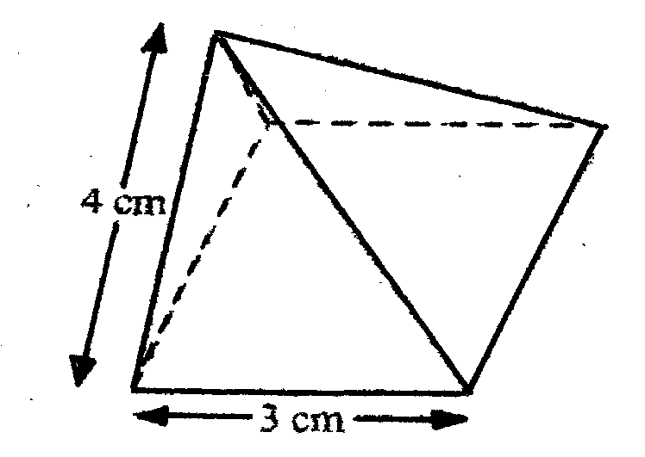
a) Draw a net of the pyramid (2 marks)

b) On the net drawn, measure the height of a triangular face from the top of the Pyramid
( 1 mark)

SECTION 11 (50 MARKS)
Answer only FIVE questions from this section.
17. The vertices of a triangle are A(2,5), B(4,3) and C(2,3). H represents a half turn rotation about the point (0,2).
a) Draw triangles ABC and A¹,B¹,C ¹under H (4 mks)

b) T represents a reflection in the line x = 0 and K represents a translation $\begin{aligned}\left(0 | \right) \\ \end{aligned}$ Find the coordinates of A” , B”,C” of A’, B’,C’ under TK. Hence draw triangle A”B”,C”. (4mks)

c) Find the area of triangle A”,B”,C’ (2mks)

18. B is 102km on the bearing of 112° from A. C is 94km on the bearing of 062° from B D is 073° from A and 336° from C.
(a) Using a scale of 1cm to represent 20km,draw a diagram to show the positions of A,B,C
and D. (6mks)

b) Using your diagram, determine;
i) The bearing of B from D and A from C. (2mks)

ii) The distance AC and BD (2mks)

19. A group of people planned to contribute equally towards a water project which needed kshs. 2,000,000 to complete. However, 40 members of the group withdrew from the project. As a result, each of the remaining members were to contribute ksh 2500 more.

(a) Find the original number of members in the group. (5mks)

(b) Forty five percent of the value of the project was funded by Constituency Development Fund (CDF). Calculate the amount that would be made by each
of the remaining members of the group. (3mks)

(c) Members contribution were in terms of labour provided and money contributed. The ratio of the value of labour to the money contributed was 6:19, calculate the total amount of money contributed by the members (2mks)

20. A bus left Kisumu at 9:30 a.m towards Nairobi at an average speed of 81 km/hr. A matatu left Nairobi at 10.10 a.m at an average speed of 72km/hr. The distance between Kisumu and Nairobi is 360km.
(a) Determine
(i) The time taken before the two vehicles met. (3mks)

(ii) The distance between the two vehicles 40 minutes after meeting. (2mks)

b) A car left Kisumu towards Nairobi at 9.50 a.m at an average speed of 90 km/hr.
Determine
i) The time when the car caught up with the bus. (3mks)

ii) The distance of Nairobi from the place where the car caught up with the bus. (2mks)

21. In the figure below E is the mid point of BC. AD: DC 3:2 and F is the meeting point of BD and AE.
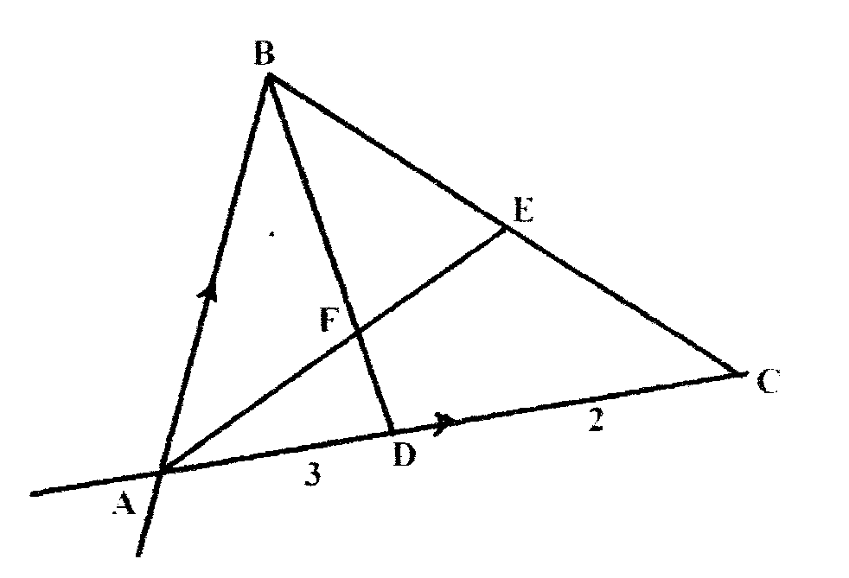

If ab = b and AC = c (2mk)
i) BD

ii) AE (2mks)

b) If BF = t BD and AF = n AE. Find the value of t and n. (5mks)

c) State the ratio of BD to BF. (1mk)

22. A surveyor recorded the measurements of a field in a field book using lines AB 260m as shown below.

 | B
 | 130 | R 40
 | 70 | Q10
 | 50 | P20
S50 | 10
 | A
a) Sketch the map of the field. (4mks)

b) Find the area of the field in hectares. (6mks)
23. A trader sold an article at sh.4800 after allowing his customer a 12% discount on the marked price of the article. In so doing he made a profit of 45%.
a) Calculate
(i) The marked price of the article. (3 marks)

(ii) the price at which the trader had bought the article (2marks)

b) If the trader had sold the same article without giving a discount. Calculate the percentage profit he would have made. (3 marks)

c) To clear his stock, the trader decided to sell the remaining articles at a loss of 12.5% calculate the price at which he sold each article. (2mks)

24. The distances S metres from a fixed point ), covered by a particle after t seconds is given by the equation, S= t³ – 6t² + 9t +5
a) Calculate the gradient to the curve at t = 0.5 seconds. (3mks)

b) Determine the values of S at the maximum and minimum turning points of the curve.
(4mks)

c) On the space provided, Stretch the curves of S = t³ – 6t +9t + 5
END

