NAME:……………………………………………………… INDEX NO:…………………………
SCHOOL:………………………………………………….. DATE:……………………………….
SIGN:………………………………..

121/2
MATHEMATICS
PAPER 2
JULY/AUGUST - 2012
TIME: 2 ½ HOURS

MANGA DISTRICT JOINT EVALUATION EXAM– 2012
Kenya National Examination Council (K.C.S.E)

121/2
MATHEMATICS
PAPER 2
JULY/AUGUST - 2012
TIME: 2 ½ HOURS

INSTRUCTIONS TO CANDIDATES
1. Write your name and Index number in the spaces provided above.
2. The paper contains two sections. Section I and II.
3. Answer all the questions in section I and only any FIVE questions from section II.
4. All answers and working must be shown on the question paper in the spaces below each question.
5. Show all steps in your calculations, giving answers at each stage.
6. Marks may be given for each correct working even if the answer is wrong.
7. Non-programmable silent electronic calculators and KNEC mathematical tables may be used.

FOR EXAMINER’S USE ONLY
SECTION I
1 | 2 | 3 | 4 | 5 | 6 | 7 | 8 | 9 | 10 | 11 | 12 | 13 | 14 | 15 | 16 | TOTAL

SECTION II GRAND TOTAL

17 | 18 | 19 | 20 | 21 | 22 | 23 | 24 | TOTAL

This paper consists of 16 printed pages. Candidates should check the question paper to ascertain that all pages are printed as indicated and that no questions are missing.
SECTION I(50MARKS)
Answer all questions.
1. When asked to find $\frac{7}{\text{18}}$of a certain number, Juma found by mistake $\frac{7}{8}$of it. Hence the answer
was too large by 105.Find the number. (3mks)

2. Without using mathematical tables or calculator, evaluate
$6{\text{Log}}_{2}3\sqrt{\text{64}}+\text{10} {\text{log}}_{3}5\sqrt{\text{243}}$ (3mks)

3. Solve for x, for $0^{0}≤x≤{\text{360}}^{0}$ (3mks)
4 tan²x +3tanx=0

4. Momanyi deposited sh. 24,000 in a fixed account for a period of 24 months .The bank pays
compound interest on quarterly basis. At the end of this period, Momanyi’s account had ksh. 64,200.Determine the rate at which interest is paid per annum. (3mks)

5. Simplify the following surd in the form $a\sqrt{2}+b\sqrt{5}$where a and b are constants. (3mks)
$\frac{5}{2\sqrt{2}−\sqrt{5}}−\frac{2}{2\sqrt{2}+\sqrt{5}}$

6. The figure below is a circle of radius 8cm.Point A,B and C are vertices of the triangle ABC, in
which ,<ABC=80⁰ and <ACB=60⁰ which is in the circle.
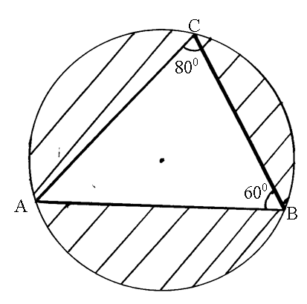
Calculate the area of the triangle ABC (4mks)

7. Expand completely (x-0.2)⁵.
Hence use your expansion to find the exact value of (9.8)⁵ (3mks)

8. Make b the subject of the formula (3mks)
$a=\frac{\text{bd}}{\sqrt{b^{2}+d}}$

9. The eleventh term of an A.P is four times the second term. If the sum of the first seven terms of the A.P is 175 find the first term and the common difference. (3mks)

10. An object whose area is 80cm² is mapped onto an image where area is 40cm² after a transformation represented by the matrix$\left(\begin{matrix}k & 2 \\ 3 & 4\end{matrix}\right)$
Find the value of k. (3mks)

11. The gradient of a curve at any point is given by the function 2-x².If the curve passes through the point (-1,3).Find its equation (3mks)

12. The velocity of water flowing through a pipe is inversely proportional to the square of the radius of the pipe. If the velocity of the water is 30cm/s when the radius of the pipe is 2cm.Find the velocity of the water when the radius of the pipe is 4cm. (3mks)

13. The sum of two numbers is 15.The difference between five times the first number and three times the second number is 19.
Find the two numbers (3mks)

14. Find the distance along a parallel of a latitude between the points A(75⁰N,38⁰E) and B(75⁰N,42⁰W) in
(a) Kilometers (2mks)

(b) nautical miles (2mks)
(Take Radius =6370 km)

15. Nyambane missed two types of coffee, type A and type B in the ration 1:3 by mass. The coffee type A and type B cost sh. 180 per kg and ksh. 120 per kg respectively.
Calculate the percentage profit when the mixture is sold at ksh. 162 per kg. (3mks)

16. A nail is known to have a diameter of 5mm. it is measured with a micrometer screw gauge and the diameter is recorded as 4.986 mm.
Calculate the percentage error in this measurement. (3mks)

SECTION II (50 MARKS)
Answer ONLY FIVE Questions
17. Use the taxation rates in the table below to answer the questions that follow:

Taxable income in K£ p.a | Rate (%)
1 – 4500  4501 – 7,500  7501 – 10,500  10501 – 13,500  13,501 – 16,500  Over 16,500 | 10  15  20  25  30  35
Mr Okweba is a manager of a certain company who is entitled to a monthly personal relief of sh. 3000 and his tax (P.A.Y.E) is sh. 9000 per month and cooperative shares of sh. 1200 per month is contributed.
Calculate
(a) Mr. Okweba’s total deductions per month from his earnings, (2mks)

(b) Total tax per month without relief. (1mk)

(c) Mr. Okweba’s monthly basic salary in his monthly allowances amounted to sh. 12,000
(7mks)

18. In the figure below AB=$\underset{\text{\sim }}{a}$AD=$\underset{\text{\sim }}{b}$ AX:XC=2:3 and DX:XB=4:5

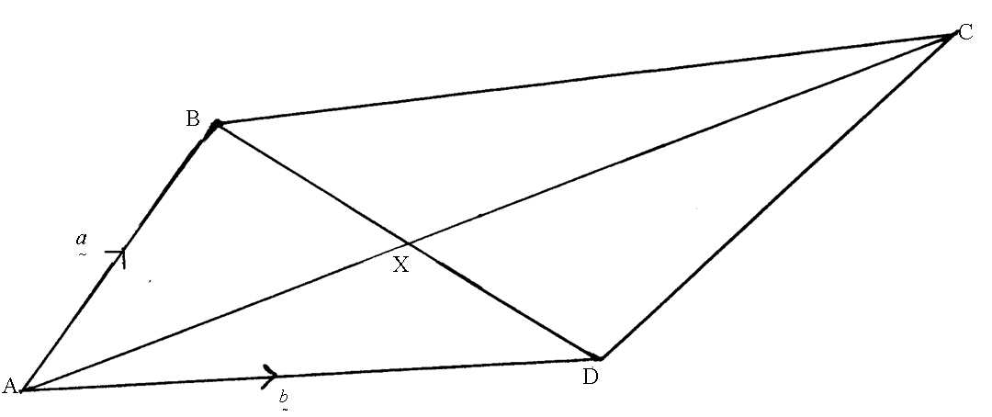
(a) Express $\underset{\text{\sim }}{\text{AC}}$in terms of $\underset{\text{\sim }}{a}$and $\underset{\text{\sim }}{b}$in the simplest form. (5mks)

(b) Express $\underset{\text{\sim }}{\text{DC}}$in terms of $\underset{\text{\sim }}{a}$and $\underset{\text{\sim }}{b}$in the simplest form (2mks)

(c) If $\underset{\text{\sim }}{\text{BC}}$=n$\underset{\text{\sim }}{a}$+m$\underset{\text{\sim }}{b}$, find the values of n and m. (3mks)

19. The marks scored by 50 students in a maths test were as follows:

Marks | 10-19 | 20-29 | 30-39 | 40-49 | 50-59 | 60-69 | 70-79 | 80-89 | 90-99
Frequency | 1 | 2 | 5 | 8 | 13 | 10 | 6 | 3 | 2
(a) State the modal class (1mk)

(b) On the grid provided draw an ogive (4mks)

(c) From the graph in (b) above determine
(i) The mediun mark (1mk)

(ii) The quartile deviation (3mks)

(iii) The pass mark is 44% of the students passed the test. (1mk)

20. Given that x+y=8 and x²+y²=34.Find the value of
(a) x²+2xy+y² (2mks)

(b) 2xy (2mks)

(c) x²-2xy+y² (2mks)

(d) x-y (1mk)

(e) x and y (3mks)

21. A particle moves such that t seconds after passing a given point O, its distance S metres from O is
given as S= t(t-2)(t-1)
(a) Find its velocity when t=2 seconds (3mks)

(b) Find its minimum velocity (2mks)

(c) Find the time when the particles is momentarily at rest. (3mks)

(d) Find its acceleration when t=3 seconds (2mks)

22. (a) On the grid provided, draw triangle ABC, AC(-2,2), BC(-5,2) and C(-5,6) and its image
A`B`C` under negative quarter turn about origin. (4mks)

(b) Draw the image A``B``C`` of A`B`C` under a reflection in the line y+x=0 (3mks)

(c) Draw the image A```B```C``` of A``B``C`` under a reflection in the line x=0 (2mks)

(d) Describe a single transformation that maps A```B```C``` onto ABC. (1mk)

23. The triangle below shows a triangular prism.AB=20m, BC=10m.
AE=ED=BF=FC=8cm.
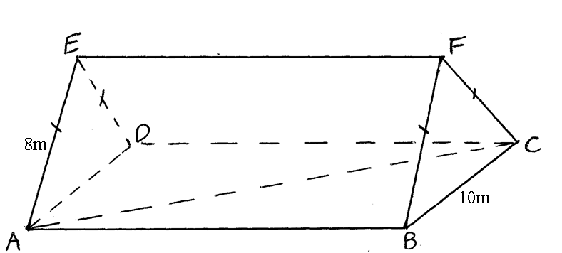
20m

- Find the length
(i) AC (1mk)

(ii) AF (2mks)

(b) (i) Calculate the angle between line AF and the base ABCD (3mks)

(ii) Find the angle between plane ADF and the base ABCD (2mks)

(c) Find the volume of the prism (2mks)

24. The results of an experiment on the variation of P and Q are tabulated below. A relationship of the
town P=aQ^{n} is expected to hold between P and Q where a and n are constants.
Q | 5 | 10 | 15 | 20 | 25
P | 17.67 | 31.86 | 44.97 | 57.42 | 69.42
- Draw a suitable linear graph to verify that the assumed relation is approximately true
(7mks)

- Hence determine the values of a and n correct to 2d.p (3mks)
END

