NAME……………………………………………………. INDEX NO………………………..
SCHOOL………………………………………………….. SIGN………………………………
DATE……………………………..

121/2
MATHEMATICS
PAPER 2
JULY/AUGUST 2012
TIME 2 ½ HOURS

KWANZA DISTRICT JOINT EVALUATION TEST 2012
Kenya Certificate of Secondary Education (K.C.S.E)

121/2
MATHEMATICS
PAPER 2
JULY/AUGUST 2012
TIME 2 ½ HOURS

INSTRUCTIONS TO THE CANDIDATES
(a) Write your name and the index number in the spaces provided above.
(b) Sign and write the date of examination in the spaces provided.
(c) The paper contains TWO sections: Section I and II.
(d) Answer ALL the questions in section I and FIVE questions in section II in the spaces provided below each question.
(e) All answer and working must be written on the question paper in the spaces provided below each question.
(f) Show all the steps in your calculations, giving your answers at each stage in the spaces below each question.
(g) Marks may be given for correct working even if the answer is wrong.
(h) Non-programmable silent electronic calculators and KNEC mathematical tables may be used, except where stated otherwise.

FOR EXAMINERS USE ONLY.
SECTION I
1 | 2 | 3 | 4 | 5 | 6 | 7 | 8 | 9 | 10 | 11 | 12 | 13 | 14 | 15 | 16 | TOTAL

SECTION II
17 | 18 | 19 | 20 | 21 | 22 | 23 | 24 | TOTAL

GRAND

TOTAL

This paper consists of 16 printed pages.
Candidates should check the question paper to ensure that all
pages are printed as indicated and no questions are missing

SECTION I (5OMARKS)
Answer all the questions in this section in the spaces provided.
1. Write the expression below in surd form and rationalize the denominator. (3mks)
$\frac{1−\text{cos}\text{60}}{1+\text{tan}\text{30}}$

2. Find the equation of a tangent and the normal to the curve yx³⁻2x²+3x-1 at x=2 (4mks)

3. A guard on a watch tower 80m high notices a thief at A, approaching the gate at an angle of depression of 020⁰ after moving x meters from A towards the gate, the angle of depression was
042° calculate the value of x. (3mks)

4. Find the area of triangle PQR such that the area of its image is 12cm² after a transformation given
by the matrix $\left(\begin{matrix}2 & 1 \\ 4 & 4\end{matrix}\right)$ (3mks)

5. Solve the equation given below. (4mks)
2xy-x² =-15
y-x=4.

6. The volume, V of a cylinder varies jointly as its height, (h) and the square of its radius, (r), Calculate the percentage increase in its volume (V), when radius increases by 5% and height, h
increases by 10%. (3mks)

7. Use binomial expansion to expand and simplify (l-3x)⁶ up to term in x³. Hence approximates the value of (0.97)⁶ correct to 4 significant figures. (4mks)

8. Given the points P(-6, -3), Q(-2, -1) and R(6, 3) express PQ and QR as column vectors. Hence
show that the points P. Q and R are collinear. (3mks)

9. A solid metal cylinder with radius 7cm and height 5 cm is melted down and recast into a spherical ball. Calculate to I decimal place the surface area of this ball. (3mks)

10. The expression I + $\frac{x}{2}$ is taken as an approximation for$\sqrt{1+x}$. Find the percentage error in doing
so if x 0.44. (3mks)

11. Chords AB and CD in the figure below intersect externally at Q. if AD 5cm BQ 6cm and
DQ = 4cm, calculate the length of chord CD. (3mks)

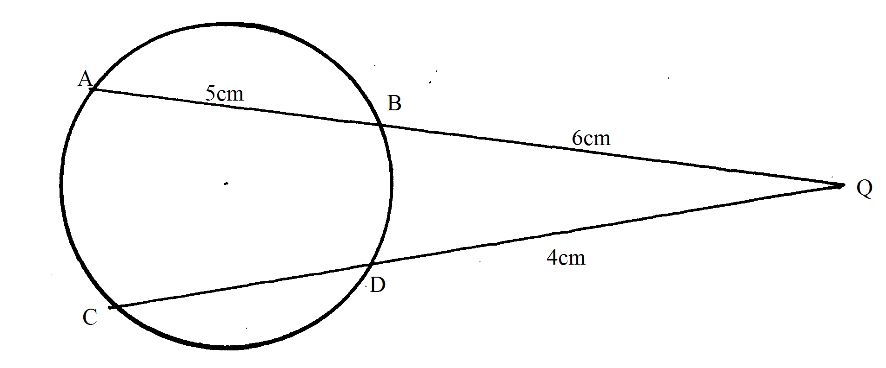

12. The sketch below represents the graph of y=x²-x-6.Find the area bounded by the x-axis, y-axis and the line x=5. (3mks)
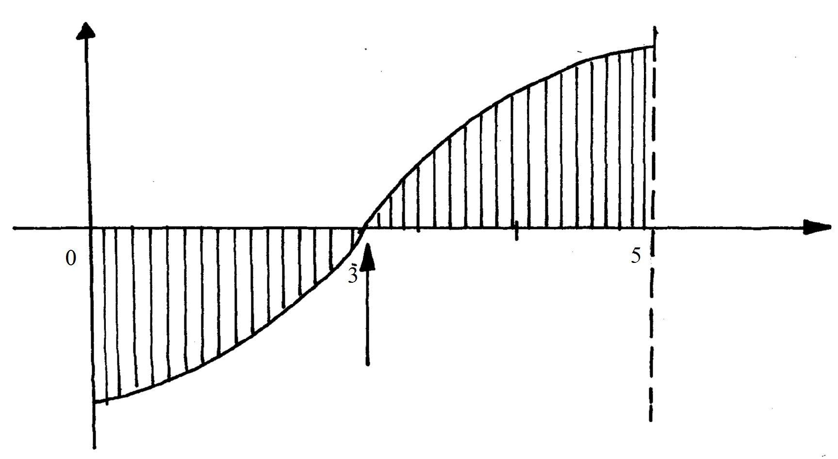

13. Use matrix method to determine the co-ordinates of the point of intersection of the two lines.
3x-2y=13, 2y+x+1=0 (3mks)

14. Calculate the semi-interquartile range of 3,4,1,2,3,6,8,5,7,9 (2mks)

15. A piece of land takes the shape shown below where AB is a straight edge. (Figure not drawn to scale).
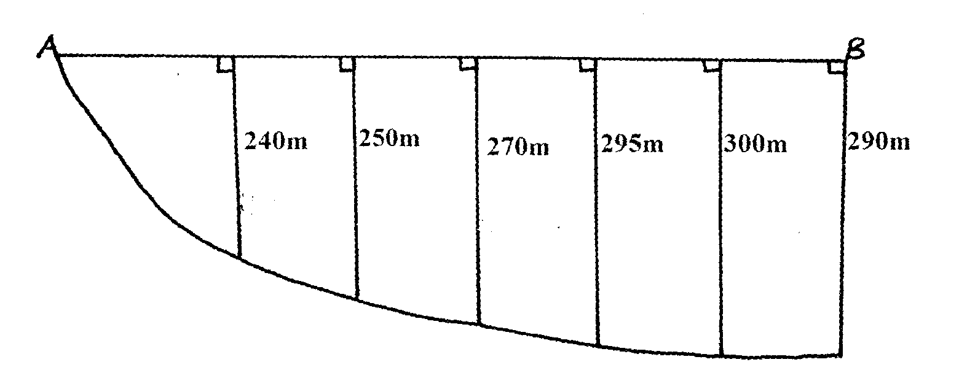

To estimate the area of the land, measurements at intervals of I OOm are taken as shown above. Estimate the area of land using the trapezium method giving your answer in hectares. (3mks)

16. Solve the following simultaneous equation (4mks)
1og₁₀(x+y) =0
21og₁₀ x =1og₁₀(y +1)

SECTION II (5OMARKS)
Answer only five questions in this section in the spaces provided
17. Income rates for income earned were charged as follows.
Income in sh. per month Rate in Ksh. per sh.20
1—8,400 2
8401—18,000 3
18001—30,000 4
30,001—36,000 5
36,001—48,000 6
48, 001 and above 7
A civil servant earns a monthly salary of ksh.19, 200. His house allowance is ksh.12, 000 per
month. Other allowances per month are transport ksh.13, 000 and medical allowance ksh.2, 300. He is entitled to a family relief of ksh.1, 240 per month. Determine
(a) (i) His taxable income per month (2mks)

(ii) Net tax (5mks)

(b) In addition, the following deductions were made.
NHIF sh.230, Service charge ksh.100, Loan repayment ksh.4, 000, Cooperative shares of
ksh.1, 200. Calculate his net salary per month (3mks)

18. (a) Using a ruler and pair of compasses only, construct triangle ABC in which AB=9cm,
BC=8.5cm and <BAC 60°. (3mks)
(b) On the same side of AB as C:
(i) Determine the locus of a point P such that <APB = 60°. (3mks)
(ii) Construct the locus of R such that AR>4cm. (2mks)
(iii) Determine the region T such that <ACT <BCT. (2mks)

19. A tailoring business makes two types of garments A and B. Garment A requires 3 metres of material while garment B requires 2 ½ metres of material. The business uses not more than 600 metres of material daily in making both garments. It must make not more than 100 garments of type A and not less than 80 of type B each day.
(a) Write down four inequalities from this information. (3mks)
(b) Graph these inequalities. (3mks)

(c) If the business makes a profit of shs 80 on garment A and a profit of shs 60 on garment B, how many garments of each type must it make in order to maximize the total profit? (4mks)

20. The table below shows the corresponding values of x and y which are connected by a relation of the form y = ab^{x} -10, where a and b are constant.

X | 1 | 2 | 3 | 4 | 5
Y | -6.5 | 4.1 | 47.5 | 197.5 | 947.5

Use the grid provided to draw a suitable linear graph and find the appropriate numerical values of a and b (l0mks)

21. A box contains 5 blue and 8 white balls all similar except for the colour. 3 balls are picked at random one after the other without replacement. Find the probability that
(a) The three balls are white (2mks)

(b) At least two are blue (4mks)

(c) Two are white and one is blue. (4mks)

22. (a) Complete the table below, given that y=2sinx+cos ½ x for $x≤\text{360}$ (2mks)

x | 0⁰ | 30⁰ | 60⁰ | 90⁰ | 120⁰ | 150⁰ | 180⁰ | 210⁰ | 240⁰ | 270⁰ | 300⁰ | 330⁰ | 360⁰
y

(b) On the grid provided draw the graph of y=2sinx+ cos ½ x for 0°$x≤$360° (3mks)
Use a scale of 1cm to represent 30° on x-axis and 1cm to represent 2 units on y-axis.

(c) Find the value of x for which the function reaches its maximum. (1mk)

(d) Use your graph to solve the equation 2(2sinx+cos ½ x) =1 (3mks)

(e) State the amplitude of y=2sinx+cos ½ x (lmk)

23. The table below shows the marks scored by students in a maths test.

Marks | 10-9 | 20-29 | 30-39 | 40-49 | 50-59 | 60-69 | 70-79 | 80-89 | 90-99
No. of students | 3 | 5 | 6 | 21 | 12 | 6 | 4 | 2 | 1

(a) From the above table determine the 20th percentile. (2mks)

b) Use the above table to draw the cumulative frequency curve (0 give curve). (4mks)
(i) Using the above graph drawn in (b)
Determine the pass mark if 40% of the students passed (2mks)

(ii) If the pass mark was pegged at 65%.How many students passed. (2mks)

24. The figure below represents a model of a tower VPQR. The horizontal base PQR is an equilateral triangle of sides 9cm. The length of the edges are VP = VQ = VR 20.5cm. Point M is the mid- point of PQ and VM = 20cm. Point N is on the base and vertically below V
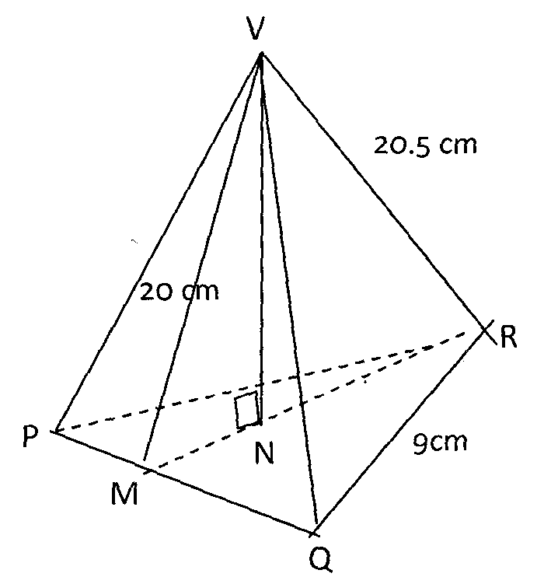
Calculate
(a) The length RM (2mks)

(b) The length of the model. (4mks)

(c) Projection of lines: VM and VN on the plane PQR (2mks)

(d) Find the surface area of slant faces. (2mks)

END

