**NAME…………………………………………INDEX NO……………ADM NO………….**

**CANDIDATE’S SIGN………………………DATE………………………………………...**

**SCHOOL……………………………………………………………………………………….**

**MOKASA JOINT EXAMINATIONS**

**Kenya Certificate of Secondary Education (K.C.S.E)**

**121/2**

**MATHEMATICS**

**PAPER 2**

**MARCH/APRIL 2015**

**TIME: 2 ½ HOURS**

**INSTRUCTIONS TO CANDIDATES.**

1) Write **your name** and **index number** in the spaces provided above.

2) Sign and write the date of examination in the spaces provided above.

3) This paper consists of two section **I** and **II**.

4) Answer **ALL** questions in section **I** and only **five** questions from section **II**.

5) Answers and working must be written on the question paper in the spaces provided below each question.

6) Marks may be given for correct working even if the answer is wrong.

7) Non-programmable electronic calculators may be used.

***FOR EXAMINERS’ USE ONLY.***

**SECTION I**

|  |  |  |  |  |  |  |  |  |  |  |  |  |  |  |  |  |
| --- | --- | --- | --- | --- | --- | --- | --- | --- | --- | --- | --- | --- | --- | --- | --- | --- |
| **1** | **2** | **3** | **4** | **5** | **6** | **7** | **8** | **9** | **10** | **11** | **12** | **13** | **14** | **15** | **16** | **TOTAL** |
|  |  |  |  |  |  |  |  |  |  |  |  |  |  |  |  |  |

**SECTION II**

Grand Total

|  |  |  |  |  |  |  |  |  |
| --- | --- | --- | --- | --- | --- | --- | --- | --- |
| **17** | **18** | **19** | **20** | **21** | **22** | **23** | **24** | **TOTAL** |
|  |  |  |  |  |  |  |  |  |

**SECTION A- 50 MARKS**

1. The cost of maize flour and millet flour is Ksh.40 and Khs.52 respectively. Calculate the ratio in which they were mixed if a profit of 15% was made by selling the mixture at Ksh.52.90 per kilogram. (3marks)

2. In the figure below XY= 8cm and O is the centre of the circle

O

O

B

A

X

Y

Determine the area of the circle if angle AOX=150 (3marks)

3. **OA=3i+4j-6k** and **OB=2i+3j+k** are two position vectors. P divides a line AB in the ratio

3:-2. Write down the coordinates of P. (3marks)

4. The table below show tax rates on a certain year

|  |  |
| --- | --- |
| Income (K£ p.a) | Rate (Ksh.per £) |
| 1 – 4200 | 2 |
| 4201 -8000 | 3 |
| 8001 – 12600 | 4 |
| 12601 and above | 5 |

Rose earns a basic salary of ksh. 20,000 per month, she is given allowances amounting to ksh.5000.She is housed by her employer therefore pays a nominal rent of sh. 700 per month and is entitled to a personal relief of Ksh. 1200 per month. Calculate;

i) Her taxable income in Kenya pounds per year. (2marks)

ii) Her gross tax per month. (2marks)

5. Rationalize the denominator and simplify (3marks)



6. Solve for x in (3marks)



7. The transformation represented by the matrix   maps a triangle whose vertices are **A (-1, 2), B (4, 1)** and **C (1,-4)** onto a straight line. Find the possible values of x.

(3marks).

8. Expand (2 + x)6, hence find the value of (2.025)6 rounded off to 3 decimal places.

(4marks)

9. The resistance to the motion of a car is partly constant and partly varies as the square of the speed. At 40km/h-1 the resistance is 530 and at 60kmh-1 it is 730N. What will be the resistance at 70kmh-1 (4marks)

10. By completing the square, solve for x in the equation **2x2 -6 = x.**  (3marks)

11. A die has two of its faces numbered 3.Calculate the probability of obtaining a 1or a 3 on a

single cast. (3marks)

12. Solve the equation (3marks)

13. The top of a table is regular pentagon. Each side of the pentagon measures 40.0cm. Find the maximum percentage error in calculating the perimeter of the top of the table. (3marks)

14. The points P(8,4) and Q(2,2) are the ends of a diameter of a circle. Find the equation of the

circle. (3marks)

1. In the diagram below, PQ = 10cm,and the radius of the circle centers P and Q are 2cm and 4cm respectively, calculate the length of the transverse common tangent SR. (3marks)

R

S

Q

P

16. Line **y=** is parallel to diameter LM of circle **x2+y2+6x-8y=0**. Find the equation of the tangent to the circle at L. (4marks)

**SECTION B 50 MARKS**

17. The figure below shows a frustum ABCDEFGH of a right pyramid such that AB=9cm,BC=12cm,FG=6cm,GH=8cm and the height of the frustum is 10cm.

E

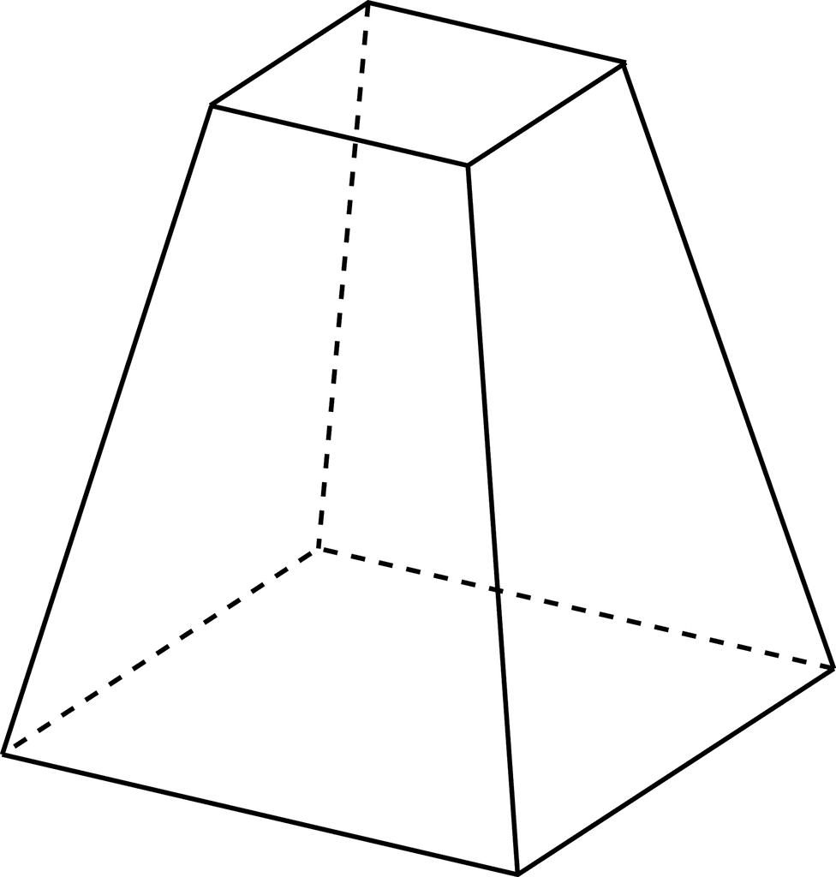

H

G

F

A

D

C

B

Find the

a) Height of the pyramid (2marks)

b) Length of

(i) AC (2marks)

(ii)AH (2marks)

c) Calculate the angle between:

i) Line AH and the plane ABCD (2marks)

ii) The planes ABHE and ABCD (2marks)

18. A and B are two points on the latitude 400N. The two points lie on the longitudes 200 W and

1000 E respectively.

(a)Calculate:

(i) The distance from A to B along a parallel of latitude. (3marks)

(ii) The shortest distance from A to B along a great circle. (4marks)

(b)Two planes P and Q left A for B at 400 knots and 600 knots respectively. If P flew along the great circle and Q along parallel latitude, which one arrived earlier and by how long. Give your answer to the nearest minute (Take R = 6370 km and π = 22/7). (3marks)

19.The following table shows the distribution of marks obtained by 50 students.

|  |  |  |  |  |  |  |  |
| --- | --- | --- | --- | --- | --- | --- | --- |
| Marks | 45-49 | 50-54 | 55-59 | 60-64 | 65-69 | 70-74 | 75-79 |
| No of Students | 3 | 9 | 13 | 15 | 5 | 4 | 1 |

a) By using an assumed mean of 62, calculate:

(i) The mean (5marks)

b) The variance (3marks)

c) The standard deviation (2marks)

20.Matrix  **S** represents a reflection on line y = x, matrix  **T** represents a rotation through positive 900 centre (0,0).A triangle whose vertices are A(-2,0), B(1,-2) and C(0,1) is subjected to these transformations, such that :the triangle AIBICI is the image of ABC under transformation matrix **S** and that AIIBII CII is the image of AIBICI under transformation matrix **T**.

a) Plot the three triangles on the grid provided below. (4marks)

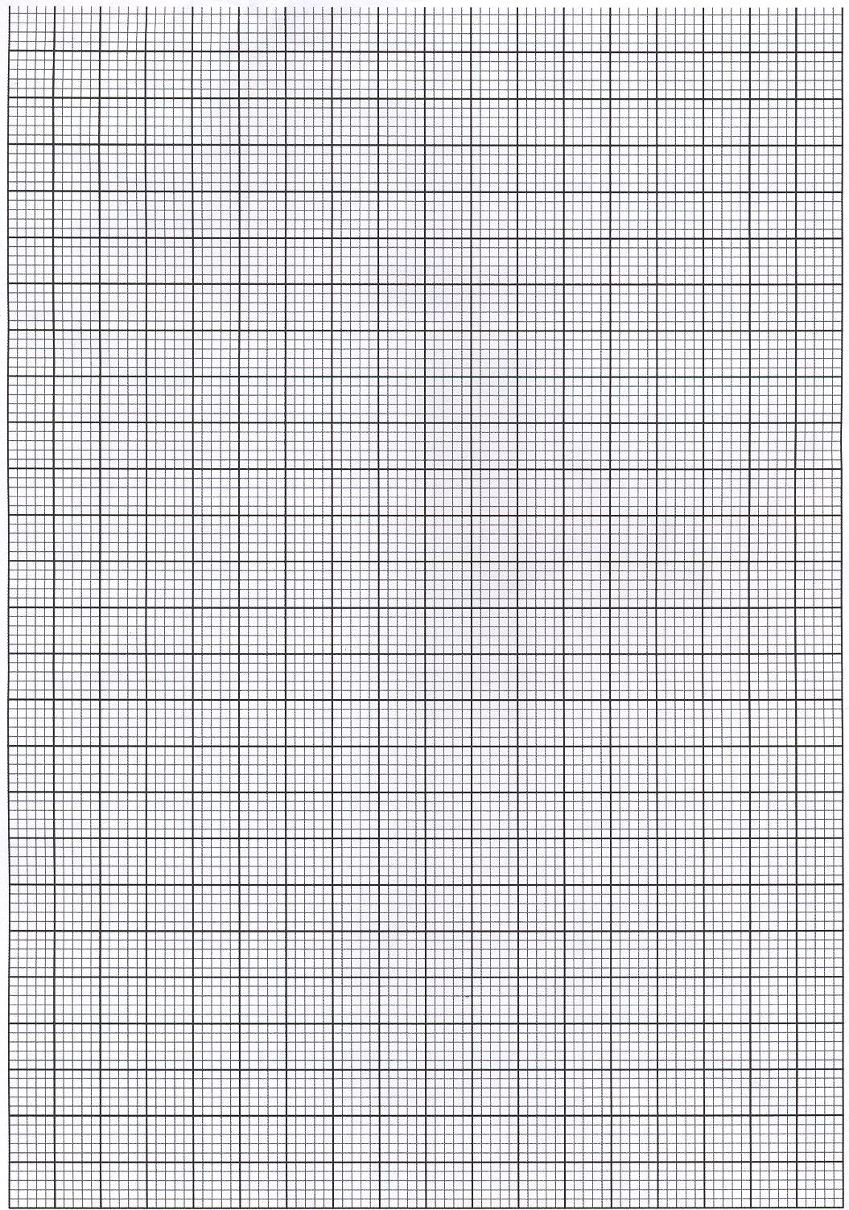

b) Find a single matrix that will map AIIBIICII onto ABC. (3marks)

c) Describe the matrix in b) above. (1mark)

d) If triangle ABC is sheared ,shear factor 2 with the y-axis invariant, find the coordinates of the image. (2marks)

21.Sigei’s Flower Achievers Company has 36 hectares of land. The company decides to prepare the land for planting wheat and maize. The labour cost of planting maize is Ksh. 300 per hectare while it costs Ksh 900 to plant a hectare of wheat. Maize takes 3 labourers per hectare while wheat takes 6 labourers per hectare. Atleast 72 labourers are to be hired and Ksh. 15,000 is to be spent for labour costs. The company hopes to make a profit of Ksh 2,000 per hectare of maize and Ksh 4,500 per hectare of wheat. $let the number of hectares for maize be x$

$$let the number of hectares for wheat be y$$

1. Write down inequalities representing the above information (3marks)
2. On the grid provided, draw the inequalities by shading unwanted regions (4marks)



c)Use the graph to:

1. determine the number of hectares of maize and wheat that should be prepared in order for the company to maximize profit (2marks)
2. Calculate the maximum profit(1mark)

22.a) Using a ruler and a pair of compasses only, construct parallelogram ABCD in which AB=7cm, BC=5cm and angle CBA=45∘. (4marks)

b) From a point T, 3cm from D on DC, construct the locus of a point Q, 3.5cm from T to intersect AD and DC at V and W respectively. Measure angle VTW. (4marks)

c) Find the area of the minor sector TVW in cm2  (2marks)

23. The thirteenth term of an arithmetic progression is 27.Given that the seventh term equals to three times the second term, find

a) The first term and the common difference of the progression. (4marks)

b) The sum of the first three even numbered terms of the progression. (3marks)

c) It’s given that (b-),b and (b+3.375) are the 2nd,3rdand 4thterms of a geometric progression. Determine the value of b. (3marks)

24. The equation of a curve is given by 

(a) Determine coordinates of the stationary point. (3marks)

b) By integration, determine the actual area bounded by the curve  and the line  (4marks)

c) Find the equation of the normal to the curve at  (3marks)