NAME……………………………………………………….. INDEX NO……………………........................

511/3 CANDIDATE’S SIGN………….….….….…..
MUSIC
PAPER 3 DATE……….…………………………………
JULY/AUGUST, 2015
TIME: 2½ HOURS

KAHURO /KIHARU DISTRICT JOINT EXAMINATION – 2015

Kenya Certificate of Secondary Education
MUSIC
PAPER 3
TIME: 2½ HOURS

INSTRUCTIONS TO CANDIDATES:
- Write your name and index number in the spaces provided above.
- Sign and write the date of the examination in the spaces provided above.
- Answer all the questions in this paper.
- In question 1 choose either (a) or (b).
- In question 4 choose any two of the questions numbered (a), (b), (c) and (d).
- All answers must be written in the spaces provided.
- Candidates should check the paper to see that all questions are there e.g. 1-7.
- Candidates should answer the questions in English.

FOR EXAMINER’S USE ONLY
Section | Question | Maximum  Score | Candidate’s  Score
A | 1 | 12
 | 2 | 20
 | 3 | 14
 | 4 | 14
B | 5 | 10
 | 6 | 10
C | 7 | 20
Grand Total |  | 100

Music Paper 3 Turnover
SECTION A: BASIC SKILLS: (30 MARKS)

1. Either: (a) Continue the following opening to make a melody of sixteen bars for voice
incorporating a triplet and syncopation. Modulate to the dominant major key
and back to the home key. Vary the tempo. (12 marks)

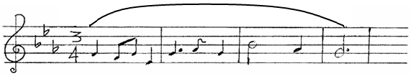

Music Paper 3 2 Kahuro/Kiharu
(b) Basing on the text below, compose a melody in staff notation. Add phrase marks to indicate
cadential points. (12 marks)
“Love is a sickness of woes,
All remedies refusing;
A plant that with most cutting grows,
Most barren with best using.

Music Paper 3 3 Kahuro/Kiharu
2. Harmonize the following melody in S.A.T.B. Make use of dominant 7th and passing notes.

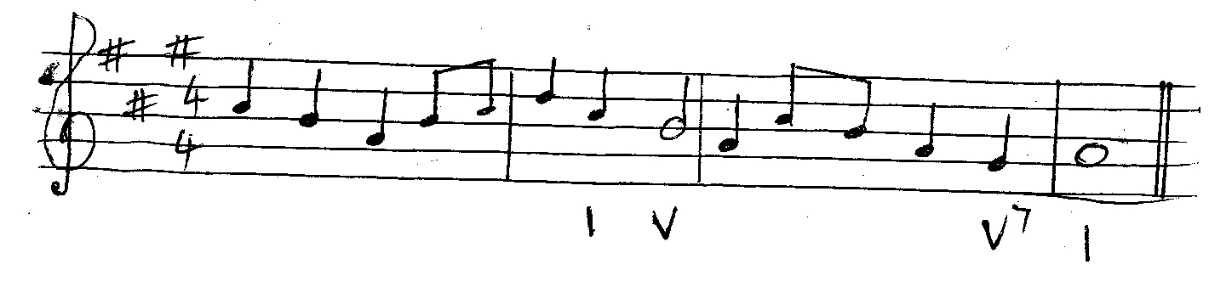

Music Paper 3 4 Kahuro/Kiharu
SECTION B: HISTORY AND ANALYSIS: (48 MARKS)

3. AFRICAN MUSIC

(a) Which of the following are lyres? (3 marks)

Nyatiti ……………………………………………………………………………………………

Marimba ………………………………………………………………………………………….

Egetweri ………………………………………………………………………………………….

Chemonge ………………………………………………………………………………………..

Ngutha ……………………………………………………………………………………………

Iritungu …………………………………………………………………………………………..

(b) Explain the role of the following in a traditional musical performance. (4 marks)
(i) Instruments.

…………………………………………………………………………………………………………..

…………………………………………………………………………………………………………..

…………………………………………………………………………………………………………..

- Ochre.

…………………………………………………………………………………………………………..

…………………………………………………………………………………………………………..

…………………………………………………………………………………………………………..

- Vibration of lips.

…………………………………………………………………………………………………………..

…………………………………………………………………………………………………………..

…………………………………………………………………………………………………………..

- Soloist.

…………………………………………………………………………………………………………..

…………………………………………………………………………………………………………..

…………………………………………………………………………………………………………..

- Name any two dances from the Giriama and state the gender that performed it. (4 marks)

…………………………………………………………………………………………………………..

…………………………………………………………………………………………………………..

…………………………………………………………………………………………………………..
Music Paper 3 5 Kahuro/Kiharu
(d) State any two functions of music in a dance. (2 marks)

…………………………………………………………………………………………………………..

…………………………………………………………………………………………………………..

…………………………………………………………………………………………………………..

(e) State two ways in which a musician learnt how to play an instrument in an African setting.
(2 marks)

…………………………………………………………………………………………………………..

…………………………………………………………………………………………………………..

…………………………………………………………………………………………………………..

4. WESTERN MUSIC

- Claudio Monteverdi.
(i) Name any two madrigals by Monteverdi. (2 marks)

…………………………………………………………………………………………………………..

…………………………………………………………………………………………………………..

…………………………………………………………………………………………………………..

- Outline three experiences which influenced Monteverdi as a musician during his youthful stage. (3 marks)

…………………………………………………………………………………………………………..

…………………………………………………………………………………………………………..

…………………………………………………………………………………………………………..

…………………………………………………………………………………………………………..

(iii) Name two types of services that Monteverdi offered at Mantua. (2 marks)

…………………………………………………………………………………………………………..

…………………………………………………………………………………………………………..

…………………………………………………………………………………………………………..

- George F. Handel.
(i) Name any three composers who influenced him. (3 marks)

…………………………………………………………………………………………………………..

…………………………………………………………………………………………………………..

…………………………………………………………………………………………………………..

…………………………………………………………………………………………………………..

Music Paper 3 6 Kahuro/Kiharu
(ii) For what purpose did he write ode? (1 mark)

…………………………………………………………………………………………………………..

…………………………………………………………………………………………………………..

…………………………………………………………………………………………………………..

(iii) Explain Handel’s contribution to vocal music. (3 marks)

…………………………………………………………………………………………………………..

…………………………………………………………………………………………………………..

…………………………………………………………………………………………………………..

…………………………………………………………………………………………………………..

- Sir Edward Elgar.
(i) Name Elgar’s Nationality. (1 mark)

…………………………………………………………………………………………………………..

(ii) Name four types of instruments which Elgar played. (4 marks)

…………………………………………………………………………………………………………..

…………………………………………………………………………………………………………..

…………………………………………………………………………………………………………..

…………………………………………………………………………………………………………..

(iii) What type of work are each of the following. (2 marks)

- Faistaff……………………………………………………………………………

(b) Oh happy eyes ……………………………………………………………………

- Sergei Prokofiew.
(i) In which period did he live? (1 mark)

…………………………………………………………………………………………………………..

…………………………………………………………………………………………………………..

(ii) Name three of his orchestral music. (3 marks)

…………………………………………………………………………………………………………..

…………………………………………………………………………………………………………..

…………………………………………………………………………………………………………..

…………………………………………………………………………………………………………..

Music Paper 3 7 Kahuro/Kiharu
(iii) Identify three characteristics of his music. (3 marks)

…………………………………………………………………………………………………………..

…………………………………………………………………………………………………………..

…………………………………………………………………………………………………………..

…………………………………………………………………………………………………………..

5. Prescribed Traditional African Music.

“Mijikenda ensemble from folk music of East Africa”.

(i) Describe the singer in terms of gender. (1 mark)

…………………………………………………………………………………………………………..

(ii) How does voice feature in the recording. (3 marks)

…………………………………………………………………………………………………………..

…………………………………………………………………………………………………………..

…………………………………………………………………………………………………………..

…………………………………………………………………………………………………………..

(iii) List the media in the order of entry in the recording. (3 marks)

…………………………………………………………………………………………………………..

…………………………………………………………………………………………………………..

…………………………………………………………………………………………………………..

…………………………………………………………………………………………………………..

(iv) Describe the role of the instruments in the recording. (3 marks)

…………………………………………………………………………………………………………..

…………………………………………………………………………………………………………..

…………………………………………………………………………………………………………..

…………………………………………………………………………………………………………..

…………………………………………………………………………………………………………..

Music Paper 3 8 Kahuro/Kiharu
6. Prescribed Western Music.

Recitative: “I tell you a mystery” and “The trumpet shall sound”.

(i) How long is the inverted pedal in the strings? (1 mark)

…………………………………………………………………………………………………………..

(ii) What is the meaning of (C) at the beginning? (1 mark)

…………………………………………………………………………………………………………..

…………………………………………………………………………………………………………..

…………………………………………………………………………………………………………..

(iii) How does the air start? (1 mark)

…………………………………………………………………………………………………………..

…………………………………………………………………………………………………………..

…………………………………………………………………………………………………………..

(iv) Identify the two instruments sharing the melody at the beginning. (2 marks)

…………………………………………………………………………………………………………..

…………………………………………………………………………………………………………..

…………………………………………………………………………………………………………..

(v) Name the bars where the motif at bars 1-3 is repeated. (2 marks)

…………………………………………………………………………………………………………..

…………………………………………………………………………………………………………..

…………………………………………………………………………………………………………..

(vi) With reference to bar numbers, give an example of where each of the following devices occurs.
(a) Melisma. (1 mark)

…………………………………………………………………………………………………………..

…………………………………………………………………………………………………………..

…………………………………………………………………………………………………………..

(b) Sequence. (1 mark)

…………………………………………………………………………………………………………..

…………………………………………………………………………………………………………..

…………………………………………………………………………………………………………..

Music Paper 3 9 Kahuro/Kiharu
(c) Unison. (1 mark)

…………………………………………………………………………………………………………..

…………………………………………………………………………………………………………..

…………………………………………………………………………………………………………..

7. GENERAL MUSIC KNOWLEDGE: (20 MARKS)

(a) (i) What is an art song. (1 mark)

…………………………………………………………………………………………………………..

…………………………………………………………………………………………………………..

…………………………………………………………………………………………………………..

(ii) Outline four effects of modern technology on African dances. (4 marks)

…………………………………………………………………………………………………………..

…………………………………………………………………………………………………………..

…………………………………………………………………………………………………………..

…………………………………………………………………………………………………………..

…………………………………………………………………………………………………………..

…………………………………………………………………………………………………………..

(b) Transpose this melody a semitone down into alto clef. Prefix one new key signature. (5 marks)

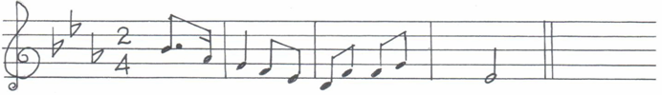

Music Paper 3 10 Kahuro/Kiharu
(c) Define each of the following. (5 marks)
(i) Double headed drum.

…………………………………………………………………………………………………………..

…………………………………………………………………………………………………………..

…………………………………………………………………………………………………………..

(ii) Transposing instrument.

…………………………………………………………………………………………………………..

…………………………………………………………………………………………………………..

…………………………………………………………………………………………………………..

- Dirge.

…………………………………………………………………………………………………………..

…………………………………………………………………………………………………………..

…………………………………………………………………………………………………………..

- Contralto.

…………………………………………………………………………………………………………..

…………………………………………………………………………………………………………..

…………………………………………………………………………………………………………..

- Double stopping.

…………………………………………………………………………………………………………..

…………………………………………………………………………………………………………..

…………………………………………………………………………………………………………..

(d) State how each of the following is played. (5 marks)

(i) Mchirima………………………………………………………………………………..

- Shiriri …………………………………………………………………………………..

- Asili…………………………………………………………………………………….

- Iritungu …………………………………………………………………………………

- Chemonge ………………………………………………………………………………

Music Paper 3 11 Kahuro/Kiharu

