SUNSHINE SECONDARY SCHOOL
232 / 2
PHYSICS
PAPER 2
PRE MOCK 1 – MARCH / APIRL 2015
2 HOURS

NAME: ………………………………………………..…..INDEX NO: ……………………...
CANDIDATES SIGNATURE:…………………………..DATE:…………………………...

INSTRUCTIONS:
- Answer all questions in the space provided.
- This paper consists of two sections A and B.
- All working must be shown clearly.
- Electronic calculators may be used.

EXAMINER’S USE ONLY
SECTION | QUESTION | MARKS | CANDIDATES SCORE
A | 1 – 13 | 25
B | 14 | 13
 | 15 | 12
 | 16 | 7
 | 17 | 15
 | 18 | 8

1.State the laws of reflection of light. (2mks)
-----------------------------------------------------------------------------------------------------------------------------------------------------------------------------------------------------------------------------------------------------------------------------------------------------------------------------------------------------------------------------------------------------------------------------------------------------------------------------------
2.The diagram below shows how to charge two spheres simultaneously.
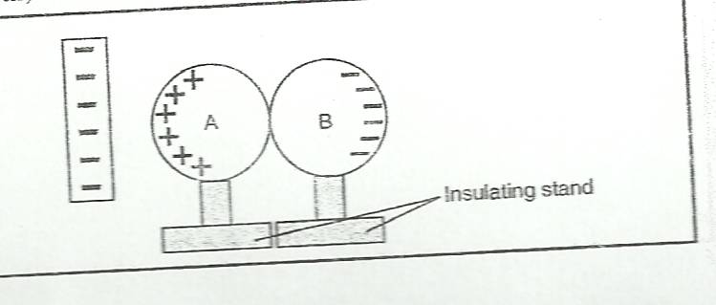

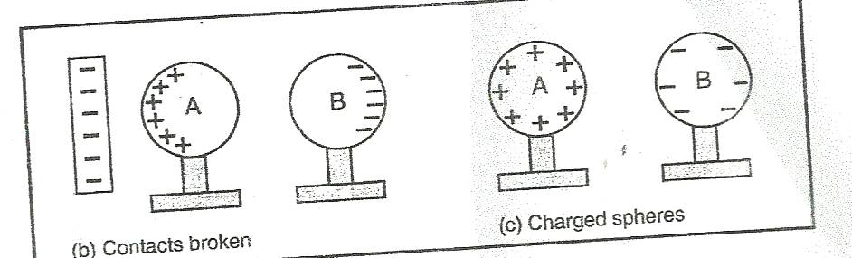

On the diagram indicate the charge acquired by spheres A and B in step two. (2mks)

3.Complete the diagram below to show how the lens forms the image. (1mk)
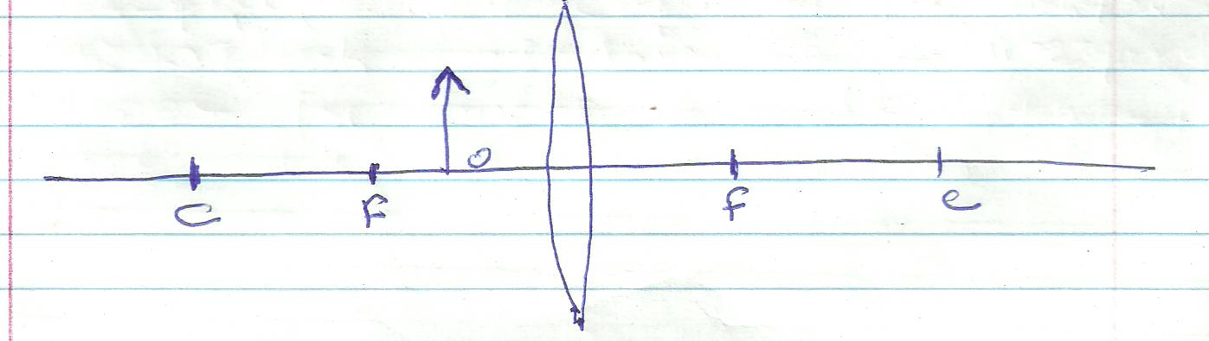

4.)Name one detector of infra-red radiations (1mk)

5) Using a diagram explain how soft iron keepers are used to retain magnetism in stored magnets(2mks)

6) A battery is rated 30Ah,determine the amount of current it can supply in 20 minutes (2mks)

7) Sketch rays to show the image formed by the object in the following. (2mks)
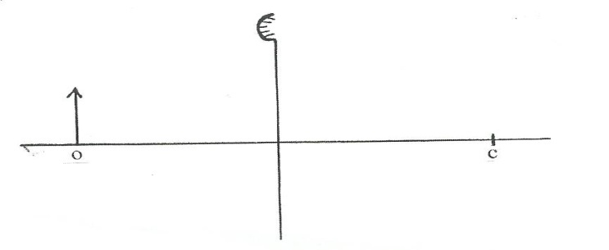
8.Name any one common property of electromagnetic waves. (1mk)

9.The figure below shows a conductor carrying current placed within the magnetic field of two magnets. Complete the diagram by showing the field pattern and the direction of force F that acts on the conductor. (2mk)
10.What is meant by donor impurity in semiconductor. (1mk)

11.The figure below shows ray B, incident through a glass block to air interface.
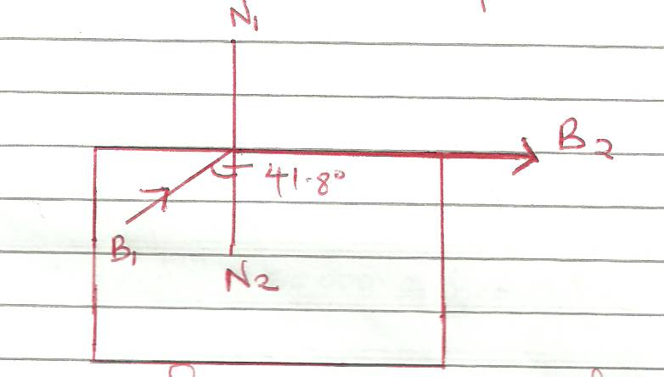
B2 is the emergent ray of B1. Determine the refractive index of the glass block.

12.A pendulum bob takes 0.5 seconds to move from its mean position to a maximum displacement position. Calculate its frequency. (2mks)

13.A potential difference of 50kv is applied across an x-ray tube. Given that the charge of an electron e = 1.6 x 10⁻¹⁹ c and the mass of an electron m_{e} = 9.1 x 10⁻³¹ kg, calculate the velocity of the electron. (3mks)

14.An electric heater is rated 3kw and 240v when in operation. Calculate the cost of running the heater for 5 hours if the cost per kwh is ksh.6.70. (2mks)

15.The diagram below shows part of a cathode ray tube.
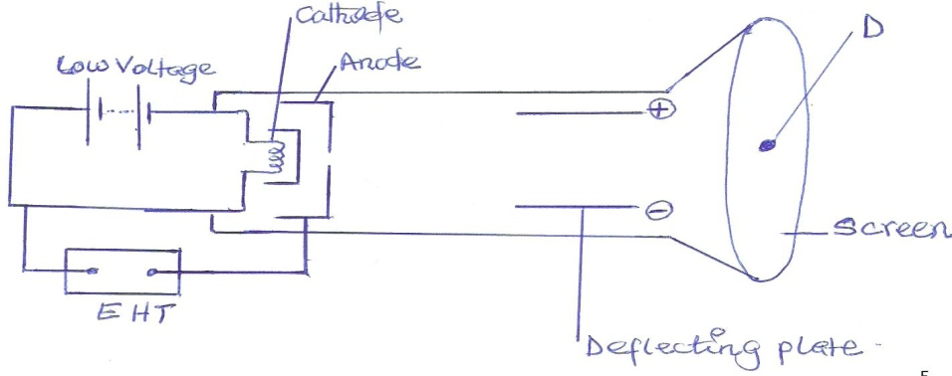
i)Explain how the cathode rays are produced. (2mks)

ii) On the same diagram draw the path of the cathode rays to the spot produced on the screen at D. (2mks)

iii)Explain the observation made on the spot when the connection to the high voltage supply are interchanged so that the anode is made negative. (2mks)

iv)What behavior of cathode rays shows that they move on a straight line. (2mks)

v)Name the components of an electron gun of a cathode ray oscilloscope. (3mks)

16.a) In a photoelectric effect experiment, a certain surface was illuminated with radiation of different wavelengths and stopping potential determined for each wavelength. The following results were obtained:
Wavelength (x 10⁻⁷ m) | 3.77 | 4.05 | 4.36 | 4.92 | 5.46
Stopping potential, (V_{s}), (V) | 1.35 | 1.15 | 0.93 | 0.62 | 0.36
Frequency (x 10¹⁴Hz)

i)complete the table above given that c = 3.0 x 10⁸ m/s (1mk)

ii)Plot a graph of stopping potential (Y-axis) against frequency (4mks)

iii) Determine plank’s constant, h and the work function of the surface given that eV_{s} = hf – hf_{o}, where e = 1.6 x10⁻¹⁹ C (3mks)

b) A surface whose work function Q = 6.4 x 10⁻¹⁹ J is illuminated with light of frequency 3.0 x10¹⁵ H_{z}. Find the maximum velocity of the emitted photo electrons (use value of h obtained in a(ii) above) (3mks)

17. a) State the difference between longitudinal and transverse waves. (1mk)

b)The figure below shows a transverse wave travelling along X-axis. T he frequency of the vibrations producing the waves is 20Hz.
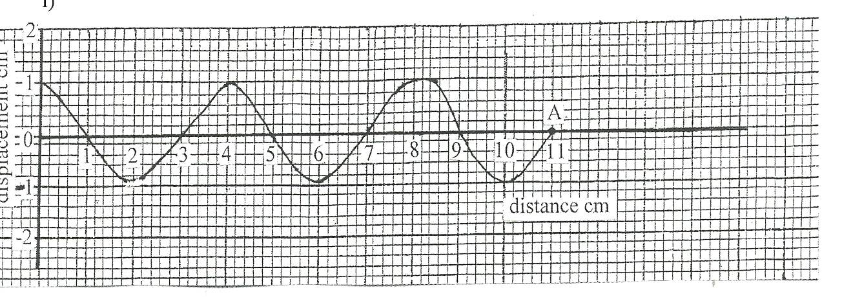
i)Determine the amplitude in SI unit. (1mk)

ii) If it takes 0.1375 seconds for the wave to move from O to A, determine the speed of the wave.
(2mks)

ii)Calculate the periodic time of the wave. (2mks)

c i)State two factors affecting the speed of sound in air. (2mks)

ii)A man makes a loud sound and hears the echo of the sound after 1.25 seconds. If the speed of sound in air is 330ms-1, calculate the distance between the man and the wall causing the echo. (3mks)

18. Three resistors of resistance 2Ω, 4Ω and 6Ω are connected together in a circuit. Draw a circuit diagram to show the arrangement of the resistor which gives

a) Effective resistance of 3Ω (2mks)

b) In the figure below, the voltmeter reads 2.1v when the switch is open. When the switch is closed, the voltmeter reads 1.8v and the ammeter reads 0.1A.

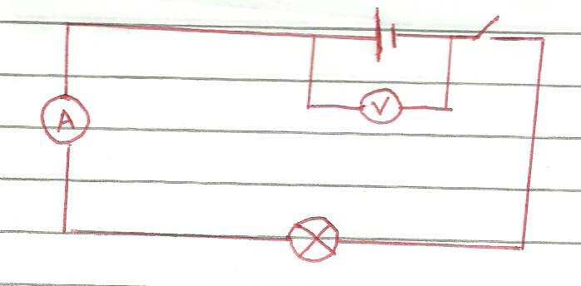

Determine :-

- The e.m.f of the cell (1mk)

- The internal resistance of the cell. (3mks)

- The resistance of the lamp. (2mks)

c. Calculate the length of a wire required to make a resistor of 0.5Ω , if the resistivity of the material is 4.9 x 10⁻⁷ Ω m and the cross sectional area is 2.0 x 10⁻⁶ m2. (3mks)

19.ai)Define half-life of a radioactive substance. (1mk)

ii)The following radioactive equation, find the value of N and Z.

b) The half-life of radioactive substance is 4 years. How long will the sample take for the
activity to decrease to 1/32 of its original value. (3mks)

c)The diagram below shows the cross section of a diffusion cloud chamber used to detect radiation from radioactive source.

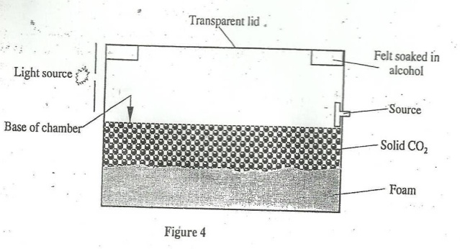

i)State one function of each of the following Alcohol. (1mk)
------------------------------------------------------------------------------------------------------------------------------------------------------------------------------------------------------------------------------------------
Solid carbon dioxide (1mk)

------------------------------------------------------------------------------------------------------------------------------------------------------------------------------------------------------------------------------------------
ii)When radio actions from the source enter the chamber some white traces are observed.
Explain how these traces are formed and state how the radio action is identified. (4mks)

--------------------------------------------------------------------------------------------------------------------------------------------------------------------------------------------------------------------------------------------------------------------------------------------------------------------------------------------------------------------------------------------------------------------------------------------------------------------------------------------------------------------------------------------------------------------------------------------------------
ii)A leaf electroscope can also be used as a detector of radio actions. State two advantages of the diffusion cloud chamber over the leaf electroscope as a detector. (2mks)
---------------------------------------------------------------------------------------------------------------------------------------------------------------------------------------------------------------------------------------------------------------------------------------------------------------------------------------------------------------------------------------------------------------------------------------------------------------------------------------------------------------------------------------------------------------------------------------------------------

