NAME……………………………………………………….. INDEX NO……………………........................

232/1 CANDIDATE’S SIGN………….….….….…...
PHYSICS
PAPER 1 DATE……….…………………………………
(THEORY)
JULY/AUGUST, 2015
TIME: 2 HOURS

KAHURO /KIHARU DISTRICT JOINT EXAMINATION - 2015

Kenya Certificate of Secondary Education
PHYSICS
PAPER 1
(THEORY)
TIME: 2 HOURS

INSTRUCTIONS TO THE CANDIDATE:
(a) Write your name and index number in the spaces provided.
(b) Sign and write the date of examination in the spaces provided.
(c) This paper consists of two Sections A and B.
(d) Answer all the questions in sections A and B in the spaces provided.
(e) All working must be clearly shown in the spaces provided.
(f) Mathematical tables and electronic calculators may be used.

FOR EXAMINER’S USE ONLY:
Section | Question | Maximum  Score | Candidate  Score
A | 1 – 13 | 25
 | 14 | 9
 | 15 | 8
B | 16 | 11
 | 17 | 6
 | 18 | 11
 | 19 | 10
Total Score |  | 80

Physics Paper 1 Turnover
SECTION A: (25 MARKS)

1. A micrometer screw gauge is used to measure the diameter of a copper wire. The reading
with the wire in position is as shown in diagram 1. The wire is then removed and the jaws closed.
Diagram 2 shows the new reading.
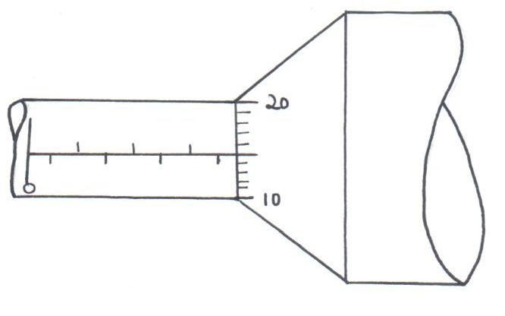
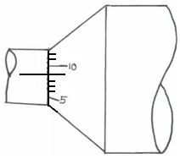

Diagram (1) Diagram (2)

What is the diameter of the wire? (2 marks)

___________________________________________________________________________

___________________________________________________________________________

___________________________________________________________________________

___________________________________________________________________________

2. The two identical springs of spring constant 3N/cm are used to support a load of 60N.
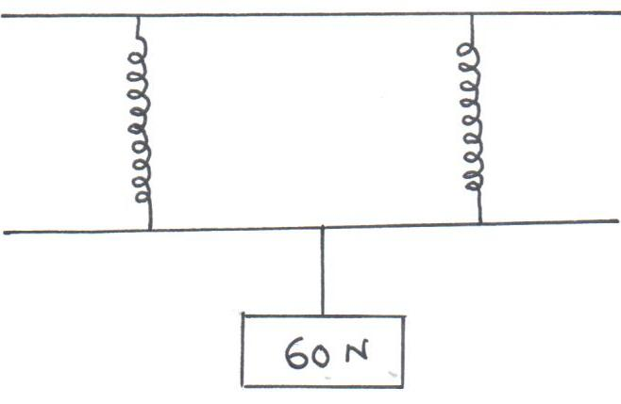

Fig. 2

Determine the extension of the spring in units. (2 marks)

______________________________________________________________________

______________________________________________________________________

______________________________________________________________________

______________________________________________________________________

Physics Paper 1 2 Kahuro/Kiharu
3. The bulb of a thermometer is dipped into ether at room temperature, when the thermometer
is removed, its reading drops below room temperature. Explain this observation. (1 mark)

___________________________________________________________________________

___________________________________________________________________________

___________________________________________________________________________

4. A metallic pin was observed to float on the surface of pure water. When a few drops
of kerosene were carefully added to the water, the pin sank. Explain this observation. (2 marks)

___________________________________________________________________________

___________________________________________________________________________

___________________________________________________________________________

___________________________________________________________________________

5. State one force that changes as an object moves inside a liquid in a cylinder when dropped downwards. (1 mark)

__________________________________________________________________________

__________________________________________________________________________

6. The figure below shows a wire A and a spring B made of the same material. The thickens
of the wire is the same in both cases. Masses are added on each at the same interval and the extension noted each time. On the same axes provided. Sketch the graphs of load against extension for each assuming Hookes law is obeyed. (2 marks)
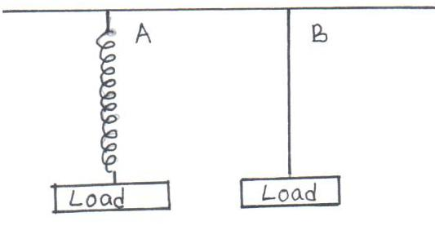

Fig. 3

Physics Paper 1 3 Kahuro/Kiharu
7. Explain why a glass container with thicker walls is more likely to crack than one with thin
wall when a very hot liquid is poured onto it. (2 marks)

___________________________________________________________________________

___________________________________________________________________________

___________________________________________________________________________

___________________________________________________________________________

8. The figure below shows a sheet of paper rolled into a tube. (2 marks)
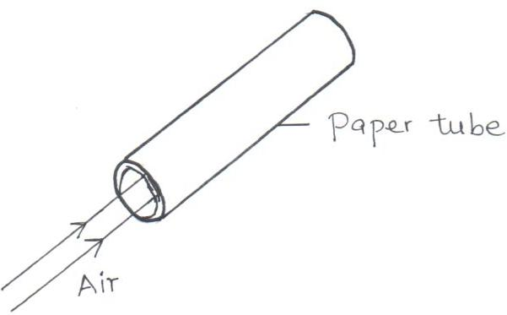

Fig. 4

When a stream of air at high speed is blown into the tube, the paper tube collapses.
Explain this observation. (2 marks)

___________________________________________________________________________

___________________________________________________________________________

___________________________________________________________________________

___________________________________________________________________________

9. Complete figure (a) and (b) below by showing the level of the liquids in the glass tubes. (2 marks)
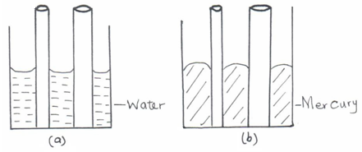

Fig. 5

Physics Paper 1 4 Kahuro/Kiharu
10. The diagram below shows an empty wine glass.
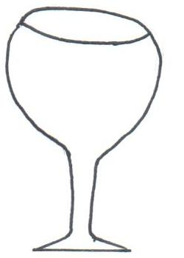

Fig. 6

(a) State the effect on its stability when wine is put into the glass. (1 mark)

_____________________________________________________________________

_____________________________________________________________________

_____________________________________________________________________

(b) Explain your answer in (a) above. (1 mark)

_____________________________________________________________________

_____________________________________________________________________

_____________________________________________________________________

11. A metal bench feels colder than a wooden one when one sits on it on a cold morning even though both are at the same temperature. Explain this observation. (1 mark)

___________________________________________________________________________

___________________________________________________________________________

___________________________________________________________________________
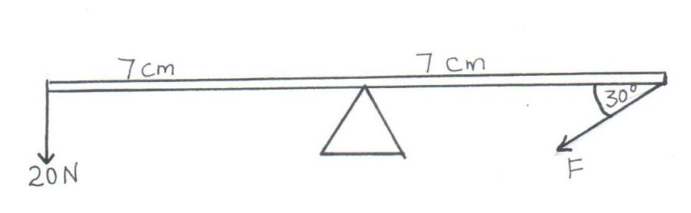
12. The figure below shows a uniform bar in equilibrium under the action of tin forces.

Fig. 7

Determine the value of F. (3 marks)

____________________________________________________________________________

____________________________________________________________________________

____________________________________________________________________________

____________________________________________________________________________

____________________________________________________________________________

Physics Paper 1 5 Kahuro/Kiharu
13. A bottle containing a smelling perfume is opened at the front bench of a lab. After some
time the perfume is detected throughout the lab. Explain. (1 mark)

____________________________________________________________________________

____________________________________________________________________________

____________________________________________________________________________

SECTION B: (55 MARKS)

14. (a) Using the kinetic theory of gases explain how a rise in the temperature of a gas
causes a rise in the pressure of the gas of the volume is kept constant. (3 marks)

______________________________________________________________________

______________________________________________________________________

______________________________________________________________________

______________________________________________________________________

______________________________________________________________________

- The figure below shows a set-up that can be used to verify Charles law of gases.
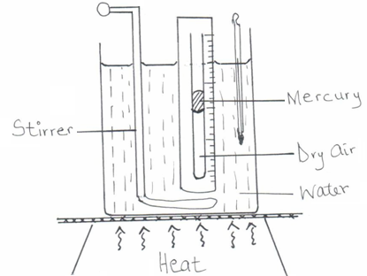

Fig. 8

(i) State the measurements that should be taken in the experiment. (2 marks)

_________________________________________________________________

_________________________________________________________________

_________________________________________________________________

_________________________________________________________________

Physics Paper 1 6 Kahuro/Kiharu
- Explain how the measurements taken in (i) above can be used to verify Charles law. (4 marks)

_________________________________________________________________

_________________________________________________________________

_________________________________________________________________

_________________________________________________________________

15. (a) The figure below shows a graph of force acting on a body against its velocity as it falls
through a liquid.
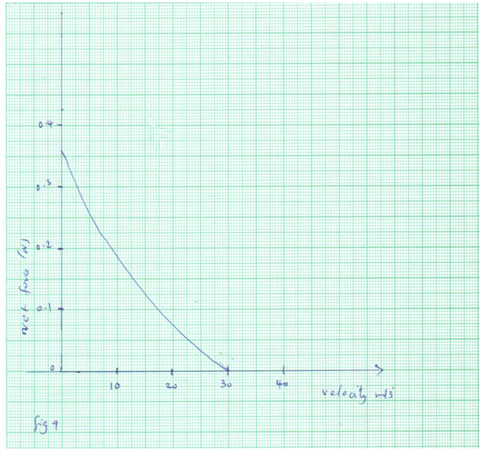

Determine the terminal velocity of the body. (1 mark)

______________________________________________________________________

______________________________________________________________________

______________________________________________________________________

Physics Paper 1 7 Kahuro/Kiharu
- A ball of mass 100g is dropped from a height of 1.25m above the ground surface.
It rebounds to a height of 1.1m. Calculate
(i) velocity of the ball before impact. (3 marks)

_________________________________________________________________

_________________________________________________________________

________________________________________________________________

________________________________________________________________

- force of impact if the ball is in contact with the surface for 0.2S (g = 10N/kg).
(3 marks)

________________________________________________________________

________________________________________________________________

________________________________________________________________

________________________________________________________________

(c) Distinguish between elastic and inelastic collision. (1 mark)

______________________________________________________________________

______________________________________________________________________

______________________________________________________________________

______________________________________________________________________

16. (a) Explain why water kept in a porous pot on a hot day remains cooler than that contained
in a metallic vessel. (1 mark)

______________________________________________________________________

______________________________________________________________________

______________________________________________________________________

- An immersion heater takes 30 minutes to heat 20kg of water from 25°C to 60°C. How long would the same heater take to heat the same mass of kerosene through the same temperature range. (Assume no heat is lost to the surrounding).
Specific heat capacity of water = 4200JKgˉ¹Kˉ¹
Specific heat capacity of kerosene = 2200JKgˉ¹Kˉ¹ (4 marks)

______________________________________________________________________

______________________________________________________________________

Physics Paper 1 8 Kahuro/Kiharu
______________________________________________________________________

______________________________________________________________________

______________________________________________________________________

(c) State two factors that affect the boiling point of water. (2 marks)

______________________________________________________________________

______________________________________________________________________

(d) The following figure shows a wheel and axle used to raise a load W by applying an effort F. The radius of the larger wheel is R and the small wheel is γ.
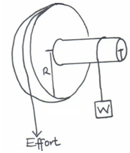

Fig.10

Given that v = 5cm and R is 8cm, determine the effort required to raise a load of 20N
if the efficiency of the system is 80%. (4 marks)

______________________________________________________________________

______________________________________________________________________

______________________________________________________________________

______________________________________________________________________

______________________________________________________________________

______________________________________________________________________

17. (a) Explain how a person is able to draw milk from a glass using a straw. (2 marks)

______________________________________________________________________

______________________________________________________________________

______________________________________________________________________

______________________________________________________________________

Physics Paper 1 8 Kahuro/Kiharu
- The diagram below shows a simplified hydraulic braking system of a car.
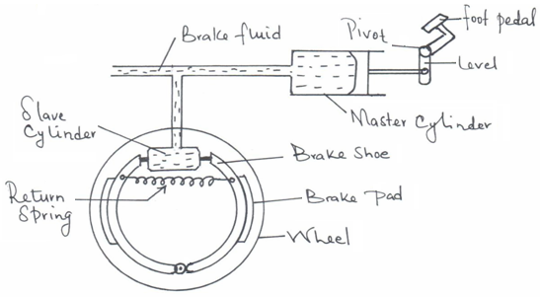

Fig. 11

(i) State the property of the liquid (oil) that makes its more suitable than a gas for use as a brake fluid. (1 mark)

_________________________________________________________________

- Explain how the system works starting from when the driver presses the foot pedal. (3 marks)

_________________________________________________________________

_________________________________________________________________

_________________________________________________________________

_________________________________________________________________

18. A matatu starts from rest and accelerates to cover a distance of 49m in 7 seconds. Determine
(i) its acceleration. (3 marks)

______________________________________________________________________

______________________________________________________________________

______________________________________________________________________

______________________________________________________________________

(ii) its velocity after 7 seconds. (2 marks)

______________________________________________________________________

______________________________________________________________________

______________________________________________________________________

______________________________________________________________________

Physics Paper 1 10 Kahuro/Kiharu
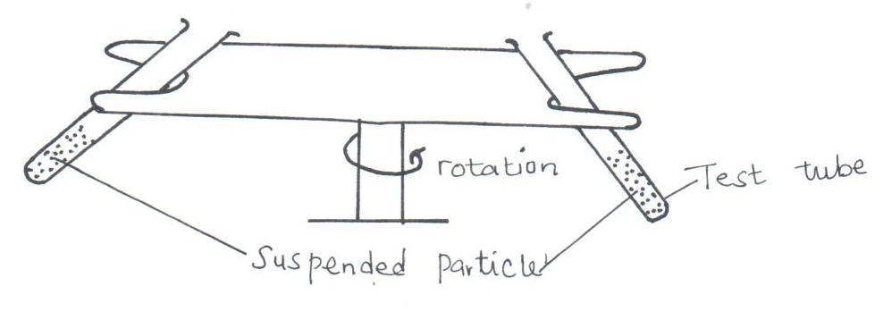
- The figure below shows a centrifuge that is used to separate particles suspended in a liquid.

Fig.12

Particle of different mass M₁, M₂ and M₃ are suspended in a liquid which they do not dissolve. The system is then rotated in the direction shown.
- Explain why the particles of different masses will acquire different radii as the system is rotated. (2 marks)

_________________________________________________________________

_________________________________________________________________

_________________________________________________________________

_________________________________________________________________

- If M₃, >M₂ > M₁, arrange the particle in increasing radii when the centrifuge is rotated for some time. (1 mark)

_________________________________________________________________

- A car of mass 1200kg is negotiating a curve of radius 45m on a horizontal road. The force of friction between the tyres and the road is 6700N. Determine the maximum speed at which the car can be driven on the curve without going off the road. (3 marks)

______________________________________________________________________

______________________________________________________________________

______________________________________________________________________

______________________________________________________________________

______________________________________________________________________

______________________________________________________________________

19. (a) State the law of flotation. (1 mark)

______________________________________________________________________

______________________________________________________________________

______________________________________________________________________

Physics Paper 1 11 Kahuro/Kiharu
(b) The figure below shows a uniform rod of height 8cm floating vertically in a beaker containing two immiscible liquids P and Q. The densities of the liquids are
800kg/m³ and 1200g/m³ respectively the cross-sectional area of the rod is 2cm².
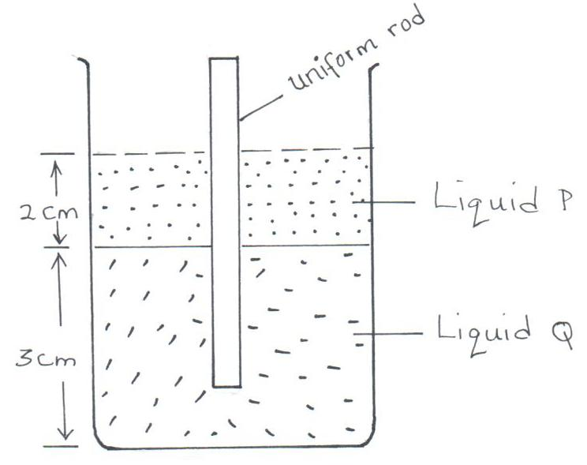

Fig.12

Determine
(i) the weight of liquid P displaced by the rod. (3 marks)

_________________________________________________________________

_________________________________________________________________

_________________________________________________________________

_________________________________________________________________

(ii) the weight of liquid Q displaced by the rod. (2 marks)

_________________________________________________________________

_________________________________________________________________

_________________________________________________________________

_________________________________________________________________

(iii) the mass of the rod. (2 marks)

_________________________________________________________________

_________________________________________________________________

_________________________________________________________________

_________________________________________________________________

(iv) the density of the rod. (2 marks)

_________________________________________________________________

_________________________________________________________________

_________________________________________________________________

_________________________________________________________________

Physics Paper 1 12 Kahuro/Kiharu

