NAME……………………………………………………….. INDEX NO……………………........................

232/2 CANDIDATE’S SIGN………….….….….…...
PHYSICS
PAPER 2 DATE……….…………………………………
(THEORY)
sTIME: 2 HOURS

CENTRAL KENYA NATIONAL SCHOOLS JOINT EXAM - 2015

Kenya Certificate of Secondary Education
PHYSICS
PAPER 2
(THEORY)
TIME: 2 HOURS

INSTRUCTIONS TO THE CANDIDATE:
(a) Write your name and index number in the spaces provided above.
(b) Sign and write the date of examination in the spaces provided above.
(c) This paper consists of two Sections A and B.
(d) Answer all the questions in sections A and B in the spaces provided.
(e) All working must be clearly shown in the spaces provided.
(f) Mathematical tables and electronic calculators may be used.

FOR EXAMINER’S USE ONLY:
Section | Question | Maximum  Score | Candidate’s  Score
A | 1 – 13 | 25
 | 14 | 11
 | 15 | 9
B | 16 | 7
 | 17 | 9
 | 18 | 9
Total Score |  | 80

Physics Paper 2 Turnover
SECTION A: (25 MARKS)

1. The figure below shows two mirrors M₁ and M₂ placed at an angle of 80°. A ray of light incident
to the mirror makes an angle of 45° with the mirror M₁. Find the angle the ray turns after reflection
in the two mirrors. (3mks)

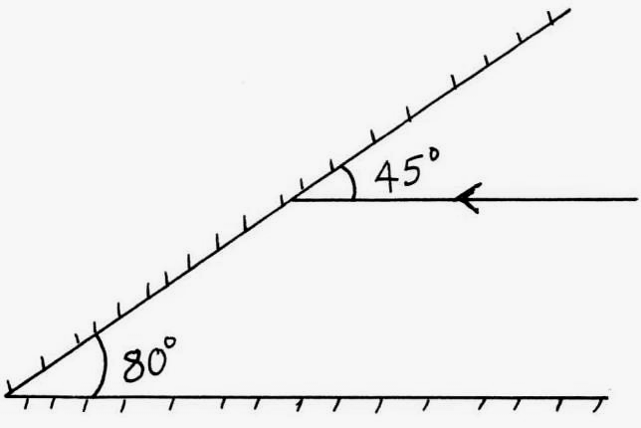
Incident ray

2. The figure below shows two charged spheres A and B. If the two spheres are brought into contact
and then separated complete the diagram showing charge distribution on the two spheres after separation. (2mks)

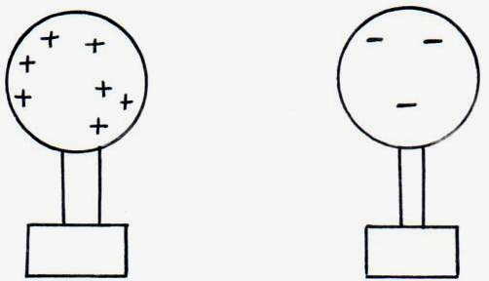

3. Explain how polarization reduces the emf in a simple cell. (1mk)

________________________________________________________________________________

________________________________________________________________________________

________________________________________________________________________________

4. The diagram below shows a method of magnetization.

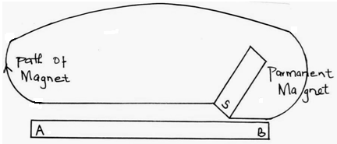

Physics Paper 2 2
Ferromagnetic material is being magnetized sketch a graph to show how the strength of a magnet being created varies with the number of strokes. (2mks)
Number of strokes
Magnetic strength

5. The figure below shows the magnetic field between two parallel current carrying conductors
A and B placed close to one another current flows in the opposite directions.
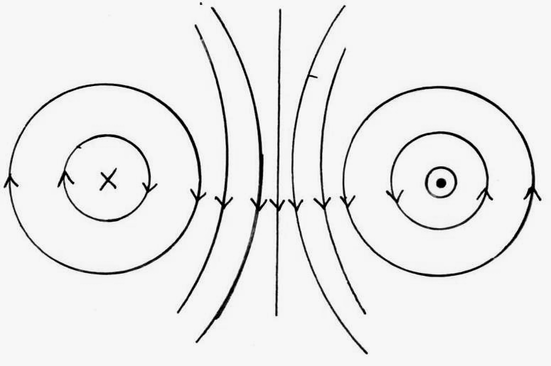

Indicate the direction of force F, due to the current on each conductor.

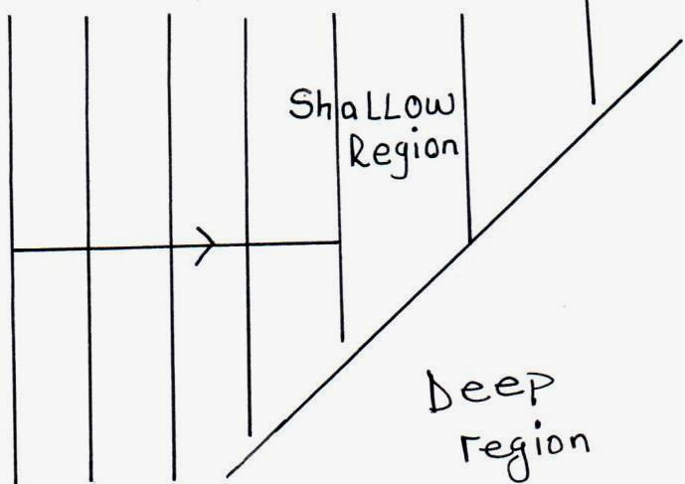
6. The figure below show water waves moving from a shallow region to a deep region. Complete the diagram to show the appearance of the waves in the deeper region. (2mks)

7. An echo sounder produces a pulse and an echo is received from the sea bed after 0.4 seconds.
If the speed of sound in water is 1500m/s. Calculate the depth of the sea bed. (2mks)

_________________________________________________________________________________

_________________________________________________________________________________

_________________________________________________________________________________

_________________________________________________________________________________

Physics Paper 2 3
8. The diagram below shows a ray of light travelling from water to glass given that the refractive index of water and glass are 1.33 and 1.5 respectively find the angle of refraction in glass. (3mks)
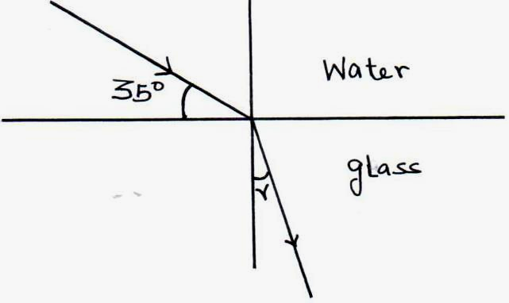

9. Below is part of the electromagnetic spectrum in order of increasing wavelength.
A | B | C | Visible light | Infra-red | D | E

How are waves A produced? (2mks)

__________________________________________________________________________________

__________________________________________________________________________________

__________________________________________________________________________________

__________________________________________________________________________________

10. The figure below shows an image formed by concave mirror. Complete the drawing rays and locate the position of the object. (2mks)

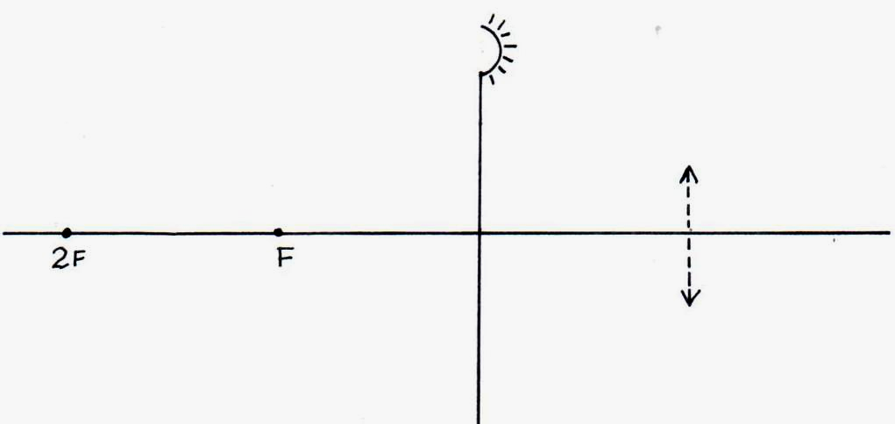

Physics Paper 2 4
11. The figure below shows capacitors connected to a d.c. supply.
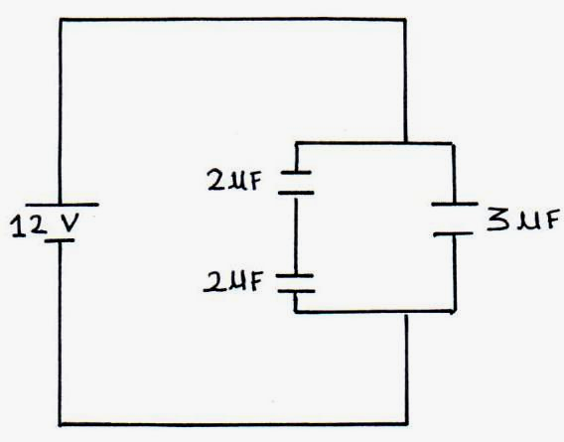

Determine the charge stored in the 3μF capacitor. (3mks)

__________________________________________________________________________________

__________________________________________________________________________________

__________________________________________________________________________________

__________________________________________________________________________________

12. A pendulum bob takes 0.5 seconds to move from its mean position to a maximum displacement position. Calculate its frequency. (2mks)

__________________________________________________________________________________

__________________________________________________________________________________

__________________________________________________________________________________

__________________________________________________________________________________

SECTION B: (55 MARKS)

13. (a) A defective eye focuses a near object as shown in the figure below.

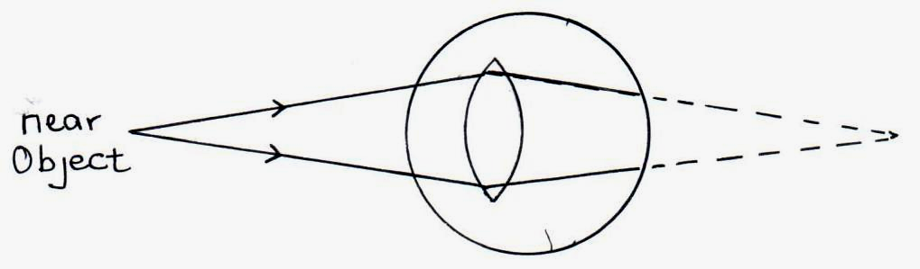

(i) State the defect. (1mk)

______________________________________________________________________

(ii) Suggest a suitable lens that can be used to correct the defect. (1mk)

______________________________________________________________________

Physics Paper 2 5
(iii) Draw a diagram to illustrate the correction of the defect. (2mks)

(b) (i) A real image, half the size of the object is formed by a lens. If the distance
between the object and the image is 450mm. Determine the focal length of
the lens. (3mks)

- The figure below shows a virtual image formed by a convex lens. Complete the
ray diagram to show the position of the object. (3mks)

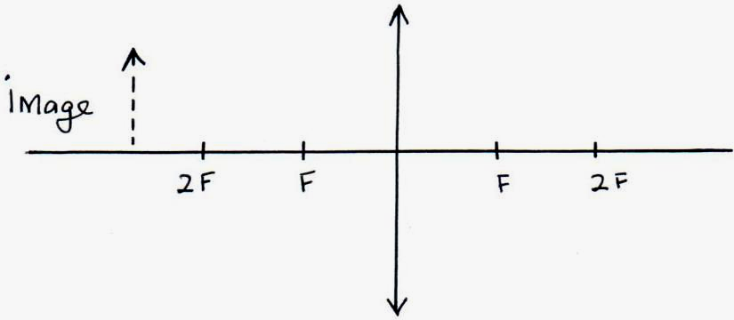

14. (a) State Faraday’s law of electromagnetic induction. (1mk)

____________________________________________________________________________

____________________________________________________________________________

____________________________________________________________________________

Physics Paper 2 6
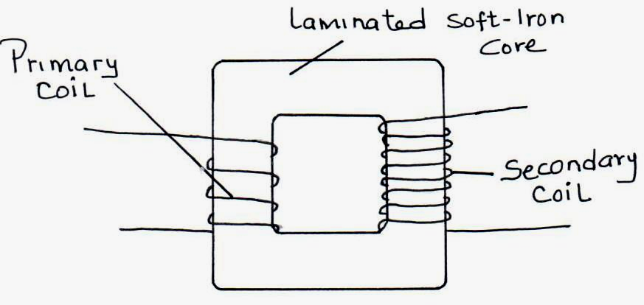
(b) The figure below shows a simple transformer. Study it and answer the questions that follow.

(i) Explain why the core is a continuous loop. (1mk)

______________________________________________________________________

______________________________________________________________________

______________________________________________________________________

(ii) Give a reason as to why the core is laminated. (1mk)

______________________________________________________________________

______________________________________________________________________

______________________________________________________________________

(iii) State and explain which coils are thicker. (2mks)

______________________________________________________________________

______________________________________________________________________

______________________________________________________________________

______________________________________________________________________

- State one difference and one similarity between a step up transformer and an induction coil.
(2mks)

____________________________________________________________________________

____________________________________________________________________________

____________________________________________________________________________

____________________________________________________________________________

- State two advantages of the use of alternating voltage for the transmission of electrical
energy. (2mks)

____________________________________________________________________________

____________________________________________________________________________

____________________________________________________________________________

Physics Paper 2 7
- In the circuit below, the e.m.f of the battery is 2.1V and has an internal resistance of 0.5Ω.
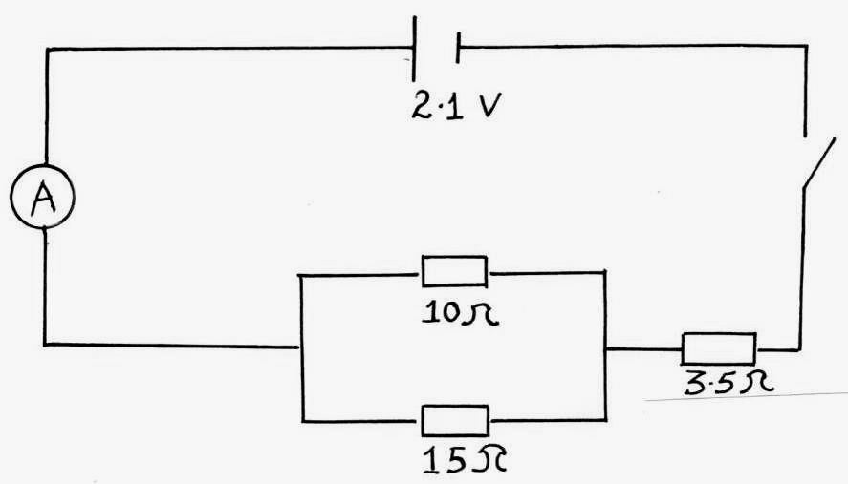

(i) Determine the effective resistance in the circuit. (2mks)

______________________________________________________________________

______________________________________________________________________

______________________________________________________________________

(ii) Determine the ammeter reading when the switch is closed. (2mks)

______________________________________________________________________

______________________________________________________________________

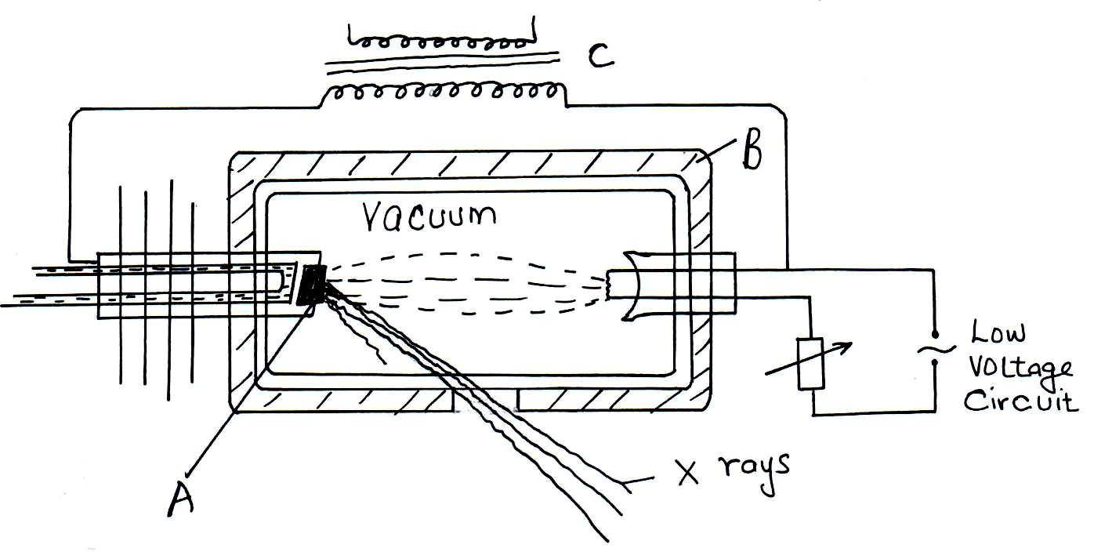
15. (a) Figure 6 below shows an X-ray tube.

(i) Name the elements used in making the parts labelled A and B. (2mks)

______________________________________________________________________

______________________________________________________________________

(ii) Explain the use of the part labelled C. (1mk)

______________________________________________________________________

_____________________________________________________________________

______________________________________________________________________

Physics Paper 1 8
(iii) Explain how the X-rays are produced. (2mks)

______________________________________________________________________

______________________________________________________________________

______________________________________________________________________

______________________________________________________________________

(iv) Why is the X-ray tube evacuated? (1mk)

______________________________________________________________________

______________________________________________________________________

______________________________________________________________________

- The penetrating power of X-rays is normally varied depending on the intended use. Explain briefly how this is done. (1mk)

____________________________________________________________________________

____________________________________________________________________________

____________________________________________________________________________

- The energy of X-rays is 1.989 × 10ˉ¹⁴ joules. Given that the speed of light is 3.0 × 10⁸m/s and plank’s constant is 6.63 × 10⁻³⁴JS. Find the wavelength of the X-rays. (2mks)

- The figure below shows a wave form displayed on the screen of C.R.O when the time base
is set at 20ms per division.
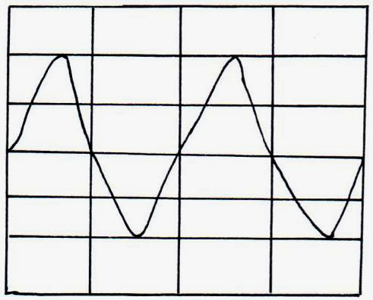

Physics Paper 2 9
Determine the frequency of the signal. (3mks)

16. (a) Give a condition necessary for electrons to be emitted from the cathode of a photocell. (1mk)

____________________________________________________________________________

____________________________________________________________________________

____________________________________________________________________________

- In an experiment using a photocell, ultraviolet light of varying frequency strikes a metal surface. The maximum Kinetic Energy (K.E_{max}) of photoelectrons for each frequency $f$
is measured. The graph below shows how the maximum kinetic energy varies with the frequency $f$.
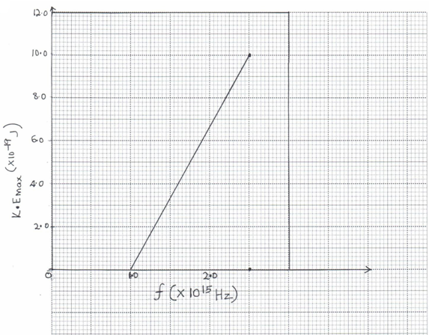

Use the graph to determine:
(i) The Threshold frequency, $f$. (1mk)

______________________________________________________________________

______________________________________________________________________

Physics Paper 2 10
(ii) Planck’s constant, h. (3mks)

______________________________________________________________________

______________________________________________________________________

______________________________________________________________________

(iii) Work function of the metal. (3mks)

______________________________________________________________________

______________________________________________________________________

______________________________________________________________________

- The figure below shows the variation of photoelectric current with applied voltage when
a surface was illuminated with light of a certain frequency. On the same axes, sketch the
graph when a light of higher intensity but same frequency is used to illuminate the same
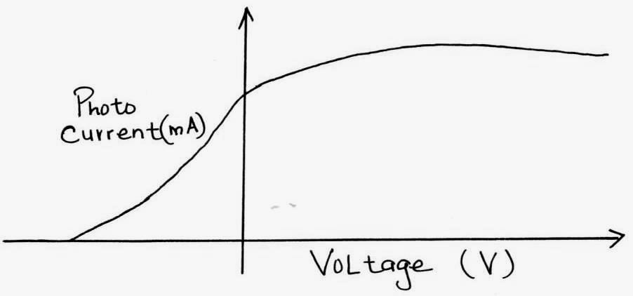
surface. (1mk)

17. (a) (i) Define the term half life of a radioactive material. (1mk)

______________________________________________________________________

______________________________________________________________________

______________________________________________________________________

- The figure below shows a decay of a certain element. The diagram is drawn to scale.
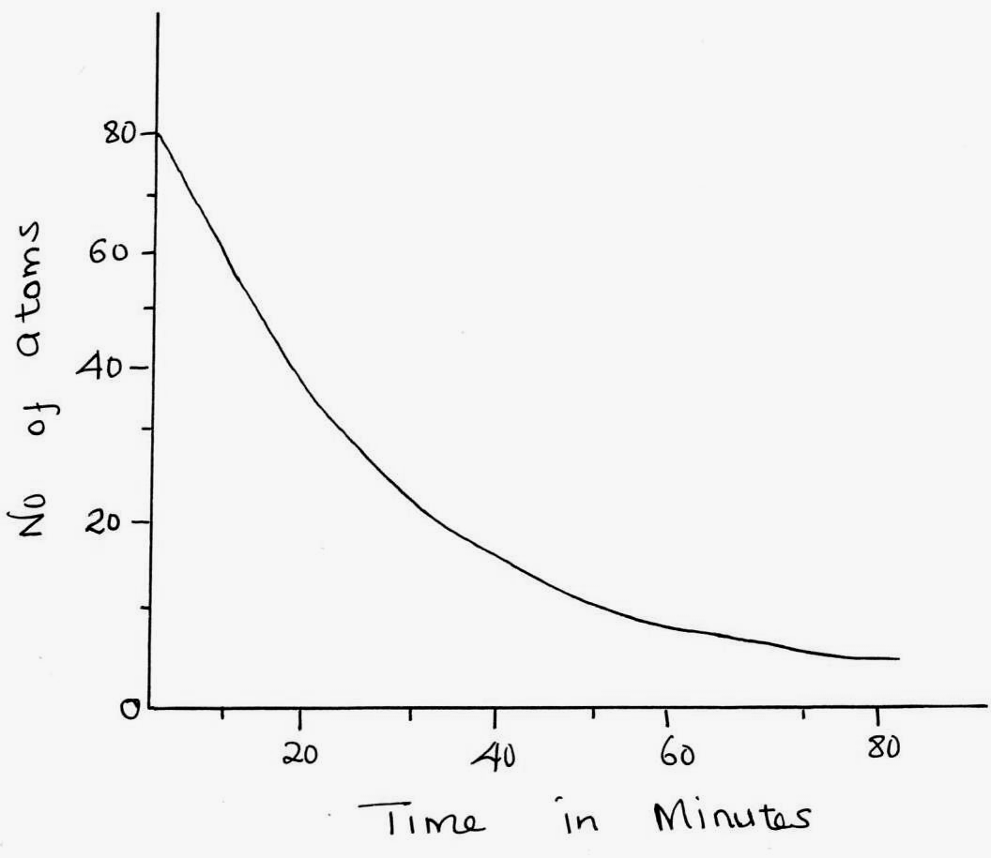

Physics Paper 2 11
From the graph find:
(i) Half life of the element. (1mk)

______________________________________________________________________

(ii) Number of half lives undergone when the count rate is 10 atoms. (2mks)

______________________________________________________________________

______________________________________________________________________

- The following is part of a radioactive decay series.

${}_{\text{90}}^{\text{232}}{} \text{Th} \vec{β} {}_{\text{91}}^{a}{} X \vec{Υ} {}_{b}^{\text{228}}{} Y$

Determine the value of ‘a’ and ‘b’. (2mks)

______________________________________________________________________

______________________________________________________________________

18. (a) Define the term doping. (1mk)

____________________________________________________________________________

____________________________________________________________________________

____________________________________________________________________________

- The diagram below shows a bridge rectifier for alternating current. Complete the diagram by placing the diodes in the correct order. (2mks)
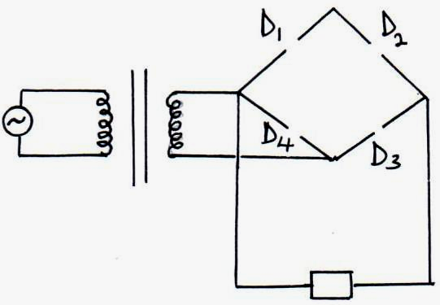

(c) Explain why a bridge rectifier circuit is better than a single diode rectifier circuit. (1mk)

____________________________________________________________________________

____________________________________________________________________________

____________________________________________________________________________

(d) What happens to depletion layer when diode is reverse biased. (1mk)

____________________________________________________________________________

Physics Paper 2 12

