NAME……………………………………………………….. INDEX NO……………………........................

232/2 CANDIDATE’S SIGN………….….….….…...
PHYSICS
PAPER 2 DATE……….…………………………………
(THEORY)
JULY/AUGUST, 2015
TIME: 2 HOURS

KAHURO /KIHARU DISTRICT JOINT EXAMINATION - 2015

Kenya Certificate of Secondary Education
PHYSICS
PAPER 2
(THEORY)
TIME: 2 HOURS

INSTRUCTIONS TO THE CANDIDATE:
(a) Write your name and index number in the spaces provided.
(b) Sign and write the date of examination in the spaces provided.
(c) This paper consists of two Sections A and B.
(d) Answer all the questions in sections A and B in the spaces provided.
(e) All working must be clearly shown in the spaces provided.
(f) Mathematical tables and electronic calculators may be used.

FOR EXAMINER’S USE ONLY:
Section | Question | Maximum  Score | Candidate  Score
A | 1 – 12 | 25
 | 13 | 14
 | 14 | 13
B | 15 | 15
 | 16 | 15
Total Score |  | 80

Physics Paper 2 Turnover
SECTION A: (25 MARKS)

1. When a negatively charged rod is brought near the cap of a leaf electroscope, the leaf rises. Explain this observation. (2 marks)

______________________________________________________________________

______________________________________________________________________

______________________________________________________________________

______________________________________________________________________

2. Figure 1 below represents a displacement-time graph for a wave.
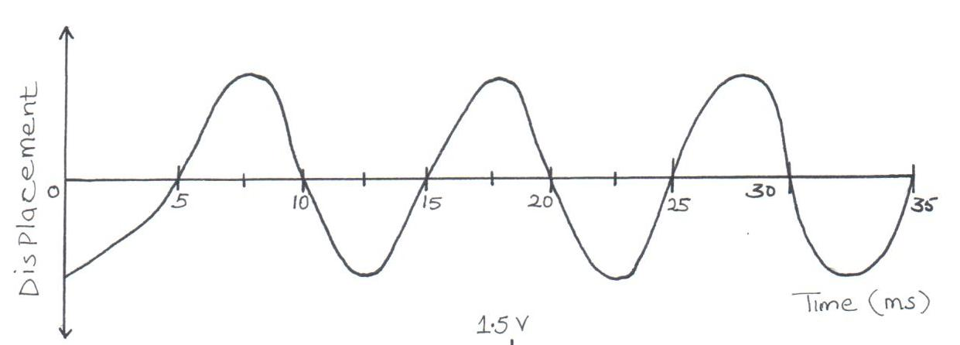

Figure 1

Determine the frequency of the wave. (2 marks)

______________________________________________________________________

______________________________________________________________________

______________________________________________________________________

______________________________________________________________________

3. A hair drier is rated 2000W, 240V. Determine its resistance. (2 marks)

______________________________________________________________________

______________________________________________________________________

______________________________________________________________________

______________________________________________________________________

Physics Paper 2 2 Kahuro/Kiharu
4. Why is repulsion the sure test for a magnet? (1 mark)

______________________________________________________________________

______________________________________________________________________

______________________________________________________________________

5. What is the voltage output for the cell arrangement below? (2 marks)
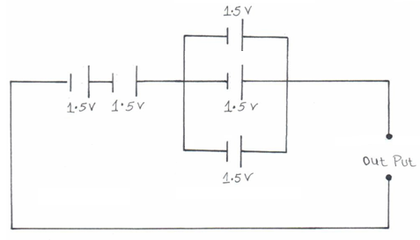

______________________________________________________________________

______________________________________________________________________

6. A ray of light is incident on a plane mirror as shown.
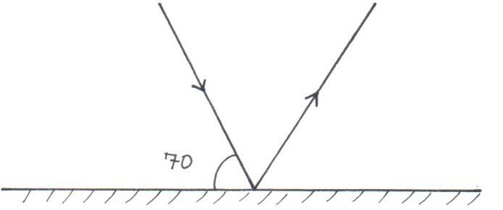

- What will be the angle through which the reflected ray rotates if the mirror is rotated anticlockwise through an angle of 35°?

_________________________________________________________________

_________________________________________________________________

_________________________________________________________________

(b) What would be the new angle of reflection? (2 marks)

_________________________________________________________________

_________________________________________________________________

_________________________________________________________________

Physics Paper 2 3 Kahuro/Kiharu
7. A radioactive substance decays as shown below.
228208
92 82
X
Y

How many alpha and beta particles are emitted?

______________________________________________________________________

______________________________________________________________________

______________________________________________________________________

8. Sketch a circuit diagram to show how two diodes can be used as a current full wave rectifier. (2 marks)

9. Four capacitor are connected as shown.
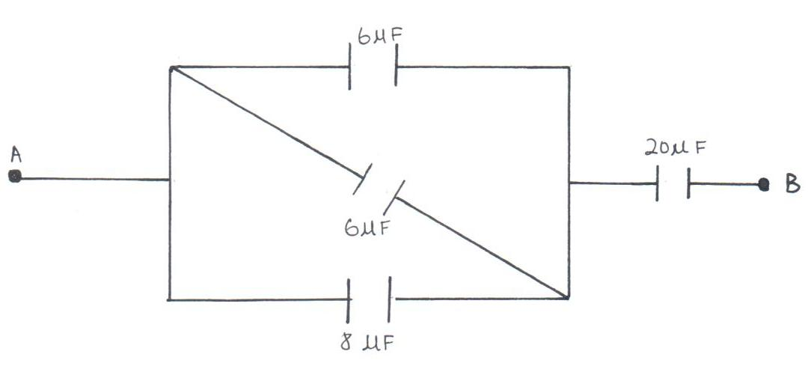

Calculate the effective capacitance between A and B. (3 marks)

______________________________________________________________________

______________________________________________________________________

______________________________________________________________________

______________________________________________________________________

Physics Paper 2 4 Kahuro/Kiharu
10. Use the domain theory to explain how an unmagnetized piece of iron becomes magnetized when it is heated and then allowed to cool in a magnetic field. (2 marks)

______________________________________________________________________

______________________________________________________________________

______________________________________________________________________

______________________________________________________________________

11. A girl observes her face in a concave mirror of focal length 10cm. If the mirror is
8cm away. State one characteristic of the image observed. (1 mark)

______________________________________________________________________

______________________________________________________________________

______________________________________________________________________

12. The coil is an electric motor is usually wound on a soft iron armature. State two purposes of this armature. (2 marks)

______________________________________________________________________

______________________________________________________________________

______________________________________________________________________

______________________________________________________________________

SECTION: (55 MARKS)

13. (a) Define the term work function. (2 marks)

_________________________________________________________________

_________________________________________________________________

_________________________________________________________________

- The work function of a clean metal surface is 7.5eV. Calculate.
  - The minimum frequency of radiation that will cause the emission of electrons from the surface. (Plank’s constant h = 6.63 x 10⁻³⁴Js,
electronic charge e = 1.6 x 10⁻¹⁹C). (3 marks)

____________________________________________________________

____________________________________________________________

____________________________________________________________

____________________________________________________________

Physics Paper 2 5 Kahuro/Kiharu
  - The maximum energy of the electrons emitted when the surface is illuminated with a radiation of frequency 2.0 x 10¹⁵H_{Z}. (3 marks)

____________________________________________________________

____________________________________________________________

____________________________________________________________

____________________________________________________________

- The graph below show stopping potential Vs against frequency f.
(Take C = 3.0 x 10⁸msˉ¹).
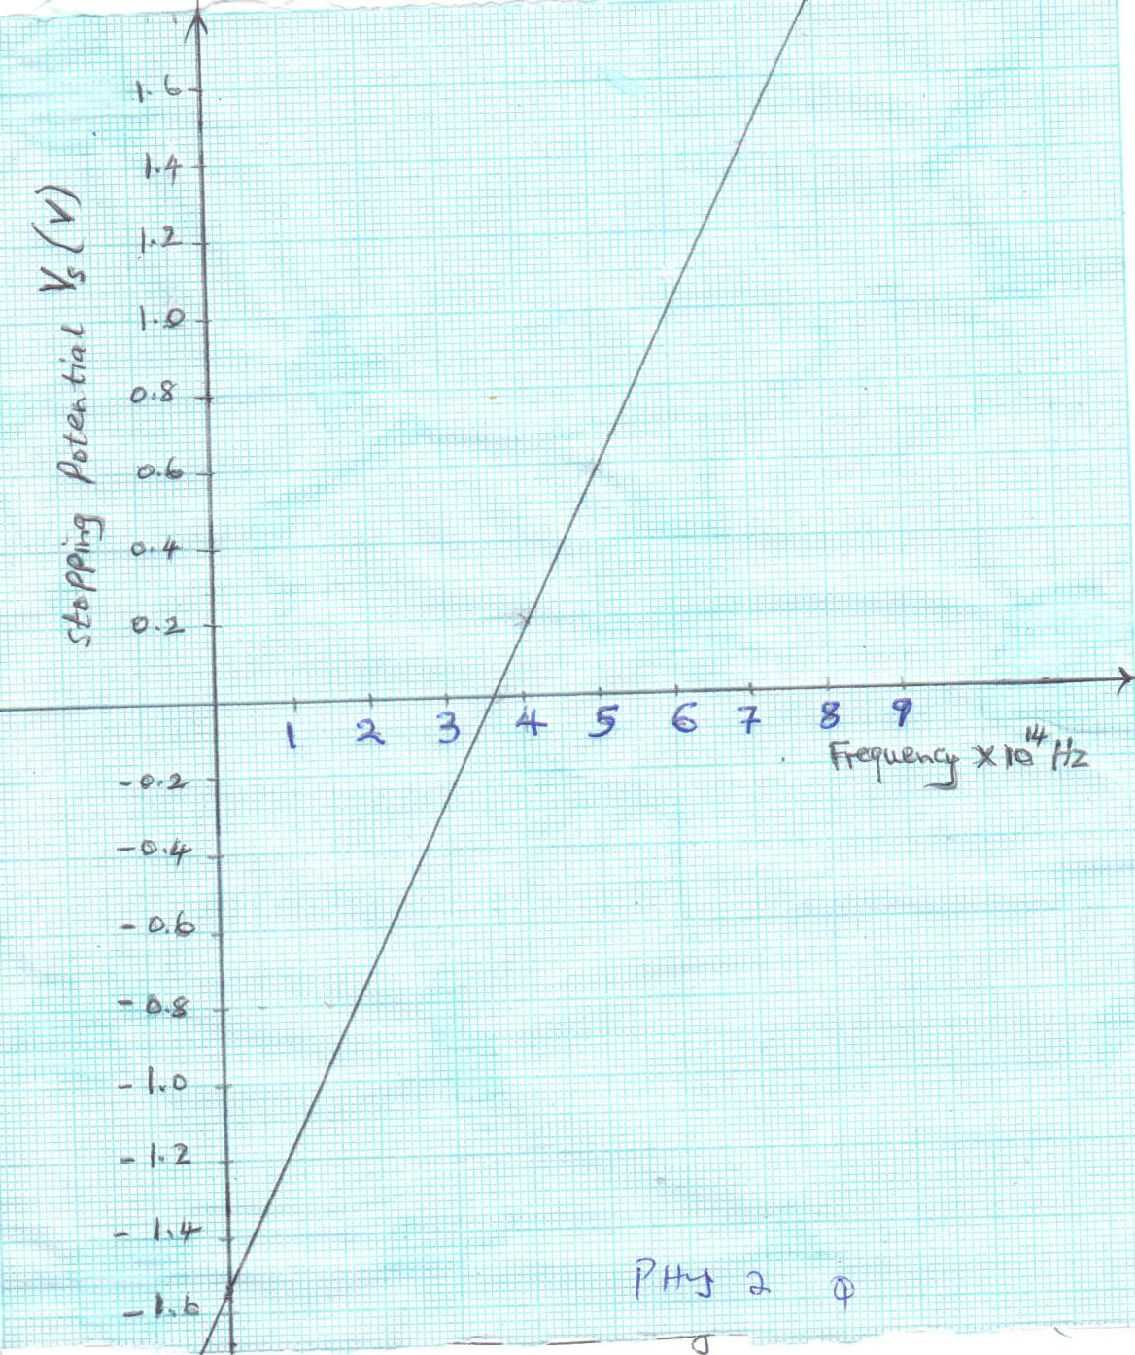

Physics Paper 2 6 Kahuro/Kiharu
Use the graph to determine:-
(i) the threshold wavelength. (2 marks)

____________________________________________________________

____________________________________________________________

____________________________________________________________

____________________________________________________________

(ii) Planck’s constant. (2 marks)

____________________________________________________________

____________________________________________________________

____________________________________________________________

____________________________________________________________

(iii) the work function of the metal. (2 marks)

____________________________________________________________

____________________________________________________________

____________________________________________________________

____________________________________________________________

14. (a) The figure below shows an object in front of lens.
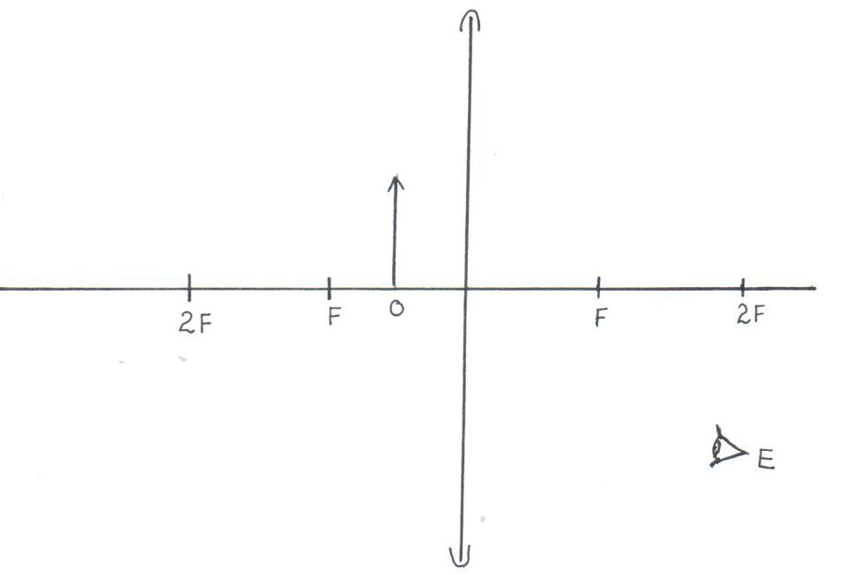

Physics Paper 2 7 Kahuro/Kiharu

(i) Using rays locate the image as seen by observer, E. (2 marks)

(ii) Give one application of such a lens as used above. (1 mark)

____________________________________________________________

(iii) Write three similarities between an eye and a camera. (3 marks)

____________________________________________________________

____________________________________________________________

____________________________________________________________

____________________________________________________________

(b) Figure (a) and (b) show diagrams of the human eye.

(a)
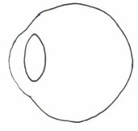

(b)

(i) In figure (a), sketch a ray diagram showing long sightedness. (1 mark)

- In figure (b), sketch a ray diagram showing how lens is used to correct
long sightedness. (2 marks)

Physics Paper 2 8 Kahuro/Kiharu
(d) An object of height 10.5cm stands before a diverging lens of focal length 20cm and a distance of 10cm from the lens. Determine;
(i) image distance. (2 marks)

____________________________________________________________

____________________________________________________________

____________________________________________________________

____________________________________________________________

(ii) height of the image. (1 mark)

____________________________________________________________

____________________________________________________________

____________________________________________________________

____________________________________________________________

(iii) magnification. (1 mark)

____________________________________________________________

____________________________________________________________

____________________________________________________________

____________________________________________________________

15. (a) A heater is rated 2000W is used to heat water for 5 hours. Calculate the cost of
electricity at Ksh.6.70 per unit. (3 marks)

_________________________________________________________________

_________________________________________________________________

_________________________________________________________________

_________________________________________________________________

(b) Give a reason why transmission of electricity is done at very high voltage. (1 mark)
_________________________________________________________________

_________________________________________________________________

_________________________________________________________________

Physics Paper 2 9 Kahuro/Kiharu
- Figure below shows a connection of a three pin plug.
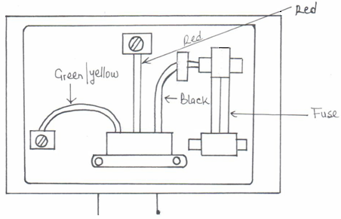

(i) Identify any two mistakes in these wires. (2 marks)

____________________________________________________________

____________________________________________________________

____________________________________________________________

____________________________________________________________

- Suggest what would happen if this plug was connected to the mains of the socket. (1 mark)

____________________________________________________________

____________________________________________________________

- The figure below shows an induction coil used to produce sparks.
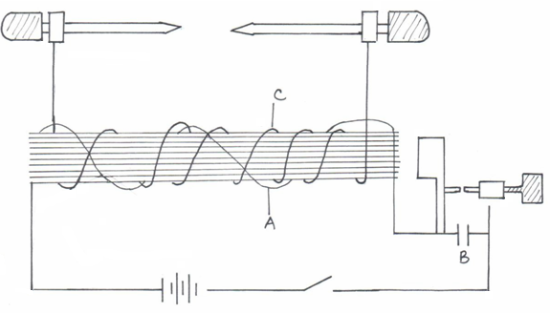

Physics Paper 2 10 Kahuro/Kiharu
(i) Name the parts labelled A, B and C. (3 marks)

A __________________________________________________________

B __________________________________________________________

C __________________________________________________________

(ii) Briefly explain how induction coil works. (3 marks)

____________________________________________________________

____________________________________________________________

____________________________________________________________

____________________________________________________________

____________________________________________________________

16. (a) The refractive index of glass is $32$and that of water is $43$. Calculate the
refractive index of glass with respect to water. (2 marks)

_________________________________________________________________

_________________________________________________________________

_________________________________________________________________

_________________________________________________________________

- The figure below shows a ray of light incident at an angle of 35.6° at point D
on the first face of a glass prism ABC. The refractive index of the prism
is 1.6.
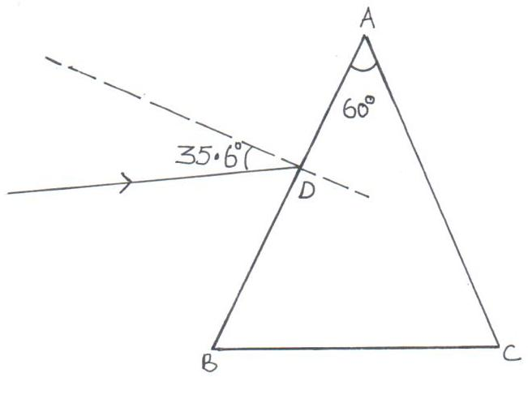

Physics Paper 2 11 Kahuro/Kiharu
(i) Determine the angle of refraction at point D. (3 marks)

____________________________________________________________

____________________________________________________________

____________________________________________________________

____________________________________________________________

- Find the angle of incidence of the refracted ray on the face AC to 1 decimal point. (2 marks)

____________________________________________________________

____________________________________________________________

____________________________________________________________

____________________________________________________________

(iii) Complete the ray diagram to show the emergent ray from the face AC.
(2 marks)

(iv) State two conditions necessary for total internal reflection to occur. (2 marks)

____________________________________________________________

____________________________________________________________

____________________________________________________________

____________________________________________________________

(c) Name two detectors of infrared radiation. (2 marks)

_________________________________________________________________

_________________________________________________________________

Physics Paper 2 12 Kahuro/Kiharu

