NAME……………………………………………………….. INDEX NO……………………..........................

232/3 CANDIDATE’S SIGN………….….….….….....
PHYSICS
PAPER 3 DATE……….…………………………………..
(PRACTICAL)
JULY/AUGUST, 2015
TIME: 2½ HOURS

KAHURO/KIHARU DISTRICT JOINT EXAMINATION – 2015

Kenya Certificate of Secondary Education
PHYSICS
PAPER 3
(PRACTICAL)
TIME: 2½ HOURS

Instructions to candidates:
(a) Answer all the questions in spaces provided in the question paper.
(b) You are supposed to spend the first 15 minutes of 2½ hours allowed for this paper
reading the whole paper carefully before commencing the work.
(c) Marks are given for clear record of the observations actually made, their suitability,
accuracy and the use made of them.
(d) Candidates are advised to record their observations as soon as they are made.
(e) Non-programmable silent electronic calculators and KNEC Mathematical table may be used.

FOR EXAMINER’S USE ONLY:
Question 1 | (ii) | (vii) | (viii) | (ix) | (x) | (xii) | (xiii) | (xiv) | (xv)
Maximum Score | 1 | 5 | 5 | 1 | 3 | 1 | 1 | 1 | 2
Candidate’s Score |  |  |  |  |  |  |  |  | Total  Total

Question 2 | a | b | d | e | i | j | k | l
Maximum Score | ½ | 1½ | 1 | 1 | 6 | 5 | 2 | 3
Candidate’s Score

Physics Paper 3 Turnover
Question 1

Part 1

You are provided with the following apparatus:
- A triangular prism.
- A white sheet of paper.
- A sot board.
- Four optical pins.
- A 30cm ruler.
- A protractor.
- A piece of plasticine.
- Four thumb tacks.

Proceed as follows:
- Mount the white sheet of paper on the soft board using the thumb tacks provided and trace
the outline of the prism on the paper.

(ii) Measure the refracting angle A, see the diagram below of the outline using a protractor and mark
on the prism the vertex corresponding to A with a small bob of plasticine. This is should be
maintained throughout the experiment.

Angle A = _________° (1 mark)

Figure 1
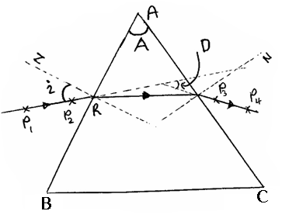

(iii) Draw a normal at point R on the side AB of the prism and construct on angle of incidence
of 30° to this normal as shown in figure 1 above. Place the prism back on the outline.

(iv) Fix pins P₁ and P₂ on the line drawn. Viewing through side AC, fix pins P₃ and P₄ on so
that they appear in line with the images of P₁ and P₂ .

(v) Remove the prism and join P₃ P₄ to side AC to define the emergent ray.

(vi) Produce the incident and emergent rays to intersect as shown in the diagram. This gives
the angle of deviation D. Measure and record angle D in Table 1 below.

(vii) Repeat steps (iii – vi) for angles of incidence of 40°, 50°, 60° and 70° and complete the
table I below. (5 marks)

Physics Paper 3 2 Kahuro/Kiharu
Table 1
i° | 30 | 40 | 50 | 60 | 70
D°

(viii) Plot a graph of D against i on the grid provided below. (5 marks)

Physics Paper 3 3 Kahuro/Kiharu
(ix) Use your graph in part (viii) to find the value of minimum deviation, D_{min}.

D_{min} = __________° (1 mark)

(x) Given that
$\text{Sin} \frac{1}{2} \left(A + D\right) = n \text{Sin} \left(\frac{A}{2}\right)$
Where n is a constant, determine the value of n for the glass prism. (3 marks)

Part 2
You are provided with the following apparatus.
- A diode.
- A voltmeter.
- A potentiometer.
- 8 connecting wires, one with a crocodile clip at one end.
- 2 dry cells and a cell holder.
- 1 KΩ carbon resistor.

Proceed as follows:

(xi) Set up the apparatus as shown in figure 2 below. Close the switch

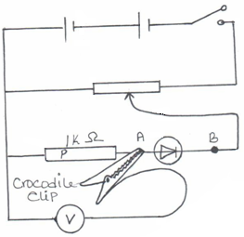
Figure 2

(xii) Starting with the crocodile clip connected to terminal A, adjust the potentiometer until the
voltmeter reads 1.20 volts. Now move the crocodile clip to terminal B. Record the new
voltmeter reading.

p.d = ____________ V (1 mark)

Physics Paper 3 4 Kahuro/Kiharu
(xiii) Given that the value of the carbon resistor P is 1 KΩ, calculate the current I_{R} through
the resistor in amperes.

I_{R} = _____________ A (1 mark)

(xiv) Calculate the p.d V_{d} across the diode from your results in part (xii) above.

Vd = ____________ V (1 mark)

(xv) Determine the resistance Rd of the diode given that

$R = \frac{V}{I}$= ___________Ω (2 marks)

Question 2

This question consists of two parts; part 1 and part 2. Attempt both parts.

Part 1
You are provided with the following apparatus.
- A soft board (the one used in question 1)
- A wooden block with a hook.
- A spring balance.
- 1 100g mass.
- A beam balance (To be shared).

Proceed as follows:
(a) Measure the mass of the wooden block in kg and record its value in Table 2 below.

(b) Calculate the weight of the block in Newton’s and the normal reaction on the block
in Newton’s and record this values in table 2 below.

(c) Lay the wooden block on the soft board and attach the spring balance on the hook
provided in the wooden block.

(d) Place the 100g mass on top of the block and pull the wooden block gradually along
the horizontal until the block just begins to slide on the surface of the soft board see
figure 3 below. Note the maximum reading of force when it just slides and record
in the table of results. This is the limiting static friction force, F.

Figure 3
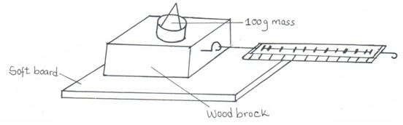

Physics Paper 3 5 Kahuro/Kiharu
(e) Given that F = μR, where μ is a constant, use your data in table 2 to determine the value
of μ for the sliding surfaces.

Table 2
Mass of block (kg) | Weight of block + 100g mass (N) | Normal reaction R(N) | Limiting static friction F(N)

μ = ________________ (1 mark)

Part 2

You are provided with the following
- 2 pieces of thread
- A stop watch
- 2 retort stands with a boss and a clamp.
- Two metre rules.
- 4 wooden strips.

Proceed as follows:
Set up the apparatus as shown in figure 4 below, with the suspending length L of the threads being
60cm and the points of suspension of the threads on the rule at 5cm from either end. The thread
should be looped at the bottom so that the rule rests on a horizontal plane.
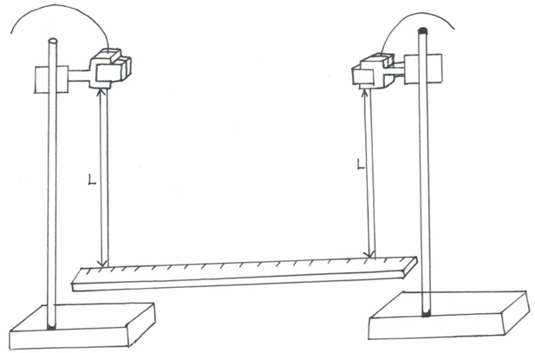

- Displace the two ends of the rule through a small angle along the horizontal, so that the rule performs oscillations along the horizontal plane. Determine and record the time t for 10 oscillations.

(h) Adjust the suspending lengths L of the threads to L = 55.0cm, and repeat step (g) above.

(i) Repeat step g for the other values of L and complete table 3 below.

Table 3
L(cm) | Time for 10 oscillation (s) | Periodic time T(s) | Log L | Log T
60.0
55.0
50.0
45.0
40.0
35.0 |  |  |  |  | (6 marks)

Physics Paper 3 2 Kahuro/Kiharu
(j) Plot a graph of Log T against Log L. (5 marks)

Physics Paper 3 7 Kahuro/Kiharu
(k) Find the slope S of the graph. (2 marks)

- Given that Log T – Log K = n Log L where K and n are constants, use your graph in part (j) above
to determine the values of K and n. (3 marks)

Physics Paper 3 8 Kahuro/Kiharu

