Name: …………………………………………………………… Index No.:……………………................
School: …………………………………………………………. Candidate’s Sign:……………………...
Date:…..……………..…………………………….........................

232/1
PHYSICS
PAPER 1
(THEORY)
JULY/AUGUST - 2015
TIME: 2 HOURS

TRANS-NZOIA COUNTY JOINT EVALUATION EXAM – 2015
Kenya Certificate of Secondary Education (K.C.S.E)

PHYSICS
PAPER 1
2 HOURS

INSTRUCTIONS TO THE CANDIDATES
- Write your name and index number in the spaces provided above.
- Sign and write the date of examination in the spaces provided.
- This paper consists of two sections, A and B.
- Answer all the questions in section A and B in the spaces provided.
- All workings must be clearly shown.
- Silent non programmable electronic calculators may be used.
- Candidates should answer the questions in English.
For Examiner’s Use Only:-
SECTION | QUESTION | MAXIMUM SCORE | CANDIDATE’S SCORE
A | 1 – 14 | 25
B | 15 | 10
 | 16 | 12
 | 17 | 13
 | 18 | 09
 | 19 | 11
TOTAL SCORE |  | 80

This paper consists of 8 printed pages.
Candidates should check the question paper to ascertain that all pages are printed as indicated.
And that no questions are missing.
SECTION A; (25 MARKS)
Answer all questions in this section.
1. Figure 1 below shows a vernier calipers being used to measure the diameter of an object.

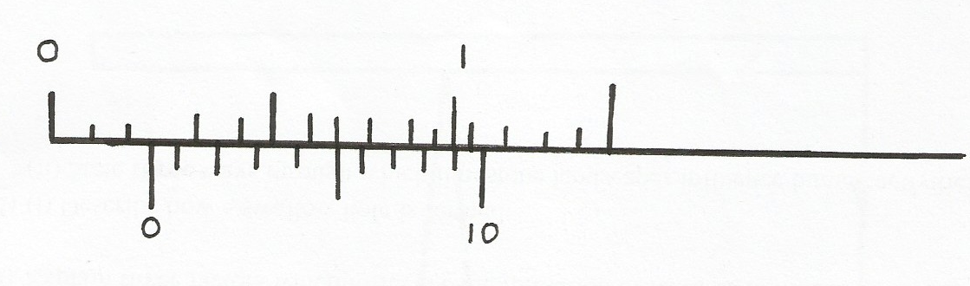

0
cm
1

Fig.1
10
0

The reading on the calipers when the jaws were fully closed without the object was -0.11 cm. What
is the actual diameter of the object? (2 mks)
…………………………………………………………………………………………………………..
…………………………………………………………………………………………………………..
2. Explain why a high mountain climber is likely to experience nose bleeding. (2 mks)
…………………………………………………………………………………………………………..
…………………………………………………………………………………………………………..
3. A beaker is filled completely with water. A spoonful of common salt is added slowly. The salt
dissolves and the water does not overflow. Give a reason why the water doesn’t overflow. (1 mk)
…………………………………………………………………………………………………………..
4. Cloudy nights are warmer than clear (cloudless) nights. Explain. (1 mk)
…………………………………………………………………………………………………………..
5. Air is blown over a piece of paper as shown in fig. 2 below.
Piece of paper hold horizontally here

Air blown horizontally
Piece of paper
Fig.2

State what is observed. (1 mk)
…………………………………………………………………………………………………………..
6. Explain why a hollow glass sphere just floats in cold water in a copper can but sinks when the water
is heated. (2 mks)
…………………………………………………………………………………………………………..…………………………………………………………………………………………………………..
7. A drop of oil has a volume of 3.0 x 10⁻⁶m³ and spreads to form a patch of radius 16 cm on the surface of water. Determine the thickness of the oil patch. (2 mks)
…………………………………………………………………………………………………………..
…………………………………………………………………………………………………………..
…………………………………………………………………………………………………………..
8. A body is projected vertically upwards and returns to the original point. Sketch a velocity – time
graph on the grid below. (1 mk)
Fig. 3
Velocity
time

9. Fig. 4 shows a uniform rod of the length 4 m and mass 4 kg pivoted at the 3.6m mark. The rod is held horizontally with a vertical rope at 4 m mark as shown below.
3.6cm
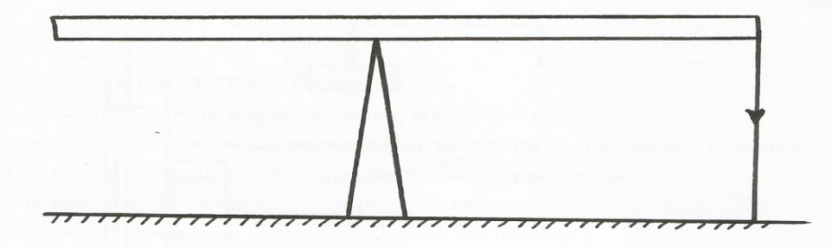
4m

Rope

Fig.4
Calculate the tension T in the rope (Take g = 10N/kg) (3 mks)
…………………………………………………………………………………………………………..
…………………………………………………………………………………………………………..
…………………………………………………………………………………………………………..
10. Why are people who are maimed or have lost one leg provided with crutches? (1 mk)
…………………………………………………………………………………………………………..
11. An uncalibrated thermometer is placed first in melting ice then in boiling water. The lengths of the
liquid column are 22 mm and 79 mm respectively. What temperature in ⁰C would correspond to a
length of 63 mm? (2 mks)
…………………………………………………………………………………………………………..
…………………………………………………………………………………………………………..
…………………………………………………………………………………………………………..
12. The pressure acting on a gas in a container was changed steadily while the temperature of the gas
was maintained at a constant. The value of volume V of the gas was measured for various values of
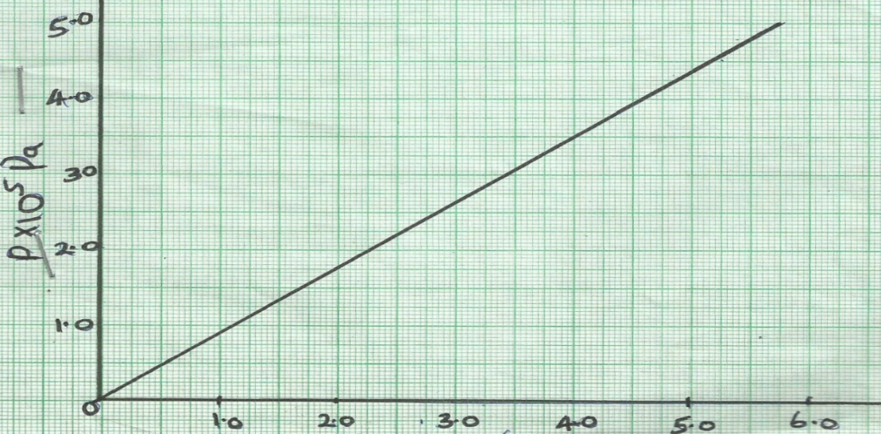
pressure. The graph below shows the relation between pressure P and the reciprocal of volume $\frac{1}{v}$.

Given that the relation between pressure P and the volume V of the gas is given by PV = K. When K
is constant, use the graph to determine the value of K. (3 mks)

13. It is observed that a bubble at the base of the container rises up the water column until the surface.
Explain what happens to the bubble as it rises up the water column. (2 mks)
…………………………………………………………………………………………………………..
…………………………………………………………………………………………………………..
14. A block of steel sinks in water while a ship which is mainly made of steel floats. Explain. (2 mks)
…………………………………………………………………………………………………………..
…………………………………………………………………………………………………………..
SECTION B: (55 MARKS)
Answer all questions from this section.
15. (a) State Newton’s second law of motion. (1 mk)
…………………………………………………………………………………………………………..
(b) A matatu starts from rest and accelerates to cover a distance of 98 m in 14 seconds. Determine:-
(i) Its acceleration; (3 mks)
…………………………………………………………………………………………………………..
…………………………………………………………………………………………………………..
…………………………………………………………………………………………………………..
(ii) Its velocity after 14 seconds. (2 mks)
…………………………………………………………………………………………………………..
…………………………………………………………………………………………………………..
(c) A trolley moving on a horizontal bench of height 1.2 m, strikes a barrier at the edge of the bench.
The brass mass on the top of the trolley flies off on impact and lands on the ground 2.5 m from the edge of the bench.
Determine:-
(i) The time taken by the brass mass to reach the ground. (2 mks)
…………………………………………………………………………………………………………..
…………………………………………………………………………………………………………..
…………………………………………………………………………………………………………..
…………………………………………………………………………………………………………..

(ii) The speed at which the trolley struck the barrier. (2mks)
…………………………………………………………………………………………………………..
…………………………………………………………………………………………………………..
…………………………………………………………………………………………………………..
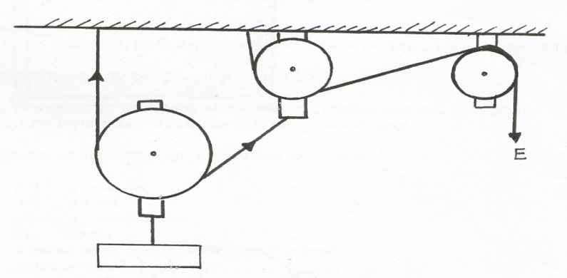
16. Figure 5 shows a pulley system being used to raise a load.

Load
Fig.5

This pulley system has an efficiency of 75%.
(i) Determine the velocity ratio of the system. (1 mk)
…………………………………………………………………………………………………………..
…………………………………………………………………………………………………………..
(ii) Calculate the mechanical advantage of the pulley system. (2 mks)
…………………………………………………………………………………………………………..
…………………………………………………………………………………………………………..
(iii) What effort is required to raise a load of 240 kg? (2 mks)
…………………………………………………………………………………………………………..
…………………………………………………………………………………………………………..
(iv) Calculate the work done by a person using this machine in raising a load of 120 kg through a
vertical distance of 2.5 m. (2 mks)
…………………………………………………………………………………………………………..
…………………………………………………………………………………………………………..
(v) Give one reason why the efficiency of a machine cannot be 100%. (1 mk)
…………………………………………………………………………………………………………..
…………………………………………………………………………………………………………..
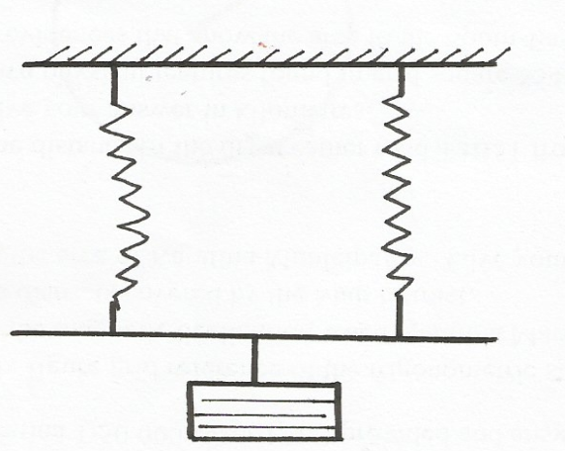
(b) In an experiment, forces are applied to a spring as shown in figure 6 below.

Fig. 6
Identical springs
Load

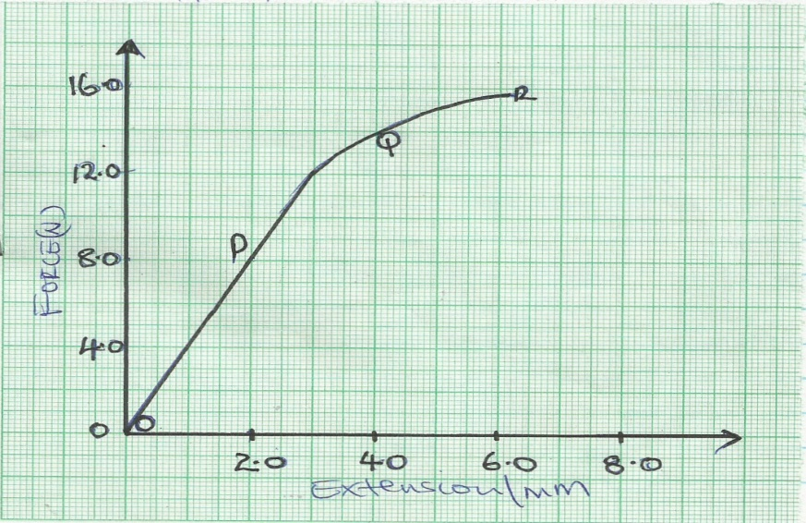
The results of the experiment are shown on the graph below.

The part OP of the graph shows the springs stretching according to the expression F = kx.
(i) Use values from the graph to calculate the values of k for the two springs. (2 mks)
…………………………………………………………………………………………………………..
…………………………………………………………………………………………………………..
(ii) Determine the work done in stretching the springs between O and P. (3 mks)
…………………………………………………………………………………………………………..
…………………………………………………………………………………………………………..
…………………………………………………………………………………………………………..
17. (a) Figure 7 below shows apparatus that a student uses to make an estimate of specific heat
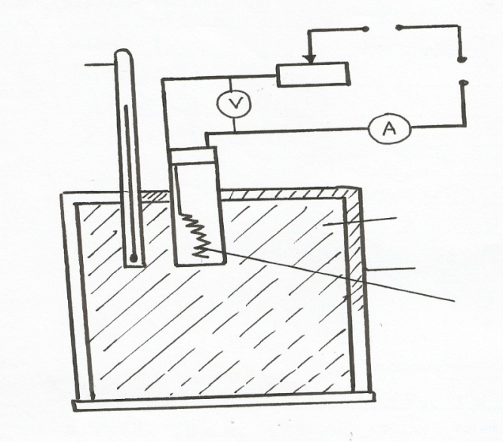
capacity of iron. The power of the heater is known.
Fig. 7
Thermometer

Low voltage supply

Metal block

Lagging

Heater

(i) State two readings the student must take to find the specific heat capacity of iron. (2 mks)
…………………………………………………………………………………………………………..
…………………………………………………………………………………………………………..
(ii) How would you use the measurements above to find the specific heat capacity of iron?(2 mks)
…………………………………………………………………………………………………………..
…………………………………………………………………………………………………………..
(iii) Explain why the value obtained above with these apparatus is higher than the actual value. (1 mk)
…………………………………………………………………………………………………………..
…………………………………………………………………………………………………………..
(iv) State one addition to the apparatus that would help improve the accuracy of the value obtained.
(1 mk)
…………………………………………………………………………………………………………..
(b) 20g of a certain fuel produces 3.5 x 10⁷ J/Kg of heat when burnt in a plentiful supply of oxygen.
This mass of fuel was burnt and the heat obtained was used without loss to heat 400g of a liquid
originally at 10ºC. After all the heat has been absorbed by the liquid, 140g of it remained as a liquid.
The specific heat capacity of the liquid was 2.5 x 10³J/Kg/k and its boiling point was 80⁰ c.
Calculate the specific latent heat of vaporization of the liquid. (Ignoring heat losses, the thermal
capacity of the container and any liquid evaporated before reaching the boiling point) (4 mks)
…………………………………………………………………………………………………………..
…………………………………………………………………………………………………………..
…………………………………………………………………………………………………………..
…………………………………………………………………………………………………………..
…………………………………………………………………………………………………………..
…………………………………………………………………………………………………………..
(c) (i) State the purpose of the double walls in the refrigerator. (1 mk)
…………………………………………………………………………………………………
(ii) Give one property that makes the liquid used (refrigerant) appropriate for use in the
refrigerator. (1 mk)
……………………………………………………………………………………………………..
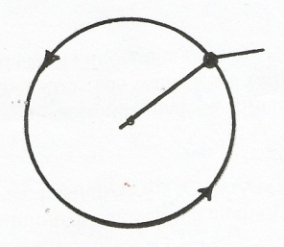
18. (a) Fig 8 below shows a stone moving with uniform speed in a horizontal circle.
10cm
Stone (2kg)

Fig.8

Indicate on the figure the centripetal force (T). (1 mk)
(b) If the stone takes 15 seconds to describe an arc length of 5 cm. Calculate:-
(i) The angle it subtends at the centre. (2 mks)
…………………………………………………………………………………………………
…………………………………………………………………………………………………
(ii) The angular velocity, ω (2 mks)
…………………………………………………………………………………………………
…………………………………………………………………………………………………
…………………………………………………………………………………………………
(iii)The linear velocity V of the stone (2 mks)
…………………………………………………………………………………………………
…………………………………………………………………………………………………
…………………………………………………………………………………………………
(iv) The centripetal force (T) (2 mks)
…………………………………………………………………………………………………
…………………………………………………………………………………………………
19 (a) State Archimedes’ Principle. (1 mk)
…………………………………………………………………………………………………
…………………………………………………………………………………………………
…………………………………………………………………………………………………
(b) In an experiment to determine the relative density of methylated spirit, applying Archimedes’
Principle the results in the table below were obtained.
Mass (g) | 100 | 150 | 200
Weight in air | 1.00 | 1.50 | 2.00
Weight in water | 0.88 | 1.32 | 1.76
Weight in methylated | 0.91 | 1.36 | 1.82

(i) For each mass, determine the upthrust in water and in the spirit. (3 mks)
…………………………………………………………………………………………………
…………………………………………………………………………………………………
…………………………………………………………………………………………………
(ii) Determine the average relative density of the spirit. (3 mks)
…………………………………………………………………………………………………
…………………………………………………………………………………………………
…………………………………………………………………………………………………
(c) A weather balloon of volume 1.2m³is tied to a rigid support while being filled with helium
gas and mass of the fabric making the balloon is 0.3kg. Determine the maximum tension on
the string and the balloon to the rigid support.(Density of air is 1.25kgm⁻³ and density of helium is 0.018 kgm⁻³ ) (4 mks)
…………………………………………………………………………………………………
…………………………………………………………………………………………………
…………………………………………………………………………………………………
…………………………………………………………………………………………………
…………………………………………………………………………………………………

