Name………………………………………………………. Index No…………………/…….
School……………………………………………………… Date ………………………….…
Candidate’s Signature…………

232/1
PHIYSICS
Paper 1
July / August, 2012
Time: 2 Hours
TESO SOUTH DISTRICT JOINT EVALUATION TEST - 2012
Kenya Certificate of Secondary Education – K.C.S.E
232/1
PHIYSICS
Paper 1
July / August, 2012
Time: 2 Hours

INSTRUCTIONS TO CANDIDATES
1. Write your Name and Index Number in the spaces provided above.
2. This paper consists of two sections A and B.
3. Answer ALL the questions in section A and B in the spaces provided.
4. All working MUST be clearly shown.
5. Mathematical tables and silent non-programmable calculators may be used.
FOR EXAMINERS USE ONLY
SECTION | QUESTION | MAX  SCORE | CANDIDATE  SCORE
A | 1-10 | 25
B | 11  12  13  14  15 | 12  11  11  15  06
 | TOTAL

This paper consists of 12 printed pages.
Candidates should check the question paper to ensure that all pages are printed as indicated and that no questions are missing.
SECTION A
Answer all questions
- The thickness of a glass block is 11.55cm.A Venires calliper that has an error of +0.04 is used to
measure this thickness. Sketch and show how this reading will appear on the caliper. (2mks)

2. State two factors that affect the boiling point of water . (2mks)
………………………………………………………………………………………………………………
………………………………………………………………………………………………………………
3. Water flows steadily along a horizontal pipe at a volume rate of 8×10⁻³m3s⁻¹, If the area of cross-section of the pipe is 20cm², Calculate the velocity of the fluid. (3mks)

4. The figure show san insect walking on the surface of a liquid.
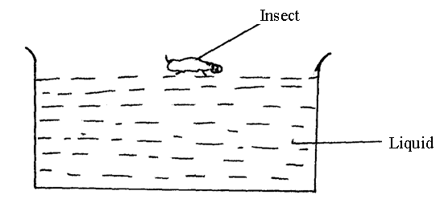
(a) What is the name of the force that makes the insect walk without sinking (1mk)
………………………………………………………………………………………………………………
………………………………………………………………………………………………………………

(b) Explain how the force above can be increased. (2mks)
………………………………………………………………………………………………………………
………………………………………………………………………………………………………………
………………………………………………………………………………………………………………
………………………………………………………………………………………………………………
5. The earth moves around the sun at constant speed .Explain why it’s true to say that the earth is accelerating. (1mk)
………………………………………………………………………………………………………………
………………………………………………………………………………………………………………
6. A point on a rim of a bicycle wheel has a velocity of 5.6m/s.If the rim has a radius of 0.4m,Calculate:
(a) Angular velocity of the point (1mk)

(b) Centripetal acceleration (2mks)

7. A boy standing in front of a cliff blows a whistle and hears the echo after 0.5 seconds. He then moves 17 meters further away from the cliff and blows the whistle again. He now hears the echo after 0.6seconds .Determine the speed of sound. (3mks)

8. A uniform rod of length 4m and mass of 4kg is pivoted at 3.6m mark. The rod is held horizontally with a vertical rope at the 4m mark as shown below:
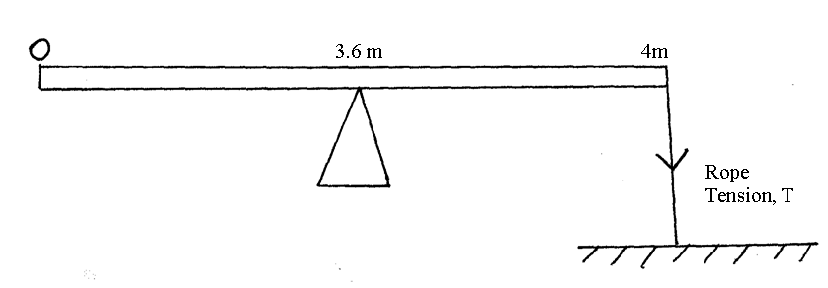
Calculate tension T in the rope (Take g = 10N/ kg) (3mks)

9. An electric motor raise a 60kg mass at a constant velocity .Calculate the power of the motor if it takes 30 seconds to raise the mass through a height of 25m (take g=10N/kg) (3mks)

10. A paper windmill is horizontal axis was placed above a lit candle as shown
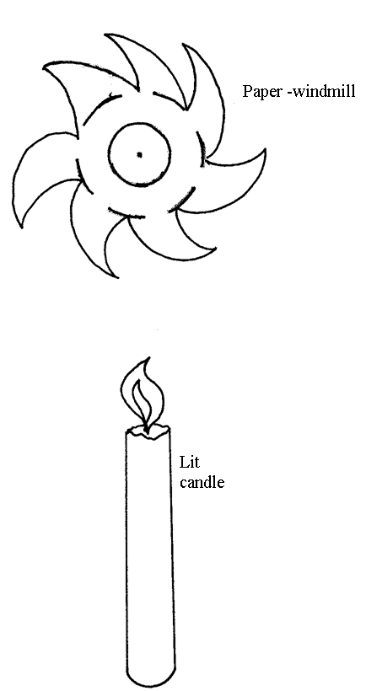
When the candle was lit the paper windmill began to rotate.
Explain this observation (2mks)
………………………………………………………………………………………………………………
………………………………………………………………………………………………………………
………………………………………………………………………………………………………………
………………………………………………………………………………………………………………
SECTION B
(Answer all the questions)
11. (a) State any two differences between boiling and evaporation. (2mks)
………………………………………………………………………………………………………………
………………………………………………………………………………………………………………
………………………………………………………………………………………………………………
………………………………………………………………………………………………………………

(b) In an experiment to determine the specific latent heat of vaporization of water the flowing
results were obtained.
Mass of calorimeters 0.25kg
Mass of calorimeters plus water 0.75kg
Mass of ice at Oºc in the calorimeters 0.02kg
Final temperature when dry steam is passed over the calorimeter 25⁰c
Mass of condensed steam 25g
Given that the latent heat of fusion of water is 3.36×10⁵ Jkg⁻¹ and the specific heat
capacity of copper is 400Jkg ⁻¹ k⁻¹; determine,
- Heat gained by
(i) ice (1mk)

(ii) Water (2mks)

(iii) Calorimeters (1mk)

(c) If L is the specific heat latent heat of vaporization of water, Use an appropriate to find L
(4mks)

(d) State two assumptions that you’ve made to arrive at the value of L above. (2mks)
………………………………………………………………………………………………………………
………………………………………………………………………………………………………………

12. (a) Describe the motion represented by the following motion graph in the region
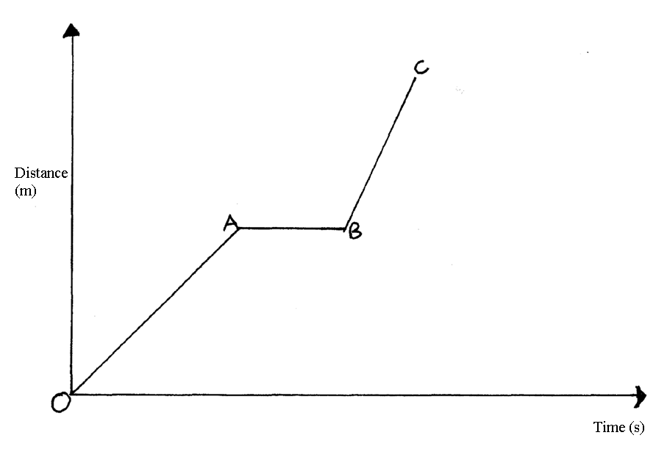
(i) OA (1mk)

- AB (1mk)

- BC (1mk)

(b) Paul throws a stone from the top of a building 20m high .The horizontal velocity of the
stone is 10m/s Calculate:
- The time the stone takes to hit the ground. (3mks)

- The distance from the foot of the building to where the stone hits the ground.
(2mks)

- The vertical velocity at the time the stone hits the ground. (3mks)

13. (a) State Archimede’s Principle (1mk)
………………………………………………………………………………………………………………
………………………………………………………………………………………………………………

(b) Figure 8 shows a stone of mass 4.0kg immersed in water and suspended from a spring balance with a sting. The beaker was placed on a compression balance whose reading was 85 Newtons.The density of the stone was 3000kgm⁻³ while the density of the liquid was 800kgm⁻³.
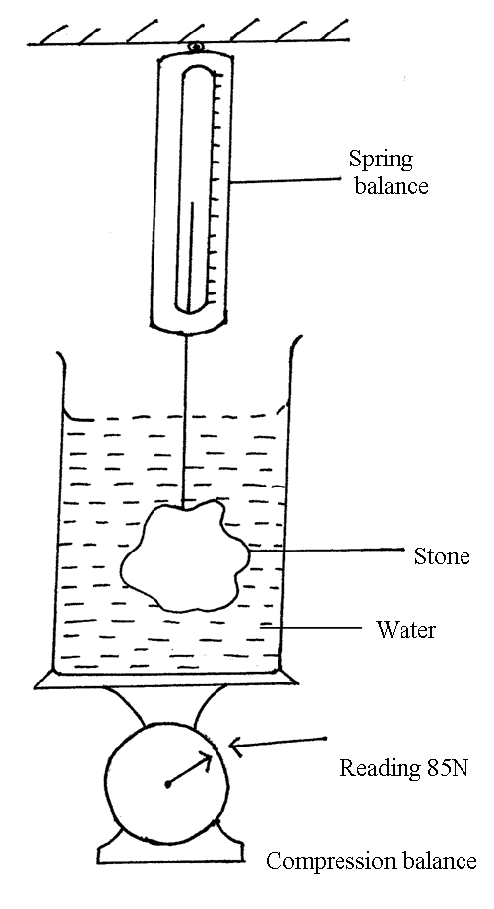
Determine the
(i) Volume of liquid displaced (2mks)

- Up thrust on the stone (4mks)

(iii) Reading of the spring balance (2mks)

(iv) Reading of the compression balance when the stone was removed from the water. (2mks)

14. (a) Define angular velocity and state it’s SI unit (2mks)

(b) The table below gives the centripetal force F, and the radius r when a body is undergoing uniform circular motion with a speed of 2m/s.
r (cm) | 4.0 | 4.4 | 5.0 | 5.7 | 6.6 | 8.0
F(N) | 50 | 45 | 40 | 35 | 30 | 25
$1v$(cm ⁻¹)
- Complete the table (1mk)

- Draw a graph from the above results of F against $1r$ (5mks)

(iii) Calculate the slope of the graph (2mks)

(iv) Given that F =$\frac{{\text{MV}}^{2}}{r}$, determine the mass of the body executing uniform circular motion (3mks)

(c) State two factors that affect the centripetal force on a body in circular motion (2mks)
………………………………………………………………………………………………………………
………………………………………………………………………………………………………………
15. (a) State Newton’s third law of motion (1mk)
………………………………………………………………………………………………………………
………………………………………………………………………………………………………………
(b) A ball of mass 0.75kg rests on the surface of a level bench.
(i) Draw a sketch showing the forces acting on the ball and give the magnitude of the forces (2mks)

(ii) If the ball was raised 1.5m above surface and then released, what would be its velocity just before hitting the surface? (3mks)

END

