NAME:………………………………………………….. INDEX NO:……………………/…………...
SCHOOL:………………………………………………. CANDIDATE’S SIGN………………………
DATE:……………………………………………………

232/2
PHYSICS
PAPER 2
JUNE/JULY 2012
TIME: 2 HOURS

BUTERE DISTRICT JOINT EVALUATION - 2012
Kenya Certificate of Secondary Education (K C.S.E.)

INSTRUCTIONS TO CANDIDATES
a) Write your name and Admission number in the spaces provided.
b) Sign and write the date of the examination in the spaces provided.
c) This paper consists of Two sections A and B
d) Answer ALL questions in sections A and B in the spaces provided.
e) All working MUST be clearly shown.
f) Non-programmable silent scientific calculators and mathematical tables may be used.
g) This paper consist of 12 printed pages
h) Candidates should check the question paper and ascertain that all the pages are printed and that no questions are missing.

For Examiners’ Use Only
SECTION | QUESTION | MAXIMUM SCORE | CANDIDATE’S SCORE
A | 1 - 12 | 25
B | 13 | 08
 | 14 | 11
 | 15 | 09
 | 16 | 12
 | 17 | 15
TOTAL |  | 80

This paper consists of 12 Printed pages. Candidates should check to ascertain
that all pages are printed as indicated and that no questions are missing.
SECTION A (25 marks)
Answer ALL questions in this section in the spaces provided.
1. A gold leaf electroscope is positively charged as shown in the diagram below where C is the cap and L is the gold leaf. State and explain what happens to L when a positively charged rod is brought near C without touching it. (2mks)
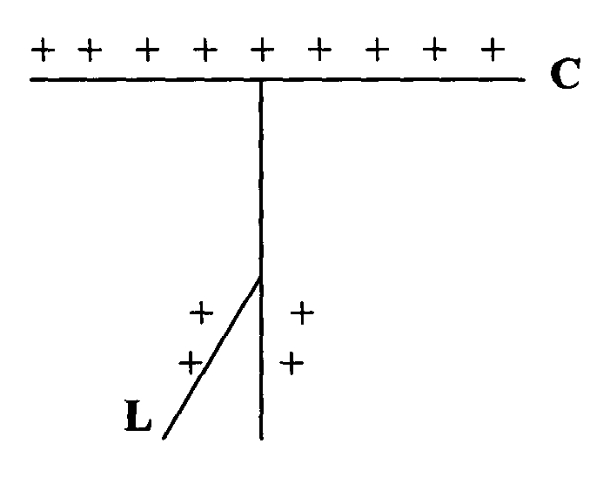
…………………………………………………………………………………………………………………………………………………………………………………………………………………………………………………………………………………………………………………………………………………………………………………………………………………………………………
2. Sketch the magnetic field pattern between the two poles of the magnet shown below. (2mks)
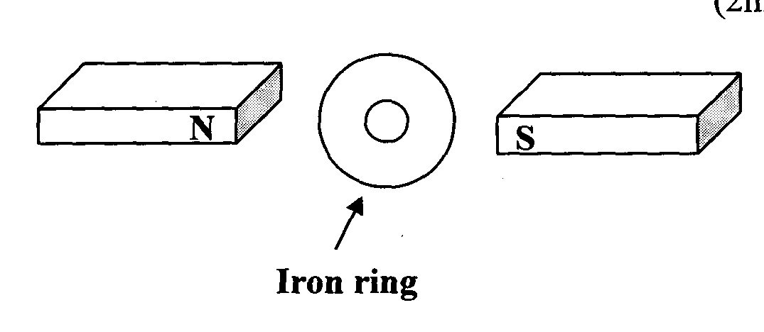

3. State one advantage of generating a.c rather than d.c voltages in a power station. (1mk)
……………………………………………………………………………………………………………………………………………………………………………………………………………………
4. A metal has a work function of 2.0ev. Calculate the threshold wavelength of the metal given that
e= 1.6 x 1O⁻¹⁹C and h=6.6 x 1O⁻³⁴Js. (3mks)
………………………………………………………………………………………………………………………………………………………………………………………………………………………………………………………………………………………………………………………………………………………………………………………………………………………………………………………………………………………………………………………………………………………………………………………………………………………………………………………………
5. A student designed an a.c generator which produces a current of 10A at a p.d of 340V. State two ways in which he can improve his generator to increase the p.d output. (2mks)
…………………………………………………………………………………………………………………………………………………………………………………………………………………………………………………………………………………………………………………………………………………………………………………………………………………………………………
6. The following equation represents a decay series.
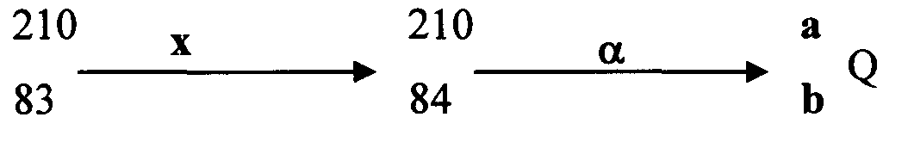
Identify the radiation x and determine the values of a and b (3mks)
………………………………………………………………………………………………………………………………………………………………………………………………………………………………………………………………………………………………………………………………………………………………………………………………………………………………………………………………………………………………………………………………………………………………………………………………………………………………………………………………

7. State one reason why in the construction of car head lamps parabolic reflectors are
preferred to spherical reflectors. (1 mk)
……………………………………………………………………………………………………………………………………………………………………………………………………………………
8. An electric heater 480 is connected to a 240V mains supply. Determine the energy
dissipated in 4 minutes. (3mks)
………………………………………………………………………………………………………………………………………………………………………………………………………………………………………………………………………………………………………………………………………………………………………………………………………………………………………………………………………………………………………………………………………………………………………………………………………………………………………………………………
9. The figure below shows the paths of two rays which enter the extremities of the eye from a small object immersed in water.
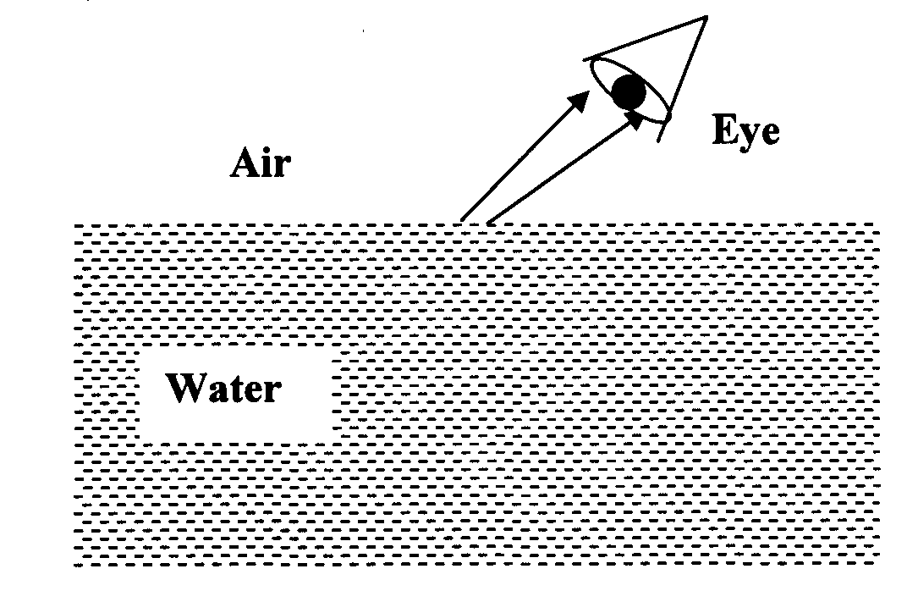
Draw lines on the diagram to show a possible apparent position of the object and its true position (2mks)

10. The diagram below shows part of a wave form. The numbers on the diagram show scales in meters. If the speed of the wave is 20ms⁻¹, determine the frequency and wavelength of the wave. (3mks)
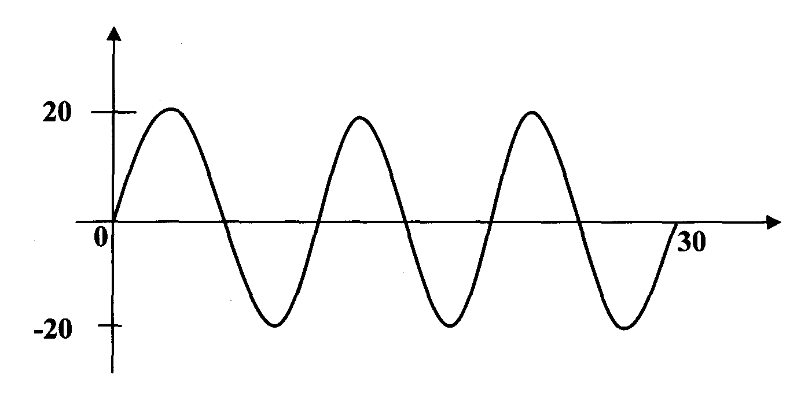
………………………………………………………………………………………………………………………………………………………………………………………………………………………………………………………………………………………………………………………………………………………………………………………………………………………………………………………………………………………………………………………………………………………………………………………………………………………………………………………………
11. The chart below shows an arrangement of different parts of the electromagnetic spectrum.
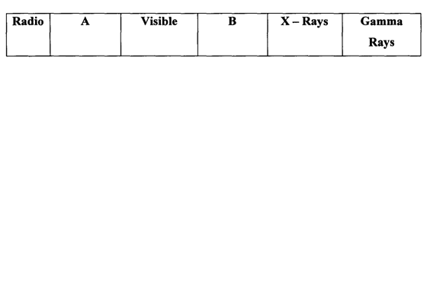
Name the possible radiations represented by letter B. (1mk)
……………………………………………………………………………………………………………………………………………………………………………………………………………………
12. The diagram below shows an object placed some distance from a biconcave lens.
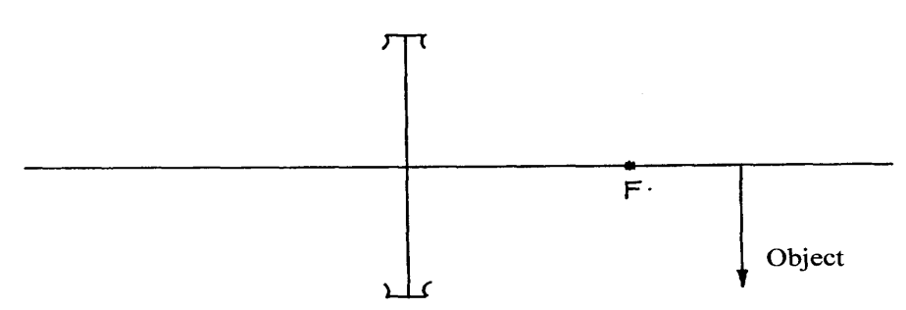
Construct the image on the diagram (2mks)

SECTION B (55 MARKS)
Answer ALL questions in this section in the spaces provided after each question.
13. a) The graph below shows the relationship between 1/u and 1/v for a converging lens where u and v are the object and image distances respectively.
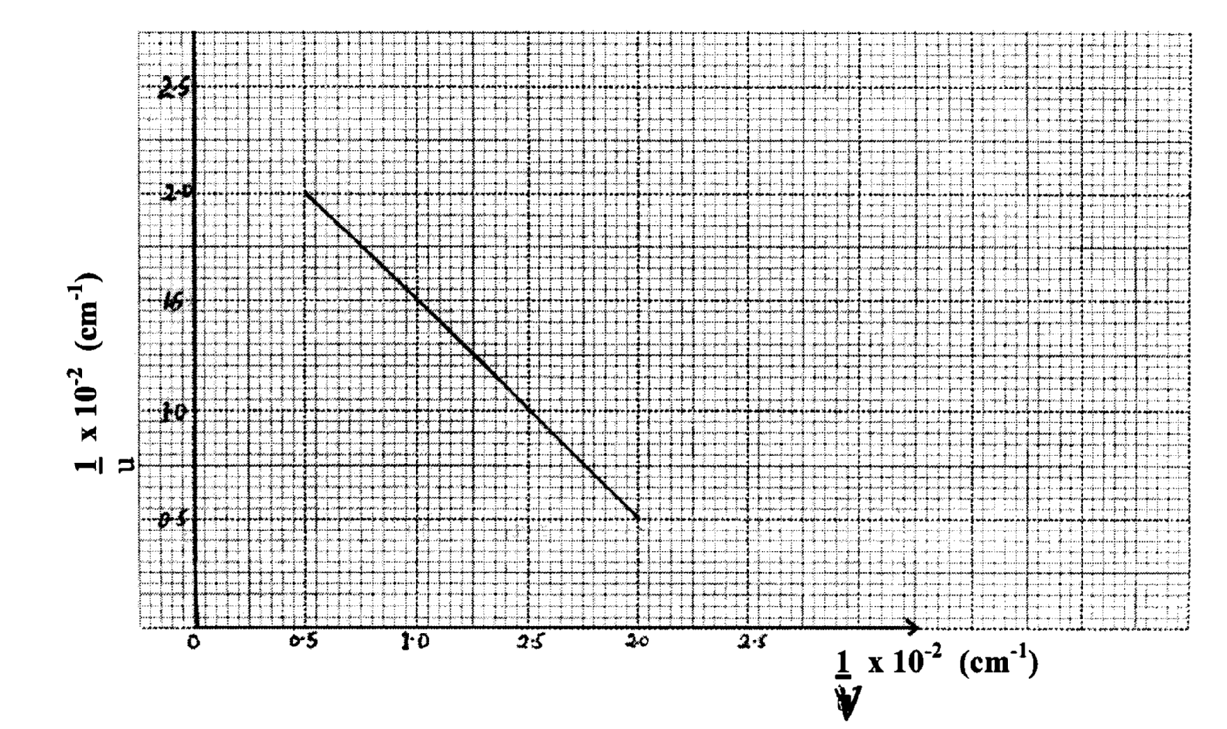
From the graph, determine the focal length, f of the lens (4mks)
……………………………………………………………………………………………………………………………………………………………………………………………………………………………………………………………………………………………………………………………………………………………………………………………………………………………………………………………………………………………………………………………………………………………………………………………………………………………………………………………………………………………………………………………………………………………………………………………………………………………………………………………………………………
b) State two conditions necessary for total internal reflection to occur. (2mks)
…………………………………………………………………………………………………………………………………………………………………………………………………………………………………………………………………………………………………………………………………………………………………………………………………………
c) The figure below shows the path of a ray of light passing through a rectangular block of Perspex placed in air.
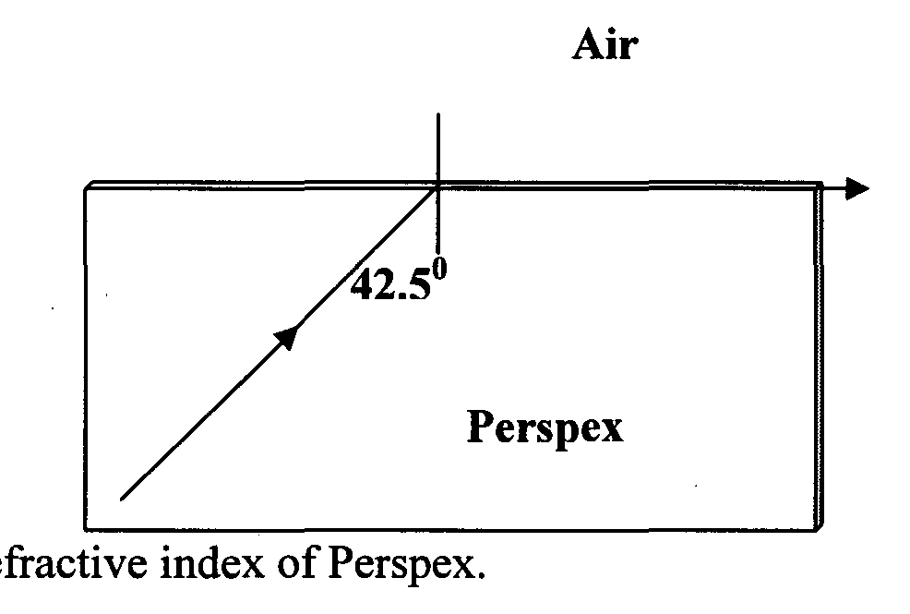
Calculate the refractive index of Perspex. (2mks)
…………………………………………………………………………………………………………………………………………………………………………………………………………………………………………………………………………………………………………………………………………………………………………………………………………
14. a) (i) State two properties of X — rays (2mks)
…………………………………………………………………………………………………………………………………………………………………………………………………………………………………………………………………………………………………………………………………………………………………………………………………………
(ii) In a certain X-ray tube, electrons are accelerated by a potential difference of 10KV. Assuming that 5% of the energy is converted into X — rays, determine the frequency of the X-rays produced. (h = 6.62 x 10⁻³⁴Js , e = 1.6 x 10⁻¹⁹ C) (3mks)
………………………………………………………………………………………………………………………………………………………………………………………………………………………………………………………………………………………………………………………………………………………………………………………………………………………………………………………………………………………………………………………………………………………………………………………………………………

b) Describe how a P-type semiconductor is formed (3mks)
………………………………………………………………………………………………………………………………………………………………………………………………………………………………………………………………………………………………………………………………………………………………………………………………………………………………………………………………………………………………………………………………………………………………………………………………………………
c) The diagram below shows results obtained in an experiment to study diffraction patterns in a double slit experiment.
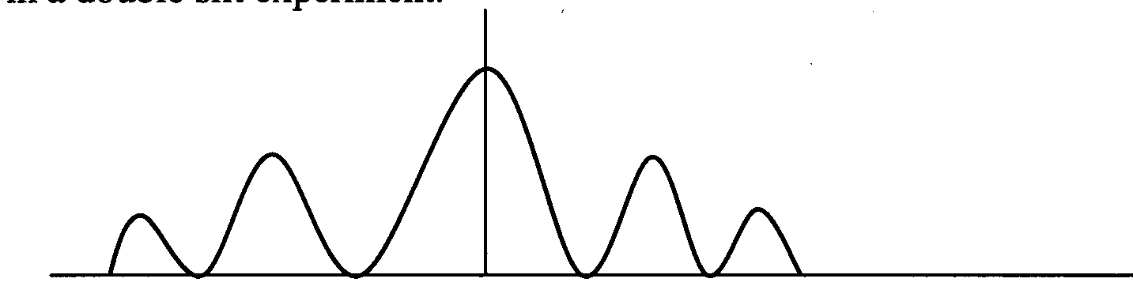
Explain the shape of the graph. (3mks)
………………………………………………………………………………………………………………………………………………………………………………………………………………………………………………………………………………………………………………………………………………………………………………………………………………………………………………………………………………………………………………………………………………………………………………………………………………
15. a) The figure below shows a transverse stationary wave along a string.
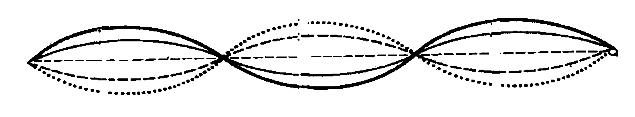
i. Label the nodes and antinodes. (1 mk)

ii. If the distance between an anti node and a node is 1.0 x 10⁻³m, determine the
wavelength of the stationary wave. (2 mks)

b) Five successive wave-fronts in a ripple tank are observed to spread a distance of 6.4 cm. If the vibrator has a frequency of 8 Hz, determine the speed of the waves. (2 mks)

c) The figure below shows one of the common eye defects.
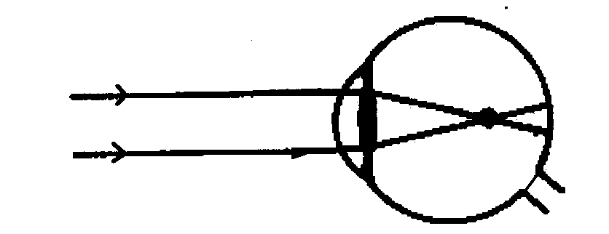
i. State the type of defect and its possible cause. (2 mks)
…………………………………………………………………………………………………………………………………………………………………………………………………………………………………………………………………………………………………………………………………………………………………………………………………………
ii. On the same diagram, show how the defect can be corrected (2 mks)
16. a) State two ways of increasing the capacitance of a parallel plate capacitor (2mks
…………………………………………………………………………………………………………………………………………………………………………………………………………………………………………………………………………………………………………………………………………………………………………………………………………
b) The figure below shows a capacitor network setup.
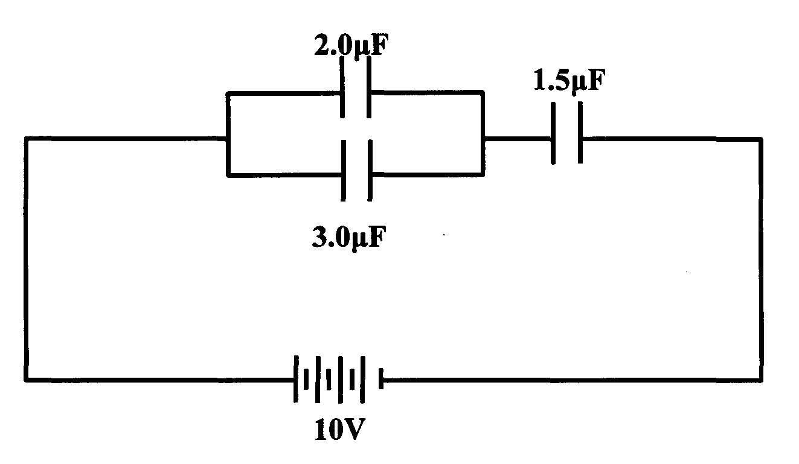
Calculate the charge stored by the 1.5 µ. F capacitor. (3mks)

c) Indicate the direction of the current in the coil in the set up below. Label the
polarity at the points marked X and Y (3mks)
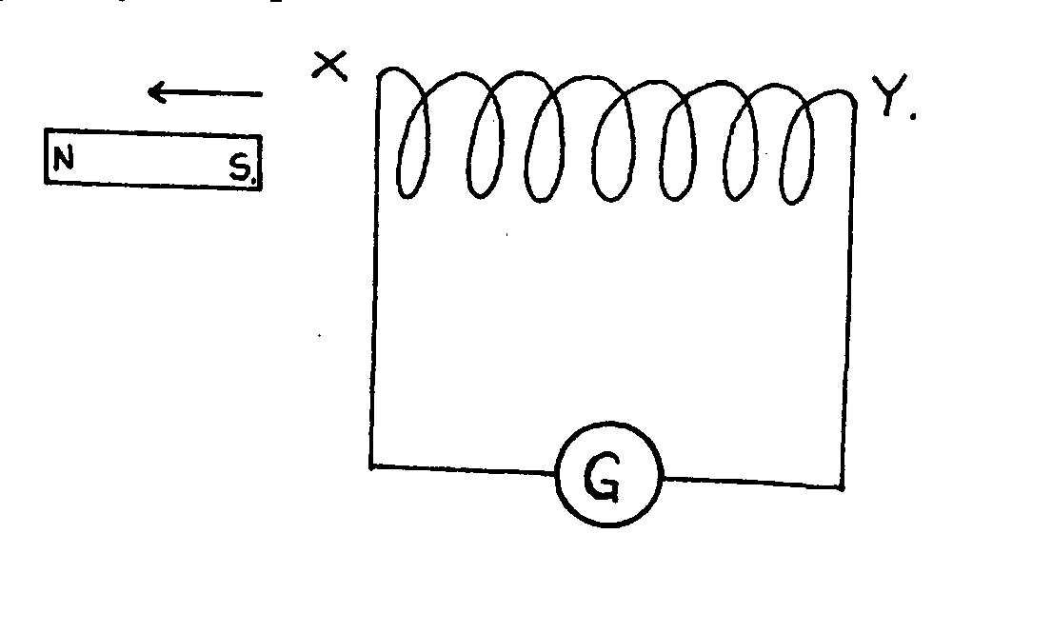

d) In a radio therapy unit of a hospital, a transformer is used to supply a potential difference of 150 KV to an X — ray tube from a 240 V a.c. mains supply. A current of 100 m A flows in the X-ray tube. Assuming the transformer is 100 % efficient, calculate
i. Current in the primary coil (2 mks)
…………………………………………………………………………………………………………………………………………………………………………………………………………………………………………………………………………………………………………………………………………………………………………………………………………
ii. The turns ratio of the transformer (2mks)
…………………………………………………………………………………………………………………………………………………………………………………………………………………………………………………………………………………………………………………………………………………………………………………………………………
17. (a) What do you understand by the term e.m.f of a cell?. (1mk)
………………………………………………………………………………………………………………………………………………………………………………………………………………………………………………………………………………………………………
(b) A cell of e.m.f E and internal resistance r is used to pass a current through various resistors R, Ohms and the values of current recorded in the table below.
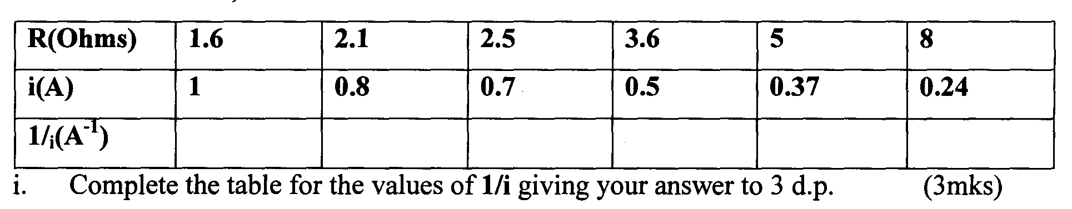
i. Complete the table for the values of 1/i giving your answer to 3 d.p. (3mks)
ii. Plot a graph of 1/i versus R. (5mks)
iii. Given that the equation E =I(R +r), use your graph to determine the values of E and
r. (5mks)

END

