Name………………………………………………………. Index No…………………/…….
School……………………………………………………… Date ………………………….…
Candidate’s Signature………………………

232/2
PHYSICS
Paper 2
(THEORY)
JULY / AUGUST 2012
Time: 2 Hours

KWANZA DISTRICT JOINT EVALUATION TEST – 2012
Kenya Certificate of Secondary Education (K.C.S.E)

232/2
PHYSICS
Paper 2
(THEORY)
JULY / AUGUST 2012
Time: 2 Hours

INSTRUCTIONS TO CANDIDATES
(a) Write your name and index number in the spaces provided above.
(b) Sign and write the date of examination in the spaces provided above
(c) This paper consists of TWO sections A and B
(d) Answer ALL the questions in section A and B in the spaces provided
(e) All working MUST be clearly shown.
(f) Non-programmable silent electronic calculators and KNEC mathematical table
may be used.

This paper consists of 12 printed pages.
Candidates should check the question paper to ensure that all
pages are printed as indicated and no questions are missing
1. A bar magnet A attracts an iron nail as shown in figure 1
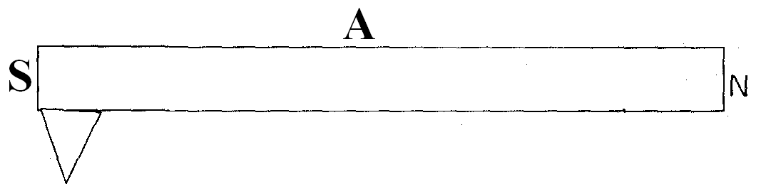
A second bar magnet B of the same strength is brought close to the magnet A as shown in
Fig. 2
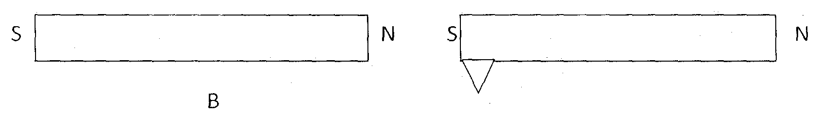
State and explain the observation made (2mks)
………………………………………………………………………………………………………
………………………………………………………………………………………………………
2. A student was investigating the brightness of bulbs when set up in circuits. He used identical
bulbs and cells. The circuits A and B were what he set up
Fig. 3
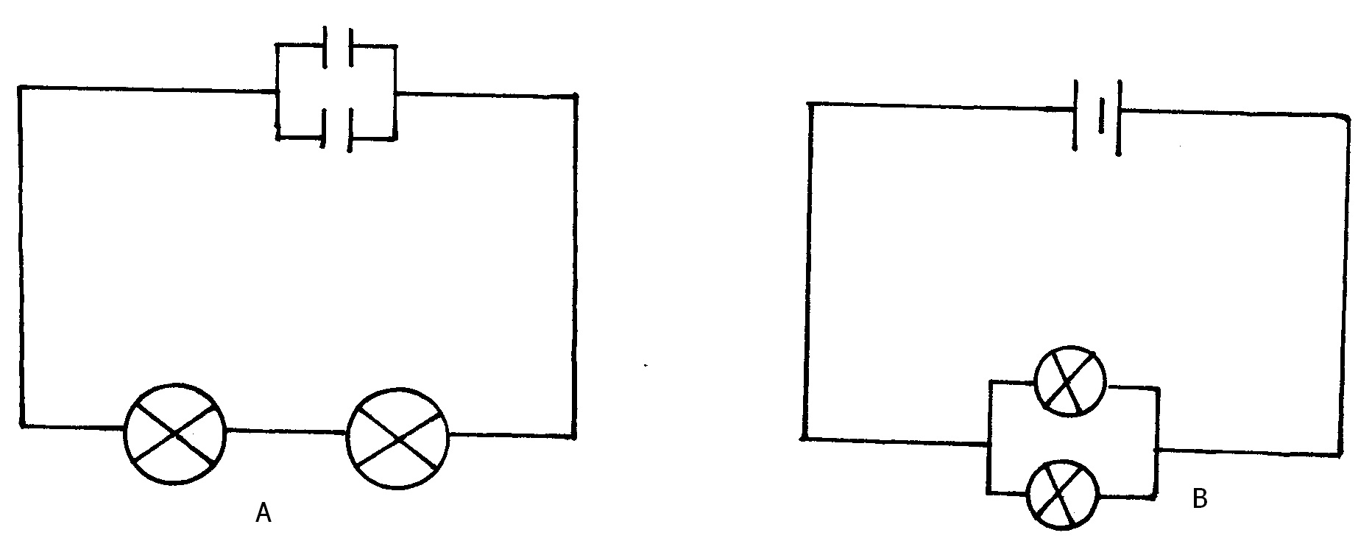
State and explain which set-up had the bulbs brightest (3mks)
………………………………………………………………………………………………………
………………………………………………………………………………………………………

3. Figure 4. Below shows the pattern produced by an A.C voltage on a C.R.C screen
On the same figure, show the pattern produced by the same voltage when the time base is of
(1mk)
Fig.4
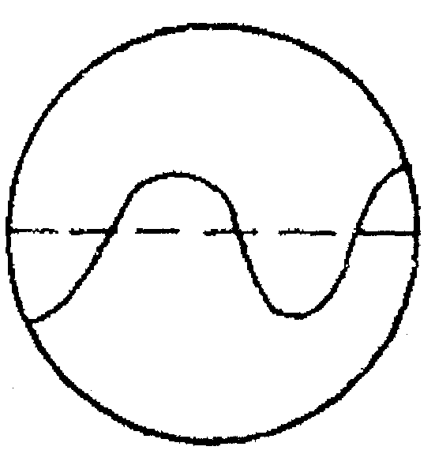

4. Figure 5 below shows as observer facing sound and light source A and B
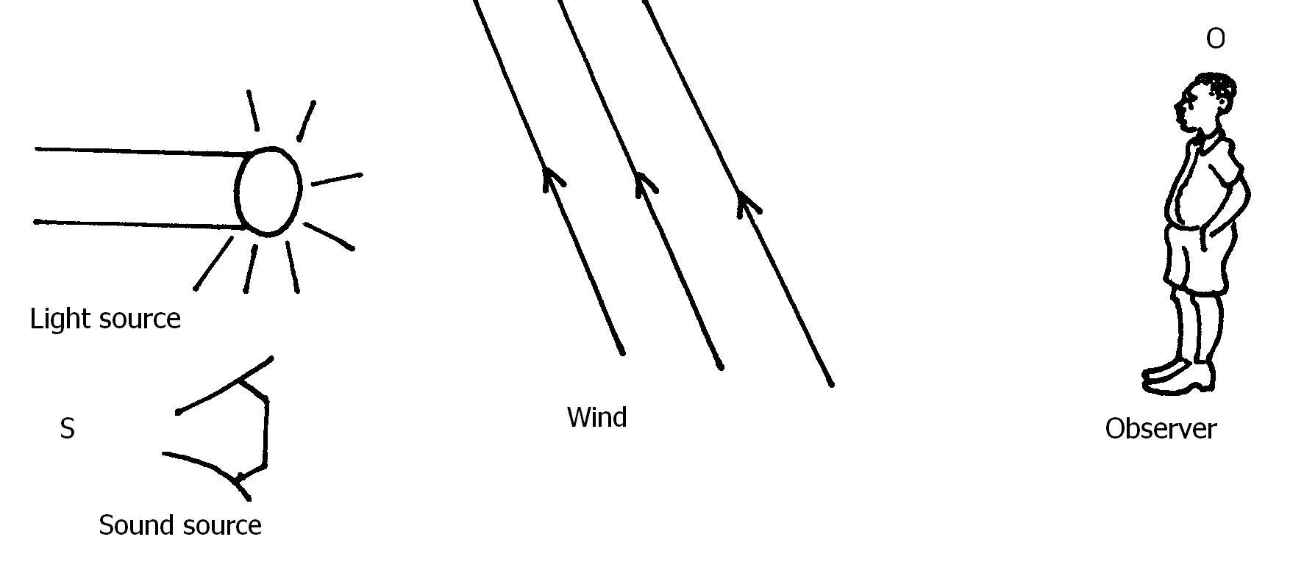
If the wind blows as shown, state and explain what the observer at C noted (2mks)
………………………………………………………………………………………………………
………………………………………………………………………………………………………
5. An electromagnet is made by winding insulated copper wire on an iron core. State two changes
that could be made to increase the strength of the electromagnet. (2mks)
………………………………………………………………………………………………………
………………………………………………………………………………………………………

6. The figure below show the wave before rectification
Fig. 6
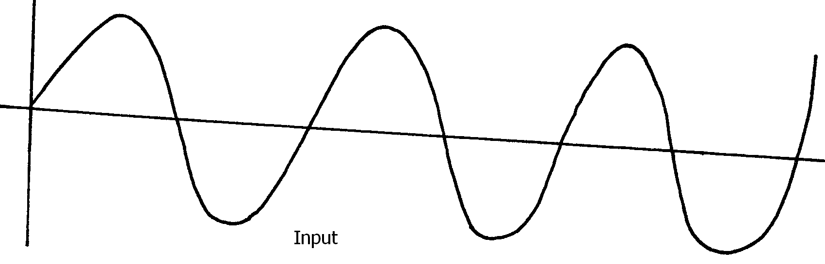

Sketch the wave output when it is full wave rectified (2mks)

Fig. 7
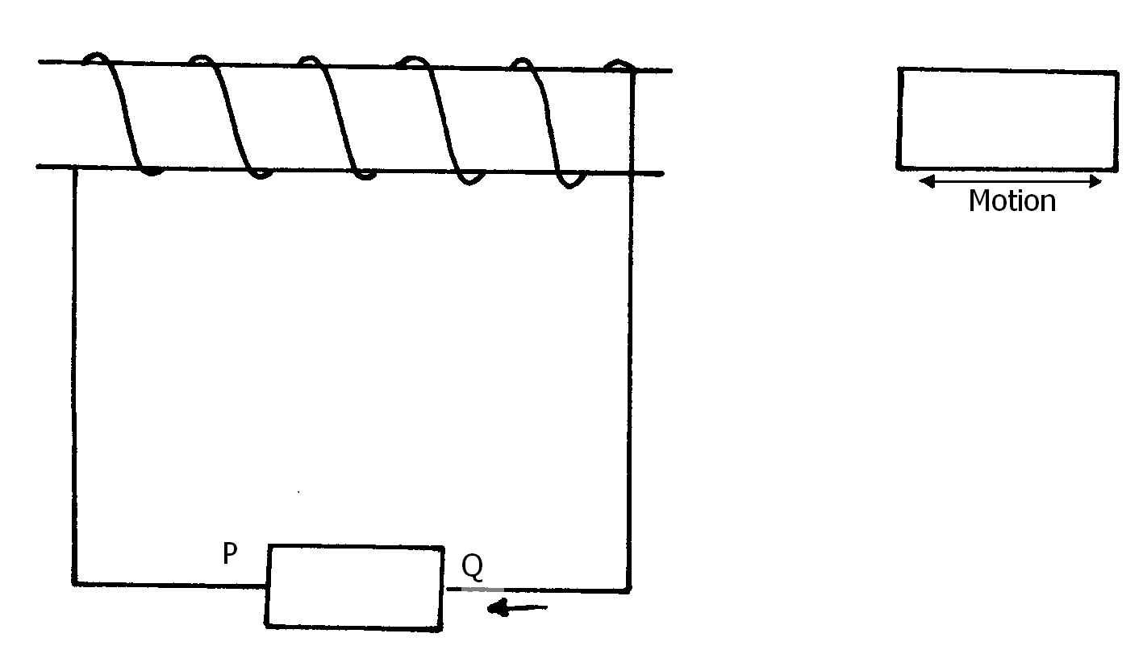
Use the information above to answer question 7
7. Explain how the current is produced (2mks)
………………………………………………………………………………………………………
………………………………………………………………………………………………………

8. Give a reason why it is necessary to leave the caps of the cells open when charging an
accumulator (1mk)
………………………………………………………………………………………………………
………………………………………………………………………………………………………
9. Determine the speed of light in water given that the speed of light in air is 3.0 x 10⁸ms ⁻¹ and
refractive index of water is 1.33. (3mks)
………………………………………………………………………………………………………
………………………………………………………………………………………………………
………………………………………………………………………………………………………
………………………………………………………………………………………………………
10. (a) Figure 8 below shows a pair of parallel plates of capacitor connected to a battery.
The upper plate is displaced slightly to the left.
Fig 8
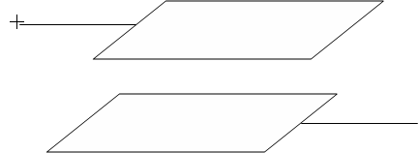

State with a reason the effect of this movement on the capacitance (2mks)
………………………………………………………………………………………………………
………………………………………………………………………………………………………
………………………………………………………………………………………………………
………………………………………………………………………………………………………
11. In nuclear reactor what is the function of boron rods (2mks)
………………………………………………………………………………………………………
………………………………………………………………………………………………………
12. State Lenz’s law of electromagnetic induction (2mks)
………………………………………………………………………………………………………
………………………………………………………………………………………………………
13. Differentiate between hard x-rays and soft x-rays (2mks)
………………………………………………………………………………………………………
………………………………………………………………………………………………………
14. Explain how the grid in the CRO controls the brightness of the spot on the screen (2mks)
………………………………………………………………………………………………………
………………………………………………………………………………………………………

SECTION B 55 MARKS

15. (a) Define the term “work function” (2mks)
………………………………………………………………………………………………………
………………………………………………………………………………………………………
(b) The work function of a clean metal surface is 4.5ev. Calculate
(i) The minimum frequency of radiation that will cause the emission of electrons
From the surface (3mks)
………………………………………………………………………………………………………
………………………………………………………………………………………………………
………………………………………………………………………………………………………
………………………………………………………………………………………………………
(ii) The maximum energy of the electrons emitted when the surface is illuminating with a
radiation of frequency 1.2 x 10¹⁵Hz (3mks)
………………………………………………………………………………………………………
………………………………………………………………………………………………………
………………………………………………………………………………………………………
………………………………………………………………………………………………………
(c) The table below shows the stopping potential and the corresponding frequencies for
a certain photocell
Stopping Potential Vs (V) | 0.2 | 0.6 | 1.10 | 1.42 | 1.83
Frequency (x10¹⁴ H£) | 4.0 | 5.0 | 6.0 | 7.0 | 8.0

Plot a graph of stopping potential Vs (v)(y-axis)against frequency (x-axis)
From the graphs determine

(i) The threshold wavelength (2mks)
………………………………………………………………………………………………………
………………………………………………………………………………………………………
(ii) Planks constant (2mks)
………………………………………………………………………………………………………
………………………………………………………………………………………………………
(iii) The work function of the metal (2mks)
………………………………………………………………………………………………………
………………………………………………………………………………………………………
16. (a) The figure below shows an object in front of a lens
Fig. 9
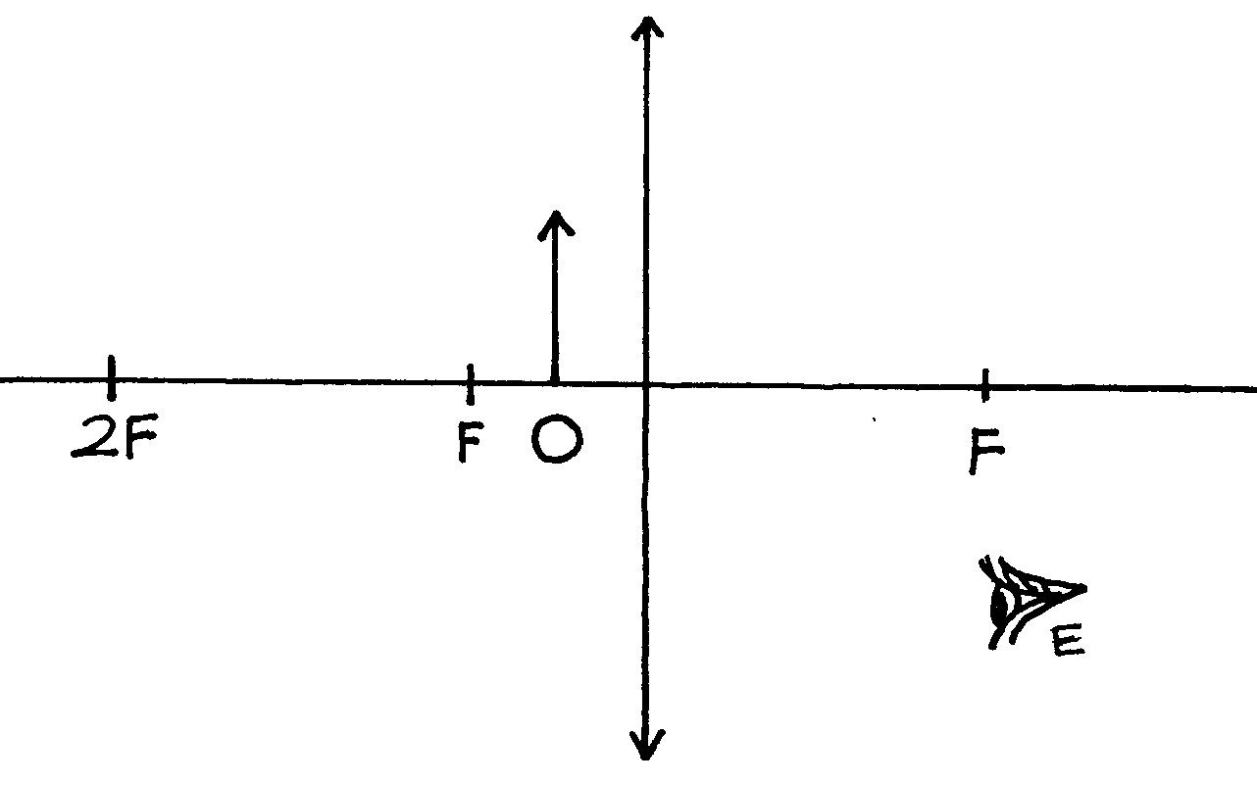
(i) Using rays locate the image as seen by observer, E (2mks)
(ii) Give one application of such a lens as used above (1mk)
………………………………………………………………………………………………………
………………………………………………………………………………………………………
(iii) Write three similarities between an eye and a camera (3mks)
………………………………………………………………………………………………………
………………………………………………………………………………………………………
………………………………………………………………………………………………………
………………………………………………………………………………………………………

(b) Figure (a) and (b) show diagrams of the human eye;
Fig. 10

(i) In figure (a), sketch a ray diagram showing long sightedness (1mk)
(ii) In figure (b), sketch a ray diagram showing how lens is used to correct
the long sightedness (2mks)

(c) An object of height 10.5cm stands before a diverging lens of length 20cm and a distance
of 10cm from the lens. Determine;
(i) Image distance (2mks)
………………………………………………………………………………………………………
………………………………………………………………………………………………………
(ii) Height of the image (1mk)
………………………………………………………………………………………………………
………………………………………………………………………………………………………
(iii) Magnification (1mk)
………………………………………………………………………………………………………
………………………………………………………………………………………………………

17. (a) Figure below shows the path of radiation from a radioactive source. The field is
perpendicular to the paper and directed out of the paper
Fig. 11
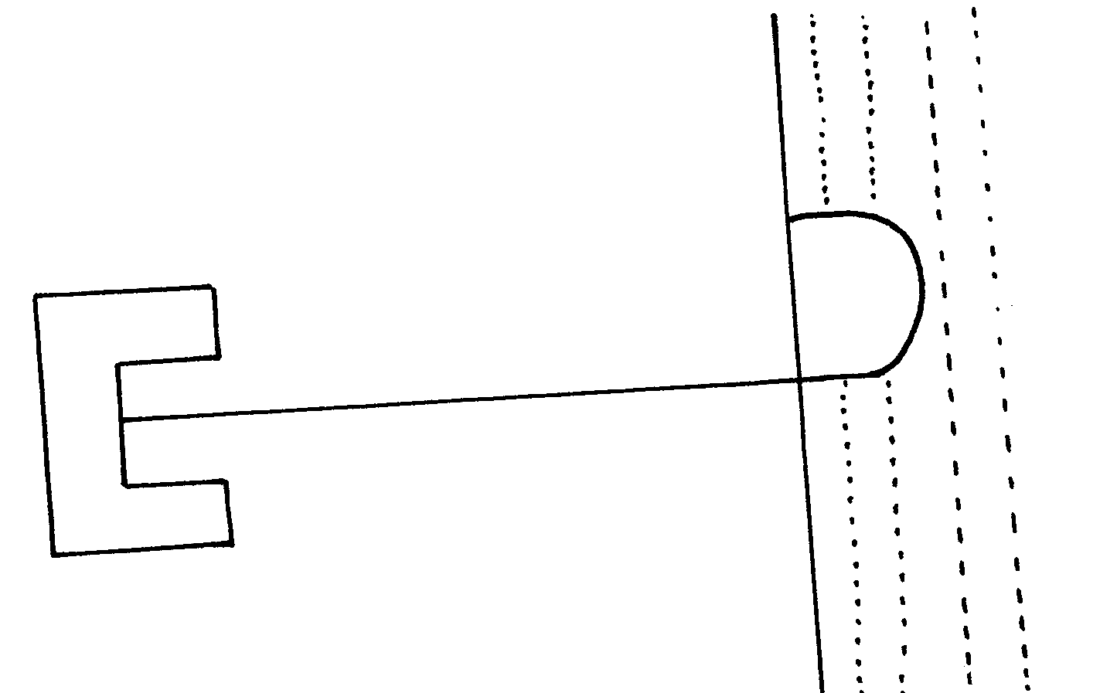
(i) Identify the radiation (1mk)
………………………………………………………………………………………………………
………………………………………………………………………………………………………
(ii) State two properties of the radiation stated in a (i) above (2mks)
………………………………………………………………………………………………………
………………………………………………………………………………………………………
(b) Radiation from a radioactive source enters a G.M tube
(i) State the effect of the radiation on the gas inside the tube (1mk)
………………………………………………………………………………………………………
………………………………………………………………………………………………………
(ii) Explain how the large discharge current is created (2mks)
………………………………………………………………………………………………………
………………………………………………………………………………………………………
………………………………………………………………………………………………………
………………………………………………………………………………………………………
(c) The following is a nuclear equation for a fission process resulting from the reaction
of a neutron with uranium nucleus.
$\begin{matrix}1 \\ 0\end{matrix}n + \begin{matrix}\text{235} \\ \text{99}\end{matrix} U → \begin{matrix}\text{141} \\ \text{56}\end{matrix}\text{Th} + \begin{matrix}Y \\ X\end{matrix}P + \begin{matrix}1 \\ 0\end{matrix}n$
(i) Determine the values of x and y (2mks)
………………………………………………………………………………………………………
………………………………………………………………………………………………………
………………………………………………………………………………………………………
………………………………………………………………………………………………………

(ii) State the source of the energy released (1mk)
………………………………………………………………………………………………………
………………………………………………………………………………………………………
(iii) Explain how this reaction is made continuous in a nuclear reactor (2mks)
………………………………………………………………………………………………………
………………………………………………………………………………………………………
………………………………………………………………………………………………………
………………………………………………………………………………………………………
18. (a) Figure 12 below shows the features of an X-ray tube (2mks)
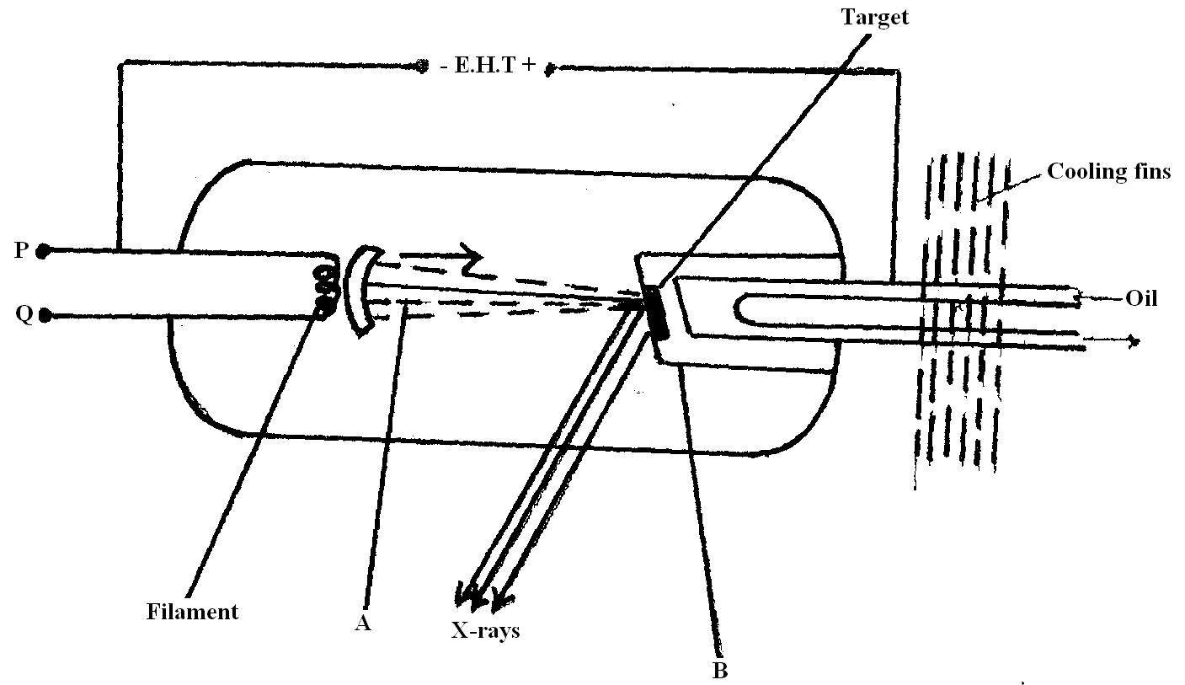

(i) Name the parts marked with letters A and B
A ……………………………………………………
B……………………………………………………..
(ii) Explain how a change in the potential across PQ changes the intensity of x-rays produced in the tube
………………………………………………………………………………………………………
………………………………………………………………………………………………………
(iii) During the operation of the tube, the target becomes very hot. Explain how this he caused (2mks)
………………………………………………………………………………………………………
………………………………………………………………………………………………………

(iv) State the property of lead that makes it suitable for use as shielding material (1mk)
………………………………………………………………………………………………………
………………………………………………………………………………………………………
(b) If a certain x-ray tube, the electrons are accelerated by a p.d of 12,000V. Assuming
all the energy goes to produce x-rays, determine the frequency of the x-rays produced
(plank’s constant, h = 6.62 x 10⁻³⁴) is and charge on an electron. E = 1.6 x 10’9c) (3mks)
………………………………………………………………………………………………………
………………………………………………………………………………………………………
………………………………………………………………………………………………………
………………………………………………………………………………………………………
End

