NAME…………………………………………………………. INDEX NO. ………………/………
SCHOOL ……………………………………………………... SIGN ………………………………
DATE……………………………..

232/2
PHYSICS
Paper 2
JULY/ AUGUST, 2012
2 Hours

MANGA DISTRICT JOINT EVALUATION EXAM– 2012
Kenya Certificate of Secondary Education (K.C.S.E)

232/2
PHYSICS
Paper 2
JULY/ AUGUST, 2012
2 Hours

INSTRUCTION TO CANDIDATES

1. Write your name and index number in the spaces provided above.
2. Sign and write the date of the examination in the spaces provided above.
3. This paper consists of TWO sections A and B.
4. Answer ALL questions in section A and B in the spaces provided
5. ALL working must be clearly shown where necessary
6. Mathematical tables and silent electronic calculators may be used.
7. Where applicable take acceleration due to gravity g = 10 m/s²
Take :acceleration due to gravity g=10m⁻² or 10N/kg
Density of water=1000kgm⁻³.

FOR EXAMINER’S USE ONLY
SECTION | QUESTION | MAXIMUM.SCORE | CANDIDATE’S SCORE
A | 1-12 | 25
B | 13 | 11
 | 14 | 09
 | 15 | 12
 | 16 | 10
 | 17 | 10
TOTAL SCORE |  | 80

This paper consists of 12 printed pages.
Candidates should check the question paper to ensure that all pages are printed as indicated and no questions are missing

SECTION A (25 MARKS)

1. Figure 1 shows a ray of light incident on plane mirror at point 0.
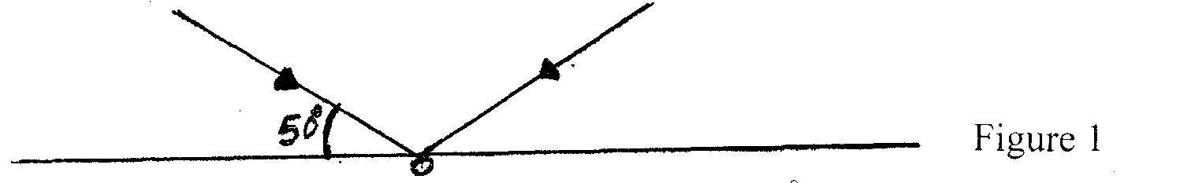
The mirror is rotated clockwise through an angle 30⁰ about an axis perpendicular to the paper, Determine the angle through which the reflected ray rotated. (3 mks)

2. Figure 2 shows a sharp pin fixed on a cap of leaf electroscope. The electroscope is highly charged and then left for sometime.
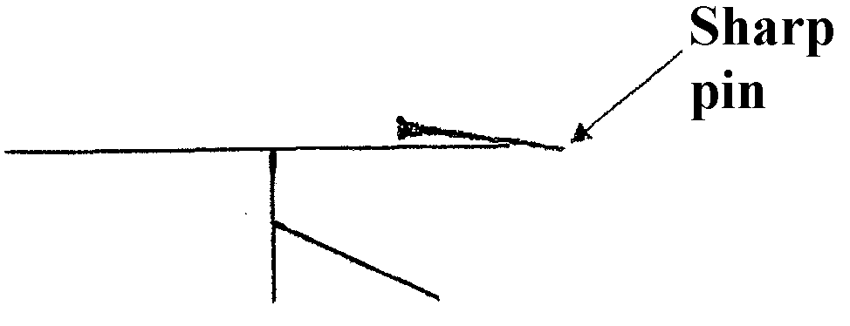
Figure 2
Explain why the leaf collapses. (2 mks)
………………………………………………………………………………………………………………………………………………………………………………………………………………
………………………………………………………………………………………………………………………………………………………………………………………………………………
3. Determine the ammeter reading when the a.p.d of 3.0 volts is supplied across pq in figure 3.
(3 mks)
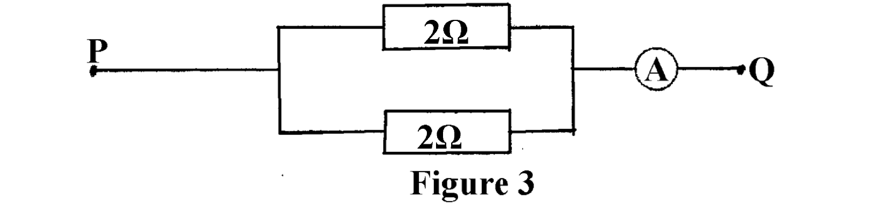

4. Figure 4 shows a wire carrying a current whose direction is into the paper.
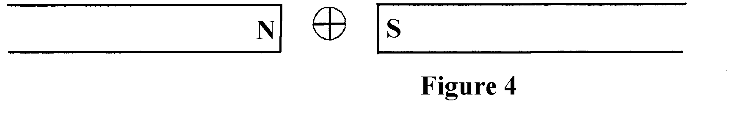
The wire is placed in a magnetic field.
Indicate on the figure the direction of the force acting on the wire. (2 mks)

5. Figure 5 shows how displacement varies with time as a wave passes a fixed point.
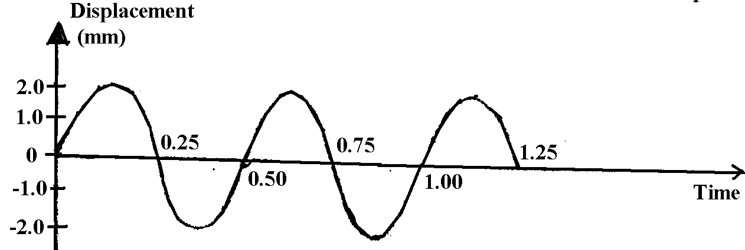
Figure 5
Determine the frequency of the waves. (3 mks)

6. Arrange the following in order of increasing frequencies — Gamma radiation, radio waves, infrared, and X —rays. (1 rnk)

7. Sketch a ray diagram to show the position of an object, when a converging lens is used as a magnifying glass. (2 mks)

8. State two factors other than the speed of rotation that affect the magnitude of the e.m.f generated.
(2 mks)
………………………………………………………………………………………………………………………………………………………………………………………………………………
………………………………………………………………………………………………………………………………………………………………………………………………………………
9. Fig 6. Shows water waves incident on a shallow region of the shape shown with dotted
line.
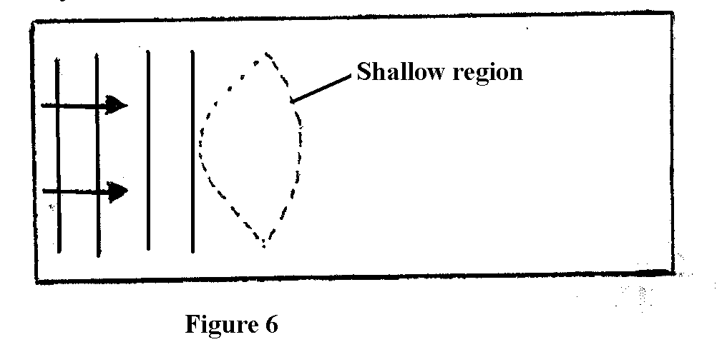
On the same diagram, sketch the wave pattern in and beyond the shallow region. (2 mks)

10. An electric heater rated 240V; 300w is to be connected to a 240V mains supply, through a 10A fuse. Determine whether the fuse is suitable or not. (3 mks)

11. Fig. 7 shows an electric generator. The point P and Q are connected to a cathode ray oscilloscope (CR0).
The points P and Q are connected to a cathode ray
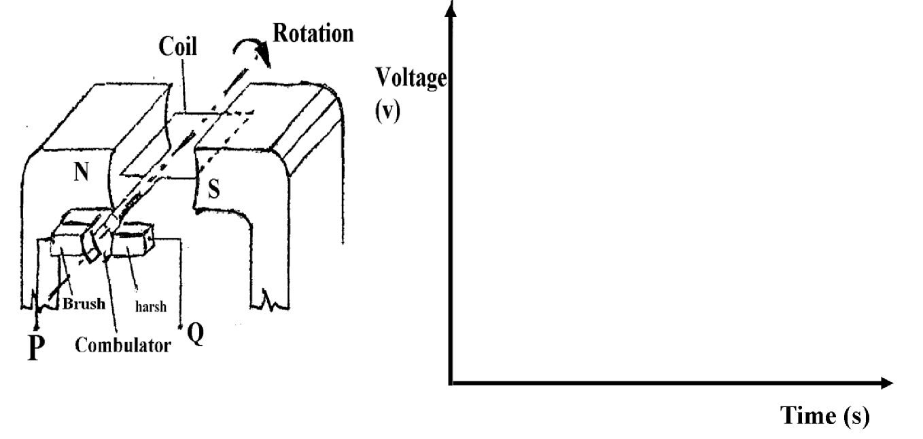
Sketch on the axes provided the graph of the voltage output as seen on the CRO Given that when
t = 0 when the coil is at the position shown in the figure. (2 mks)

12. Light of a certain wavelength strikes the surface of a metal. State what determines the maximum kinetic energy of the electron emitted. (1 mk)
………………………………………………………………………………………………………………………………………………………………………………………………………………

SECTION B (55 MARKS)

13. a) Figure 8 shows a Geiger muller (GM) tube
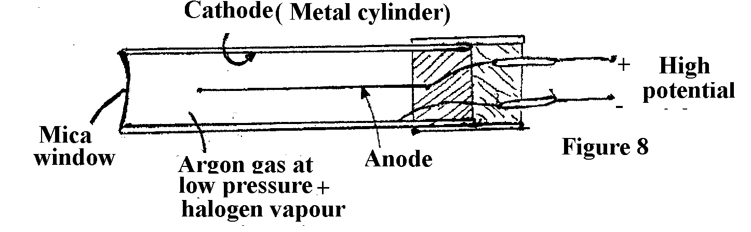
(i) Give the reason why the mica window is made thin. (1 mk)
………………………………………………………………………………………………………………………………………………………………………………………………………………
………………………………………………………………………………………………………………………………………………………………………………………………………………

(ii) Explain how the radiation entering the tube through the window is detected by the tube. (3mks)
………………………………………………………………………………………………………………………………………………………………………………………………………………
………………………………………………………………………………………………………………………………………………………………………………………………………………
………………………………………………………………………………………………………
(iii) What is the purpose of the halogen vapour (1 mk)
………………………………………………………………………………………………………………………………………………………………………………………………………………
(b) Two samples of the same radioactive material have initial masses M and 2M respectively. On the axes provided, sketch the graph of activity versus time for each sample. Label the graph for each sample. (2mks)

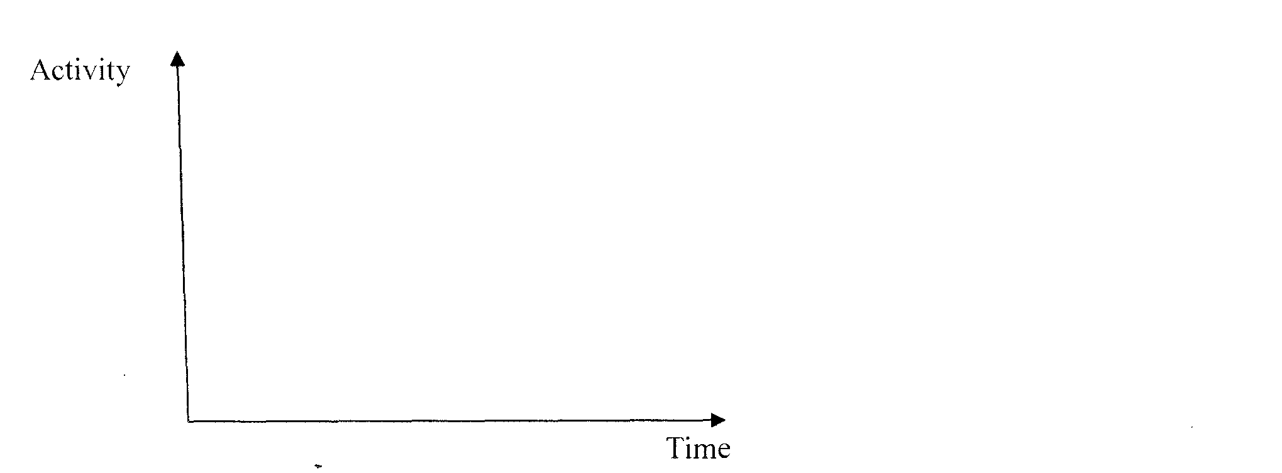
ii) A radioactive sample of half-life 130 days initially has 1.0 x 10²⁰ radioactive atoms. Determine the number of radioactive atoms that have decayed after 390 days. (3mks)

14. a) i) What is a capacitor? (l mk)
………………………………………………………………………………………………………………………………………………………………………………………………………………
………………………………………………………………………………………………………
ii) State two factors that affect the capacitance of a parallel plate capacitor. (2 mks)
………………………………………………………………………………………………………………………………………………………………………………………………………………
………………………………………………………………………………………………………………………………………………………………………………………………………………

b) The figure below shows a circuit where a battery of emf 4.5V, switches A and B, two capacitors C₁ 0.3$μ$F and C₂ 0.5 $μ$F and a voltmeter are connected.
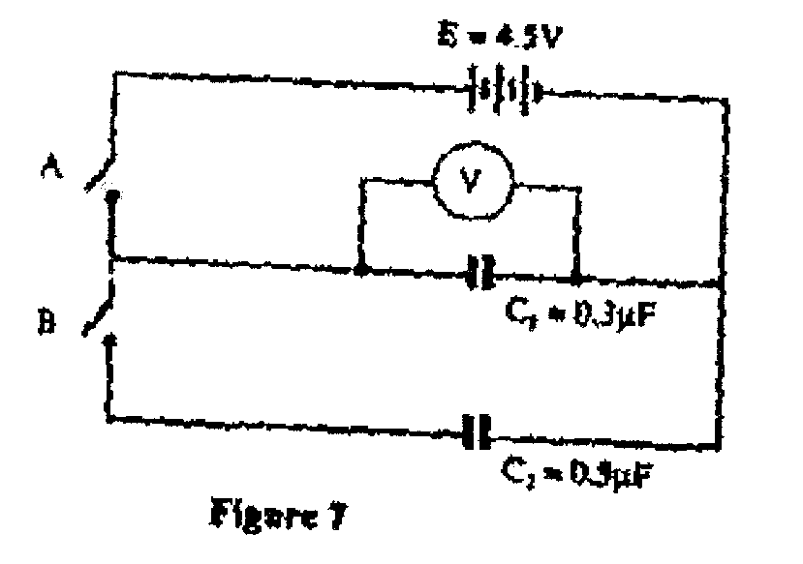

(a) Determine the charge on C₁ when switch A is closed and switch B is open
(3 marks)

(b) What is the effective capacitance C₁ when both switches A and B are closed?
(2 mks)

(c) State and explain what is observed on the voltmeter when both switches A and B are open,
(2 mks)

15. (a) Define the refractive index of a substance (1 mark)
………………………………………………………………………………………………………………………………………………………………………………………………………………
………………………………………………………………………………………………………………………………………………………………………………………………………………
(b) In an experiment to determine the refractive index of a liquid, the liquid was poured into a measuring cylinder. A pin was placed at the bottom of the cylinder and another pin was used to locate the apparent position of the first pin. The real depth and apparent depth were measured. The experiment was repeated with other values of real depth. The table below shows the results obtained.
Real depth (cm) | 5 | 10 | 15 | 20 | 25
Apparent depth (cm) | 3.3 | 6.7 | 10 | 13.3 | 16.7

(i) Plot the graph of real depth against apparent depth (5 marks)
(ii) From the graph determine the refractive index of the liquid (4 marks)

(c) Figure 9 shows a ray of light incident on a glass air interface
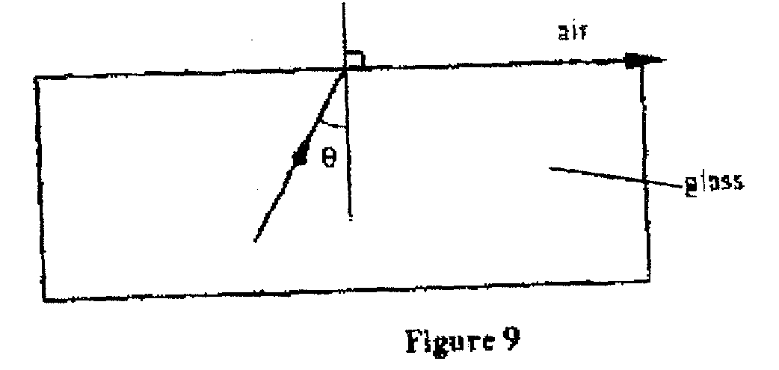
Given that the refractive index of the glass is I .6. Determine angle $θ$ (3 marks)

16. (a) Figure 12 shows a section of a house wiring system
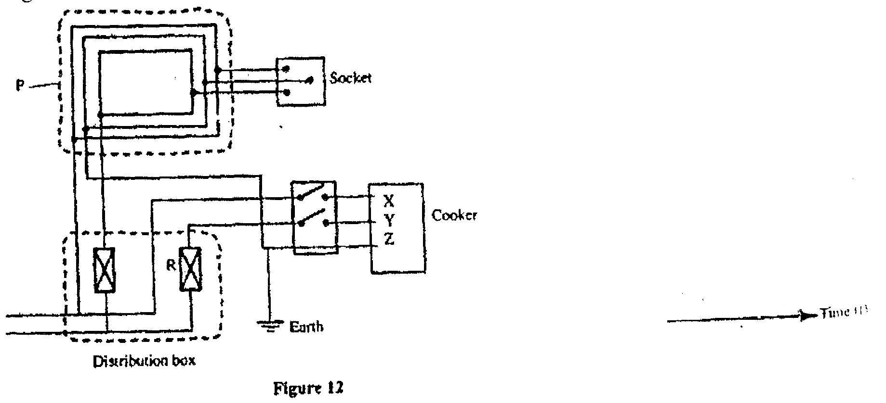
(i) Name: (1 mark)
The circuit labeled P
The terminals labeled X and Y
X……………………………… Y………………………………. (2 marks)
II Give a reason why R is connected to Y but not to X (1 mark)
(iii) Why is the earthing necessary in such a circuit? (1 mark)
(b) Determine the cost of using an electric iron rated 1500W, for a total of 30 hours given
that the cost of electricity per kWh is Kshs 8. ( 2 mark)

(c) A transformer with 1200 turns in the primary circuit and 120 turns in the secondary
circuit has its primary circuit connected to a 400V a.c source. It is found that when a heater is connected to the secondary circuit, it produces heat at the rate of 600w. Assuming 100% efficiency, determine the:
(i) Voltage in the secondary circuit (2 marks)

(ii) Current in the primary circuit (2 marks)

(iii) The current in the secondary circuit (1 mark)

17. (a) State Ohm’s Law (1 mark)
………………………………………………………………………………………………………………………………………………………………………………………………………………
………………………………………………………………………………………………………………………………………………………………………………………………………………
(b) The graph in figure 9 shows the current – voltage characteristics of a certain device, X
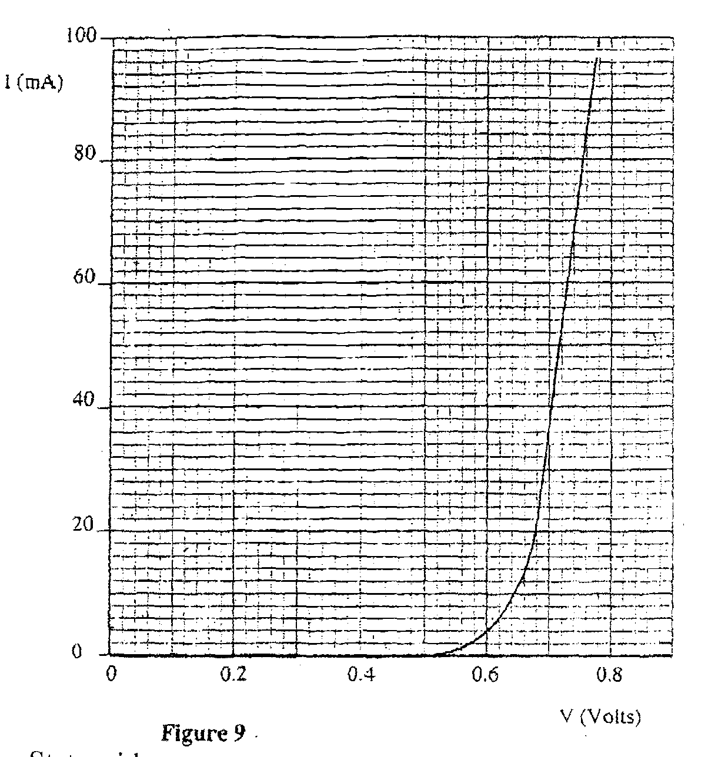
(i) State with a reason whether the device obeys Ohm’s law. (2 mks)
………………………………………………………………………………………………………………………………………………………………………………………………………………
………………………………………………………………………………………………………………………………………………………………………………………………………………
(ii) Determine the resistance of the device, X, when the current through it is 60mA. (2 mks)
(c) The cell figure 10 has an e.m.f of 2.1 V and negligible internal resistance.
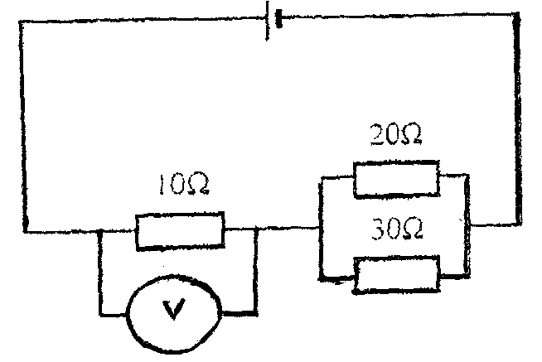Figure 10
Determine the
(i) Total resistance in the circuit (2 marks)

(ii) Current in the circuit (1 mark)

(iii) Reading of the voltmeter (2 marks)
END

