NAME:……………………………………………………… INDEX NO:…………………………
SCHOOL:………………………………………………….. DATE:……………………………….
SIGN:………………………………..

232/3
PHYSICS
PAPER 3
JULY / AUGUST - 2012
TIME: 2 ½ HOURS

KERICHO DISTRICT JOINT KCSE TRIAL EXAMINATION-2012
Kenya Certificate of Secondary Education (K.C.S.E)

232/3
PHYSICS
PAPER 3
JULY / AUGUST- 2012
TIME: 2 ½ HOURS

INSTRUCTIONS TO CANDIDATES

-Write your name and index number in the spaces provided above.
-Sign and write the date of the examination in the spaces provided above.
-You are advised to spend the first 15 minutes of the 2 ½ hours given reading the entire question paper.
-Marks are given for clear record of observations actually made for their suitability and accuracy for the use of them.

For Examiner’s use only
QUESTION 1 | (i) | (ii) | (vii) | (viii) | (ix ) | ( ) | TOTAL
STUDENT’S MARKS
QUESTION 2 | (i) | (ii) | (viii) | (x) | (xi) | (xii)
STUDENTS’S MARKS

This paper consists of 8 printed pages. Candidates should check the question paper to ensure that all pages are printed as indicated and that no questions are missing.

Question 1
You are provided with the following apparatus
- Meter rule
- One 50g mass
- Vernier callipers
- Stopwatch
- Raised surface
- G-clamp
- Cellotape
- Three 100g masses
Proceed as follow

(i) Using the vernier callipers, measure and record the width b and thickness h of the meter rule
b=............................................m (1mk)
h=...........................................m (1mk)
(ii) Arrange the apparatus as shown in the fig below
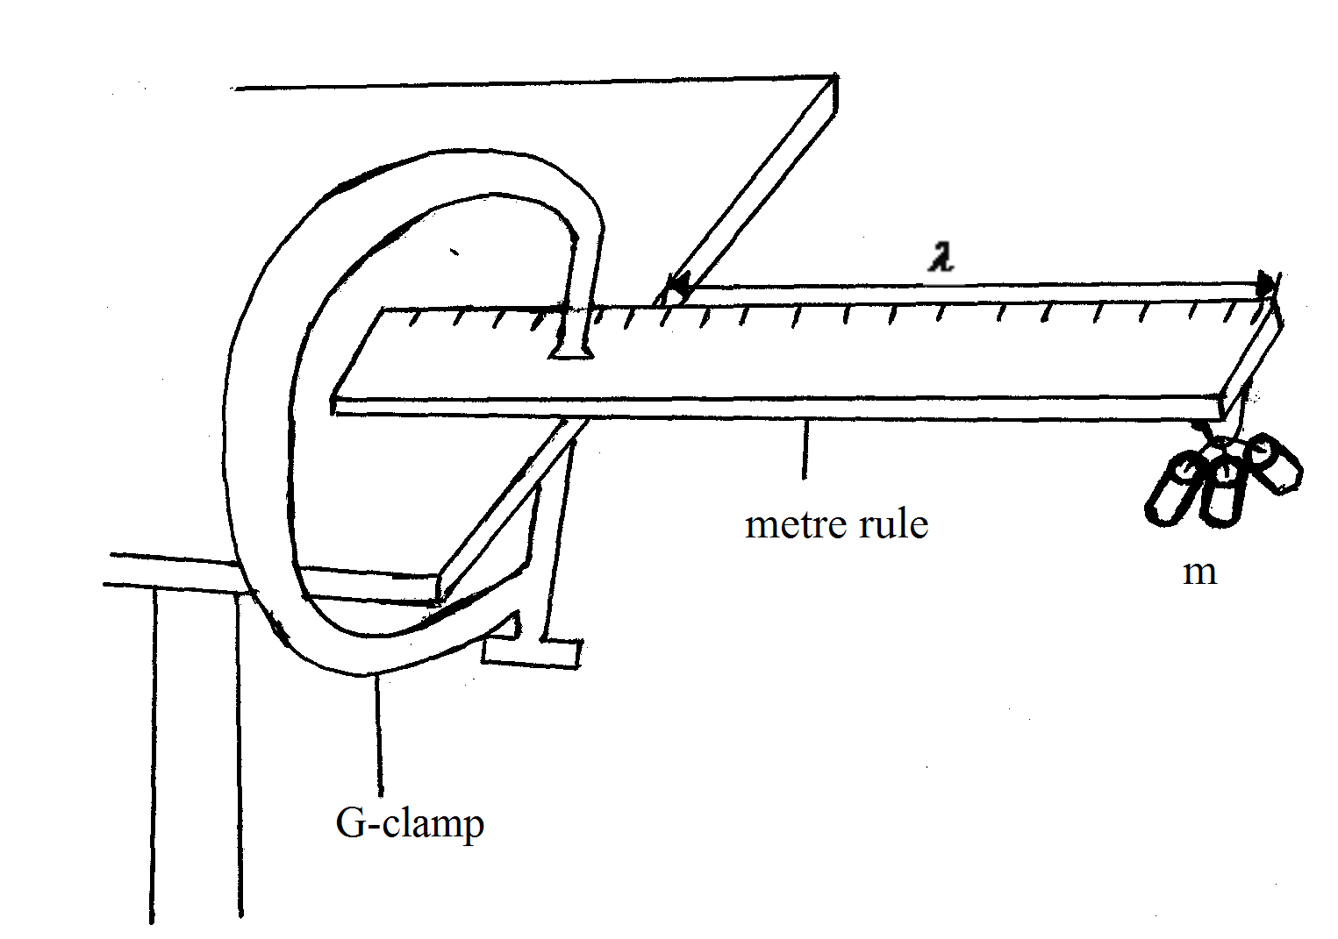
(iii) Set the metre rule such that the length l=95cm.
(iv) Take the 100g mass and using the cellotape, fix firmly so that its geometric at centre is directly below the free edge of the metre rule.
- Pull the end of the metre rule with the mass m to give it vertical displacement, then release as you start the stop watch to determine the time t for 10 oscillations. Record the time t in the table of results.

(vi) Repeat step (iv)-(v) for the other masses and complete the table of results (6mks)
Mass m(kg) | Time t for 10 oscillation(s) | Periodic table t(s) | T²(S²)
0.1
0.15
0.20
0.25
0.30

(vii) Plot a graph of T² against m on the grid provided.

(viii) Determine the slope s of the graph (3mks)

(ix) The equation of the graph is given by
$T=\frac{\text{16}π^{2}{\text{ml}}^{3}}{{\text{bh}}^{3}k}$
Determine the value of K ,the elastic constant of the metre rule. (4mks)

QUESTION 2
You have been provided with the following apparatus
2 dry cells
A cell holder
A bulb
A cardboard with a slit
A meter rule
A white screen
A beaker containing water about ¾ full
A cotton thread about 50cm long.
(a)
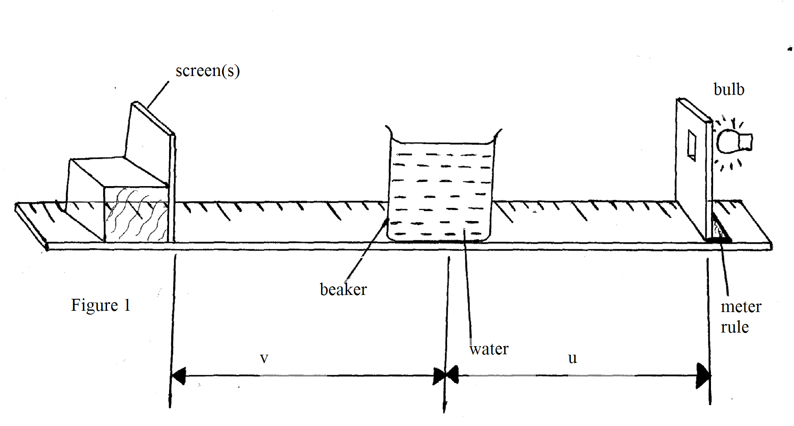
(i) With the cotton thread provided , measure C the external circumference of the beaker
C=______________________________________cm (1mk)
(ii) Find $Δ$the diameter of the beaker given that $Δ$=$\frac{C}{π}$_______________cm (1mk)
(iii) Place the beaker such that its centre is at the 50cm mark-as shown in the figure 1 above.
(iv) Set the illuminated slit at a distance u=15cm from the beaker.
(v) Move the screens to and fro to obtain a sharp image on it.
(vi) Measure and record the distance V from the screen to the centre of the beaker.
(vii) Repeat steps (iv to vi) above for values of u as 20 ,25,30,35 and 40 cm respectively.
(viii) Complete the table below (7mks)
Object distance u(cm) | 15 | 20 | 25 | 30 | 35 | 40
Image distance x(cm)
$$\frac{1}{u}{\text{cm}}^{−1}$$
$$\frac{1}{v}{\text{cm}}^{−1}$$

(ix) Plot the graph of $\frac{1}{u}{\text{cm}}^{−1}$ against $\frac{1}{v}{\text{cm}}^{−1}$ (5mks)

(x) State the intercepts (i)Iy y-intercept_____________________________ (1mk)
(2)Ix x-intercept____________________________ (1mk)
(xi) Calculate A if A =$\frac{\text{Iy}+\text{Ix}}{2}$____________________________ (1mk)

(xii) Given that k=$\frac{4}{4−\text{AD}}$ to the nearest 3 d.p (3mks)

End

