Name…………………………………………………………………………… Index No……………..
School………………………………………………………………………….. Date………………….
Candidate’s signature…………………………………..

232/3
PHYSICS
PRACTICAL
PAPER 3
JULY / AUGUST 2011
TIME: 2 ½ HOURS

KISII SOUTH DISTRICT JOINTEVALUATION TEST-2012
Kenya Certificate of Secondary Education (K.C.S.E)

INSTRUCTIONS TO THE CANDIDATES:
1. Write your name and Index Number in the spaces provided above.
2. Sign and write the date of examination in the spaces provided above
3. Answer all the questions in the spaces provided in the question paper.
4. You are supposed to spend the first 15 minutes of the 2 ½ hours allowed for this paper reading the whole paper carefully before commencing.
5. Marks are given for a clear record of the observation actually made, their suitability, accuracy and the use of them.
6. Candidates are advised to record their observations as soon as they are made.
7. Non-programmable silent electronic calculators and KNEC mathematical tables may be used.

FOR EXAMINERS’ USE ONLY
Question 1
QUESTION | a | d | e | f | TOTAL
MAXIMUM SCORE | 1 | 7 | 5 | 7
CANDIDATES SCORE

Question 2
QUESTION | a | b | TOTAL
MAXIMUM SCORE | 13 | 7
CANDIDATES SCORE

This paper consists of 8 Printed pages.
Candidates should check to ascertain that all pages are printed as indicated and that no questions are missing.
1. You are provided with the following:
- A metre rule
- Vernier calipers
- A 300g mass
- Two knife edges
- Some thread.
Proceed as follows:
a) Place the metre rule on the knife edge such that each knife edge is 45 cm from the 50 cm mark
(centre of the rule). See figure 1. Ensure that the millimetre scale of the metre rule is facing upwards. The distance L between the knife edges is now 900 mm.
Place the vernier calipers vertically against the metre rule at the 50 cm mark with the depth gauge lowered to touch the bench as shown in figure 1.
Record the height h0, of the upper edge of the metre rule at the 50 cm mark. (See figure 1).
h₀=………………………………………………….. mm (1 mark)
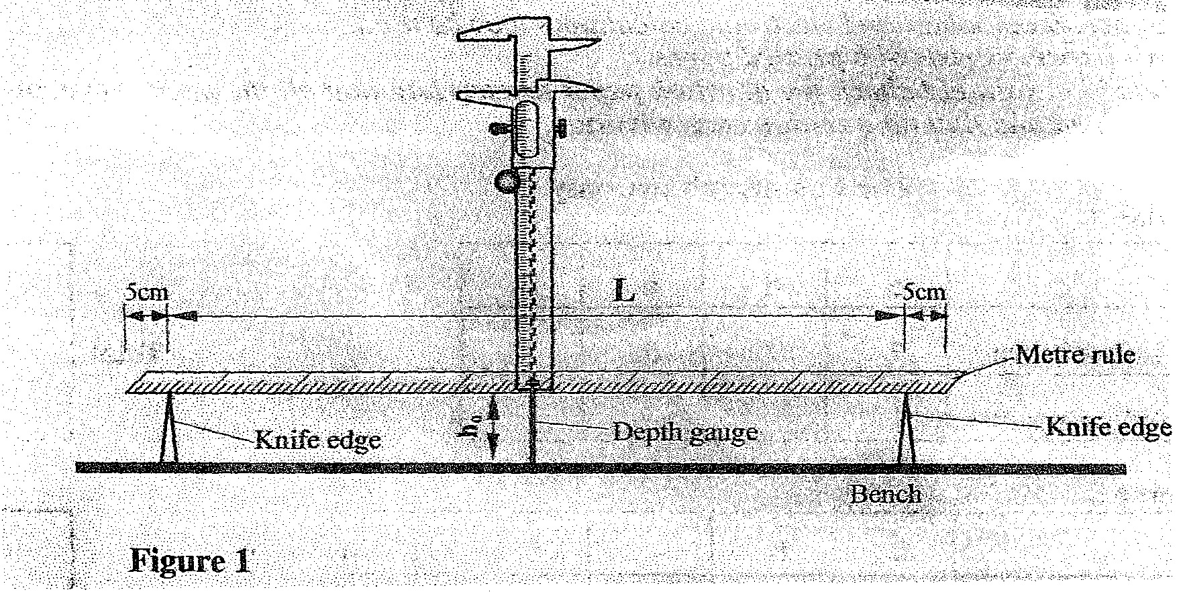
b) Using the thread provided, hang the 300g mass at the 50cm mark of the metre rule. Ensure that the
mass does not touch the bench. Measure and record in table 1, the height h of the edge of the metre rule at the 50 cm mark.
c) With the 300g mass still at the 50 cm mark, adjust the position of the knife edges so that L is now
800 mm. (The knife edges should be equidistant from the centre of the metre rule). Measure and record in table 1 the height h of the edge of the metre rule at the 50 cm mark.
d) Repeat the procedure in (c) for other values of L shown in table 1. Complete the table.
Length L(mm) | 900 | 800 | 700 | 600 | 500
Height h(mm)
Depression d(h₀-h)mm
Log L
Log d
(7 marks)
e) Plot a graph of Log L(y-axis) against log d. (5 marks)

f) i) Determine the slope of the graph. (3 marks)

- Evaluate y=$\frac{1}{S}$
y=…………….. (1 mark)

iii) Determine G, the value of log L, when log d=0 (2 marks)

iv) Given that G=$\frac{\text{log}K}{y}$, determine the value of K. (1 mark)
2. You are provided with the following apparatus
- 7 connecting wires
- Bulb
- 2 dry cells(1.5V)
- Voltmeter
- Ammeter
- Switch
- Rheostat

i) Set up the apparatus as in the figure below.

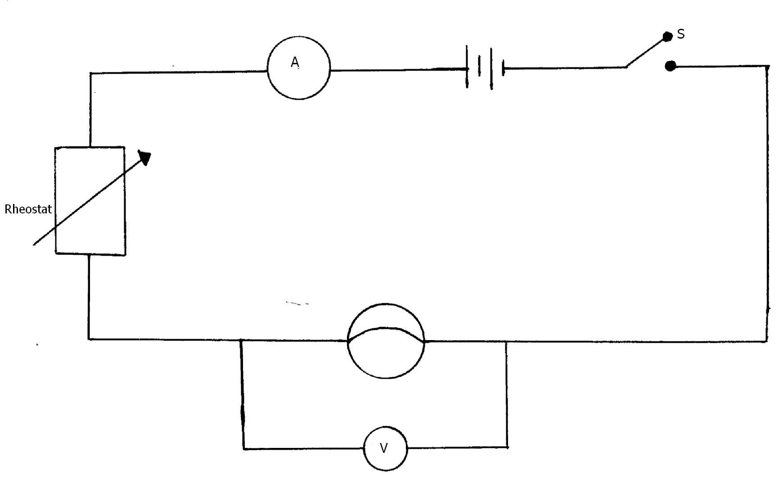

- Close switch S
- Use rheostat to adjus your current I to 0.5A and record the corresponding values for the p.d across the bulb
- Repeat the procedure for different values of current as shown in the table below.
Current I(A) | 0 | 0.05 | 0.10 | 0.15 | 0.20 | 0.25 | 0.30
p.d(V)
(6 marks)
- Plot a graph of p.d(y-axis) against current I. (5 marks)

ii) Determine the resistance of the filament of the bulb when I=0.18A, given that Resistance R=$\frac{V}{I}$ (2 marks)

- You are provided with the following apparatus
- Prism
- 4 optical pins
- Plain paper
- Protractor
- Some plasticine
i) Set up the apparatus as shown below

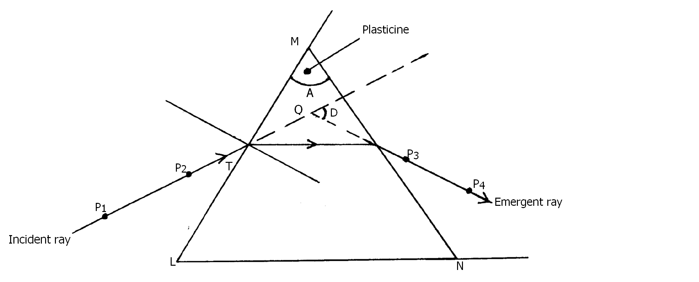

- Measure angle A of the prism using a protractor
A=………………………………………………. (1 mark)

- Place the prism on a plain paper and trace its outline with a pencil
Attach some plasticine to the prism to indicate the refractive angle A
Consruct a normal at point T along LM. Draw an incident ray to strike the prism at T at 60⁰. Replace the prism and press pins P₁ and P₂ to define the incident ray. View the pins P₁ and P₂ from the opposite face(MN). Insert pins P₃ and P₄ so that they appear to be in line with the images of P₁ and P₂ .
Remove the prism and join P₃ and P₄ to give the emergent ray.
Extrapolate the emergent ray into the prism so as to meet the extrapolated incident ray at Q.
iv) a) Measure angle D
D=…………………………… (2 marks)

- Calculate the value of n, from the expression (3 marks)
$$n=\frac{\text{Cos}\left\{{\text{90}}^{0}−\left(\frac{A+D}{2}\right)\right\}}{\text{Sin}\frac{A}{2}}$$

c) What is the significance of “n”? (1 mark)

End

