Name………………………………………………………. Index No…………………/…….
School……………………………………………………… Date ………………………….…
Candidate’s Signature………………………

232/3
PHYSICS
Paper 3
(PRACTICAL)
JULY / AUGUST 2012
Time: 2 ½ Hours

KWANZA DISTRICT JOINT EVALUATION TEST – 2012
Kenya Certificate of Secondary Education (K.C.S.E)

232/3
PHYSICS
Paper 3
(PRACTICAL)
JULY / AUGUST 2012
Time: 2 ½ Hours

INSTRUCTIONS TO CANDIDATES
1. Write your name and Index Number in the spaces provided above.
2. Sign and write the date of examination in the spaces provided above
3. Answer all the questions in the spaces provided in the question paper.
4. You are supposed to spend the first 15 minutes of the 2 ½ hours allowed for this paper reading the
whole paper carefully before commencing your work.
5. Marks are given for a clear record of the observations actually made, their suitability, accuracy
and the use made of them.
6. Candidates are advised to record their observations as soon as they are made.
7. Non-programmable silent electronic calculators and KNEC mathematical tables may be used.

QUESTION I
PART A | II | IV | V | VI  TOTAL
MAXIMUM SCORE | 1 | 1 | 1 | 2
CANDIDATES SCORE

PART B | II | III | IV | V  TOTAL
MAXIMUM SCORE | 5 | 5 | 3 | 2
CANDIDATES SCORE
QUESTION 2
PART C | a | g | h(i) | h(ii) | i
MAXIMUM SCORE | 2 | 6 | 5 | 3 | 4  TOTAL
CANDIDATES SCORE
GRAND TOTAL

This paper consists of 8 printed pages.
Candidates should check the question paper to ensure that all
pages are printed as indicated and no questions are missing
Question 1
You are provided with the following:
- a metre rule
- a lens (Convex) mounted on a lens holder
- a candle
- a white screen

Proceed as follows
Part A
i) Set up the apparatus as shown in figure 1 below. (Ensure that the burning candle and the lens are in a straight line)
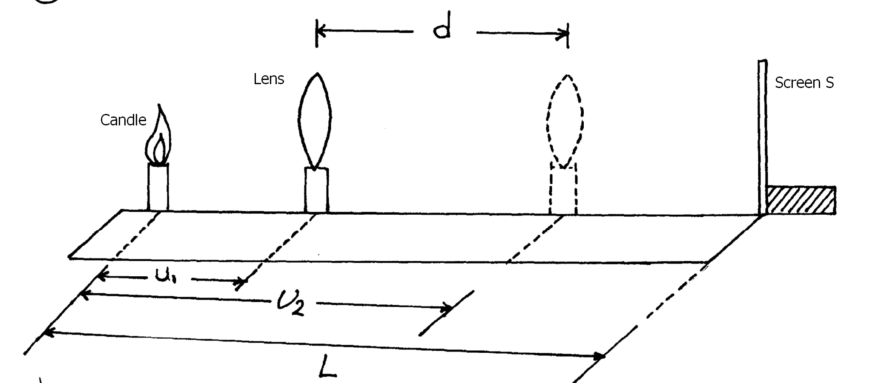

ii) With the candle placed at a distance L = 100cm from the screen, determine the position of
a sharply focused magnified image of the candle on the screen by moving the lens towards
the screen.
iii) Measure the distance U₁ between the lens and the candle
U₁ = ……………………………… cm. (1mk)
iv) Now move the lens towards the screen until you get a sharply focused diminished image.
Measure the new distance, U₂ between the lens and the candle.
U₂ = ………………………………cm (1mk)
v) Calculate the displacement d of the lens given that d = U₂ – U₁
d = ……………………………..
…………………………………cm (1mk)

vi) Given that $f = \frac{L^{2} − d^{2}}{4L}$, calculate the value of f. (2mks)
………………………………………………………………………………………………………
………………………………………………………………………………………………………
………………………………………………………………………………………………………
Part B
i) With the same set up, ensuring that L = 100cm, adjust the lens until you get a sharp
diminished image on the screen. Measure the object distance U and the image distance V.
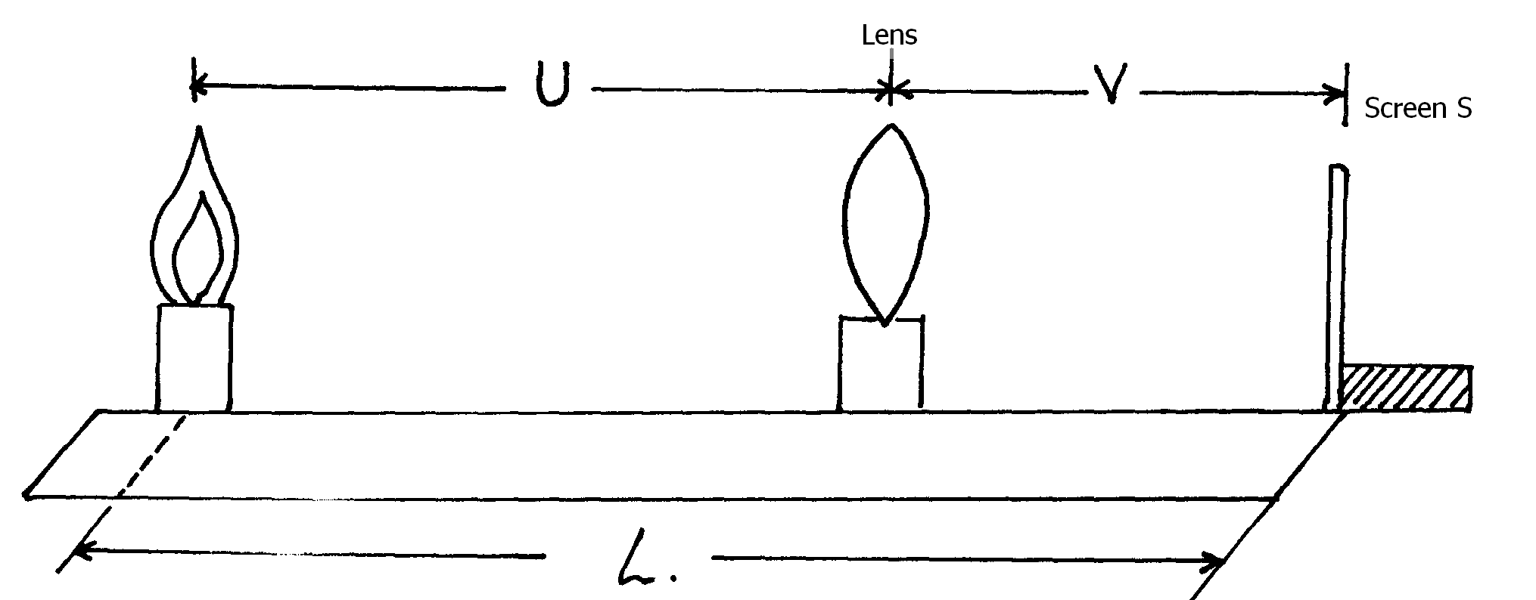
ii) Repeat the procedure in (i) with L = 95cm, 90cm, 85cm and 80cm each time recording the
values of U and V and tabulating the results in the table I below.
Table I
L (cm) | 100 | 95 | 90 | 85 | 80
U (cm)
V (cm)
$$M = \frac{V}{U}$$
(5mks)

iii) Plot the graph of M against V (5mks)

iv) Determine the slope of the graph (3mks)
………………………………………………………………………………………………
………………………………………………………………………………………………
………………………………………………………………………………………………
………………………………………………………………………………………………
v) Given that V = fm + f, determine the focal length, f of the lens from the graph above
(2mks)
………………………………………………………………………………………………
………………………………………………………………………………………………
………………………………………………………………………………………………
………………………………………………………………………………………………
Question 2
You are provided with the following
A measuring cylinder
Glycerine
Two rubber bands
One metre ruler
Steel ball bearing
A magnet
A micrometer screw gauge
A stop watch
Proceed as follows.
a) Measure the diameter D of the steel ball using the micrometer screw gauge.
D = ……………………………….mm (1mk)
D = ……………………………….m (1mk)
b) Take a measuring cylinder and fill it with glycerine. Fix the bands A and B such that band A is
3cm from the surface of glycerine as shown in the fig. 2 below.
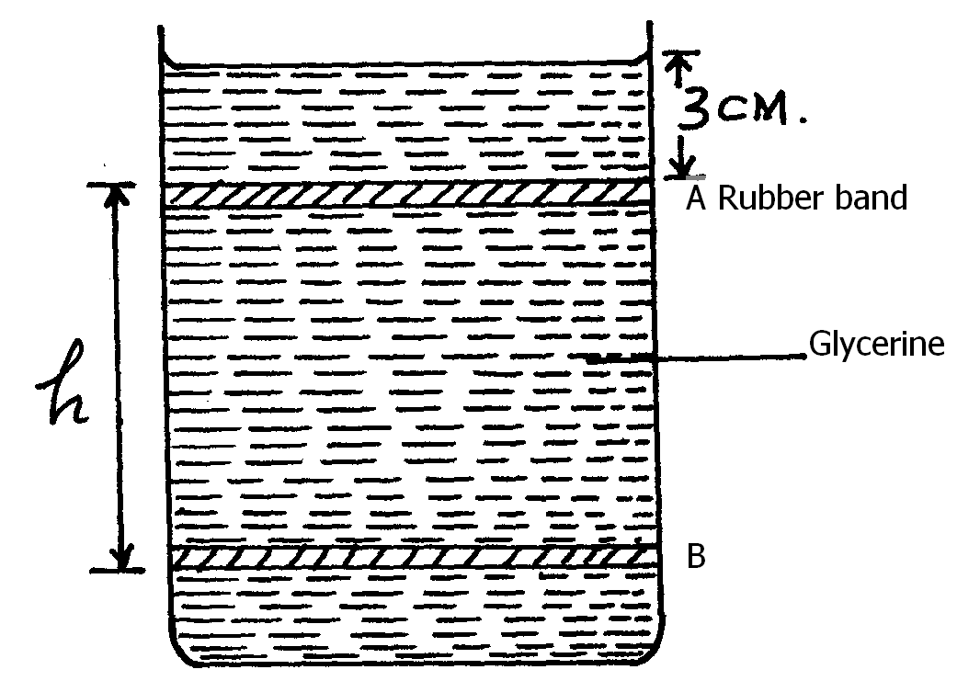
c) Adjust the lower rubber band B so that h = 35cm.
d) Release the steel ball from the surface of the liquid and obtain the time, t it takes to travel the
distance h = 35cm. Record this value in the table 2 shown below.
e) Use the magnet provided to remove the steel ball from the liquid,
f) Repeat procedures (b), (c) and (d) for values of h given in the table below.
g) Record the values in the table below.
Table 2
h (cm) | 35 | 30 | 25 | 20 | 15 | 10
t(s)
h) i) Plot the graph of t (vertical axis) against h. (5mks)

ii) Determine the slope S of your graph (3mks)
………………………………………………………………………………………………
………………………………………………………………………………………………
………………………………………………………………………………………………
………………………………………………………………………………………………
………………………………………………………………………………………………
………………………………………………………………………………………………
i) The equation of the graph is given by
$K = \frac{D^{2}g (t) (a − b)}{\text{18}h}$
Determine the value of K given that (4mks)
g = 10m/s²
a = 7.0 x 10³kg/m³
b = 1.26 x 10³kg/m³
………………………………………………………………………………………………
………………………………………………………………………………………………
………………………………………………………………………………………………
………………………………………………………………………………………………
………………………………………………………………………………………………
………………………………………………………………………………………………

End

