NAME……………………………………………………….. INDEX NO……………/….…
SCHOOL……………………………………………………. DATE …………………………...
CANDIDATE’S SIGNATURE……………………………..

232/3
PHYSICS
Paper 3
(PRACTICAL)
JULY/ AUGUST - 2012
Time: 2 ½ Hours

MANGA DISTRICT JOINT EVALUATION EXAM– 2012
Kenya Certificate of Secondary Education (K.C.S.E)

232/3
PHYSICS
Paper 3
(PRACTICAL)
JULY/ AUGUST - 2012
Time: 2 ½ Hours

INSTRUCTIONS TO CANDIDATES
1. Write your name, and Index Number in the spaces provided above.
2. Sign and write the date of examination in the spaces provided above.
3. This paper consists of two sections: A and B
4. Answer all the questions in section A and B in the spaces provided.
6. All working must be clearly shown
7. Mathematical tables and silent electronic calculators may be used.

FOR EXAMINER’S USE ONLY

Question | Maximum Score | Candidate’s Score
1
2
TOTAL

This paper consists of 8 printed pages.
Candidates should check the question paper to ensure that all
pages are printed as indicated and no questions are missing.

PART I

1. You are provided with the following apparatus
a metre rule
a lens holder
a concave lens
a candle, and
a mounted white screen.
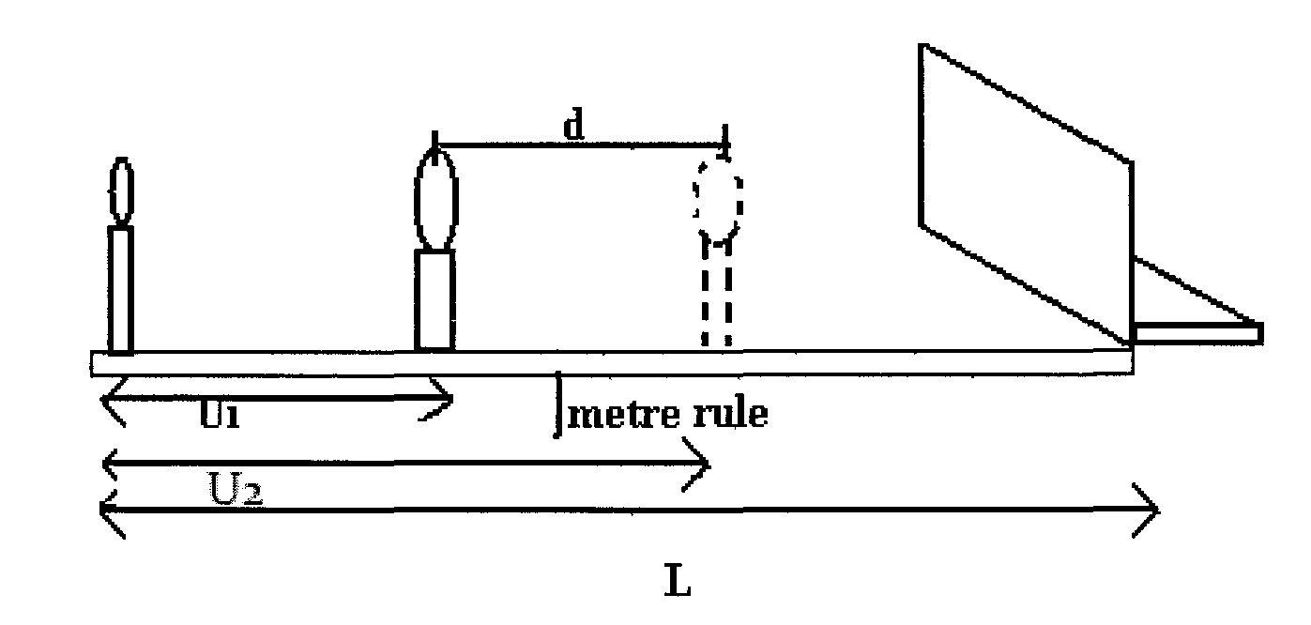
Proceed as follows:

i Set up the apparatus as shown in figure 2 above. (ensure that the candle and the lens are in the line)

ii) With the candle placed a distance L =100cm from the screen ,determine the position of a sharply focused magnified image of the candle on the screen by moving the lens

iii) Determine the distance of the lens from the candle U₁
U₁………………………. .cm (l mk)

iv) Now move the lens towards the screen until you get a sharply focused diminished image. Determine the new distance of the lens from the candle U₂
U₂………………………cm (l mk)

v) Calculate the displacement d of the lens (l mk)
d = U₂ — U₁ = …………………….cm

Give that f =$\frac{L^{2}−d^{2}}{4L}$ , calculate the value of f. (2 mks)

PART II
1. You have been provided with the following apparatus
— A wooden plank
— A stop watch
— Optical pin
— Retort stand
— Wooden pegs
(a) Proceed as follows.
i) Set the apparatus as shown in the fig below with the optical pin being at the
position A which is 4 cm from the centre of gravity of the wooden plank. (Marked G)
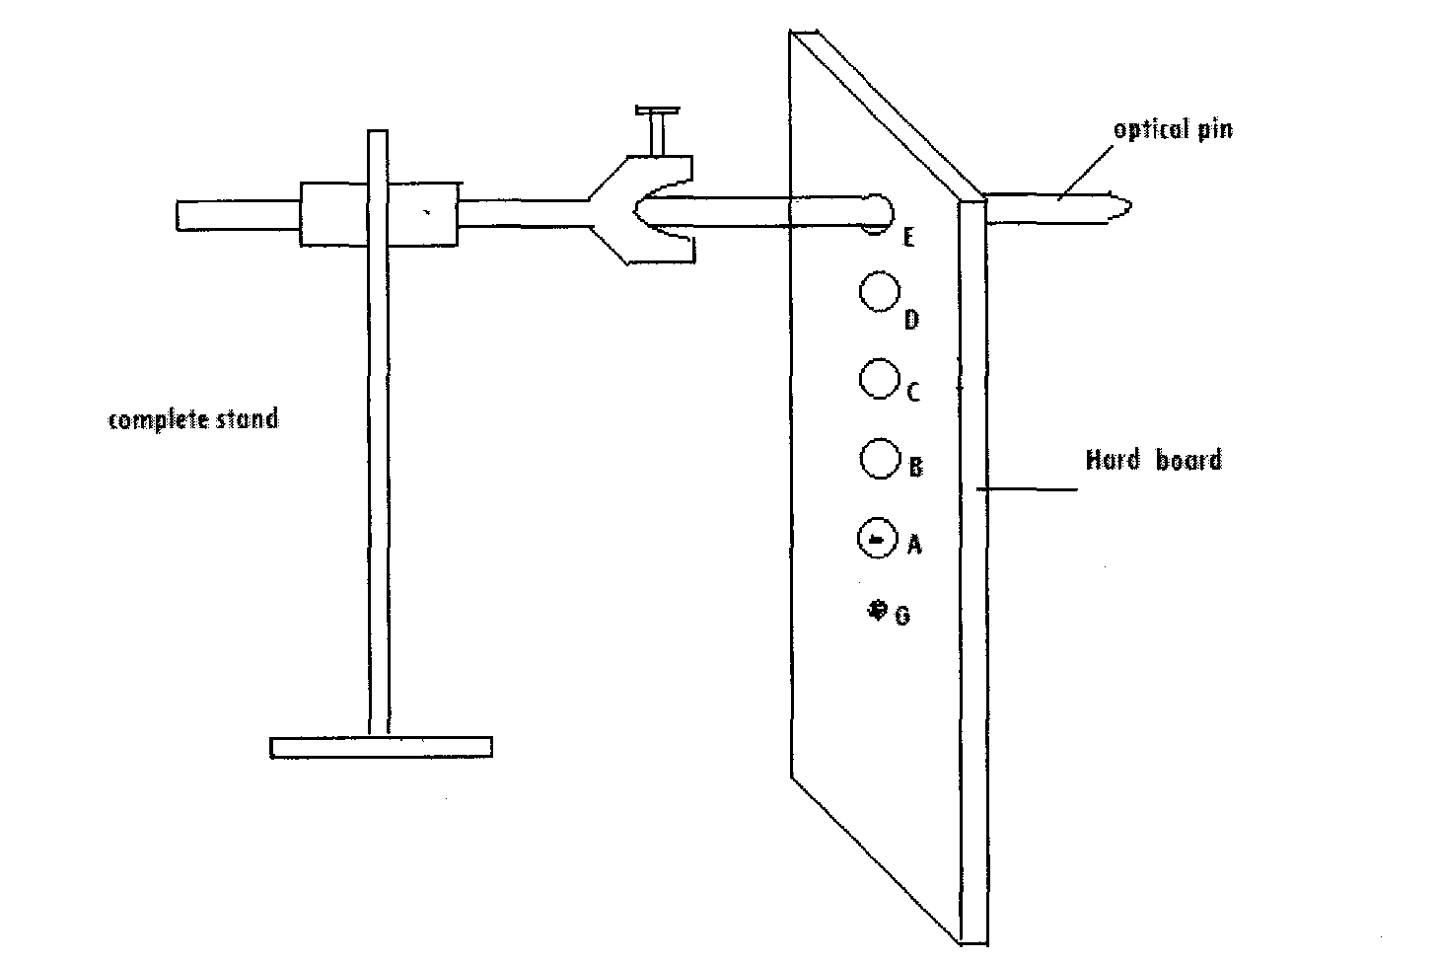

ii) Displace the strip through an angle of about 15° from its rest position and
release it to swing to and fro (oscillate). Measure the time t for 10
oscillations of the wooden plank. Record your observations.

b) Repeat steps (ii) with the pin through the holes B, C, D and E of lengths L =6 cm, 8cm,
10cm and 12cm repective1y from the centre of gravity of the wooden plank marked G and tabulate your results in table. (5 mks)
(ii)
Hole | A | B | C | D | E
Distance L(m) | 0.04 | 0.06 | 0.08 | 0.10 | 0.12
Time for 10 osc
Period time T sec
T² sec²
L² (m²)
L² × 10⁻⁴ (m²)
c). Plot a graph of T² sec² against L² (m²) (4 mks)

d). Determine the value of the slope S of your graph. (2 mks)
e). The equation of the line is represented by $T^{2}=\frac{4π^{2}L}{R}+\frac{4π^{2}k^{2}}{R}$
i. Find the value of the constant R given $π$= 3.142. (2mks)

ii. Find the value of the intercept C of your graph and hence find the value of K.
(2mks)

2. You have been provided with the following apparatus.
— Resistor R
— Cell size D new
— Cell holder
— Two potentiometers marked W and X.

a) Proceed as follows.
(i) Measure and record the diameter of wire W
D = m² (1 mark)
(ii) Use the information to calculate the cross-sectional area of the wire. (A)
A = m² (2 mks)
(iii) Set up the apparatus as shown in the figure below.
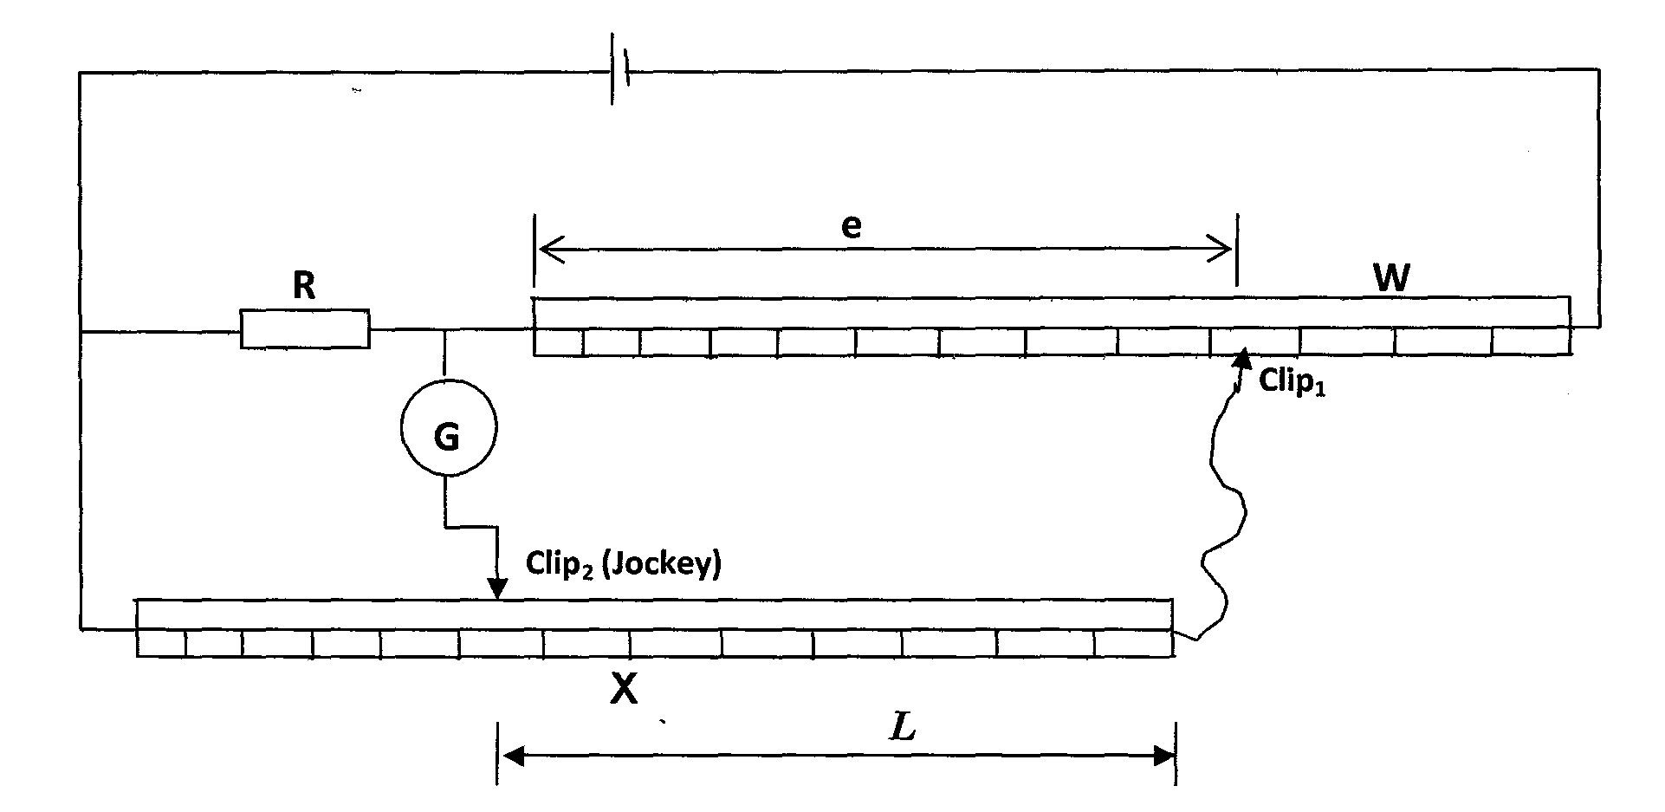

(iv) Move the crocodile clip along W such that the length e =10cm, then move the
jockey to obtain a balance point along the wire X. Record the length L and the value of the balance point along wire X.

b) Repeat steps (iii) for values of e =20cm, 30, 40, 50, 70 and 80cm and complete the table.
(6mks)
e cm | 10.0 | 20.0 | 30.0 | 40.0 | 50.0 | 70.0 | 80.0
L cm
$$\frac{1}{L} {\text{cm}}^{−1}$$
c) Plot a graph of e cm against $\frac{1}{L} {\text{cm}}^{−1}$ (5mks)

d) From the graph find the slope S of your graph. (3mks)
S=
e) From the graph state the value of $\frac{1}{L}\left({\text{cm}}^{−1}\right)$When e = 0 (l mk)

f) Given that $e=\frac{\text{100}R}{\text{JL}}−\frac{R}{J}$find the value of J when R=$\text{10}Ω$ (2mks)

END

