Name…………………………………………………………………………… Index No……………..
School………………………………………………………………………….. Date………………….
Candidate’s signature…………………………………..

232/3
PHYSICS
PAPER 3
JULY / AUGUST 2012
TIME: 2 HOURS

MBITA-SUBA DISTRICTS JOINT EXAMINATION - 2012
Kenya Certificate of Secondary Education – K.C.S.E

INSTRUCTIONS TO THE CANDIDATES:
1. This paper consists of two questions both of which are compulsory.
2. Marks are awarded for the observations actually; y made, accuracy, suitability and correct use made with them.
3. Electronic calculations and mathematical tables may be used.
4. All the workings must be clearly shown.

FOR OFFICIAL USE ONLY

Question | Max | Score
1 | 20
2 | 20
 | 40

This paper consists of 8 printed pages.
Candidates should check the question paper to ensure that all pages are printed as indicated
and no questions are missing

1. You are provided with the following apparatus:
1. Rectangular glass block
2. Soft board
3. Five sheets of plain papers
4. Four optical pins.
5. A pair of compasses, a protractor and a set square:- N/B these three items are found in the student’s geometrical set.
6 Half metre rule.
7. Four office pins

a) Using the office pins provided mount one sheet of plain paper on the soft board. Place the rectangular glass block on the plain paper and trace around it using a pencil.
b) Remove the block, draw a normal at a point O and draw a line making an angle of 15⁰ with the normal to represent incident ray as shown in the diagram below.
c) Stick two optical pins P and Q along the incident ray and replace the glass block. While closing one eye, look through the glass block from the opposite side and insert two other pins R and S exactly in line with the images of P and Q.
d) Remove the glass block and join SR to the outline of block. Hence obtain the refracted ray inside the glass block as shown in the diagram.
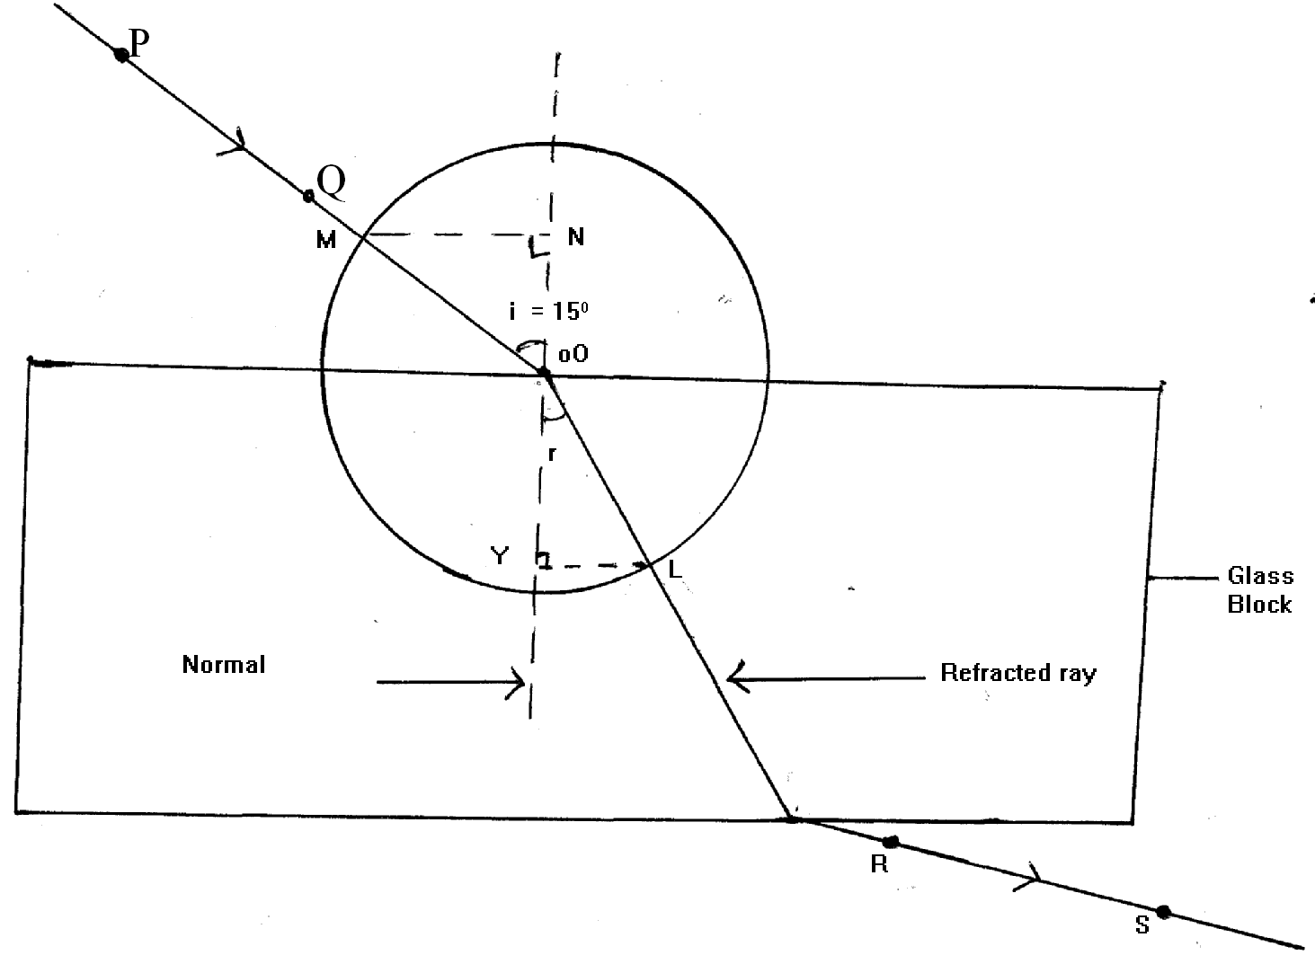
e) With O as the centre, Draw a circle of radius 5 cm to cut both the incident ray and the refracted ray at M and L respectively.

f) Using a set square, draw the perpendiculars LY and MN. Measure LY and MN in millimeters and record your value in the table below.

Angle of incidendence i | 15 | 3 | 45 | 60 | 75
LY (mm)
MN (mm)
g) Repeat the above steps for other angles of incidence shown in the table above.
i) Plot a graph of LY ( y – axis) against MN. (5mks)

(j) Calculate the slope,$β$, of your graph. (2mks)
...........................................................................................................................................................
...........................................................................................................................................................
...........................................................................................................................................................
...........................................................................................................................................................
...........................................................................................................................................................

k) Determine the quantity w defined$ω$= Sin ⁻¹$β$ (2mks)
...........................................................................................................................................................
...........................................................................................................................................................
...........................................................................................................................................................
...........................................................................................................................................................
...........................................................................................................................................................

N/B: Plain papers containing your drawing should be submitted together with the question paper to the invigilator.
Part II
- You are provided with the following apparatus:
- 50 ml measuring cylinder
- One 50g hooked mass.
- 50 cm piece of thread
- Some water in a beaker

a) Pour exactly 20 cm³of water into the measuring cylinder
b) Tie one end of the thread provided to the hooked mass using the thread lower the 50g mass carefully and gently into the water contained in the measuring cylinder. Record the new level V₁ of water in the measuring cylinder.
c) De touch the thread from the mass at a point near the hook. Wind five close turns round the mass. Place an ink mark at the beginning of the first turn and at the end of the fifth turn. Unwind the thread and determine length L between the two ink marks using the half metre rule.
L = _________________________________mm (1mk)
d) Determine the quantity K defined by:
K = $\frac{l}{\text{10} Π}$
Where $Π$ = 3. 142 (1mk)
...........................................................................................................................................................
...........................................................................................................................................................
...........................................................................................................................................................
...........................................................................................................................................................
........................................................................................................................................................... e) Find the quantity q defined by: $Q = \frac{v_{1} −\text{20}}{\text{50}}$
...........................................................................................................................................................
...........................................................................................................................................................
...........................................................................................................................................................
...........................................................................................................................................................
...........................................................................................................................................................

2. You are provided with the following apparatus
- Two metre rules
- One half metre rule
- Two pieces of cotton thread.
- Two heavy stands and two clamps
- One stop watch.
a) Set up the apparatus as shown in the figure below.

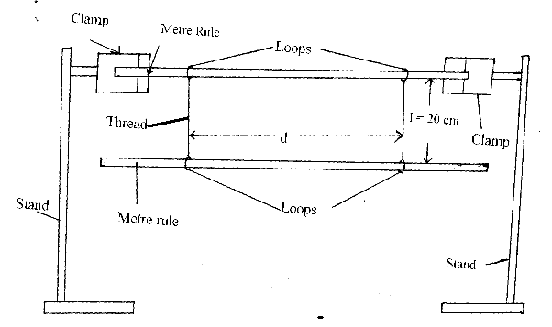

N/B:- Ensure the loops on the upper and lower metre rule are loose to enable easy sliding of the threads along the rules. Also the separation between the two rules must be 20cm throughout the experiment.
b) Adjust the position of the threads such that one is on the 10 cm mark and the other on the 90 cm. Mark on the lower metre rule. i.e d = 80 cm.
N/B: Maintain the threads vertical by making same adjustment on the upper metre rule.

Displace one end of the lower metre rule. Slightly on a horizontal plane so that when released it oscillated about a vertical axis as shown by the arrows In fig(b). Measure the time for 20 Oscillations and record in the table below.
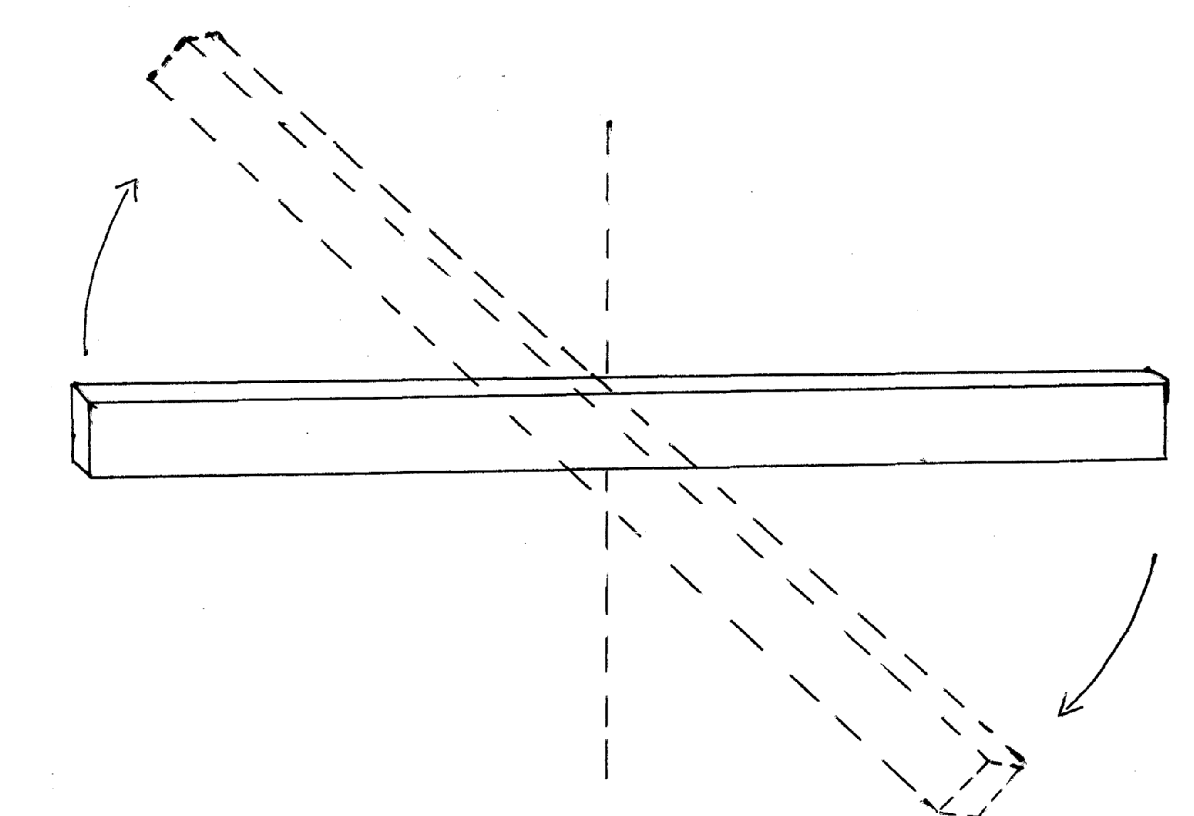
Fig (b)
c) Repeat the procedure in (b) for other values of d shown in the table below ( Set the values of d by adjusting the positions of the loops in steps of 5cm on both sides)
Complete the table

d (cm) | 80 | 70 | 60 | 50 | 40 | 30
d (m)
1/d² ( m⁻²)
Time for 20 Osc. (s)
Period T (s)
T² (s²)
(6mks)

d) Plot a graph of T ²( y – axis) against 1/d^{2.} (4mks)

e) i) Determine the slope of your graph. (2mks)

...........................................................................................................................................................
...........................................................................................................................................................
...........................................................................................................................................................

ii) Given that T² = $\frac{\text{16} K^{2}}{5d^{2}}$ where K is a constant; determine the value of k. (2mks)
...........................................................................................................................................................
...........................................................................................................................................................
...........................................................................................................................................................
PART II
You are provided with the following apparatus:
- One voltmeter ( 0 – 3V or ) -5v )
- One ammeter ( 0 – 1A)
- Six connecting wires, each at least 30 cm long. Three of which are connected to crocodile clips at one end.
- One new dry cell placed in a cell holder.
- One metre long microme wire mounted on a table and labeled MN
a) Set up the circuit shown below.
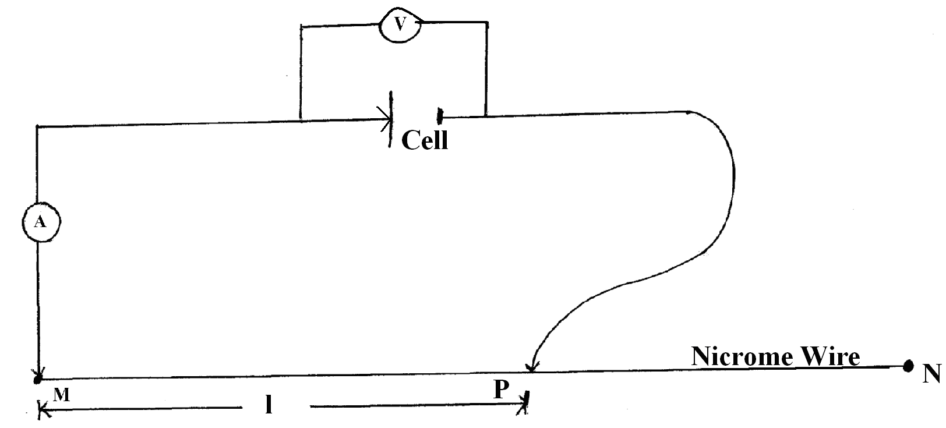
N/B: The arrows in the diagram indicate crocodile clips. The crocodile clip next to the cell should be used as a switch.
Connect the crocodile clip next to the cell and disconnect the one at P.
Record the voltmeter reading V_{0.}
V₀ ₌ ___________________________ (1mk)
b) Connect the crocodile clip at p, at a distance L = 50 cm from m.
Record the reading of both the ammeter and the voltmeter when the crocodile clip next to the cell is connected.
Reading of ammeter I = ........................................................................A ( ½ mk)
Reading of voltmeter V = ........................................................................V ( ½ mk)
c) Determine the quantity $ρ$, given the following relationship.
$ρ$ = $\frac{i}{V_{0} − V}$
...........................................................................................................................................................
...........................................................................................................................................................
...........................................................................................................................................................
...........................................................................................................................................................
...........................................................................................................................................................
PART III
You are provided with the following apparatus.
Lit candle
One biconvex lens mounted on a lens stand
Small amount of plasticine
One metre rule
One white screen
a) Arrange the lit candle and the white screen on the bench at a distance of 100 cm from each other. Mount the metre rule on the bench as shown so that its zero mark coinside with the point of the lit candle and the 100 cm mark coinside with the point of the screen.

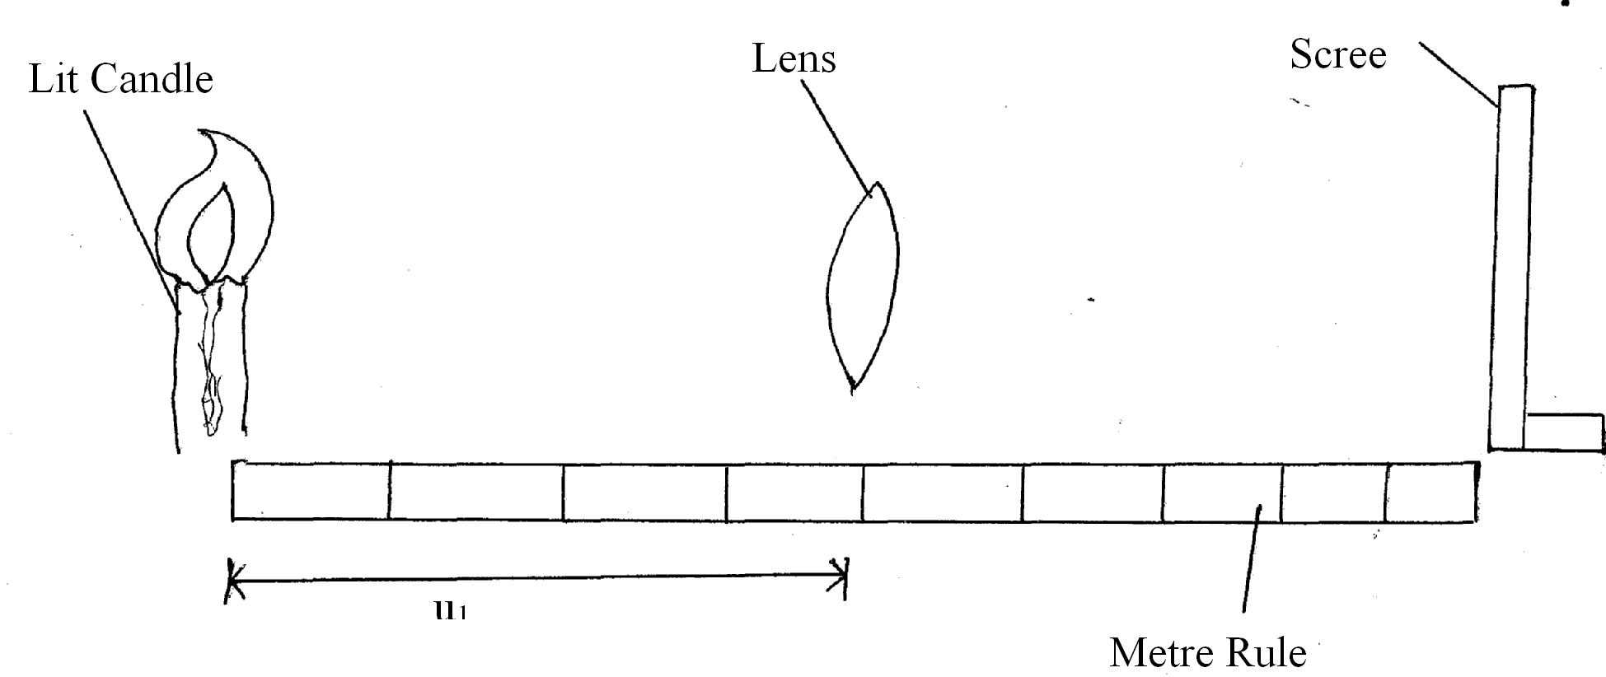

b) Place the lens between the screen and the lit candles at a point near the candle. Move the lens systems together with it holder towards the screen until you obtain a sharp magnified inverted image of the flame of the lit candle on the screen.
Record distance U₁ between the lens and the lit candle.
U 1 = ................................................................................................................................................cm ( ½ mk)
c) Move the lens system further towards the screen until you obtain another position where sharp diminished inverted image of the flame is formed on the screen.
Record the new distance u₂ of the lend u₂ .............................................cu( ½ mk) (1mk)
...........................................................................................................................................................
...........................................................................................................................................................
...........................................................................................................................................................
...........................................................................................................................................................
d) Determine displacement d of the lens system
...........................................................................................................................................................
...........................................................................................................................................................
...........................................................................................................................................................
...........................................................................................................................................................
e) Determine the constant $θ$ given that = $\frac{1+m}{{\text{mu}}_{1}}$
and m = $\frac{\text{100}−u_{1}}{u_{1}}$ (1mk)
...........................................................................................................................................................
...........................................................................................................................................................
...........................................................................................................................................................
...........................................................................................................................................................
...........................................................................................................................................................

END
END

