Name………………………………………………………. Index No…………………/…….
School……………………………………………………… Date ………………………….…
Candidate’s Signature…………
232/3
PHIYSICS
Paper 3
PRACTICAL
July / August, 2012
Time: 2 ½ Hours
TESO SOUTH DISTRICT JOINT EVALUATION TEST - 2012
Kenya Certificate of Secondary Education – K.C.S.E
232/3
PHIYSICS
Paper3
PRACTICAL
July / August, 2012
Time: 2 ½ Hours
INSTRUCTIONS TO THE CANDIDATES:
. Write your name and Index Number in the spaces provided above.
2. Sign and write the date of examination in the spaces provided above
3. Answer all the questions in the spaces provided in the question paper.
4. You are supposed to spend the first 15 minutes of the 2 ½ hours allowed for this paper reading the whole paper carefully before commencing your work.
5. Marks are given for a clear record of the observations actually made, their suitability, accuracy and the use made of them.
6. Candidates are advised to record their observations as soon as they are made.
7. Non-programmable silent electronic calculators and KNEC mathematical tables may be used.
8. This paper consists of 6 printed pages.
9. Candidate should check question paper to ascertain that all pages are printed as indicated and that no question are missing.

FOR EXAMINER’S USE ONLY
Q1
QUESTION | e | h | i | j | k | TOTAL
MAXIMUM SCORE | 1 | 8 | 5 | 3 | 3
CANDIDATES SCORE

Q.2
QUESTION | a(ii) | a(iii) | a(iv) | a(v) | a(vi) | b(i) | b(ii) | b(iii) | b(iv) | TOTAL
MAXIMUM SCORE | 4 | 1 | 5 | 3 | 1 | 1 | 2 | 1 | 2
CANDIDATES SCORE
GRAN DTOTAL

This paper consists of 8 printed pages.
Candidates should check the question paper to ensure that all pages are printed as indicated and that no questions are missing.
1. You are provided with the following apparatus:-
- Two meter rules
- Two stands and two clamps
- Two bosses
- Three pieces of thread (at least 30cm each)
- One optical pin
- A piece of cello tape and a plasticine
- A spiral spring
- One mass of 200g
- One stop watch
(a) Set the apparatus as shown in the diagram 1. Below ;Attach the pin (to act as the pointer)at
one end of the meter –rule using cellotape or plasticine;
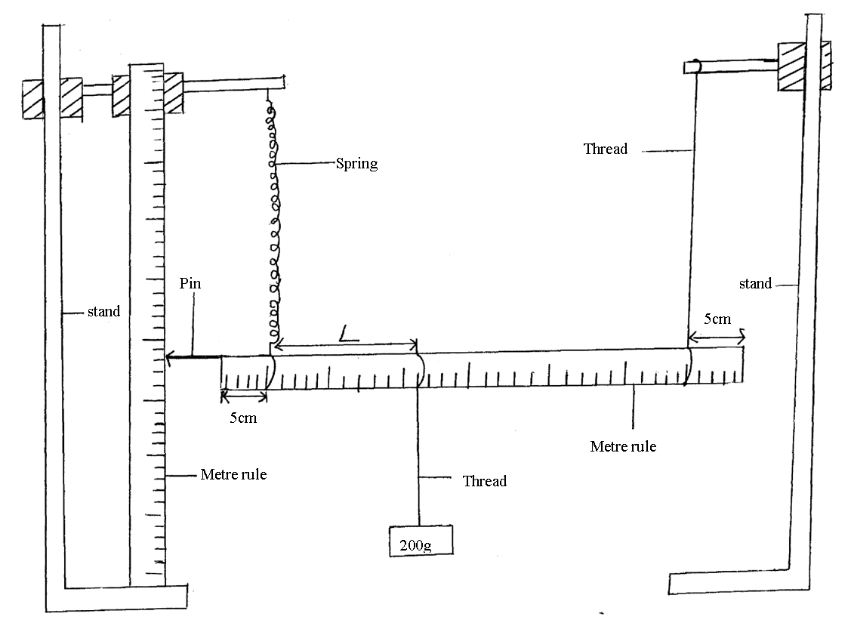
(b) Suspend one end of the metre –rule with thread at 5cm mark from the end .
(c) Suspend the other end with a spring also 5cm from the end so that metre rule is horizontal.
(d) Hold the other rule (with the spring)vertical on the beneath so that it is near the end with a
pointer as shown in the diagram.
(e) Read the pointer position .Lo=…………………………….cm, (1mk)
(f) Hang on the horizontal metre rule, the 200g mass at a length, L =10cm from the spring.
Record the extension, e of the spring in the table below.
(g) Displace the mass slightly downwards and release it to oscillate vertically. Take time for 20 oscillations and record in the table below.
(h) Repeat for other position of L,of the mass.
N/B before taking the reading, ensure the oscillation is steady. (8mks)
L(cm) | Extension e(cm) | Time (+) for 20 oscillation | Periodic table  T(s) | T²(s²)
10.0
20.0
30.0
40.0
50.0

(i) On the grid provided plot a graph of extension, e (m) y-axis against T²(s²)(5mks)

(j) Calculate the gradient of the graph drawn (3mks)

(k) Given that $e=\frac{{\text{RT}}^{2}}{4\prod{}}+C$, determine the value of R (3mks)

2. You are provided with the following
- An ammeter
- A voltmeter
- Two dry cells size D
- A mounted resistance wire on a metre-rule or millimeter scale
- A bulb on bulb holder
- A cell holder
- A switch
- A jockey or crocodile clip
- Micro metre screw gauge (can be shared)

- (i) Connect the apparatus provided as shown in the circuit diagram below diagram 2.
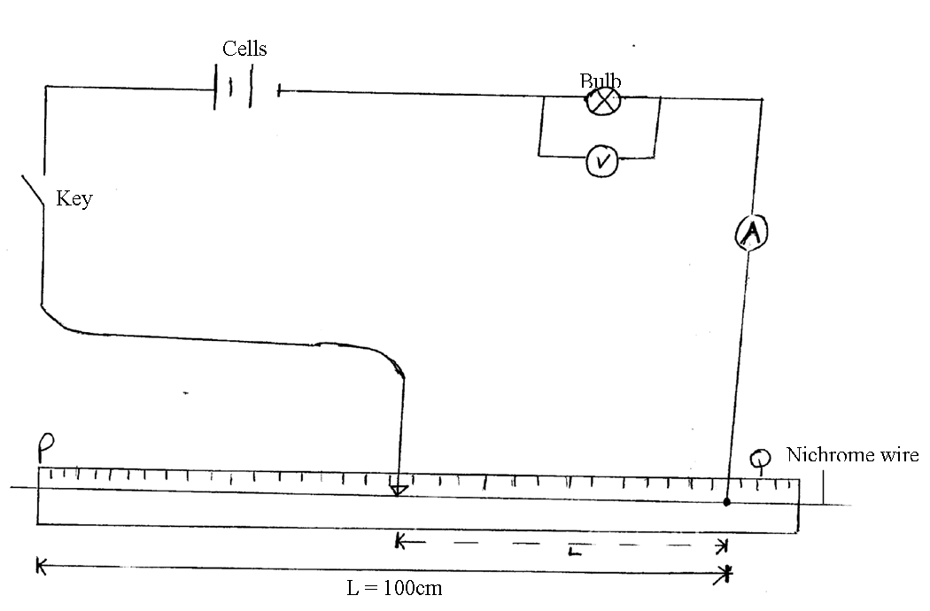
(ii) With the crocodile clip at P take the voltmeter reading and the ammeter reading,
Record V and I, Repeat the readings for L=80,60,40,20 and 0, respectively.
Complete the table below. (4mks)
Length l(cm) | Voltage v(v) | Current I(A)
100
80
60
40
20
0

(iii) What changes do you observe on the bulb as L decreases from P? (1mk)
………………………………………………………………………………………………………………………………………………………………………………………………………………………...........

(iv) On the grid provided plot the graph of Ammeter reading (y-axis) against voltmeter
reading. (5mks)

(v) Determine the slope of your graph at v =1volt. (3mks)

(vi) What physician quantity is represented by the slope of the graph at the point in (v)
above (1mk)
………………………………………………………………………………………………………………………………………………………………………………………………………………………...........
(b) (i) Given the apparatus in a (i) above, draw a diagram of the circuit you would use to
determine the current through the resistance wire and potential differences across it
(1mk)

(ii) Set up the circuit you have drawn using the available apparatus in a(i) above.
Record the ammeter reading I and voltmeter reading v, when L =100cm. (2mks)
V =…………………………………………………………………………………
I = ………………………………………………………………………………….
(iii) Using a micrometer screw gauge provided, measure the diameter d of the wire.
(1mk)
(iv) Calculate the quantity P = 0.785$\left(\frac{V}{I}\right){\left(\frac{d}{L}\right)}^{2}$and give its SI units, where L is IM.
(2mks)
END

