NAME:……………………………………………………… INDEX NO:…………………………
SCHOOL:………………………………………………….. DATE:……………………………….
SIGN:………………………………..

232/3
PHYSICS
PAPER 3
(PRACTICAL)
JULY/AUGUST - 2012
TIME: 2 ½ HOURS

BORABU-MASABA DISTRICTS JOINT EVALUATION TEST– 2012
Kenya Certificate of Secondary Education (K.C.S.E)

232/3
PHYSICS
PAPER 3
(PRACTICAL)
JULY/AUGUST - 2012
TIME: 2 ½ HOURS

INSTRUCTIONS TO CANDIDATES

1. Write your name admission number and class in the spaces provided above.
2. Sign and write the date of examination in the spaces provided above.
3. Answer ALL the questions in the spaces provided in question paper.
4. You are supposed to spend the first 15 minutes of the 2 ½ hours allowed for this paper reading
the whole paper carefully before commencing your work.
5. Marks are given for a clear record of the observation actually made, their suitability, accuracy,
and the use made of them.
6. Candidates are advised to record their observations as soon as they are made.
7. Non-programmable silent electronic calculators and KNEC mathematical tables may be used.

FOR EXAMINERS USE ONLY.

Question | e | f | g | h  Total
Maximum Score | 8 | 5 | 3 | 4
Candidate’s Score
Total

Question | a | f | g | h | i  GrandTotal
Maximum Score | ½ | 9 ½ | 5 | 3 | 2
Candidate’s Score

This paper consists of 8 printed pages.
Candidates should check the question paper to ensure that all pages are printed as indicated and that no questions are missing.
1. You are provided with the following:
- seven resistors of resistance; Ry$Ω$, 10$Ω$, 1O$Ω$, 22$Ω$, 39$Ω$, 1O$Ω$ and 4$Ω$;
- one cell (new size D);
- a switch;
- a jockey;
- a centre zero galvanometer;
- a resistance wire mounted on a millimeter scale;
- eight connecting wires, four with crocodile clips.
Proceed as follows:
(a) Set up the apparatus as shown in figure 1.
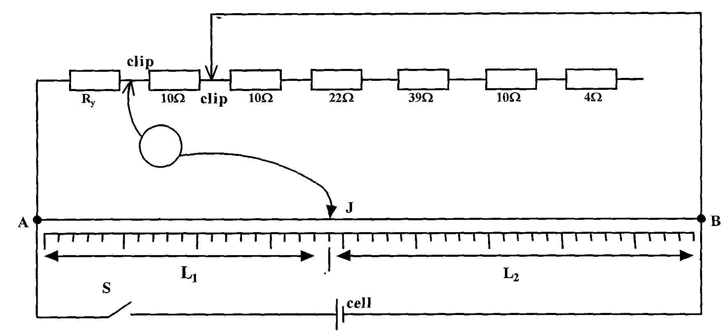
Figure 1
b) Place the crocodile clips as shown such that the resistance between them is 10$Ω$.
c) Close the switch and adjust the jockey J until there is balance (i.e the galvanometer
reading is zero)
d) Measure the distances L₁ and L₂ and record the values in Table 1.
e) Repeat the procedure in (b), (c) and (d) above for different values of resistance
R as shown in figure 1 and complete the table.
NB. The values of resistance R can be obtained by placing the crocodile clips at suitable points to give an appropriate combination of resistance R.
Table 1

Resistance R $(Ω)$ | 10 | 20 | 42 | 81 | 91 | 95
Length L₁ (cm)
Length L₂ (cm)
L₂ /L₁

f) Plot a graph of L₂ / L₁ (y – axis) against R. (5mks)

g) Determine the slope of the graph. (3mks)
.........................................................................................................................................................
.........................................................................................................................................................
.........................................................................................................................................................
.........................................................................................................................................................
h) Given the R = R_{y} x (L₂/L₁), determine:
(i) the reciprocal of the slope. (2mks)
.........................................................................................................................................................
.........................................................................................................................................................
(ii) R_{y} (2mks)
.........................................................................................................................................................
.........................................................................................................................................................
2. You are provided with the following:
- a metre rule;
- a retort stand, a boss and clamp;
- three pieces of thread;
- 200m1 of water in a 250ml beaker labelled W;
- 200m1 of a liquid in a 250m1 beaker labelled L;
- Two masses labelled m₁ and m₂.
Proceed as follows:
a) Suspend the metre rule so that it balances at its centre of gravity G and hang the
masses as in figure 2(a).
G = .................................................................................cm ( ½ mk)
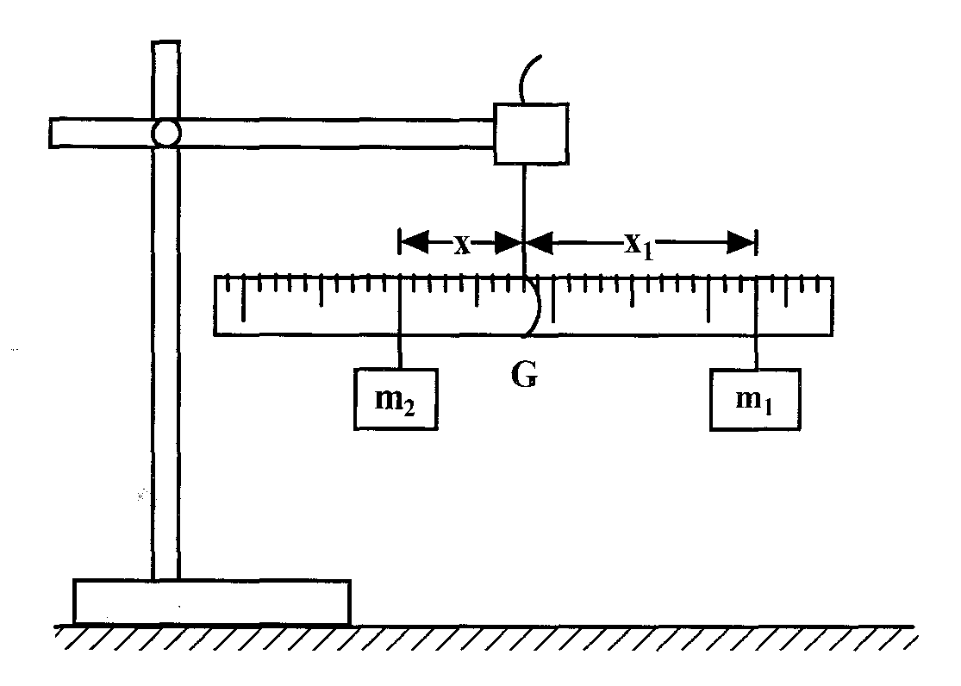
Figure 2(a)
b) Position mass m₂ at a distance x = 5 cm from the centre of gravity G and adjust the
position of m_{l} so that the metre rule balance at G. Record the x₁ of m₂ from the point
G in table 2.
c) While maintaining the distance x = 5cm, immerse m₂ completely in water. Adjust the position of m₁ until the metre rule balances again (see figure 2(b)). Record the new distance x₂.
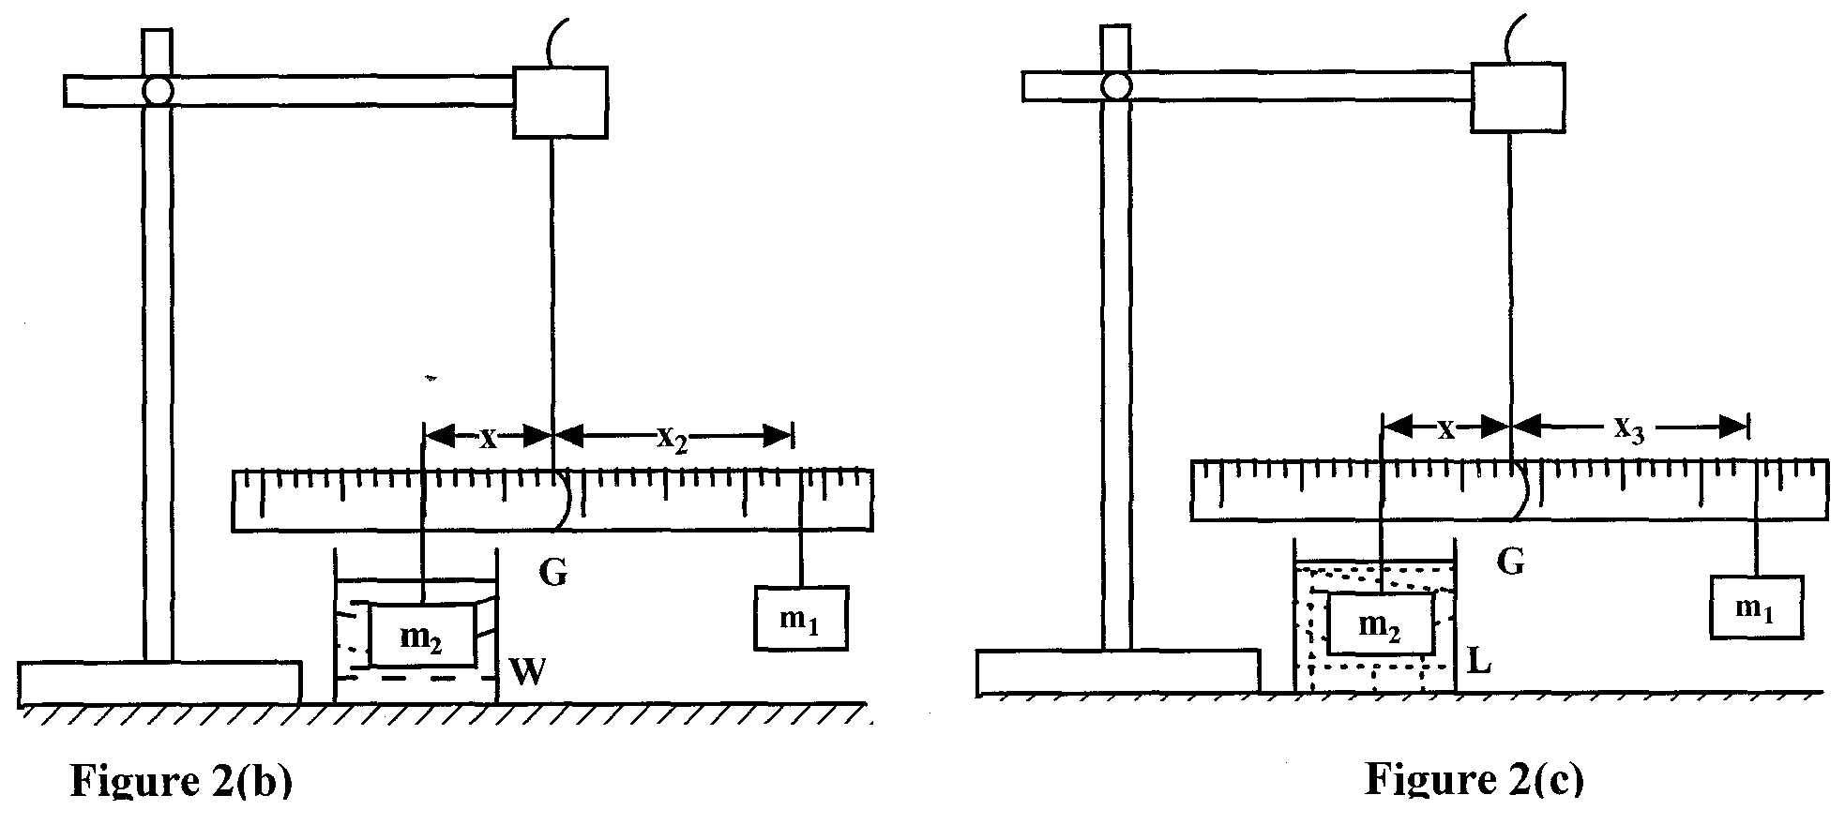

d) Still maintaining the same distance x = 5cm, remove the beaker, W with water and
replace it with the beaker L with the liquid. Immerse m₂ completely in the liquid. Adjust the position of m_{l} until the metre rule balances again (see figure 2(c)). Record the new distance x₃.
e) Remove mass m₂ from the liquid and dry it with a tissue paper.
f) With the metre rule still suspended from its centre of gravity G, repeat the procedure in
(b), (c), (d) and (e) for other values of x given in table 2. Complete the table.
Distance x (cm) | Distance x₁ (cm) | Distance x₂ (cm) | Distance x₃ (cm) | L₀ = (x₁ – x₂)  (cm) | L₁ = (x₁-x₃)  (cm)
5
10
15
17
20
(9 ½ mks)

(g) Plot a graph of L₀(y-axis) against L₁ (5mks)

(h) Find the slope S of the graph. (3mks)
.........................................................................................................................................................
.........................................................................................................................................................
.........................................................................................................................................................
.........................................................................................................................................................
.........................................................................................................................................................
.........................................................................................................................................................
(i) Find the value of k given that L₁ = $\frac{\text{25}}{K}L_{0}$ (2mks)
.........................................................................................................................................................
.........................................................................................................................................................
.........................................................................................................................................................
.........................................................................................................................................................
.........................................................................................................................................................
.........................................................................................................................................................

End

