NAME ____________________________________ INDEX NO. _______________
SCHOOL ____________________________________ SIGNATURE _______________ DATE _______________

443/2
AGRICULTURE
PAPER 2

JULY/AUGUST, 2015
TIME: 2 HOURS

443/2
AGRICULTURE
PAPER 2
TIME: 2 HOURS

INSTRUCTIONS TO CANDIDATES
- Write your name, school and index number in the spaces provided above.
- Sign and write the date of the examination in the spaces provided above.
- This paper consists of three sections: A, B and C.
- Answer all the questions in section A and B and any two questions from section C.
- All answers must be written in the spaces provided in this booklet.
- This paper consists of 12 printed pages.
- Candidates should check the question paper to ascertain that all pages are printed as indicated and that no questions are missing

For OFFICIAL use only
SECTION | QUESTIONS | MAXIMUM SCORE | CANDIDATE’S SCORE
A | 1 − 19 | 30
B | 20 − 22 | 20
C | 23 | 20
 | 24 | 20
 | 25 | 20
 | TOTAL SCORE | 90

SECTION A (30 MARKS)
Answer ALL the questions in this section in the spaces provided.
1. Name two tools used for cutting galvanized iron pipes. (1 mark)
______________________________________________________________________________________________________________________________________________________________________
2. Give four ingredients that should form part of piglet feed during creep feeding. (2 marks)
____________________________________________________________________________________________________________________________________________________________________________________________________________________________________________________________________________________________________________________________________________
3. Name two distinguishing external characteristics of California breed of rabbit. (1 mark)
______________________________________________________________________________________________________________________________________________________________________
4. State a hormone that is used for caponization of male birds. (1 mark)
___________________________________________________________________________________
5. Outline any four effects of endo-parasites in livestock . (2 marks)
____________________________________________________________________________________________________________________________________________________________________________________________________________________________________________________________________________________________________________________________________________
6. Give four methods of controlling tsetse flies in livestock farming. (2 marks)
____________________________________________________________________________________________________________________________________________________________________________________________________________________________________________________________________________________________________________________________________________
7. State four reasons for culling a breeding boar. (2 marks)
____________________________________________________________________________________________________________________________________________________________________________________________________________________________________________________________________________________________________________________________________________
8. Name the function of a gizzard in digestive system of a chicken. (½ mark)
______________________________________________________________________________________________________________________________________________________________________
9. Define the following terms as used in livestock production.
a) Raddling. (½ mark)
______________________________________________________________________________________________________________________________________________________________________

b) Steaming up (½ mark)
______________________________________________________________________________________________________________________________________________________________________
10. Give four reasons why bees abscond their hives. (2 marks)
____________________________________________________________________________________________________________________________________________________________________________________________________________________________________________________________________________________________________________________________________________
11. State four components of a building truss. (2 marks)
____________________________________________________________________________________________________________________________________________________________________________________________________________________________________________________________________________________________________________________________________________
12. State any two diseases that affect livestock based on sex as predisposing factor of livestock. (1 mark)
______________________________________________________________________________________________________________________________________________________________________
13. What is cropping in fish farming? (½ mark)
______________________________________________________________________________________________________________________________________________________________________
14. State three methods of disbudding young calves. (1½marks)
_________________________________________________________________________________________________________________________________________________________________________________________________________________________________________________________
15. List three factors that would make farmers construct a ‘Machakos’ dip other than a plunge dip. (1½marks)
_________________________________________________________________________________________________________________________________________________________________________________________________________________________________________________________
16. State two reasons why calves should be housed singly . (1 mark)
____________________________________________________________________________________________________________________________________________________________________________________________________________________________________________________________________________________________________________________________________________

17. Mention two characters of a poor layer that a farmer should look for in each of the following
parts of a hen during culling.
i) Vent (1 mark)
______________________________________________________________________________________________________________________________________________________________________
ii) Comb (1 mark)
______________________________________________________________________________________________________________________________________________________________________
iii) Plumage (1 mark)
______________________________________________________________________________________________________________________________________________________________________
iv) Abdomen (1 mark)
______________________________________________________________________________________________________________________________________________________________________
18. Name one intermediate hosts for each of the following.
- Tapeworm (Taenia spp) (½ mark)
___________________________________________________________________________________
- Liver fluke (Fasciola spp) (½ mark)
___________________________________________________________________________________
19. Differentiate between the following tools:
a) Dosing gun and bolus gun. (1 mark)
_________________________________________________________________________________________________________________________________________________________________________________________________________________________________________________________
b) Copying saw and hacksaw. (1 mark)
_________________________________________________________________________________________________________________________________________________________________________________________________________________________________________________________
c) Give one reason why young lambs should be castrated (1 mark)
______________________________________________________________________________________________________________________________________________________________________

SECTION B (20 MARKS)
Answer ALL questions in this section in the spaces provided.
20. Diagram F, G, H and J illustrate farm tools.
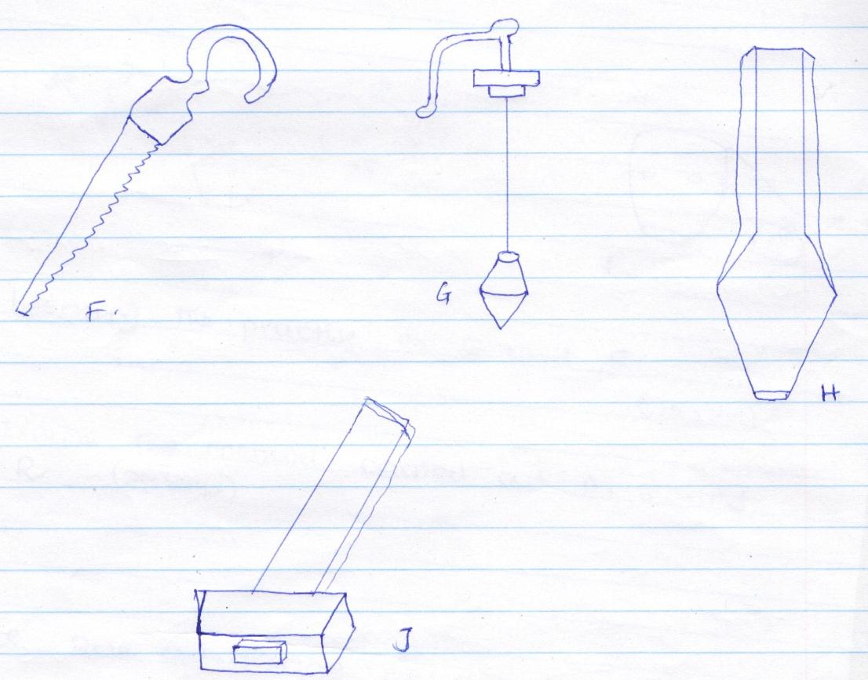
J
H
G
F

- Name the tools illustrated F, G, H and J. (2 marks)
F ______________________________________________________________________________
G ______________________________________________________________________________
H ______________________________________________________________________________
J ______________________________________________________________________________

- State the function of the tools stated above (2 marks)
F ______________________________________________________________________________
______________________________________________________________________________
G ______________________________________________________________________________ ______________________________________________________________________________
H ______________________________________________________________________________ ______________________________________________________________________________
J ______________________________________________________________________________ ______________________________________________________________________________

21. The diagrams Q and R below illustrate a practice carried out on livestock. Study the diagrams and answer the questions that follow.
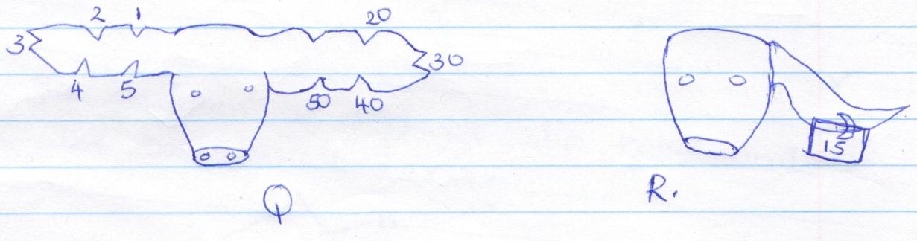
R
Q
a) i) Name the practice illustrated above. (1 mark)
___________________________________________________________________________________
ii) Give two reasons of carrying out the practice named in a)i) above. (2 marks)
____________________________________________________________________________________________________________________________________________________________________________________________________________________________________________________________________________________________________________________________________________
iii) Name the methods carried out in Q and R. (2 marks)
Q
___________________________________________________________________________________
R
___________________________________________________________________________________

b) i) State one advantage of practice R over Q. (1 mark)
______________________________________________________________________________________________________________________________________________________________________
ii) By using method Q draw the animal whose number is 100. (2 marks)

22. Study the diagram of a plunge dip below and answer the questions that follow.
B
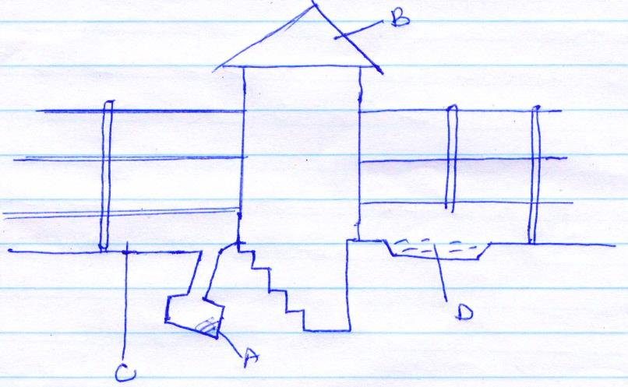
A
C
D
a) Name the parts labelled A and B. (2 marks)
A ______________________________________________________________________________
B ______________________________________________________________________________

b) State the use of parts A and D. (2 marks)
__________________________________________________________________________________________________________________________________________________________________________________________________________________________________________________________________________________________________________________________________________________________________________________________________________________________________________________________________________________________________________________

c) Give two advantages of holding livestock for some time in part C. (2 marks)
____________________________________________________________________________________________________________________________________________________________________________________________________________________________________________________________________________________________________________________________________________

d) State two uses of part labelled B. (2 marks)
____________________________________________________________________________________________________________________________________________________________________________________________________________________________________________________________________________________________________________________________________________

SECTION C (40 MARKS)
Answer any TWO questions from this section in the spaces provided.
23. a) Describe the life cycle of a three host tick. (8 marks)
b) Discuss the methods adopted to control livestock diseases . (12 marks)

24. a) Describe the short term service activities of a tractor. (10 marks)
b) Discuss the factors considered when siting a beehive. (10 marks)

25. a) Outline five disadvantages of artificial insemination in cattle management. (5 marks)
b) Describe eight signs of new castle disease in poultry. (8 marks)
c) Explain seven functions of water in livestock nutrition. (7 marks)

____________________________________________________________________________________________________________________________________________________________________________________________________________________________________________________________________________________________________________________________________________________________________________________________________________________________________________________________________________________________________________________________________________________________________________________________________________________________________________________________________________________________________________________________________________________________________________________________________________________________________________________________________________________________________________________________________________________________________________________________________________________________________________________________________________________________________________________________________________________________________________________________________________________________________________________________________________________________________________________________________________________________________________________________________________________________________________________________________________________________________________________________________________________________________________________________________________________________________________________________________________________________________________________________________________________________________________________________________________________________________________________________________________________________________________________________________________________________________________________________________________________________________________________________________________________________________________________________________________________________________________________________________________________________________________________________________________________________________________________________________________________________________________________________________________________________________________________________________________________________________________________________________________________________________________________________________________________________________________________________________________________________________________________________________________________________________________________________________________________________________________________________________________________________________________________________________________________________________________________________________________________________________________________________________________________________________________________________________________________________________________________________________________________________________________________________________________________________________________________________________________________________________________________________________________________________________________________________________________________________________________________________________________________________________________________________________________________________________________________________________________________________________________________________________________________________________________________________________________________________________________________________________________________________________________________________________________________________________________________________________________________________________________________________________________________________________________________________________________________________________________________________________________________________________________________________________________________________________________________________________________________________________________________________________________________________________________________________________________________________________________________________________________________________________________________________________________________________________________________________________________________________________________________________________________________________________________________________________________________________________________________________________________________________________________________________________________________________________________________________________________________________________________________________________________________________________________________________________________________________________________________________________________________________________________________________________________________________________________________________________________________________________________________________________________________________________________________________________________________________________________________________________________________________________________________________________________________________________________________________________________________________________________________________________________________________________________________________________________________________________________________________________________________________________________________________________________________________________________________________________________________________________________________________________________________________________________________________________________________________________________________________________________________________________________________________________________________________________________________________________________________________________________________________________________________________________________________________________________________________________________________________________________________________________________________________________________________________________________________________________________________________________________________________________________________________________________________________________________________________________________________________________________________________________________________________________________________________________________________________________________________________________________________________________________________________________________________________________________________________________________________________________________________________________________________________________________________________________________________________________________________________________________________________________________________________________________________________________________________________________________________________________________________________________________________________________________________________________________________________________________________________________________________________________________________________________________________________________________________________________________________________________________________________________________________________________________________________________________________________________________________________________________________________________________________________________________________________________________________________________________________________________________________________________________________________________________________________________________________________________________________________________________________________________________________________________________________________________________________________________________________________________________________________________________________________________________________________________________________________________________________________________________________________________________________________________________________________________________________________________________________________________________________________________________________________________________________________________________________________________________________________________________________________________________________________________________________________________________________________________________________________________________________________________________________________________________________________________________________________________________________________________________________________________________________________________________________________________________________________________________________________________________________________________________________________________________________________________________________________________________________________________________________________________________________________________________________________________________________________________________________________________________________________________________________________________________________________________________________________________________________________________________________________________________________________________________________________________________________________________________________________________________________________________________________________________________________________________________________________________________________________________________________________________________________________________________________________________________________________________________________________________________________________________________________________________________________________________________________________________________________________________________________________________________________________________________________________________________________________________________________________________________________________________________________________________________________________________________________________________________________________________________________________________________________________________________________________________________________________________________________________________________________________________________________________________________________________________________________________________________________________________________________________________________________________________________________________________________________________________________________________________________________________________________________________________________________________________________________________________________________________________________________________________________________________________________________________________________________________________________________________________________________________________________________________________________________________________________________________________________________________________________________________________________________________________________________________________________________________________________________________________________________________________________________________________________________________________________________________________________________________________________________________________________________________________________________________________________________________________________________________________________________________________________________________________________________________________________________________________________________________________________________________________________________________________________________________________________________________________________________________________________________________________________________________________________________________________________________________________________________________________________________________________________________________________________________________________________________________________________________________________________________________________________________________________________________________________________________________________________________________________________________________________________

