Name…………………………………… …………………………..………… Index No:………………………….

231/1 Candidate’s Signature …………..……………
BIOLOGY Date: …………………………
PAPER 1
(THEORY)

TIME: 2 HOURS

Kenya Certificate of Secondary Education (K.C.S.E.)

BIOLOGY
PAPER 1

INSTRUCTIONS TO CANDIDATES

- Write your name and index number in the spaces provided above
- Sign and write the date of examination in the spaces provided.
- Answer all the questions in the spaces provided.

For Examiners Use Only
Question | Maximum score | Candidate’s score
 | 80

This paper consists of 7 printed pages. Candidates should check to ascertain that all pages are printed as indicated and that no questions are missing.

1. Name the tissues whose cells are thickened with:
a) Cellulose and pectin. (1 mk)
…………………………………………………………………………………………………..………
b) Lignin. (1 mk)
…………………………………………………………………………………………………..………
2. The diagram below represents a fern.
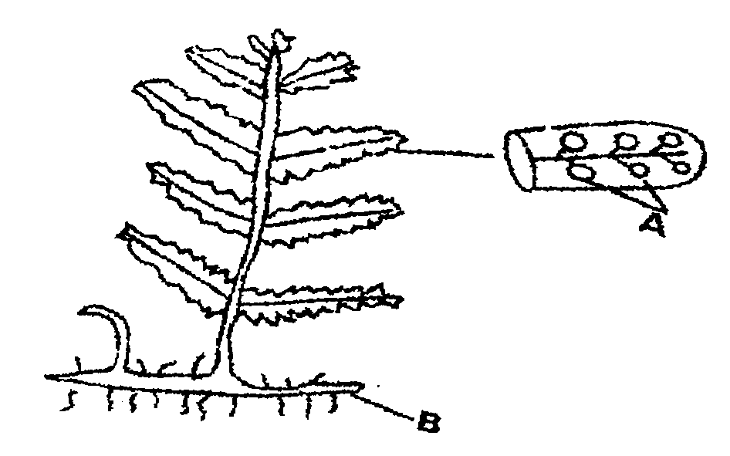

(a) Name Parts labeled A and B (2mks)
A …………………………………………………………………………………………………..………
B …………………………………………………………………………………………………..………
(b) To which division does the plant belong? (1mk)
………………………………………………………………………………………………..……… …………………………………………………………………………………………………..………
3. State three measures that can be taken to control infection of man by protozoan parasites (3mks)
………………………………………………………………………………………………..……… …………………………………………………………………………………………………..………
…………………………………………………………………………………………………..………
4. Explain how the following factors hinder self pollination in plants:
(i) Protogyny ( l mk)
…………………………………………………………………………………………………..……… …………………………………………………………………………………………………..………
(ii) Dioecism (1 mk)
………………………………………………………………………………………………..……… …………………………………………………………………………………………………..………

5. Explain the likely effect on humans and other organisms of untreated sewage discharged into water
body that supplies water for domestic use. (3mks)
………………………………………………………………………………………………..……… …………………………………………………………………………………………………..………
…………………………………………………………………………………………………..………

6. Name two structures in herbaceous stems that enhance their support. (2mks)
…………………………………………………………………………………………………..……… …………………………………………………………………………………………………..………
7. a) Define the term immunity. (lmk)
…………………………………………………………………………………………………..………
…………………………………………………………………………………………………..………
b) Distinguish between natural immunity and acquired immunity. (lmk)
………………………………………………………………………………………………..……… …………………………………………………………………………………………………..………
c) Identify one immunizable disease in Kenya. . (1mk)
…………………………………………………………………………………………………..……… …………………………………………………………………………………………………..………
8. State three differences between osmosis and active transport (3mks)
…………………………………………………………………………………………………..……… …………………………………………………………………………………………………..………
…………………………………………………………………………………………………..……… …………………………………………………………………………………………………..………
9. The diagram below illustrates part of a nephron from a mammalian kidney
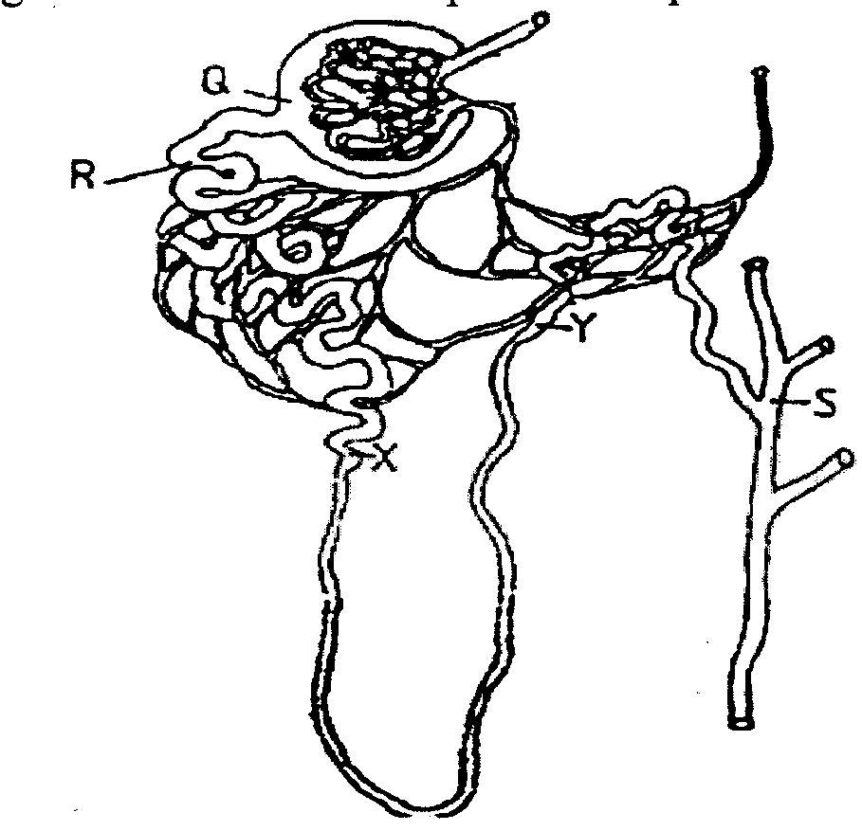

a) Name the fluid found in the part labeled Q. (lmk)
…………………………………………………………………………………………………..………
…………………………………………………………………………………………………..………

b) Identify the process responsible for the formation of the fluid named in (a) above. (lmk)
…………………………………………………………………………………………………..………
…………………………………………………………………………………………………..……… c) Which two hormones exert their effect in the nepbron? (2mks)
…………………………………………………………………………………………………..………
…………………………………………………………………………………………………..………

10. State three characteristics of members of kingdom Monera that are not found in other kingdoms.
(3mks)
…………………………………………………………………………………………………..………
…………………………………………………………………………………………………..………

11. What is meant by the following biological terms?
i) Crenation (lmk)
…………………………………………………………………………………………………..………
………………………………………………………………………………………………..………
ii) Haemolysis (lmk)
…………………………………………………………………………………………………..………
………………………………………………………………………………………………..………

iii) Plasmolysis (lmk)
…………………………………………………………………………………………………..………
………………………………………………………………………………………………..………
12. The diagram below shows a stage during fertilization in flowering plant.
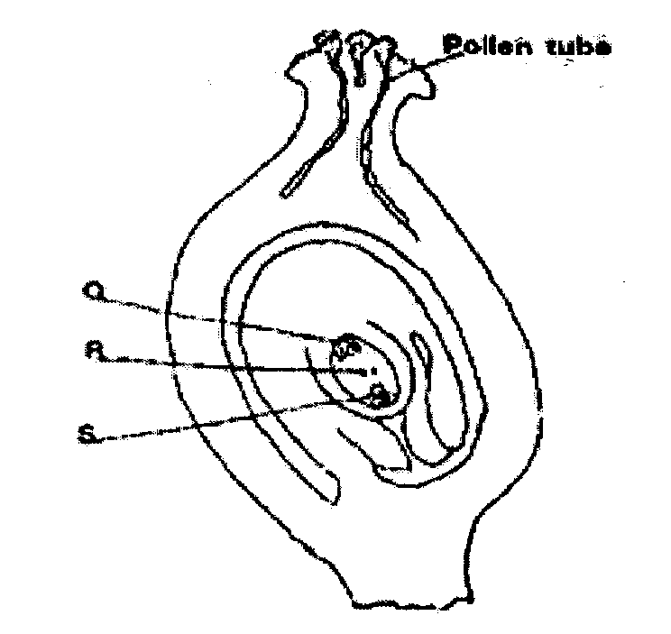

a) Name the parts labeled Q, R, and S (3mks)
Q……………………………………………………………………………
R……………………………………………………………………………
S……………………………………………………………………………
b) State the function of the pollen tube. (1mk)
…………………………………………………………………………………………………..………
………………………………………………………………………………………………..………

13. a) State the major factor in the ‘Global warming’ experienced in the world today. (lmk)
…………………………………………………………………………………………………..………
………………………………………………………………………………………………..………
b) Suggest two ways of reducing the Global warming. (2mk)
…………………………………………………………………………………………………..………
………………………………………………………………………………………………..………
14 State the function of the following cell organelles
(a) Golgi apparatus (2mks)
…………………………………………………………………………………………………..………
………………………………………………………………………………………………..………

(b) Ribosomes (lmk)
…………………………………………………………………………………………………..………
………………………………………………………………………………………………..………
15. Give a reason for each of the following actions when preparing temporary slides microscopy work;
(a) Cutting thin sections (lmk)
…………………………………………………………………………………………………..………
………………………………………………………………………………………………..………

(b) Staining the sections (lmk)
…………………………………………………………………………………………………..………
………………………………………………………………………………………………..………
(c) Keeping the sections wet during preparation (lmk)
…………………………………………………………………………………………………..………
………………………………………………………………………………………………..………

16. What are the functions of a cell sap vacuole in a cell? (3mks)
…………………………………………………………………………………………………..………
…………………………………………………………………………………………………..………
17. What are the primary functions of a stem? (2mks)
…………………………………………………………………………………………………..………
………………………………………………………………………………………………..………
18. State four adaptations of the xylem to its function (4mks)
…………………………………………………………………………………………………..………
………………………………………………………………………………………………..………
…………………………………………………………………………………………………..………
………………………………………………………………………………………………..………
19. How does haemophilia lead to death of an individual? (3mks)
…………………………………………………………………………………………………..………
………………………………………………………………………………………………..………
20. (a) Name a protein and vitamin involved in blood clotting.
i) Protein. (lmk)
…………………………………………………………………………………………………..………
………………………………………………………………………………………………..………

ii) Vitamin (lmk)
…………………………………………………………………………………………………..………
………………………………………………………………………………………………..………
b) Explain why blood is not normally used for transfusion after one month. (lmk)
…………………………………………………………………………………………………..………
………………………………………………………………………………………………..………

21. The diagram below represents an experimental set up to investigate a certain scientific concept.
The potted plant was first destarched by keeping it in dark for four days.
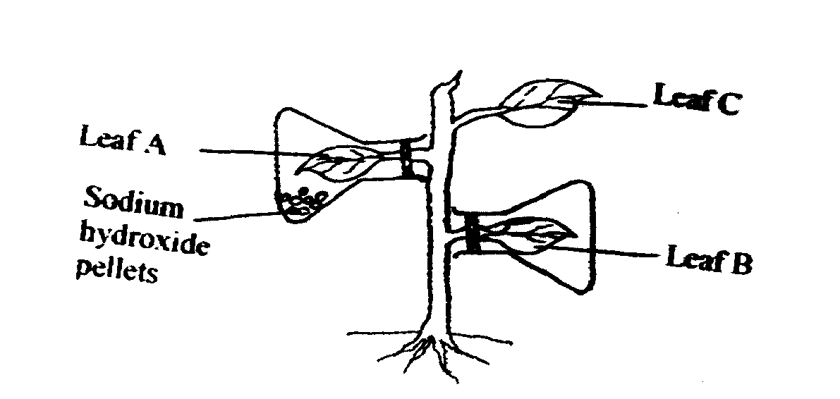

The set up was then placed in sunlight for five hours and leaves were tested for starch
(a) What scientific concept was being investigated? (1mk)
…………………………………………………………………………………………………..………
………………………………………………………………………………………………..………

(b) (i) Give the results likely to be obtained after starch test for A and B
A………………………………………………………………………………. (1mk)
B……………………………………………………………………………… (1mk)
(ii) Account for the result in leaf A in b(i) above (1mk)
…………………………………………………………………………………………………..………
………………………………………………………………………………………………..………

c) Why was leaf C included in the set-up? (1mk)
…………………………………………………………………………………………………..………
………………………………………………………………………………………………..………

22. (a) Explain the importance of transport in plants (2mks)
…………………………………………………………………………………………………..………
………………………………………………………………………………………………..………

(b) What is the role of root hairs in plants? (1mk)
…………………………………………………………………………………………………..………
………………………………………………………………………………………………..………

23. (a) Identify the source of Urea that is removed via the kidneys in a healthy human being (1mk)
…………………………………………………………………………………………………..………
………………………………………………………………………………………………..………

(b) Explain why a pregnant woman excretes less urea compared to a woman who is non-pregnant.
(3mks)
…………………………………………………………………………………………………..………
………………………………………………………………………………………………..………

…………………………………………………………………………………………………..………
………………………………………………………………………………………………..………

24. Study the reaction below and answer the questions that follow.

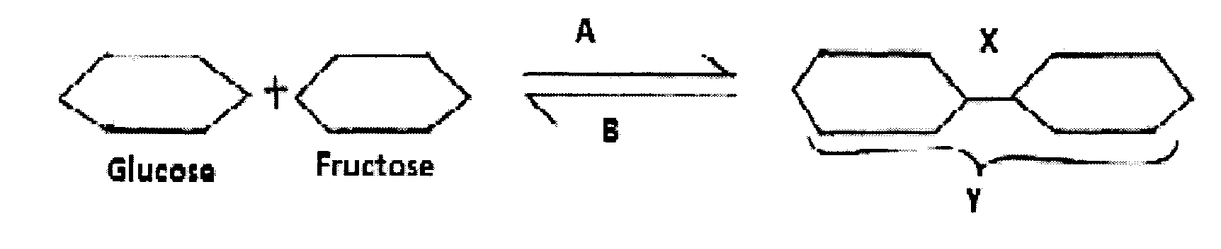

a) What biological processes are represented by A and B? (2mks)
A……………………………………………………………………………………..
B………………………………………………………………………………………
b) Identify the product Y (lmk)
…………………………………………………………………………………………………..………
………………………………………………………………………………………………..………
c) State the bond represented by X. (lmk)
…………………………………………………………………………………………………..………
………………………………………………………………………………………………..………

25. .Explain the events of the light stage of photosynthesis. (3mks)
…………………………………………………………………………………………………..………
………………………………………………………………………………………………..………
…………………………………………………………………………………………………..………
………………………………………………………………………………………………..………
26. Explain what happens in humans when the concentration of glucose in the blood rises above the normal
level. (3mks)
…………………………………………………………………………………………………..………
………………………………………………………………………………………………..………
…………………………………………………………………………………………………..………
………………………………………………………………………………………………..………

