Name……………………………………………….Index No………………………………….………...…
School……………………………………….……..Candidate’s Sign …………………….…….………….
Date……………………………………………

233/1
CHEMISTRY
PAPER 1
THEORY

TIME: 2 HOURS

Kenya Certificate of Secondary Education (K.C.S.E)

CHEMISTRY 233/1
THEORY

TIME: 2 HOURS

INSTRUCTIONS TO CANDIDATES
- Write your Name, school ,Index number and date in the spaces provided
- Answer all the questions in the spaces provided
- Mathematic tables and the electronic calculators may be used
- All working must be clearly shown where necessary

FOR EXAMINERS USED ONLY
Question | Maximum score | Candidates score
1 - 28 | 80

This paper consists of 8 printed pages.
Candidates should check the question paper to ascertain all the pages are printed as indicated
And no questions are missing.

- Starting with a named metal and a named acid, describe with the aid of a diagram how hydrogen gas is prepared in the laboratory and collected over water. (3 mark)

- Classify the following process as either physical or chemical process (3 marks)
 | Process | Type of reaction
1 | Heating hydrated copper(II) Sulphate
2 | Sewage turned to biogas
3 | Heating Ammonium chloride

- State two reasons why the non-luminous flame is preferred for heating in the laboratory instead of luminous flame (2 marks)
………………………………………………………………………………………………………
………………………………………………………………………………………………………
- a) State Charles’ law (1 mark)
………………………………………………………………………………………………………
……………………………………………………………………….………………………………
b) A given sample of oxygen gas occupies 16 cm³ at 7ºc and 335mmhg pressure. At what temperature
will it occupy 10 cm³ at 670 mmHg (2marks)
………………………………………………………………………………………………………
………………………………………………………………………………………………………
………………………………………………………………………………………………………
………………………………………………………………………………………………………
- Explain how you would obtain solid sodium carbonate from a mixture of lead carbonate and sodium carbonate powders (3 marks)
………………………………………………………………………………………………………
………………………………………………………………………………………………………
………………………………………………………………………………………………………
………………………………………………………………………………………………………

- Dry hydrogen chloride gas was bubbled into methylbenzene solution as shown below
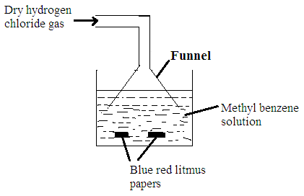
State the observations made on the blue and red litmus papers. Explain your answer (2 marks)
………………………………………………………………………………………………………
………………………………………………………………………………………………………
- When Magnesium metal is burnt in air and the product treated with water, it gives off a smell of ammonia. Explain. (2 marks)
………………………………………………………………………………………………………
………………………………………………………………………………………………………
- A compound B decolourises bromine water and forms a compound C whose formula is CH₃CHBrCH₂Br
a) Name compound C (1 mark)
………………………………………………………………………………………………………
………………………………………………………………………………………………………
b) Draw the structure of compound B (1 mark)

c) Name the homologous series to which B belong (1 mark)
………………………………………………………………………………………………………
………………………………………………………………………………………………………

- When sodium metal is dropped in water the following are the observations. Give a reason for each observation (2 marks)
 | Observation | Explanation for observation
1 | It darts on the surface of water
2 | It melts into a silvery ball
- a) Sulphur is extracted from underground by Frasch process. State two physical properties of sulphur
that makes it to be extracted by this method (2 marks)
………………………………………………………………………………………………………
………………………………………………………………………………………………………
b) Explain why sulphur melts over a range of temperature (2 marks)
………………………………………………………………………………………………………
………………………………………………………………………………………………………
- The heat of combustion of propane,carbon and hydrogen are given below
C₃H_{8 (g)} + 5O_{2(g)} $→$ 3CO_{2(g)}+4H₂O_{(I)} $∆H_{C}^{θ}$=-2220KJ/MOL
C_{(s)} +½O_{2(g)} $→$ CO_{2(g)} $∆H_{C}^{θ}$ =-393.5KJ/MOL
H_{2(g)} + ½O_{2(g)} $→$ H₂O_{(g)} $∆H_{C}^{θ}$ =-285KJ/MOL
Calculate the enthalpy of formation of propane (3 marks)

- An unknown mass of anhydrous sodium carbonate was dissolved in water and the solution made up to 250cm³. 25cm³ of this solution neutralised 20cm³ of 0.25M Nitric (IV)acid. Calculate the unknown mass of Sodium Carbonate (Na=23, C=12, O=16) (4 marks)
………………………………………………………………………………………………………
………………………………………………………………………………………………………
………………………………………………………………………………………………………
………………………………………………………………………………………………………
- The boiling point of some compounds of hydrogen with some elements in group 4 and 6 of the periodic table are given below.

Compound | B.P(ºC)
CH₄ | -164.0
SiH₄ | -112.0
H₂O | 100.0
H₂S | -61.0
- Which of the compounds CH₄ and SiH₄ has stronger molecular forces? Give reason. (1mark)
………………………………………………………………………………………………………
………………………………………………………………………………………………………
- Explain why the boiling points of H₂O show different trends from the boiling points of CH₄ and SiH₄ (2 marks)
………………………………………………………………………………………………………
………………………………………………………………………………………………………
- The following half equations are given
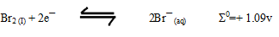
- Write the overall equation for the cell reaction (1 mark)
………………………………………………………………………………………………………
………………………………………………………………………………………………………
- Calculate the Σ⁰ value of the cell ( 2 marks)
………………………………………………………………………………………………………
………………………………………………………………………………………………………
………………………………………………………………………………………………………
………………………………………………………………………………………………………
- Name the stronger oxidizing agent (1 mark)
………………………………………………………………………………………………………
………………………………………………………………………………………………………

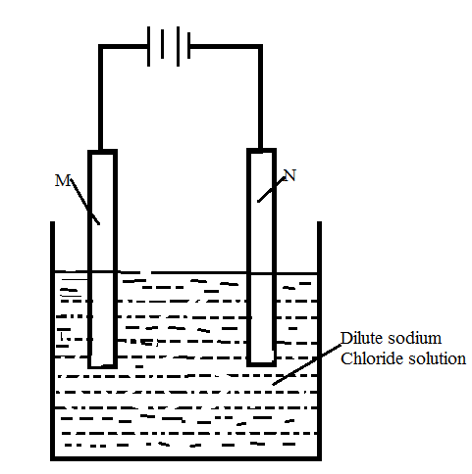
- The diagram bellow illustrates the experiment to show the effect of electric current on substances. Study it and answer the questions that follow.

- Name electrodes
M:.......................................................................... (½mark)
N:............................................................................ (½ mark)

- Write an equation for the reaction taking place in electrode M and N.
M ………………………………………………………….…………… (1 mark)
N ………………………………………………………………………. (1 mark)
- Using dot (●) and cross (x) diagram to represent bonding in carbon (II) Oxide (C=6, O=8)
(2marks)

- Chlorine gas can be prepared in the laboratory by action of concentrated hydrochloric acid on Potassium Manganate (VII).
a) Write a balanced chemical equation for the reaction taking place. (1 mark)
………………………………………………………………………………………………………
………………………………………………………………………………………………………

b) State and explain the observations made if dry chlorine gas is bubbled through Iron (II) Chloride
solution. (2 marks)
………………………………………………………………………………………………………
………………………………………………………………………………………………………
- On complete combustion of a hydrocarbon, 3.52g of carbon(IV)oxide and 1.44g of water formed. Determine the molecular formula of the hydrocarbon if its RMM is 28(H=1, O=16, C=12)
(3marks)
………………………………………………………………………………………………………
………………………………………………………………………………………………………
………………………………………………………………………………………………………
………………………………………………………………………………………………………
- In an experiment to determine molar heat of displacement of silver using iron powder, excess of iron powder were added to 50cm³ of 0.4M Silver nitrate solution. At the end of reaction the temperature change was found to be 16ºc. Calculate the molar heat of displacement of silver (C=4.2KJ/Kg/K, density of solution=1g/cm³) (3 marks)

- a) The table bellow shows the PH value of solution A, B, C, D, E and F.
Solution | A | B | C | D | E | F
PH Value | 10 | 2 | 13 | 5 | 7 | 6.5

Identify the solution
- Containing the highest concentration of hydrogen ions. (½ mark)
………………………………………………………………………………………………………
………………………………………………………………………………………………………
- Likely to be sodium chloride solution. ( ½ mark)
………………………………………………………………………………………………………
………………………………………………………………………………………………………
b) Distinguish between a weak base and a strong base (2 marks)
………………………………………………………………………………………………………
………………………………………………………………………………………………………

- An equilibrium exist between the green chromate (VI) ion (CrO₄²⁻) and the orange dichromate (VII) ion(Cr₂O₇²⁻) as follows
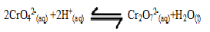
- What is meant by the term dynamic equilibrium (1 mark)

………………………………………………………………………………………………………
………………………………………………………………………………………………………
- State and explain the observations that would be made if a few drops of Sodium Hydroxide were added to the system. (2 marks)
………………………………………………………………………………………………………
………………………………………………………………………………………………………
………………………………………………………………………………………………………
………………………………………………………………………………………………………
- Element Q consists of two main isotopes, ²⁰Q and ²³Q with a relative atomic mass of 20.75. Determine the percentage abundance of each isotope (2 marks)
………………………………………………………………………………………………………
………………………………………………………………………………………………………
- a) What is allotropy (1 mark)
………………………………………………………………………………………………………
………………………………………………………………………………………………………
b) Name two non-crystalline forms of carbon. (2 marks)
………………………………………………………………………………………………………
………………………………………………………………………………………………………
- (a) Write a chemical equation to show what happens when excess carbon (IV) oxide gas is
bubbled through lime water (1mark)
………………………………………………………………………………………………………
………………………………………………………………………………………………………
(b) State two properties that make carbon (IV) oxide gas suitable for use in a fire extinguisher. (2 marks)
………………………………………………………………………………………………………
………………………………………………………………………………………………………
- An element Q has the electronic arrangement 2.8.6 and a mass number of 32.
(i) How many protons does element Q have (1mark)
………………………………………………………………………………………………………
………………………………………………………………………………………………………

(ii) What is the number of neutrons in the nucleus of Q? (1 mark)
………………………………………………………………………………………………………
………………………………………………………………………………………………………
(iii) What type of bond would be formed between Q and oxygen (1mark)
………………………………………………………………………………………………………
………………………………………………………………………………………………………
- The table below gives three experiments on the reactions of excess sulphuric (VI) acid and 0.5 g of zinc done under different conditions. In each case the volume of gas was recorded at different time intervals
Experiment | Form f Zinc | Sulphuric (VI) acid solution
I | Powder | 0.8 M
II | Powder | 1.0 M
III | granules | 0.8 M

On the same axis below sketch and label the three curves (I, II, III) that could be obtained from each results (3 marks)

Volume
of gas in cm³

Time in seconds
- In an experiment, soap solution was added to three separate samples of water. The table below shows the volumes of soap solution required to form lather with one litre of each sample of water before and after boiling.

Samples | Sample A | Sample B | Sample C
Volume of soap before water is boiled (cm³) | 30 | 3 | 13
Volume of soap after water is boiled (cm³) | 30 | 3 | 3
- Which water sample is likely to be soft? Explain. (1mark)
……………………………………………………………………………………………………
……………………………………………………………………………………………………
- Explain the change in the volume of soap used in sample C. (2marks)
……………………………………………………………………………………………………
……………………………………………………………………………………………………
- Distinguish between nuclear fission and nuclear fusion. (2marks)
………………………………………………………………………………………………………
………………………………………………………………………………………………………

