Name:………………………………………………. Index no ……..…................................... Candidate’s sign ……………………....
Date: …………………………

233/1

CHEMISTRY

PAPER 1

THEORY

MAY 2015

TIME: 2 HOURS

TIGANIA SOUTH PRE-MOCKS 2015

Kenya Certificate of Secondary Education (K.C.S.E.)

233/1

CHEMISTRY

PAPER 1

INSTRUCTIONS TO CANDIDATES:
- Write you name and index number in the spaces provided above.
- Sign and write the date of examination in the spaces provided above.
- Answer Allthe questions in the spaces provided below each question.
- Mathematical tables and electronic calculators may be used.
- All working MUST be clearly shown where necessary.

For Examiner’s Use Only

Question | Maximum score | Candidate’s score
1-28 | 80

1. (a) What is chromatography? (1mk)
…………………………………………………………………………………………………….
…………………………………………………………………………………………………….
(b) Give two applications of chromatography (2mks)
…………………………………………………………………………………………………….
…………………………………………………………………………………………………….
2. Concentrated sulphuric (vi) acid is used to drysulphuric(vi) oxide gas
(a)Explain why concentrated sulphuric(vi) acid is not used to dry hydrogen sulphide (1mk)
…………………………………………………………………………………………………….
…………………………………………………………………………………………………….
(b) Name one drying agent that can be used to dry hydrogen sulphide (1mk)
…………………………………………………………………………………………………….
3. Lead (ii) oxide reacts with acids and alkalis
(a) Write the equation for the reaction between lead (ii) oxide and
(i)Dilute nitric (v) acid (1mk)

(ii) Sodium hydroxide solution (1mk)

(b) What property of lead (ii) oxide is shown by the reactions in (a) above (1mk)
…………………………………………………………………………………………………….
4. (a)Galvanized iron does not rust when scratched. In contrast when tin can is scratched then
exposed iron underneath corrodes rapidly. Explain (2mks)
…………………………………………………………………………………………………….
…………………………………………………………………………………………………….
(b) List two methods of preventing rusting (1mk)
…………………………………………………………………………………………………….
5. The electron arrangement of the atoms of elements P,QR and Sare shown below, the letters are not the actual symbols of the elements
ELEMENT | Electron arrangement
P | 2.8.7
Q | 2.8.8.2
R | 2.8.5
S | 2.8.6
(a) Which two elements could react to form a compound soluble in water and a strong electrolyte
……………………………………………………………………………………………………(1mk)
(b) Using dot(.) and cross(x) diagrams show how the molecule between P and S is formed (1mk)

(c) Name the type of bond formed in (b) above (1mk)
…………………………………………………………………………………………………….
6. Distinguish the following terms as used in the study of chemistry (3mks)
(a) Isotopes
(b) Allotropes
c) Isomers
7. Below is a list of major constituents of crude oil and their boiling points
CONSTITUENTS | BOILING POINTS ⁰C
Diesel oil | 250-350
Petrol | 40-175
Lubricating oil | 350-400
Kerosene | 175-250

(a) Name the process by which the above constituents can be separated (1mk)
(b) List down the order by which the constituents would be obtained from the mixture (1mk)
…………………………………………………………………………………………………….
(c) When the above constituents are burned in air and the products passed through distilled
water, the pH of the water decreases. Explain (1mk)

8. Hydrogen chloride dissolves in both methylbenzene and water. What happens when sodium carbonate is added to a test tube containing a solution of hydrogen chloride in methylbenzene? Explain (2mks)

9. (a)State Charles law (1mk)

(b) A gas at 17⁰C occupies a volume of 510cm³. Calculate the temperature at which its volume would be 420cm³ (2mks)

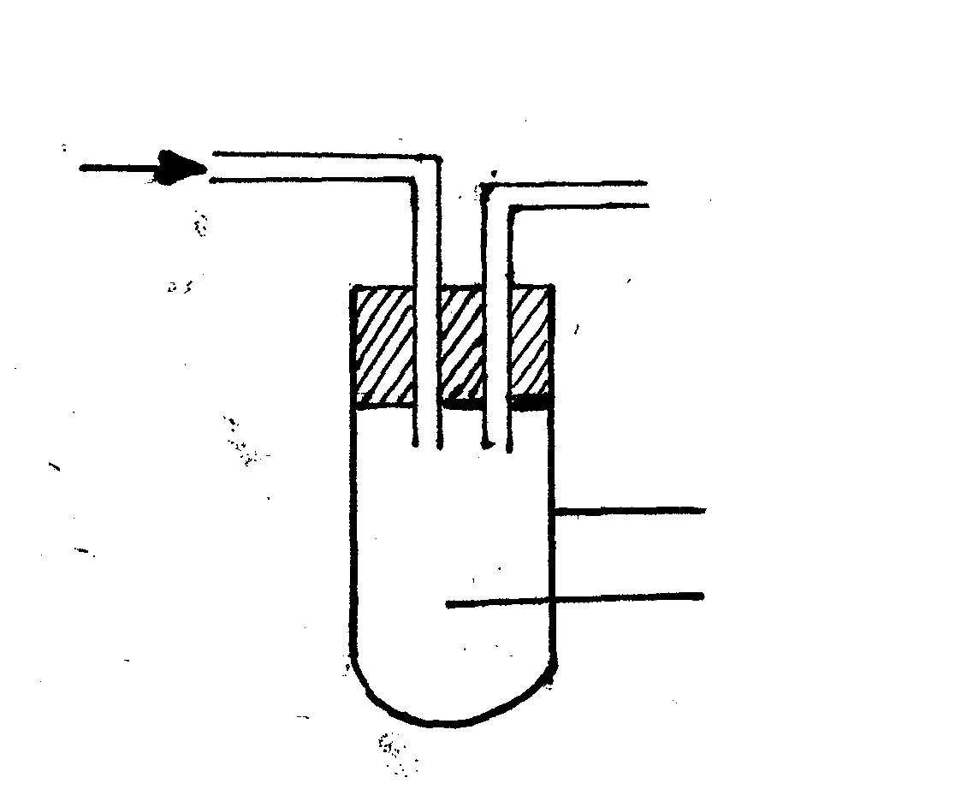
10. Moist chlorine was passed into hydrogen sulphide as shown below

Boiling tube
Hydrogen sulphide
Moist Cl_{2(g)}

(a) What observation was made in the boiling tube? (1mk)
…………………………………………………………………………………………………….
(b) Write the equation for the reaction taking place in the boiling tube (1mk)
…………………………………………………………………………………………………….
(c) State the precautions that should be taken in carrying out this experiment (1mk)
…………………………………………………………………………………………………….

11. Describe how a mixture of common salt, ammonium chloride and iron fillings would be separated into their individual solids (3mks)
…………………………………………………………………………………………………….
…………………………………………………………………………………………………….
12. Describe how you would prepare a dry sample of zinc carbonate in the laboratory starting with zinc chloride solid (3mks)
…………………………………………………………………………………………………….
…………………………………………………………………………………………………….
13. State and explain the observations that would be made if carbon (iv) oxide gas was bubbled
through lime water for long time (3mks)
…………………………………………………………………………………………………….
…………………………………………………………………………………………………….
14. The solubility of salt Y at 60⁰C is 40g/100g of water and 48g/100g of water at 100⁰C
(i) How much salt of Y would saturate 190g of water at 100⁰C ( 1 ½ mks)
…………………………………………………………………………………………………….
…………………………………………………………………………………………………….
(ii) 150g of saturated solution of Y at 100⁰C is cooled to 60⁰C. Calculate the mass of Y that crystallizes out (1 ½ mks)
…………………………………………………………………………………………………….
…………………………………………………………………………………………………….
15. Consider the reversible reaction below which is at equilibrium
CaCO_{3(s)} CaO(s) + CO_{2(g)} ∆H= +ve
State and explain what would happen to the equilibrium if;
(i) A few drops of sodium hydroxide were added to the above system (1 ½ mks)
…………………………………………………………………………………………………….
…………………………………………………………………………………………………….
(ii) The system was warmed (1 ½ mks)
…………………………………………………………………………………………………….
…………………………………………………………………………………………………….
16. Explain why hard water flowing in lead pipes may be safer for drinking than soft water
flowing in the same pipes (3mks)
…………………………………………………………………………………………………….
…………………………………………………………………………………………………….
17. When sulphur is heated in a test tube, the yellow crystals melt to form a golden yellow liquid which changes at 180⁰C into a dark brown very viscous liquid. On further heating to 400⁰C, a brown less viscous liquid is formed
(i) What is the molecular mass of sulphur in the yellow crystals (S=32) (1mk)
…………………………………………………………………………………………………….
(ii) If the brown liquid at 400⁰C is cooled rapidly at room temperature, which form of sulphur
is produced (1mk)
…………………………………………………………………………………………………….
(iii) Explain why the molten sulphur becomes viscous (2mks)
…………………………………………………………………………………………………….
18. When a hydrocarbon is completely burnt in Oxygen, 11.0g of carbon (iv) oxide and 4.5g of water are formed. Determine the molecular formula of the hydrocarbon if its relative molecular mass is 84(C=12,O=16,H=1) (3mks)
…………………………………………………………………………………………………….
…………………………………………………………………………………………………….
19. Below is an incomplete set-up for preparing a gas
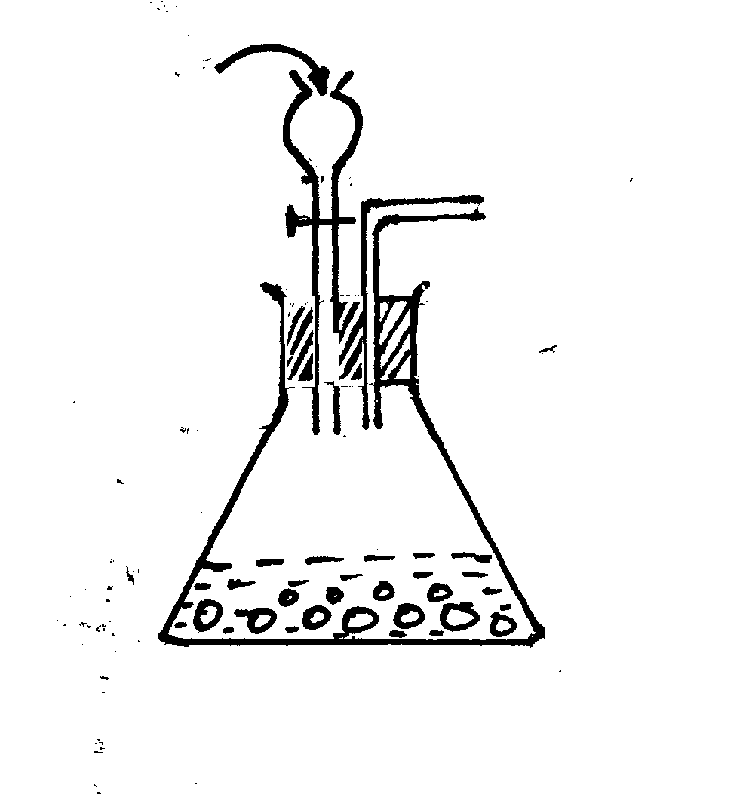
Conc. HNO₃
Copper turnings

Complete the diagram to show how a dry sample of the gas can be collected (3mks)
20. Strontium lies below calcium in the periodic table. How does the melting point of strontium
compare with the melting point of calcium? Explain (3mks)
…………………………………………………………………………………………………….
…………………………………………………………………………………………………….
21. The curves below were obtained when equal volumes of hydrochloric acid of the same concentration were reacted with 25g of marble chips. In one case the acid was first warm
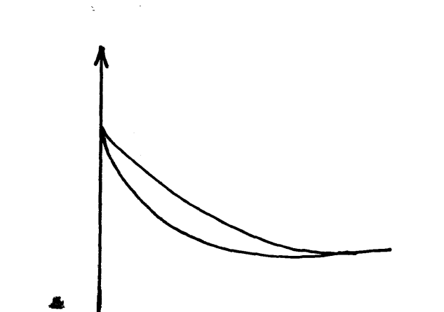

Mass of flask

2

1
Time

(a) Which curve represents the reaction involving cold acid (1mk)
…………………………………………………………………………………………………….
(b) How does increasing temperature affect the rate of reaction (1mk)
…………………………………………………………………………………………………….
…………………………………………………………………………………………………….
(c) Why does the mass of the flask decrease with time (1mk)
…………………………………………………………………………………………………….
…………………………………………………………………………………………………….
22. 100cm³ of carbon (iv) oxide gas diffused through a porous partition in 30 seconds. How long would it take 150cm³ of Nitrogen (iv) oxide to diffuse through the same partition under the same conditions. (C=12, N=14,O=16) (3mks)

23. Identify the particles that facilitate the electric conductivity of the following substances (3mks)
(i) Sodium metal………………………………
(ii) Sodium chloride solution………………….
(iii) Molten lead bromide…………………….
24. An ion of oxygen is larger than oxygen atom. Explain (2mks)
…………………………………………………………………………………………………….
…………………………………………………………………………………………………….
25. Carbon and silicon belong to the same group of the periodic table, yet carbon (iv) oxide is a gas while silicon (iv) oxide is a solid with a high melting point. Explain this difference (2mks)
…………………………………………………………………………………………………….
…………………………………………………………………………………………………….
…………………………………………………………………………………………………….
26. (a) Name the following compounds
(i) CH₂=CH CH₃
…………………………………………………………………………………………………….
(ii) CH₂ClCH₂Cl
…………………………………………………………………………………………………….
(b) Methane reacts with chlorine to form tetrachloromethane. What condition is required for the reaction to occur?
…………………………………………………………………………………………………….
27. The first step in the industrial manufacture of Nitric (v) acid is the catalytic oxidation of ammonia gas
(a) What is the name of the catalyst used (1mk)
…………………………………………………………………………………………………….
(b) Write the equation for the catalytic oxidation of ammonia gas (1mk)
…………………………………………………………………………………………………….
…………………………………………………………………………………………………….
(c) Nitric (V) acid is used to make ammonium nitrate. State one use of ammonium nitrate (1mk)
…………………………………………………………………………………………………….
28. Study the reaction below and answer the questions that follow
NH_{3(g)}+H₂O_{(l)} NH⁺_{4(aq)} + OH⁻_{(aq)}

(a) Define the term acid ( ½mk)
…………………………………………………………………………………………………….
……………………………………………………………………………………………………. (b) Identify an acid in the above reaction ( ½mk)
…………………………………………………………………………………………………….
…………………………………………………………………………………………………….
(c)Explain your answer in (b) above (1mk)
…………………………………………………………………………………………………….
…………………………………………………………………………………………………….

