Name………………………………………………………………... Index No :……………………………...
Candidate’s Signature …………………………
Date: ………………………………...
312/1
GEOGRAPHY
THEORY
PAPER 1
TIME: 2³/₄ HOURS

Kenya Certificate of Secondary Education (K.C.S.E)

312/1
GEORGRAPHY
Paper 1
2³/₄hours

INSTRUCTIONS TO CANDIDATES
- This paper consists of sections A and B
- Answer all questions in section A.
- In section B, answer question 6 and any other two questions
- All answers must be written in the answer sheets provided.

This paper consists of 4 printed pages. Candidates should check to ascertain that all pages are indicated and that no question are missing

SECTION A:
Answer all questions from this section.
1. (a) State three proofs that the earth is spherical. (3 marks)
(b) Name three effects of the earth’s rotation. (3 marks)

2. (a) What is an air mass? (2 marks)
(b) Give three benefits of humidity in the atmosphere. (3 marks)

3. Use the diagram below to answer the questions that follow:-

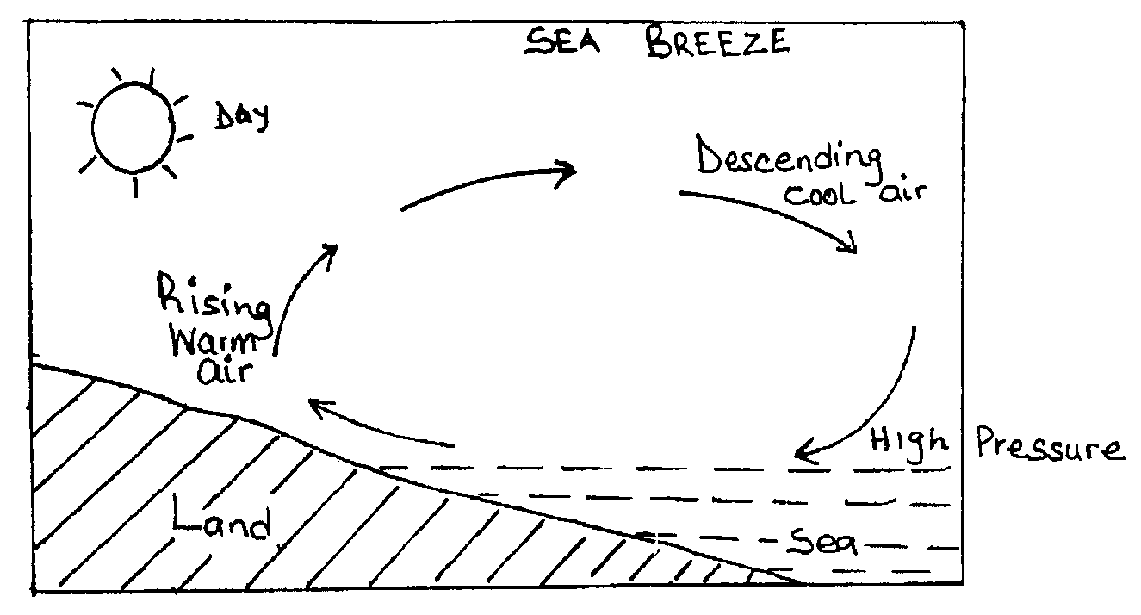

(a) What causes sea breeze? (2 marks)
(b) State two effects of sea breeze. (2 marks)

4. (a)What is faulting (2 marks)
(b) Give three ways through which a rift valley may be formed. (3 marks)

5. (a) State two reasons why a river may deposit its load. (2 marks)
(b)Give three ways through which a river carries its load. (3 marks)

SECTION B
Answer questions (compulsory) and any other two questions in this section.

6. Study the map of MIGWANI (1:50,000) and answer the following question.
(a) (i) Convert the sale of the map into a statement scale. (2 marks)
(ii) What is the magnetic variation of the map? (2 marks)
(iii) Give the six- figure grid reference for the junction of the roads C94 and D502. (2 marks)
(b) Using a vertical scale of 1 cm to represent 100 m, draw a cross section from grid reference 060640
to 130640. (4 marks)
(i) On it, mark and label the following parts
- Steep slope
- Water pipeline
- Road
- Footpath (4 marks)
(ii) Calculate the vertical exaggeration of the cross-section (2 marks)
(c) Describe the drainage of the area covered by the map. (5 marks)
(d) Citing evidence from the map, give two economic activities carried out in the area. (4marks)

7. (a) (i) What is ground water? (1 mark)
(ii) Give three sources of ground water. (3 marks)
(b) What are the ideal conditions for the formation of artesian basin? (4 marks)
(c) Explain how the following factors influence the existence of ground water.
(i) Precipitation. (2 marks)
(ii) Influence of the nature of rocks. (2 marks)
(iii) Influence of vegetation cover. (2 marks)
(d) State two other factors which influence the existence of ground water. (2 marks)
(e) You are supposed to carry out a field study of the area with ground water.
(i) Give reasons why you need a work schedule. ( 3marks)
(ii) Write three objectives for your study. (3 marks)
(ii) State three possible problems you are likely to encounter during the study. (3 marks)

8. (a) (i) State three ways in which a glacier is formed. (3 marks)
(ii) Explain the two major processes of glacial erosion. (4 marks)
(b) (i) State three causes of glacial deposition. (3 marks)
(ii) List three erosion features of glacier in the highland areas. (3 marks)
(c) (i) Describe how drumlins are formed. (4 marks)
(ii) Explain four benefits of glaciations and glaciated landscape

9. (a) (i) What is climate? (8 marks)
(ii) Name two instruments found in a Stevenson screen. (2 marks)

(b) The diagram below shows climatic regions of Kenya.
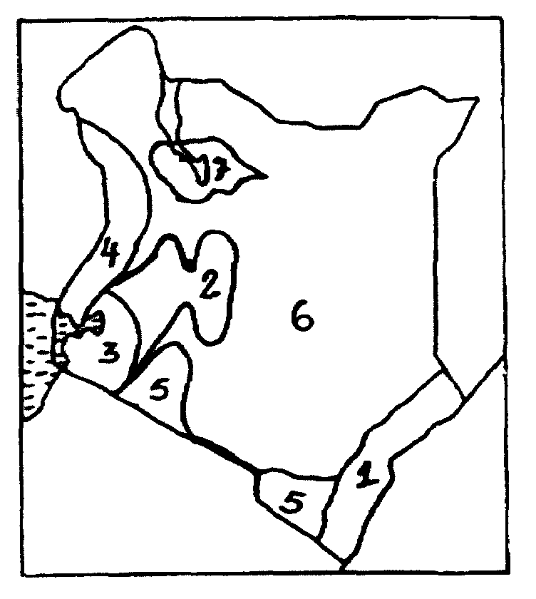

(i) Name the climatic regions marked 1, 2, 5 and 7. (4 marks)
(ii) Explain four climatic characteristics of the region marked 3. (4 marks)
(c) (i) Describe the characteristics of desert type of climate. (4 marks)
(ii)Explain three consequences of climate change. (6 marks)
(iii)Name three countries that experience tropical monsoon type of climate outside Africa. (3 marks)

10. (a) (i) What is a rock? (2 marks)
(ii) Explain the process of formation of mechanically formed sedimentary rocks. (5 marks)
(b) Explain three ways in which rocks are significant to economy of Kenya (6 marks)
(c) Students from your school carried out a field study on the type of rocks:
(i) One of the rock samples they collected is coral. Give three uses of this type of rock. (3 marks)
(ii) Give three methods of data collection they may have used during their study. (3 marks)
(iii) State three problems they are likely to have encountered during the field study. (3 marks)

