312/2
GEOGRAPHY
Theory
Paper 2
Time: 2³/₄ Hours

Kenya Certificate of Secondary Education (K.C.S.E)

312/2
GEOGRAPHY
2³/₄ Hours

INSTRUCTIONS TO CANDIDATES
- This paper consists of two sections; section A and section B.
- Answer all questions in section A. In section B answer question 6 and any other two questions.
- All answers must be written in the provided sheets.

This paper consists of 3 printed pages. Candidates should check to ascertain that all pages are indicated and that no question are missing
SECTION A
Answer all the questions in this section

1 .(a) Outline two economics factors influencing agriculture (2mks)
(b) State any three features of horticultural farming (3mks)

2. (a) A part from seining, name two methods -of large scale fishing (2mks)
(b) State three problems experienced by firsher men in L. Turkana (3mks)

3. (a) what is land rehabilitation (2mks)
(b) Give three benefits of delta plan project (3mks)

4. (a) Identify the two types of settlements below (2mks)
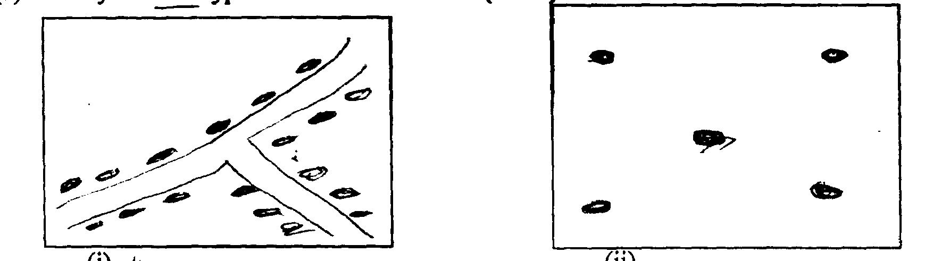

(i) (ii)
(b) List any three criteria used in defining an area as urban centre (3mks)

5. (a)Name two montane forest in Kenya (2mks)
(b) State three natural causes of forest depletion in Kenya (3mks)

SECTION A
Answer question 6 and any two other questions in this section.
6. The table below shows the quantity of minerals produced in tonnes. In the year 2004 - 2005 use it to
answer question (a) and (b)

(a)
Minerals | Amount in metric tonnes
Year | 2004 | 2005
Soda-ash | 70,000 | 130,000
Fluorspar | 200,000 | 370,000
Salt | 98,000 | 55,000
Others | 240,000 | 295,000

(a) (i)Using a scale of 1cm to represent 50,000 metric tonnes draw a simple bar graph based on the
data above . (8mks)
(ii) State two advantages of using bar graph (2mks)
(iii) Calculate percentage increase in soda ash production between the year 2004 - 2005 (2mks)
(b) Explain how the following factors influence the exploitation of minerals.
(i) Mode of occurrence of minerals (4mks)
(ii) Level of technology (4mks)
(c) Describe open cast method of mining (5mks)

7. Below is a map showing the Canadian praire province which are known for large scale cultivation of
wheat. Use it to answer questions (a) and (b)
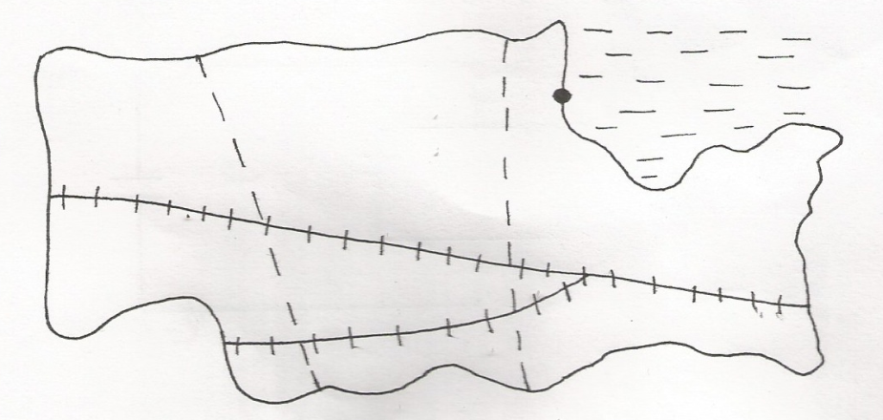
HODSOW BAY
P
O
N

CALCADY
EDMOWDON

- Name the prairie province labelled P
Name the railway line labelled O
Name the port labelled N
ii) State three climate characteristics which has farour the cultivation of wheat in Canadian prairie
provinces (3mks)
(iii)Explain three conditions that faours wheat farming in Kenya (6mks)
b) (i)Name two exotic dairy breed of dairy cattle reared in Kenya (2mks)
ii)State three factors which favour dairy farming in Kenya highlands (3mks)
- Explain four ways in which the government of Kenya assists Nomadic pastoralists to improve
their quality of livestock (8mks)

8. (a)(i) Define the term ‘transport’ (2mks)
(ii)Name the three modes of transport (3mks)
b) Explain four ways in which communication contribute to the economic development of Africa (8mks)
c)Describe any three problems facing air transport in Africa (6mks)
d)You intend to carry out a field study on traffic flow along the newly marrumed road of
Chebuyo- Emurua Dikirr,.
(i)State two reasons for preparing a work schedule (2mks)
(ii)State two methods your class may use to record data (2mks)
(iii) Identify two types of hypotheses you would develop for the study (2mks)

9. (a) Give four methods used to reclaim land in Kenya (4mks)
(b) Describe the stages in reclaiming of land from the sea in Netherlands (7mks)
(c) Explain four benefits of land reclamation in Netherlands (8mks)
(d) Explain three conditions that favour irrigation farming in Kenya. (6mks)

10. (a) What is forestry? (2mks)
(b) The map below shows the forest reserves in Kenya use it to answer question a(i)

W
Y
N
Mombasa
Z
X

(i) Name the forest reserves marked W,X,Y and Z (4mks)
(ii) Explain four measures that the government of Kenya is taking to conserve forests in the
country (8mks)
(c) Compare forestry in Kenya and Canada under the following headings :
(i) Period of Harvesting (2mks)
(ii) Transportation (2mks)
(d) Your geography class carried out a field study at chebalungu forest
(i) State two methods the class may have used to collect data (2mks)
(ii) Give two reasons why you needs a route map (2mks)
(iii) Give three advantages of sampling the forest (3mks)

