NAME ____________________________________ INDEX NO. _______________
SCHOOL ____________________________________ SIGNATURE _______________
DATE _______________

312/2
GEOGRAPHY

PAPER 2

JULY/AUGUST, 2015

TIME: 2¾ HOURS

312/2
GEOGRAPHY
PAPER 2
TIME: 2¾ HOURS

INSTRUCTIONS TO CANDIDATES
- This paper has two sections: A and B.
- Answer all the questions in section A.
- Answer question 6 and any other two questions from Section B.
- All answers must be written in the answer booklet provided.
- This paper consists of 4 printed pages.
- Candidates should check the question paper to ascertain that all pages are printed as indicated and that no questions are missing.
- Candidates should answer the questions in English.

SECTION B
Answer ALL the questions in this section.
- a) Give reasons why the government has to control the exploitation of hardwood species
in Kenya. (3 marks)
b) Identify softwood species found in Kenya. (2 marks)

- a) Give three negative effects of open cast mining on the environment. (3 marks)
b) Name two methods of placer mining. (2 marks)

- a) Differentiate between national park and national reserve. (3 marks)
b) Give three characteristics of national reserve. (3 marks)

- a) Name two provinces where wheat is grown in Canada. (2 marks)
b) Identify three diseases affecting wheat in Kenya. (3 marks)

- a) Distinguish between population growth and population increase. (2 marks)
b) Give two push factors that cause human migration. (2 marks)

SECTION B
Answer question 6 and any other two questions from this section.
- The data below shows population of a country in the developing world.
Age group | Male | Female
0 – 4 | 2,300,000 | 2,400,000
5 – 9 | 2,100,000 | 2,200,000
10 – 14 | 2,500,000 | 2,200,000
15 – 19 | 1,700,000 | 1,800,000
20 – 24 | 1,300,000 | 1,500,000
25 – 29 | 1,000,000 | 1,100,000
30 – 34 | 850,000 | 900,000
35 – 39 | 690,000 | 750,000
40 – 44 | 524,000 | 600,000
45 – 49 | 419,000 | 423,000
50 – 54 | 345,000 | 365,000
55 – 59 | 225,000 | 220,000
60 – 64 | 195,000 | 200,000
65 – 69 | 141,000 | 155,000
70 – 74 | 119,000 | 130,000
75 – 79 | 82,000 | 90,000
80+ | 100,000 | 120,000

- Using a scale of 1cm to represent 400,000 people, draw a population pyramid to present the
above data. (8 marks)
- i) What is population structure? (2 marks)
ii) Give two primary sources of population data. (2 marks)
- i) Name three types of internal migration apart from rural – urban migration (3 marks)
ii) Explain four ways of curbing rural – urban migration. (8 marks)
- Differentiate between the age structure of Kenya and Sweden. (2 marks)

- Below is a map of East Africa showing wildlife distribution.
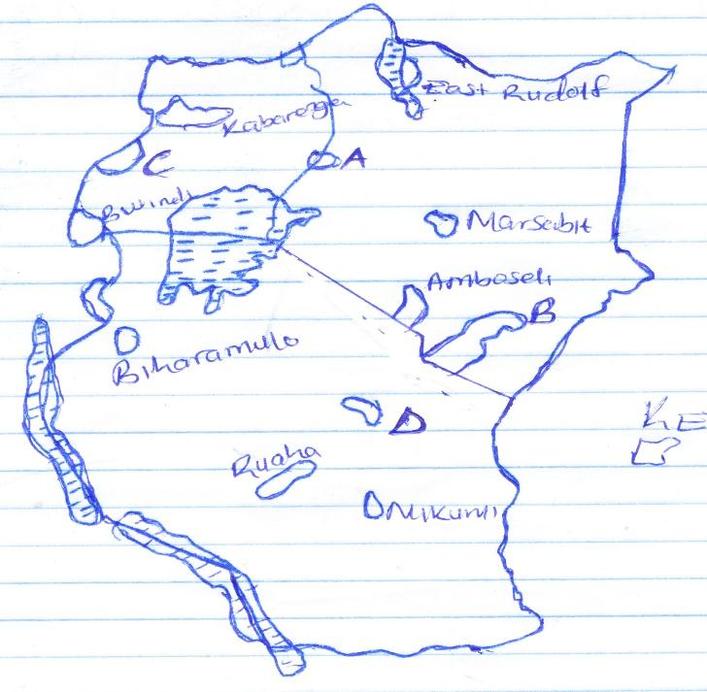
KEY

NATIONAL PARKS

Bwindi
C

Kabarenga
East Rudolf

A
Amboseli

Marsabit

B
Biharamulo

Ruaha

Mikumi

D
- Name the national parks labelled A, B, C and D. (4 marks)
- i) Name three sanctuaries found in Kenya. (3 marks)
ii) Name ‘three big’ animals in Africa. (3 marks)
- i) Explain two ways in which human activities interfere with wildlife in East Africa. (4 marks)
ii) Explain two negative effects of wildlife in East Africa. (4 marks)
- A form four class plans to visit a national park.
- State two objectives they are likely to have. (2 marks)
- State two methods of collecting data they might use. (2 marks)
- Give three follow up activities the students are likely to carryout. (3 marks)

- a) i) Define trade. (1 mark)
ii) Name three major exports of Kenya. (3 marks)
iii) State three reasons why Kenya has established trade barriers. (3 marks)
b) i) Name three member states of Economic Community of West African States. (3 marks)
ii) Give three reasons why COMESA was established. (3 marks)
c) Explain the measures Kenya has taken to reduce unfavourable balance of trade. (6 marks)
d) Explain three benefits of international trade to Kenya. (6 marks)

- a) i) What is forestry? (2 marks)
ii) Explain three factors that favour the growth of natural forests on the slopes of
Mt. Kenya. (6 marks)
iii) State five factors that have led to the reduction of the area under forest on the
slopes of Mt. Kenya. (5 marks)
b) Explain four measures that the government of Kenya is taking to conserve forests in the
country. (8 marks)
c) Give the differences in exploitation of softwood forests in Kenya and Canada under the
following sub-headings.
i) Period of harvesting. (2 marks)
ii) Transportation. (2 marks)

- a) i) Differentiate between transport and communication. (2 marks)
ii) State four causes of the decline in the use of letter writing as a means of communication
in Kenya. (4 marks)
b) i) State two recent developments that have taken place in Kenya to improve communication
of information. (2 marks)
ii) Explain three problems facing telephone as a means of communication. (6 marks)
c) i) Give three advantages of using internet. (3 marks)
ii) Explain effects of the growth of the internet access in Kenya. (4 marks)
d) Giving examples, describe two types of communication. (4 marks)

