NAME ____________________________________ INDEX NO. _______________
SCHOOL ____________________________________ SIGNATURE _______________ DATE _______________

312/2
GEOGRAPHY

PAPER 2

JUNE/JULY, 2015

TIME: 2¾ HOURS

312/2
GEOGRAPHY
PAPER 2
TIME: 2¾ HOURS

INSTRUCTIONS TO CANDIDATES
- This paper has two sections: A and B.
- Answer all the questions in section A.
- Answer question 6 and any other two questions from Section B.
- All answers must be written in the answer booklet provided.
- Candidates should answer the questions in English.
- This paper consists of 4 printed pages.
- Candidates should check the question paper to ascertain that all pages are printed as indicated and that no questions are missing.

SECTION A
Answer ALL questions in this section
- a) Name two products from beef farms in Argentina. (2 marks)
b) Identify three functional zones of an urban centre. (3 marks)
- a) Name two types of wheat grown in Canada. (2 marks)
b) Give three reasons why Canadian prairies are important wheat producing areas. (3 marks)
- a) What is a multi-purpose project? (2 marks)
b) Name three benefits of the seven folk’s scheme. (3 marks)
- a) Give two tourists attraction found in the Kenya’s inland. (2 marks)
b) Suggest three reasons why Kenyans should be encouraged to use biomass energy. (3 marks)
- Study the map of East Africa below and answer the questions that follow.
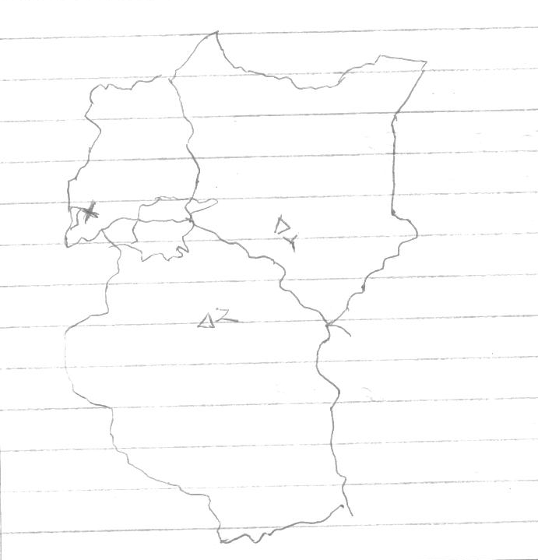
Z

X

Y

- Name the minerals mined at places marked Y, X and Z. (3 marks)
- State two problems facing mining industry in East Africa. (2 marks)

SECTION B
Answer question 6 and any other TWO questions from this section.
- a) The table below shows the production of various horticultural crops in Kenya between 2008
and 2010 in 000’s tonnes
Crop | 2008 | 2009 | 2010
Cabbages | 380 | 340 | 320
Tomatoes | 340 | 360 | 360
Onions | 360 | 320 | 340
Oranges | 400 | 380 | 380

- Using a scale of 1cm to represent 50,000 tonnes, draw a comparative bar graph to present
the data above. (6 marks)
ii) Name the crop that has the highest production within the period. (1 mark)
b) State four factors that favour the growth of cocoa in Ghana. (4 marks)
c) Outline the stages involved in processing of cocoa from harvesting to the time it is ready
for export. (8 marks)
d) Explain three importance of cocoa to the economy of Ghana. (6 marks)

7 a) What is water transport? (2 marks)
b) Give three reasons why Kenyan rivers are not suitable transport routes. (3 marks)
c) State three merits of using containerization as a means of transport. (3 marks)

Below is a sketch map of the Great Lake and the St. Lawrence Seaway.
Use it to answer question (d) and (e).
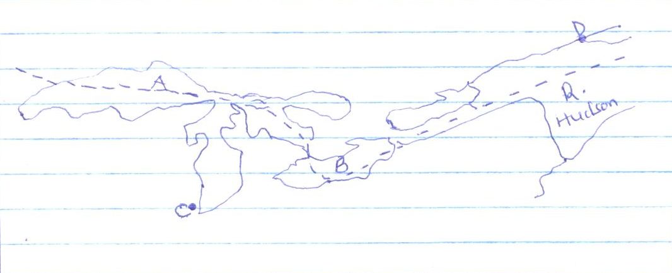
R. Hudson

B
D
C
A

d) i) Name the lakes marked A and B. (2 marks)
ii) The parts marked C and D. (2 marks)
e) Explain three benefits of St. Lawrence Seaway and the economy of the USA. (6 marks)
f) Name two towns in Kenya which are served by the Kenya pipeline. (2 marks)
g) State the role of transport and communication in Africa. (5 marks)

8. a) Name three species of hardwood grown in Kenya. (3 marks)
b) State five factors that favour the development of softwood in Kenya. (5 marks)
c) State five factors that determine the location of pulp and paper industry. (5 marks)
d) Explain three reasons why there has been decline in the areas under forest on the
slopes of Mt. Kenya. (6 marks)
e) Explain three measures which the Kenyan government has taken to manage the existing
forests and their resources. (6 marks)

9. a) Define the following terms as used in trade.
- Quota (2 marks)
- Balance of payment (2 marks)
b) Explain four factors that inhibit trade between Kenya and her neighbours. (8 marks)
c) State five problems developing countries face in international trade. (5 marks)
d) Explain four measures Kenya has taken to reduce her unfavourable balance of trade. (8 marks)

10 a) Name two agricultural non-food processing industries in Kenya. (2 marks)
b) Explain how the following factors influence the location and development of industries.
- Availability of raw materials (2 marks)
- Labour (2 marks)
- Government policy (2 marks)
c) State four measures that a government may take to attract industries to an area. (4 marks)
d) Outline any four significances of cottage industries in India. (4 marks)
e) Form IV students of Mwitika Secondary School intends to carry out a field study on an
industry in the local environment.
- How will they prepare for the study? (2 marks)
- Give three reasons why it would be necessary to carry out a pre-visit. (3 marks)
- State four methods they would use to present their data. (4 marks)

