Name………………………………………..........................……...Index No …………………………….................
School ……………………………………………………………..Candidate’s Signature ………………………….

121/1 Date………………………………………
MATHEMATICS
PAPER 1

TIME: 2¹/₂ HOURS

Kenya Certificate of Secondary Education (K.C.S.E)

121/1
Mathematics
Paper 1
2¹/₂ hours

INSTRUCTIONS TO THE CANDIDATES

- Write your name and index number in the spaces provided above
- This paper contains two sections; Section 1 and Section 11.
- Answer all the questions in section 1 and only five questions from Section 11
- All workings and answers must be written on the question paper in the spaces provided below each question.
- Marks may be given for correct working even if the answer is wrong.
- Non programmable silent electronic calculators and KNEC Mathematical tables may be used EXCEPT where stated otherwise.
- Show all the steps in your calculations, giving your answers at each stage in the spaces below each question.
- This paper consists of 15 printed pages.
- Candidates should check carefully to ascertain that all the pages are printed as indicated and no questions are missing.

FOR EXAMINER’S USE ONLY
Section 1
Question | 1 | 2 | 3 | 4 | 5 | 6 | 7 | 8 | 9 | 10 | 11 | 12 | 13 | 14 | 15 | 16 | Total
Marks

Section 1I GRAND TOTAL
Question | 17 | 18 | 19 | 20 | 21 | 22 | 23 | 24 | Total
Marks

SECTION I (50 MARKS)
Answer all the questions in this section in the space provided

1. Simplify the expression (4mks)
3x² - 5xy + 2y²
9x² -4y²

2. The first four terms of a geometric progression are 4, 8, 16, 32
a. Find the common ratio (lmk)

b. Calculate the sum of the first 8 terms. (2mks)

3. A sales lady sold goods worth sh. 128,000 at a discount of 2 ½ %. if she was paid a commission
of sh.4368, calculate the percentage commission she earned. (3mks)

4. Solve the simultaneous equations (4mks)
3x - y = 9
x²- x = 4

5. The figure shows a triangle PQR in which PQ = 5cm, QR= 7cm and angle PQR=100°. Calculate
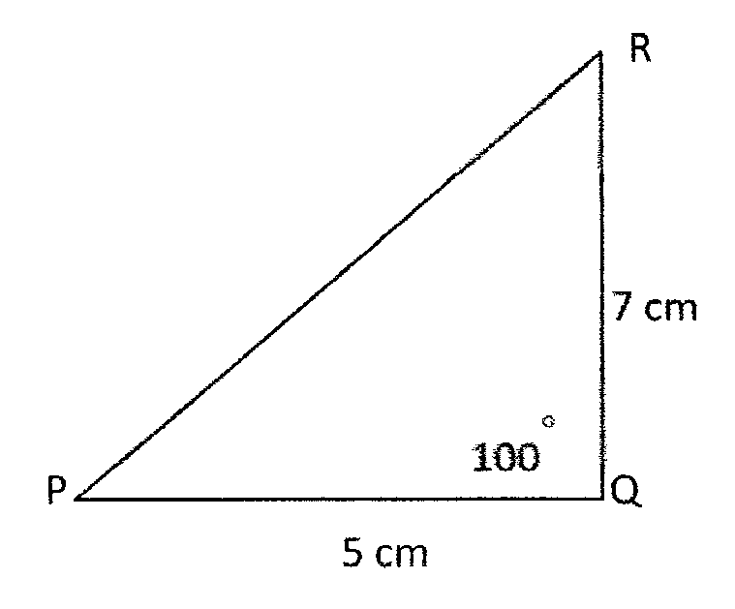
to 3d.p the length of PR. (3mks)

6. Without using mathematical tables or a calculator find tan 120°, given that tan 30º = (3mks)

7. The position vectors of A and B are OA= 4i-5j+3k and OB =3i- j±4k respectively. Calculate
|AB| correct to 3 significant figures. (3mks)

8. The figure shows the cross section of a tunnel in the form of a major segment of a circle. The
perpendicular height and the chord are each 4.4rn. Calculate the diameter of the tunnel. (3mks)
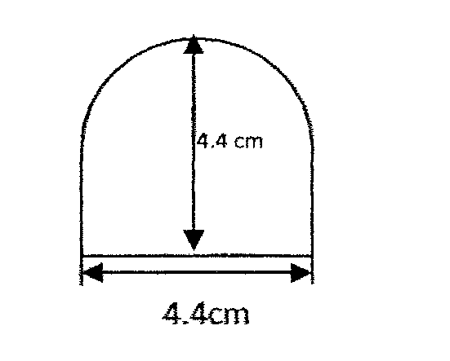

9. Two grades of sugar, grade A costing sh,94 per kg and grade B costing sh.84 per kg are to be mixed in
order to produce a blend worth sh.90 per kg. In what proportion should they be mixed? (3mks)

10. In the figure below, PQR is a tangent to the circle at Q. QT is a chord and PST is a straight line. Given
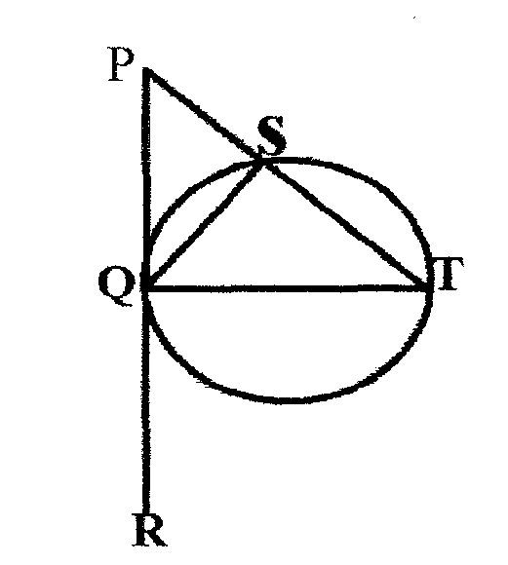
that < PQT =110⁰ and < TPQ=25°, find<SQP.(give reasons) (3mks)

11. The logarithm of the squares of a and b are 1.204 and 0.954 respectively. Find the logarithm of their
product. (2mks)

12. The internal and external diameters of a metal pipe were given as 1.8cm and 2cm respectively.
Calculate the maximum possible thickness of the pipe. (3mks)

13. State the amplitude, period and phase angle of the function y= 2 Cos (3x-40)° (3mks)

14. The figure shows triangle ABC. The triangle is rotated through +60° about the point O, Draw triangle
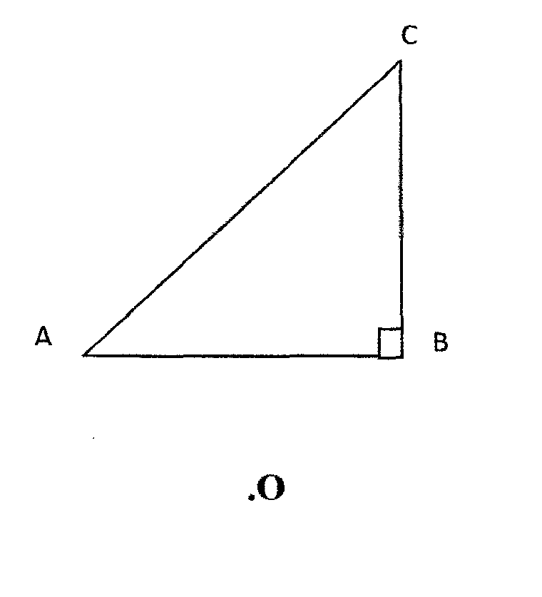
A¹B¹C¹ the image of triangle ABC. (3mks)

15. Use reciprocal tables to evaluate
(3mks)

16. The table below shows the marks obtained in a maths test
Marks | 1-14 | 15-24 | 25-34 | 35-44 | 45-50 | 51-60 | 61-74
No of students | 18 | 10 | 16 | 9 | 6 | 4 | 3
Draw a frequency polygon to represent this data (4mks)

SECTION B (50 MARKS)
Answer any five questions in this section in the spaces provided
17. The figure shows a cone of base radius 28cm and the slant side of length 35cm. At a point P 14cm
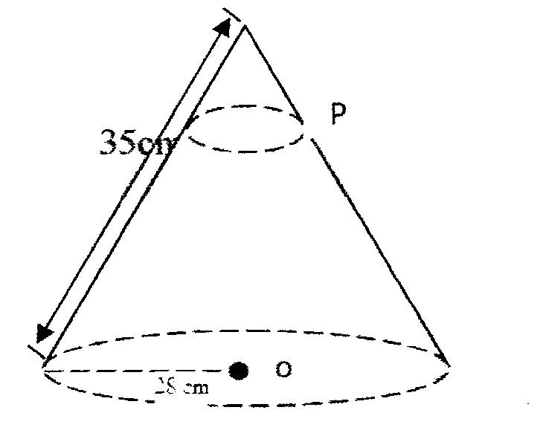
vertically below the vertex , the cone is cut across to form a smaller one.

a. Calculate the base radius of the smaller cone (4mks)

b. Find the volume of the smaller cone (2mks)

c. Find the volume of the large cone (2mks)

d. Find the volume of the frustum (2mks)

18. At 11. 15 am, a trailer left Kisumu and traveled to Nakuru at an average speed of 40km/hr At 1.45pm a
bus left Kisumu and travelled along, the same road at an average speed of 60 km/h. The distance from Kisumu to Nairobi is 500 km.

- Calculate the distance travelled by the trailer before the bus started? (2mks)

b. At what time did the bus overtake the trailer? (3mks)

c. How far from Nakuru was the bus when it overtook the trailer? (2mks)

d. Find how far from Nakuru the trailer was when the bus reached Nakuru. (3mks)

19. The members of a self- help group agreed to buy 4.8 acres of land valued at sh 500,000 per acre. Each
member was supposed to contribute the same amount of money towards the project. Before they
`bought the land, 60 members withdrew from the project and the remaining members had to pay
Sh. 20,000 more than the originally planned amoi.mt.
a) Determine:
i. The original number of members (5mks)

ii. The amount each member contributed (2mks)

b) The value of the land appreciated at the rate of 20% per annum, Determine how much
each member received if the land was sold after 4 years. (3mks)

20. (a) Complete the table below for the equation y = x³ - 5x² + 3x +7 (2mks)
X | -2 | -1 | 0 | 1 | 2 | 3 | 4 | 5
X3 |  | -1 | 0 | 1 |  | 27 | 64
-5x2 |  | -5 | 0 | -5 |  | -45 | -80
3x |  | -3 | 0 | 3 |  | 9 | 12
7 | 7 | 7 | 7 | 7 | 7 | 7 | 7 | 7
Y |  | -2 | 7 | 6 |  | -2 | 3

b) Draw the graph of y = x³ -5x² +x+7 (3mks)

c) Use the graph to estimate the roots of the equations
i. x³-5x²+ 3x+7= 0 (2mks)

ii. x³-5x²+ 2x+5=0 (3mks)

21. In the figure below, OS is the radius of the circle center O. Chords SQ and TIJ are extended to meet at P
and OR is perpendicular to QS at R.
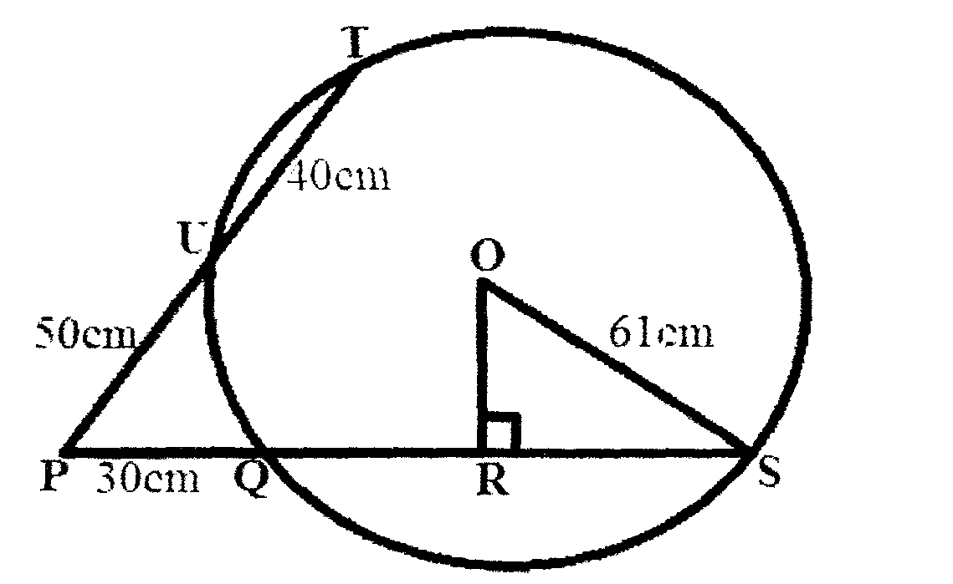
OS= 61 cm, PU= 50cm, UT= 40cm and PQ=30cm

a. Calculate the length of
(i) QS (2mks)

(ii) OR (3mks)

b. Calculate, correct to 1 decimal place;
i. The size of angle ROS (2mks)

ii. The length of the minor arc QS (3mks)

22. The following data represent the shoe sizes worn by 20 form four boys of Kamermeru Secondary
School. 7,9,8,10,8,8,9,10,8,7,9,7,8,10,9,8,7,7,8,9.
a. Make a frequency distribution table for the data (2mks)

b. Find the mode, mean and median for the data (4mks)

c. Use the circle below to represent the above data in a pie chart (4mks)

23. Three boys Podolski, Kulunye and Robinson stand in the school play ground such that Kulunye is 15
metres from Podolski on a bearing of 043°. The bearing of Robinson from Podolski is 133° and the bearing of Robinson from Kulunye is 160⁰. Calculate:

a. The distance of Robinson from Podolski (4mks)

b. The distance of Kulunye from Robinson (2mks)

c. The bearing of Podolski from Robinson (3mks)

d. The bearing of Kulunye from Robinson (lmk)

24. In an experiment involving two variables: temperature T and Time (t), the following results were
obtained for a cooling liquid.
Time(1)(min) | 0 | 2 | 4 | 6 | 8 | 10 | 12 | 14
Temperature T go (c) | 80 | 60 | 46 | 35 | 26 | 20 | 16 | 14

On the grid provided, draw a graph for the data. (4mks)

b. Use your graph to determine:
i. The rate of cooling at t = 3 minutes (3mks)

ii. The average rate of cooling of the liquid between the 2nd and 11th minutes (3mks)

