NAME ____________________________________ INDEX NO. _______________

SCHOOL ____________________________________ SIGNATURE _______________ DATE _______________

**121/2**

**MATHEMATICS ALT A**

**PAPER 2**

JUNE/JULY, 2015

**TIME: 2½ HOURS**

121/2

MATHEMATICS ALT A

PAPER 2

TIME: 2½ HOURS

**INSTRUCTIONS TO CANDIDATES**

1. Write your name and index number in the spaces provided above.
2. Sign and write the date of examination in the space provided above.
3. This paper consists of **TWO** sections: **Section I** and **Section II**.
4. Answer **ALL** the questions in **section I** and only **FIVE** questions from **Section II.**
5. All answers and working must be written on the question paper in the space provided below each question.
6. Show all the steps in your calculations, giving your answers at each stage in the spaces below each question.
7. Marks may be given for correct working even if the answer is wrong.
8. Non-programmable silent calculators and KNEC mathematical tables may be used except where stated otherwise.
9. This paper consists of **16** printed papers.
10. Candidates should check the question paper to ascertain that all the pages are printed as indicated and that no questions are missing.

**FOR EXAMINER’S USE ONLY**

SECTION I

|  |  |  |  |  |  |  |  |  |  |  |  |  |  |  |  |  |
| --- | --- | --- | --- | --- | --- | --- | --- | --- | --- | --- | --- | --- | --- | --- | --- | --- |
| 1 | 2 | 3 | 4 | 5 | 6 | 7 | 8 | 9 | 10 | 11 | 12 | 13 | 14 | 15 | 16 | TOTAL |
|  |  |  |  |  |  |  |  |  |  |  |  |  |  |  |  |  |

SECTION II

|  |  |  |  |  |  |  |  |  |  |  |  |
| --- | --- | --- | --- | --- | --- | --- | --- | --- | --- | --- | --- |
| 17 | 18 | 19 | 20 | 21 | 22 | 23 | 24 | TOTAL |  | GRAND TOTAL |  |
|  |  |  |  |  |  |  |  |  |  |

**SECTION I (50 MARKS)**

***Answer ALL questions in the spaces provided.***

1. Use logarithms to evaluate;

$\sqrt{\frac{({3196)}^{2}×{(0.024)}^{3}}{204.6}}$ (4 marks)

1. Make t the subject of the formula. V= $\sqrt{\frac{{tv}^{2}-w}{m}}$ (3 marks)
2. Solve the inequalities 2x – 5 > -11 and 3 + 2x $≤$ 13, giving the answer as a combined inequality. (3 marks)
3. Use matrix method to determine the coordinates of the point of intersection of the two lines.

3x − 2y = 13, 2y + x + 1= 0 (3 marks)

1. P and Q are the points on the ends of the diameter of the circle below.

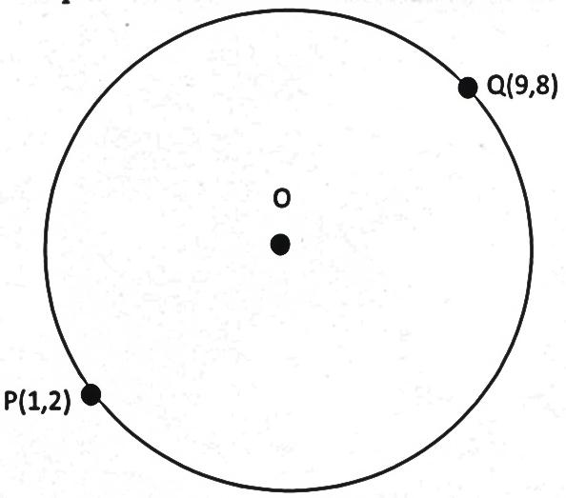

**O**

**P (1,2)**

**Q (9,8)**

1. Write down in terms of x and y the equation of the circle in the form;

ax2 + by2 + x + y + c = 0 (2 marks)

1. Find the equation of the tangent at Q in the form ax + by + c = 0 (2 marks)
2. Use binomial expansion to expand (1− )4 up to the 4th term. (2 marks)
3. Solve for x in [log­2 ­­x]2 + log2 8 = log­­­2 x4 (3 marks)
4. An arc of a circle radius 3.5cm is 9.1 cm long. Find the angle it subtends at the centre of the circle. (3 marks)
5. Simplify $\frac{4}{\sqrt{5}+\sqrt{2}}-\frac{3}{\sqrt{5}\sqrt{2}}$ (3 marks)
6. In Mr. Mukala’s shop, a radio has marked price of ksh 10,000. Mr. Mukala can allow a reduction of 15% on the marked price and still make a profit of 25% on the cost price of the radio. What was the

cost price of the radio? (3 marks)

1. A point T divides a line AB internally in the ratio 5:2. Given that A is (4,10) and B is (11, 3).

Find the coordinates of T. (4 marks)

1. Grade x and grade y sugar cost sh 60 and sh 50 per kilogram respectively. In what proportion must

the two grades be mixed to produce a blend that cost sh 53 per kilogram. (3 marks)

1. Use the identity sin2θ + cos2θ = 1 to find the values of sin θ, given that cos θ = $\frac{5}{13}$ (3 marks)
2. A two digit number is made by combining any of the two digits 1,3,5,7 and 9 at random.
3. Make an array of possible combinations (2 marks)

|  |  |  |  |  |  |
| --- | --- | --- | --- | --- | --- |
|  |  |  |  |  |  |
|  |  |  |  |  |  |
|  |  |  |  |  |  |
|  |  |  |  |  |  |
|  |  |  |  |  |  |
|  |  |  |  |  |  |

1. Find the probability that the number formed is prime. (1 mark)
2. Simplify completely $\frac{\log{49}+2\log{\sqrt{7}}}{\log{7}-\frac{1}{4}\log{7}}$ (3 marks)
3. Mukai travels from A to B at x km/h. The two towns are 40km apart. She then travels to town C at

(x + 6) km/h. Town B and C are 100km apart. If the time she takes from B to C is the same time from

A to B, find the value of x. (3 marks)

**SECTION II (50 MARKS)**

*Answer ANY* ***FIVE*** *questions from this question.*

1. Income tax is charged on annual income at the rate shown below.

|  |  |
| --- | --- |
| Taxable income (K£) | Rate (sh per K£) |
| 1 - 1500  1501 - 3000  3001 - 4500  4501 - 6000  6001 - 7500  7501 - 9000  9001 - 12000  Over 12000 | 2  3  5  7  9  10  12  13 |

1. A certain headmaster earns a monthly salary of Ksh 8570. He is housed in the school and as a result his taxable income is 15% more than his salary. He is entitled to a family relief of ksh 150 per month. How much tax does he pay in a year? (6 marks)
2. From the headmasters salary the following deductions are also made every month.

WCPS 2% of gross salary

NHIF Ksh 20

House rent, water and furniture charges ksh 246. Calculate the headmaster’s net salary for each month. (4 marks)

1. The figure below is a solid in which base ABCD is a rhombus. AC = 16cm, BD = 12cm and CE = 12cm. calculate the angle between the planes.



1. EBD and ABCD. (4 marks)
2. ECB and EBD (3 marks)
3. Length BC and BE (3 marks)
4. a) Fill the table below.

|  |  |  |  |  |  |  |  |  |  |  |
| --- | --- | --- | --- | --- | --- | --- | --- | --- | --- | --- |
| x | 0 | 15 | 30 | 45 | 60 | 75 | 90 | 120 | 150 | 180 |
| 3sin x−1 | -1 |  | 0.5 |  | 1.6 |  | 2 |  |  |  |
| Cos x | 1 |  | 0.87 | 0.71 | 0.5 |  | 0 | -0.5 | -0.87 | -1 |

(2 marks)

b) Using the same axis draw the on the graph paper provided, the graph of y = 3sin x − 1 and

y = cos x for 0o x 180o (6 marks)



c) Use your graph to solve the equations:

1. 3sin x − cos x = 1 (1 mark)
2. 3sin x = 1 (1 mark)
3. The probability of Mary, Esther and Joan coming to school late on Friday are $\frac{1}{5}$, $\frac{2}{7}$ and $\frac{1}{4}$ respectively
4. Draw a tree diagram to represent the information. (2 marks)
5. Calculate the probability that:
6. All the three students are late. (2 marks)
7. All except Esther are late. (2 marks)
8. At least one is late. (2 marks)
9. At most two girls are late. (2 marks)
10. A particle moving along a straight line covers a distance of 5 metres in time t seconds from a fixed

point O on the line where s = t3 − 6t2 + 8t − 4.

Find:

1. The velocity of the particle when t = 5. (3 marks)
2. The acceleration when t = 5 seconds. (3 marks)
3. The time when the velocity of the particle is constant. (4 marks)
4. a) Using a ruler and a pair of compass only construct a triangle ABC in which ∠BAC = 120°,

AB = 6.4cm and AC = 7.0 cm. (4 marks)

Measure

1. ∠ABC (1 mark)
2. BC (1 mark)

c) Construct the circumscribed circle of triangle ABC with O as its centre. Describe the circumscribed circle as a locus. (4 marks)

1. Two aircrafts A and B took off at the same time on Monday from Jomo Kenyatta international airport

(1°S, 37°E) at 11.00 pm. Aircraft A flew due east and aircraft B flew due west. If they met again after 18 hours at (1°S, 117°W), calculate: *(Take radius of earth = 6370km)*

1. Speed of aircraft A in km/h (to 2 d.p) (4 marks)
2. Speed of aircraft B in km/h (to 2 d.p) (4 marks)
3. The time they met again. (2 marks)
4. In the figure below DA is a diameter of the circle ABCD centre O and radius 10cm. TCS is a tangent to the circle at C, AB = BC and ∠DAC = 380.



1. Find the size of the angle;
2. ACS (2 marks)
3. BCA (2 marks)
4. Calculate the length of;
5. AC (2 marks)
6. AB (4 marks)