NAME ____________________________________ INDEX NO. _______________
SCHOOL ____________________________________ SIGNATURE _______________
DATE _______________

231/3
BIOLOGY
PAPER 3
(PRACTICAL)
JULY/AUGUST, 2015
TIME: 1¾ HOURS

231/3
BIOLOGY
PAPER 3
(PRACTICAL)
TIME: 1¾ HOURS

INSTRUCTIONS TO CANDIDATES
- Write your name, school and index number in the spaces provided above.
- Write the date of examination and sign in the spaces provided above.
- Answer ALL the questions in spaces provided.
- You are required to spend the first 15 minutes of the 1¾ allowed for this paper reading the whole paper carefully before commencing your work.
- Answers must be written in the spaces provided in the question paper.
- Additional pages must not be inserted.

FOR OFFICIAL USE ONLY
QUESTION | MAXIMUM SCORE | CANDIDATE’S SCORE
1 | 12
2 | 18
3 | 10
TOTAL SCORE | 40

This paper consists of 4 printed pages.
Candidates should check to ensure that all pages are printed as indicated and no questions are missing.

- You are provided with photographs labelled D₁, D₂, D₃ and D₄. Examine them.
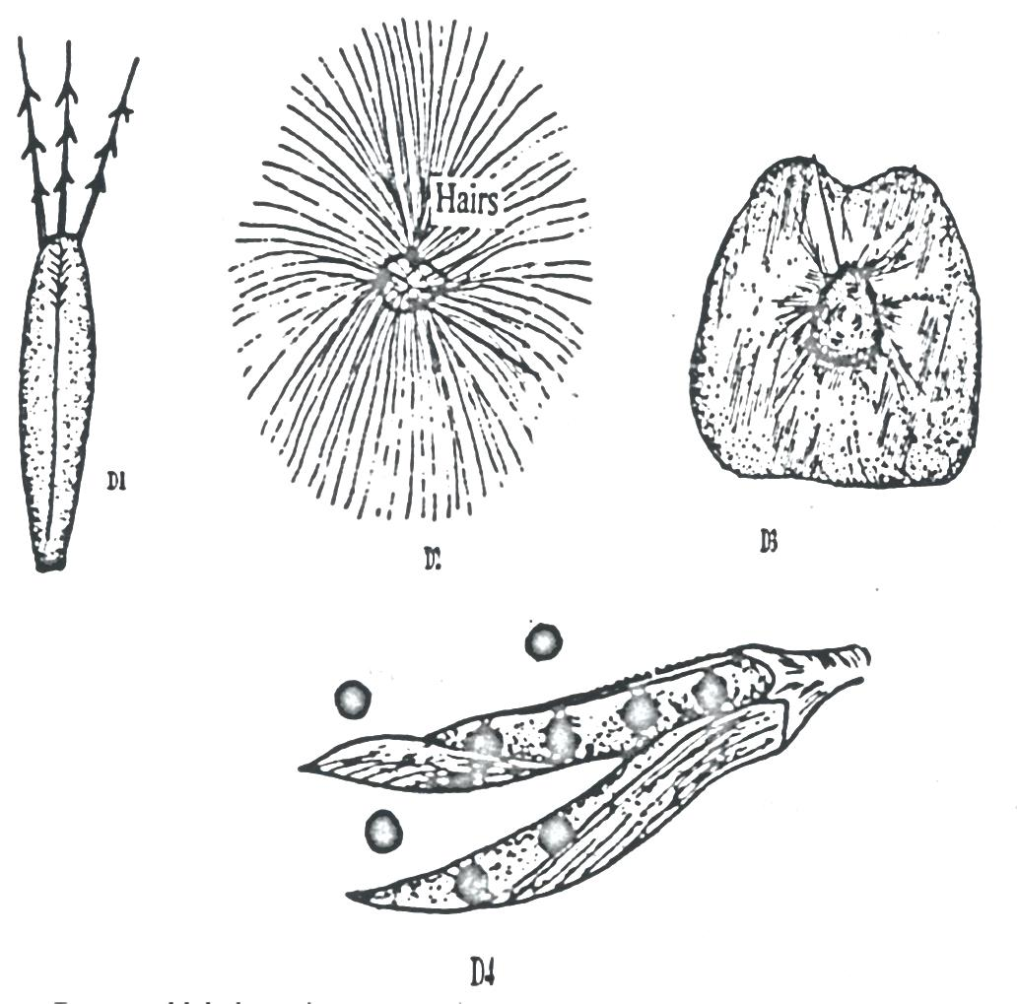
D₃
D₂
D₁
D₄
- Give reasons, state the agent or method of dispersal of the specimens. (8 marks)
SPECIMEN | Agent/method of dispersal | Reason
D₁
D₂
D₃
D₄

- State the type of gynoecium and placentation of D₄. (2 marks)
- Gynoecium _______________________________________________________________
- Placentation _______________________________________________________________
- State the other two types of placentation . (2 marks)
______________________________________________________________________________________________________________________________________________________________________
- a) You are provided with suspension W. Using the reagents provided carry out tests to identify the food substances present in the sample.
TEST | PROCEDURE | OBSERVATION | CONCLUSION

b) Explain how the food substances present in W are assimilated. (4 marks)
_____________________________________________________________________________________________________________________________________________________________________________________________________________________________________________________________________________________________________________________________________________________________________________________________________________________________________________________________________________________________________________________________________________________________________________________________________
- Study the photograph given below to answer the questions that follow.
M
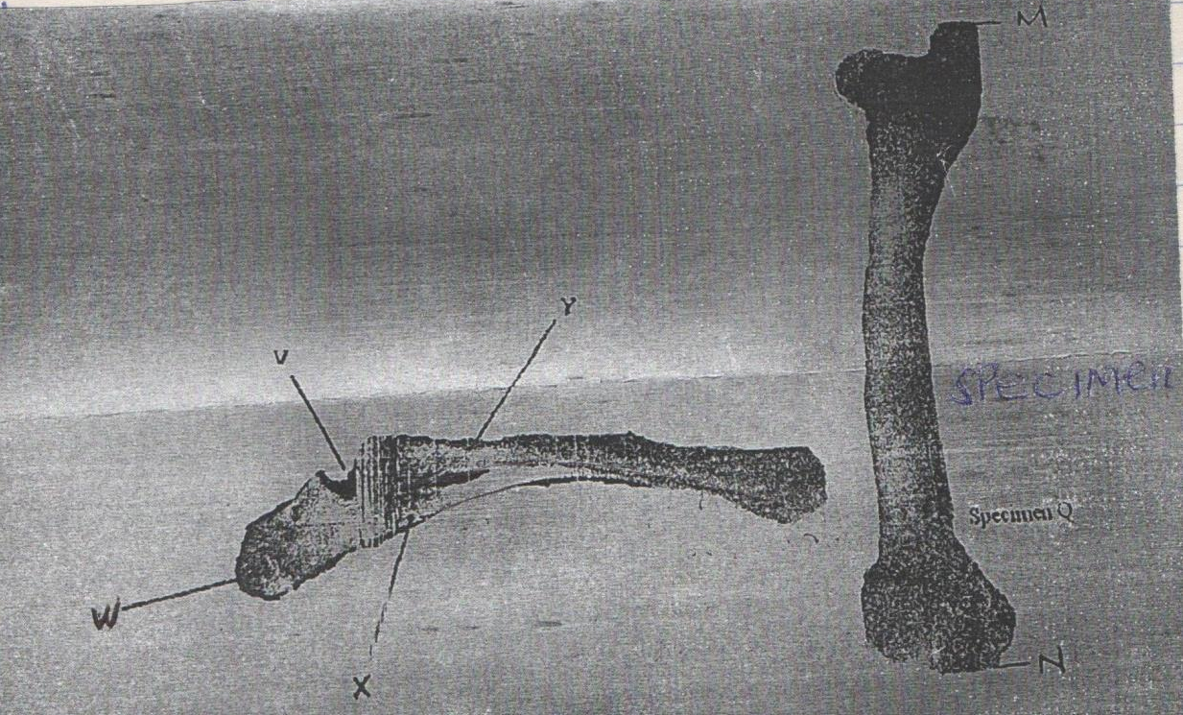
N
Specimen Q
W
X
Y
V
- Identify the specimens: (2 marks)
X ___________________________________________________________________________
Y ___________________________________________________________________________
- Name the part of the mammalian body from which the specimen X was obtained. (1 mark)
___________________________________________________________________________________
- With reasons name the type of joint formed at the proximal and distal ends of specimen Q.
Proximal end __________________________________________________________ (1 mark)
Reason (1 mark)
______________________________________________________________________________________________________________________________________________________________________
Distal end __________________________________________________________ (1 mark)
Reason (1 mark)
______________________________________________________________________________________________________________________________________________________________________
- What is the significance of part labelled W? (1 mark)
______________________________________________________________________________________________________________________________________________________________________
- Given that the actual length of specimen Q from M to N is 28cm, calculate the magnification of Q. (2 marks)
________________________________________________________________________________________________________________________________________________________________________________________________________________________________________________________________________________________________________________________________________________

